Walkthrough of a Cygwin X Server Installation

Send your web browser of choice to http://www.cygwin.com/ and you should see something like the following:

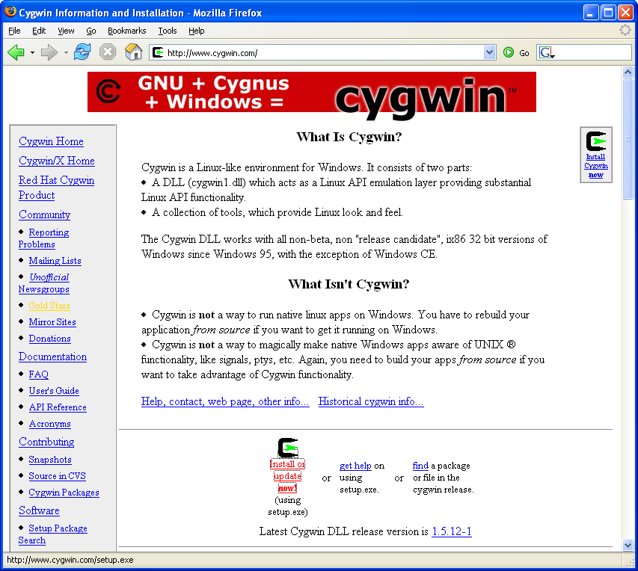

Click on the “Install or update now!” link.
(or you can send your browser directly to: http://www.cygwin.com/setup.exe )

You can save the setup.exe program somewhere on your local disk and then open it, or run it directly from the web; it doesn't matter for this walkthrough.

Upon execution, you should see the Cygwin Setup program:

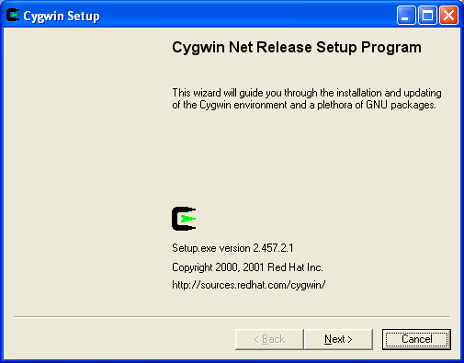

Click on Next > and you get to:

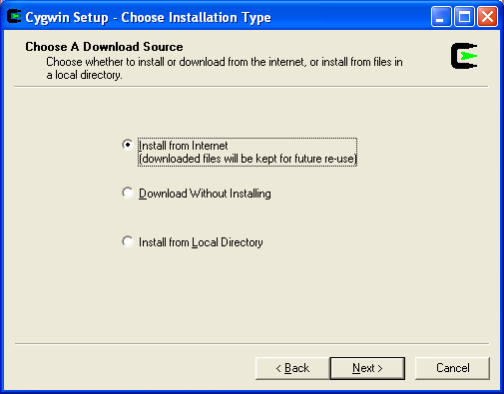

Here you will typically choose the “Install from Internet” option and click on
Next > which takes you to the following:

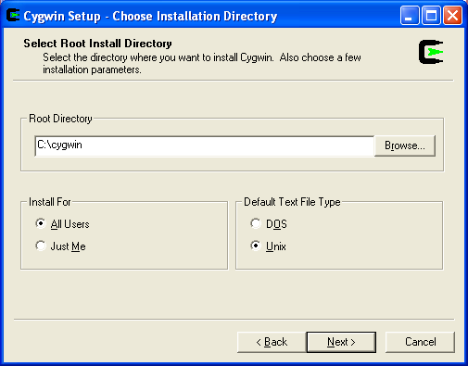

Here you can choose your cygwin base directory, in which the cygwin files will be installed. The defaults are fine for most purposes. You should definitely use a directory dedicated to cygwin to avoid clashes with other software. A basic installation with X will take around 100MB. An installation of everything will approach 1GB, so be sure you've got enough space before proceeding.

Click on Next > to get to the following:

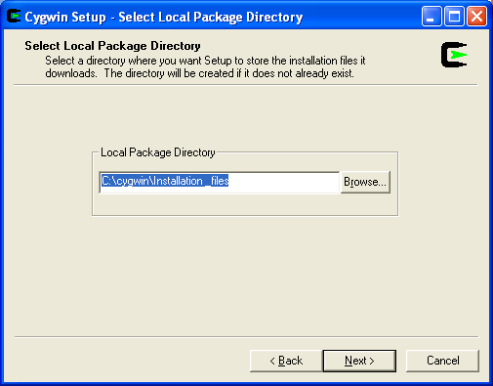

You can choose any location for cygwin to store the downloaded packages that are to be installed. I typically choose a dedicated directory in my cygwin root, but it can be wherever you want. If you input a (valid) directory that doesn't exist, the setup will attempt to create it for you.

Click on Next > to get to the following:
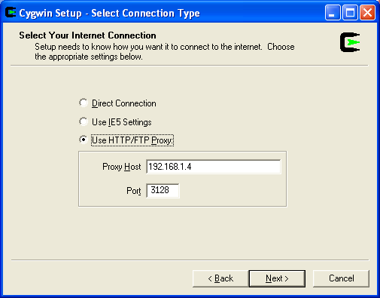
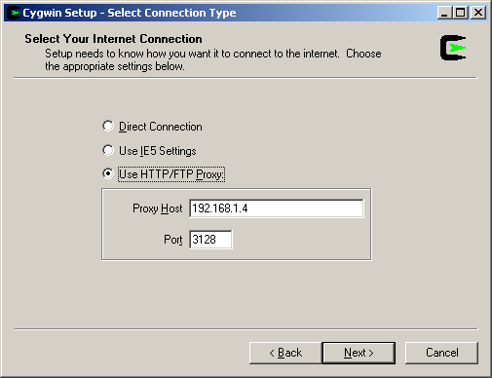

This is a potentially confusing step… If you are on the BNL internal network, you will probably want to use the BNL mirror of the cygwin site, which makes the download quite speedy. In this scenario, even though you don’t need a proxy server to reach the BNL mirror, you must still configure the proxy server as shown so that the next step (to get a list of mirrors) can proceed. You can use the explicit setting shown above, or you can try the “Use IE5 Settings”. If you are on the BNL Cygnus wireless network, use proxy host 192.168.1.130 and port 3128. If you are not at BNL, you will not have to make an appropriate choice for your location (Direct Connection being the first guess).

Click on Next > to proceed to:
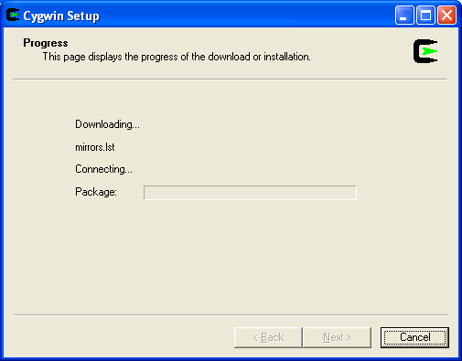

The screen above will, if things are going correctly, flash by quickly. If things are not working, this will timeout within a few seconds and present an error dialog box, in which case you'll need to go Back and check your settings. If all is well, then you'll get to:

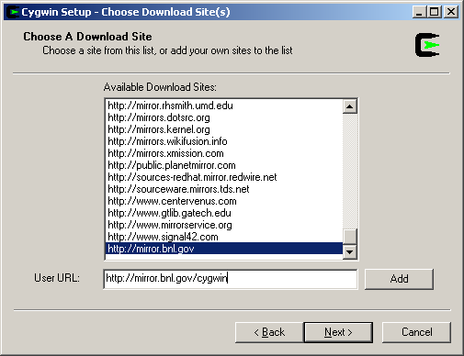

If you are inside the BNL firewall, then you can use the BNL mirror site by typing it in as shown above and pressing the Add button.
It will then show up in the list of Available Download Sites. (And will usually remain listed in subsequent uses of the installer.)
Make sure you have the mirror site of your choice selected in the long list (as in the next picture) and hit Next >.

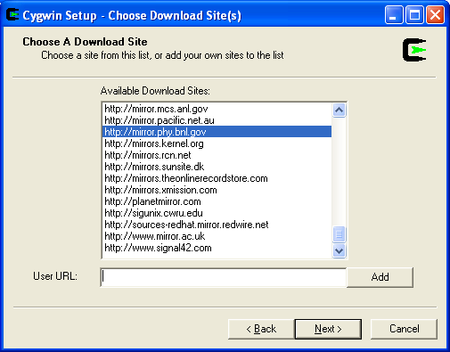

The following screen will appear (briefly if all is well):

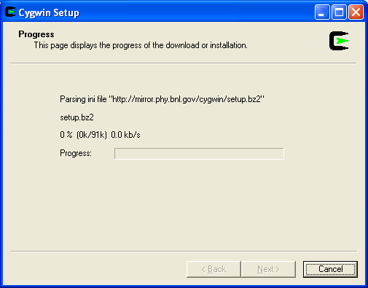

Then you should be presented with something like the following screen:

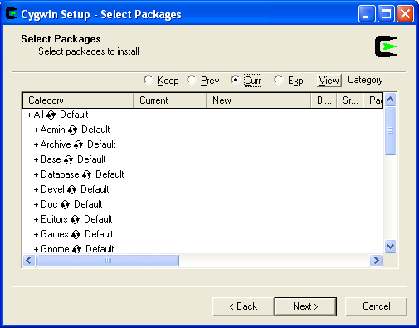

At this point you have to choose what packages you want to install. By default only the Cygwin base packages are selected. For the X server installation, you must choose, at the least, the “xorg-x11-base: Cygwin/X base” package. Scroll down (or resize the window larger as in the next two screenshots) and click on the “+” next to X11 in the category column. You'll see something like the following:

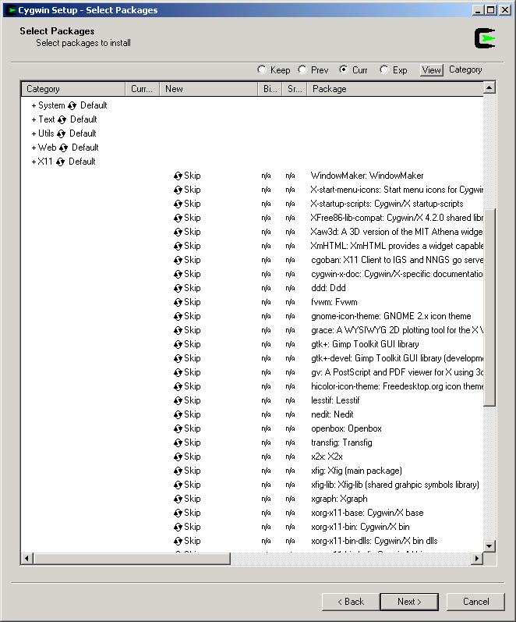

Assuming this is the initial installation, click once on the word “Skip” in the New Column for the xorg-x11-base package. “Skip” should change to a version string. (If you click on it twice you will probably not have the latest version selected for installation, so keep clicking it until you get back to “Skip” and then click it once more.) The installer does some dependency solving and will select a bunch of additional required packages at this time. (Note that if you deselect a package, the automatically selected packages may stay selected – it doesn’t remember what it did for you, it just makes sure that at any given time you have all dependencies satisfied.) You should then see something like the following:

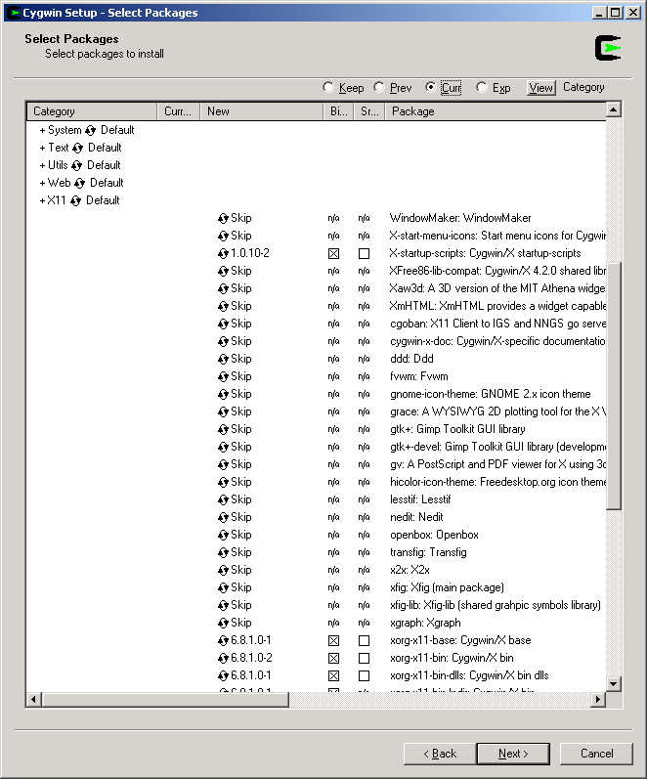

If it hasn’t already been selected, go ahead and select the xwinclip package which is also in the X11 category (click on “Skip” as you did for the xorg-x11-base package.)

At this point, you can choose to expand your cygwin functionality as much as you wish by choosing additional packages, many of which are quite useful, especially if you are familiar with them from experience with their Linux versions.
Hit Next > when you have selected your desired packages and off it goes to download and install as shown below. (This can go by quite quickly on a fast machine with good network conditions, or take tens of minutes (or more) with an old system and/or network slowness.)

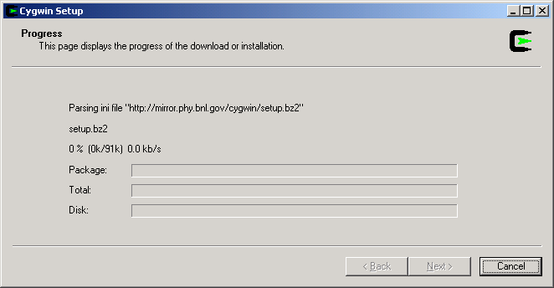
Proceed naturally through the last Next or Finish button(s) as they appear. You can choose to create shortcuts (or links or icons, whatever you want to call them) as you wish. I suggest you choose at least one of them, but that's up to you.

It is worth noting that the shortcuts offered by the installer will NOT start the X server for you, but merely a command-line shell. For that reason, if you only want Cygwin as an X server, you might consider these shortcuts to be unnecessary clutter. You can always create (or remove) your own links later if desired (the default shortcuts point to <CygwinRootDirectory>/cygwin.bat). Continue reading a bit further for a suggestion on how to conveniently start the X server.

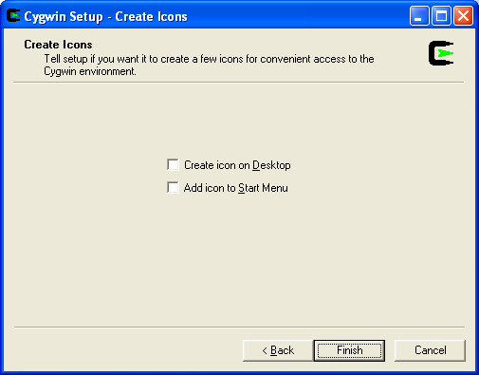

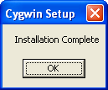

OK! That’s the basic installation! Now on to making it work for you…

To get started, use the pre-installed startup script named “startxwin.bat” which can be found in <CygwinRootDirectory>/usr/X11R6/bin/. You can create a convenient link to it wherever you want (common places would be your Desktop, QuickLaunch bar or Startup folder to automatically start the Xserver at login).

I usually edit that batch file (it is a simple text file and you should edit as such) to comment out (“REM”) the line near the bottom that starts a local xterm. This line starts with “run xterm” followed by a bunch of options. This extraneous xterm is handy to verify that the server is working, but is desktop clutter once you are sure everything is working (unless you actually want to work in the local shell, perhaps to use some of the additional software packages you selected for installation)).

For most cases, the above is enough to get things working for you to display windows from a remote host via an ssh connection.

If you want to use the Cygwin openssh client (choose to install the openssh package during Cygwin setup!), or you need multiple X configurations or connections, then you might want to try Mortens Cygwin X-Launcher, which can be found here: http://www.martin-halle.de/cxlaunch.html You can configure ssh connections, and various common X server options, and save the settings as profiles for future use.
The author has been contacted and approves the use of this software by STAR and BNL folks. (The license agreement is blessedly short and open, but “commercial use” requires his approval, into which we could conceivably fall.)

If you need to delve into the X configuration any more than this, the places to start are:

- The man pages (which are available in cygwin, as the “xorg-x11-man-pages” and “xorg-x11-man-pages-html packages”)
- The online documentation at http://x.cygwin.com/

