SSD documentation

SSD Clamshell and Mechanical Structure
Version Number : 2
27-june-02

Authors : L.Martin (for the cut and paste)

1 SSD Clamshell design 3
2 The one ladder support structure 5
3 The SSD ladder installation scenario 7
4 Mechanical drawings 10

SSD Clamshell design

The SSD is split in two half barrels each composed of 10 ladders. The mechanical support of each part as a “C” shape (Figure 1). A clamshell structure is thus build allowing to install or dismount the SSD easily. The cylindrical shape of the SSD is obtained once the two half barrels are assembled together (Figure 2). The “C” shape pieces have been designed in order to provide three fixation points to minimize the ladder sagging and to keep available space for the routing of the SVT cooling pipes and electrical cables.

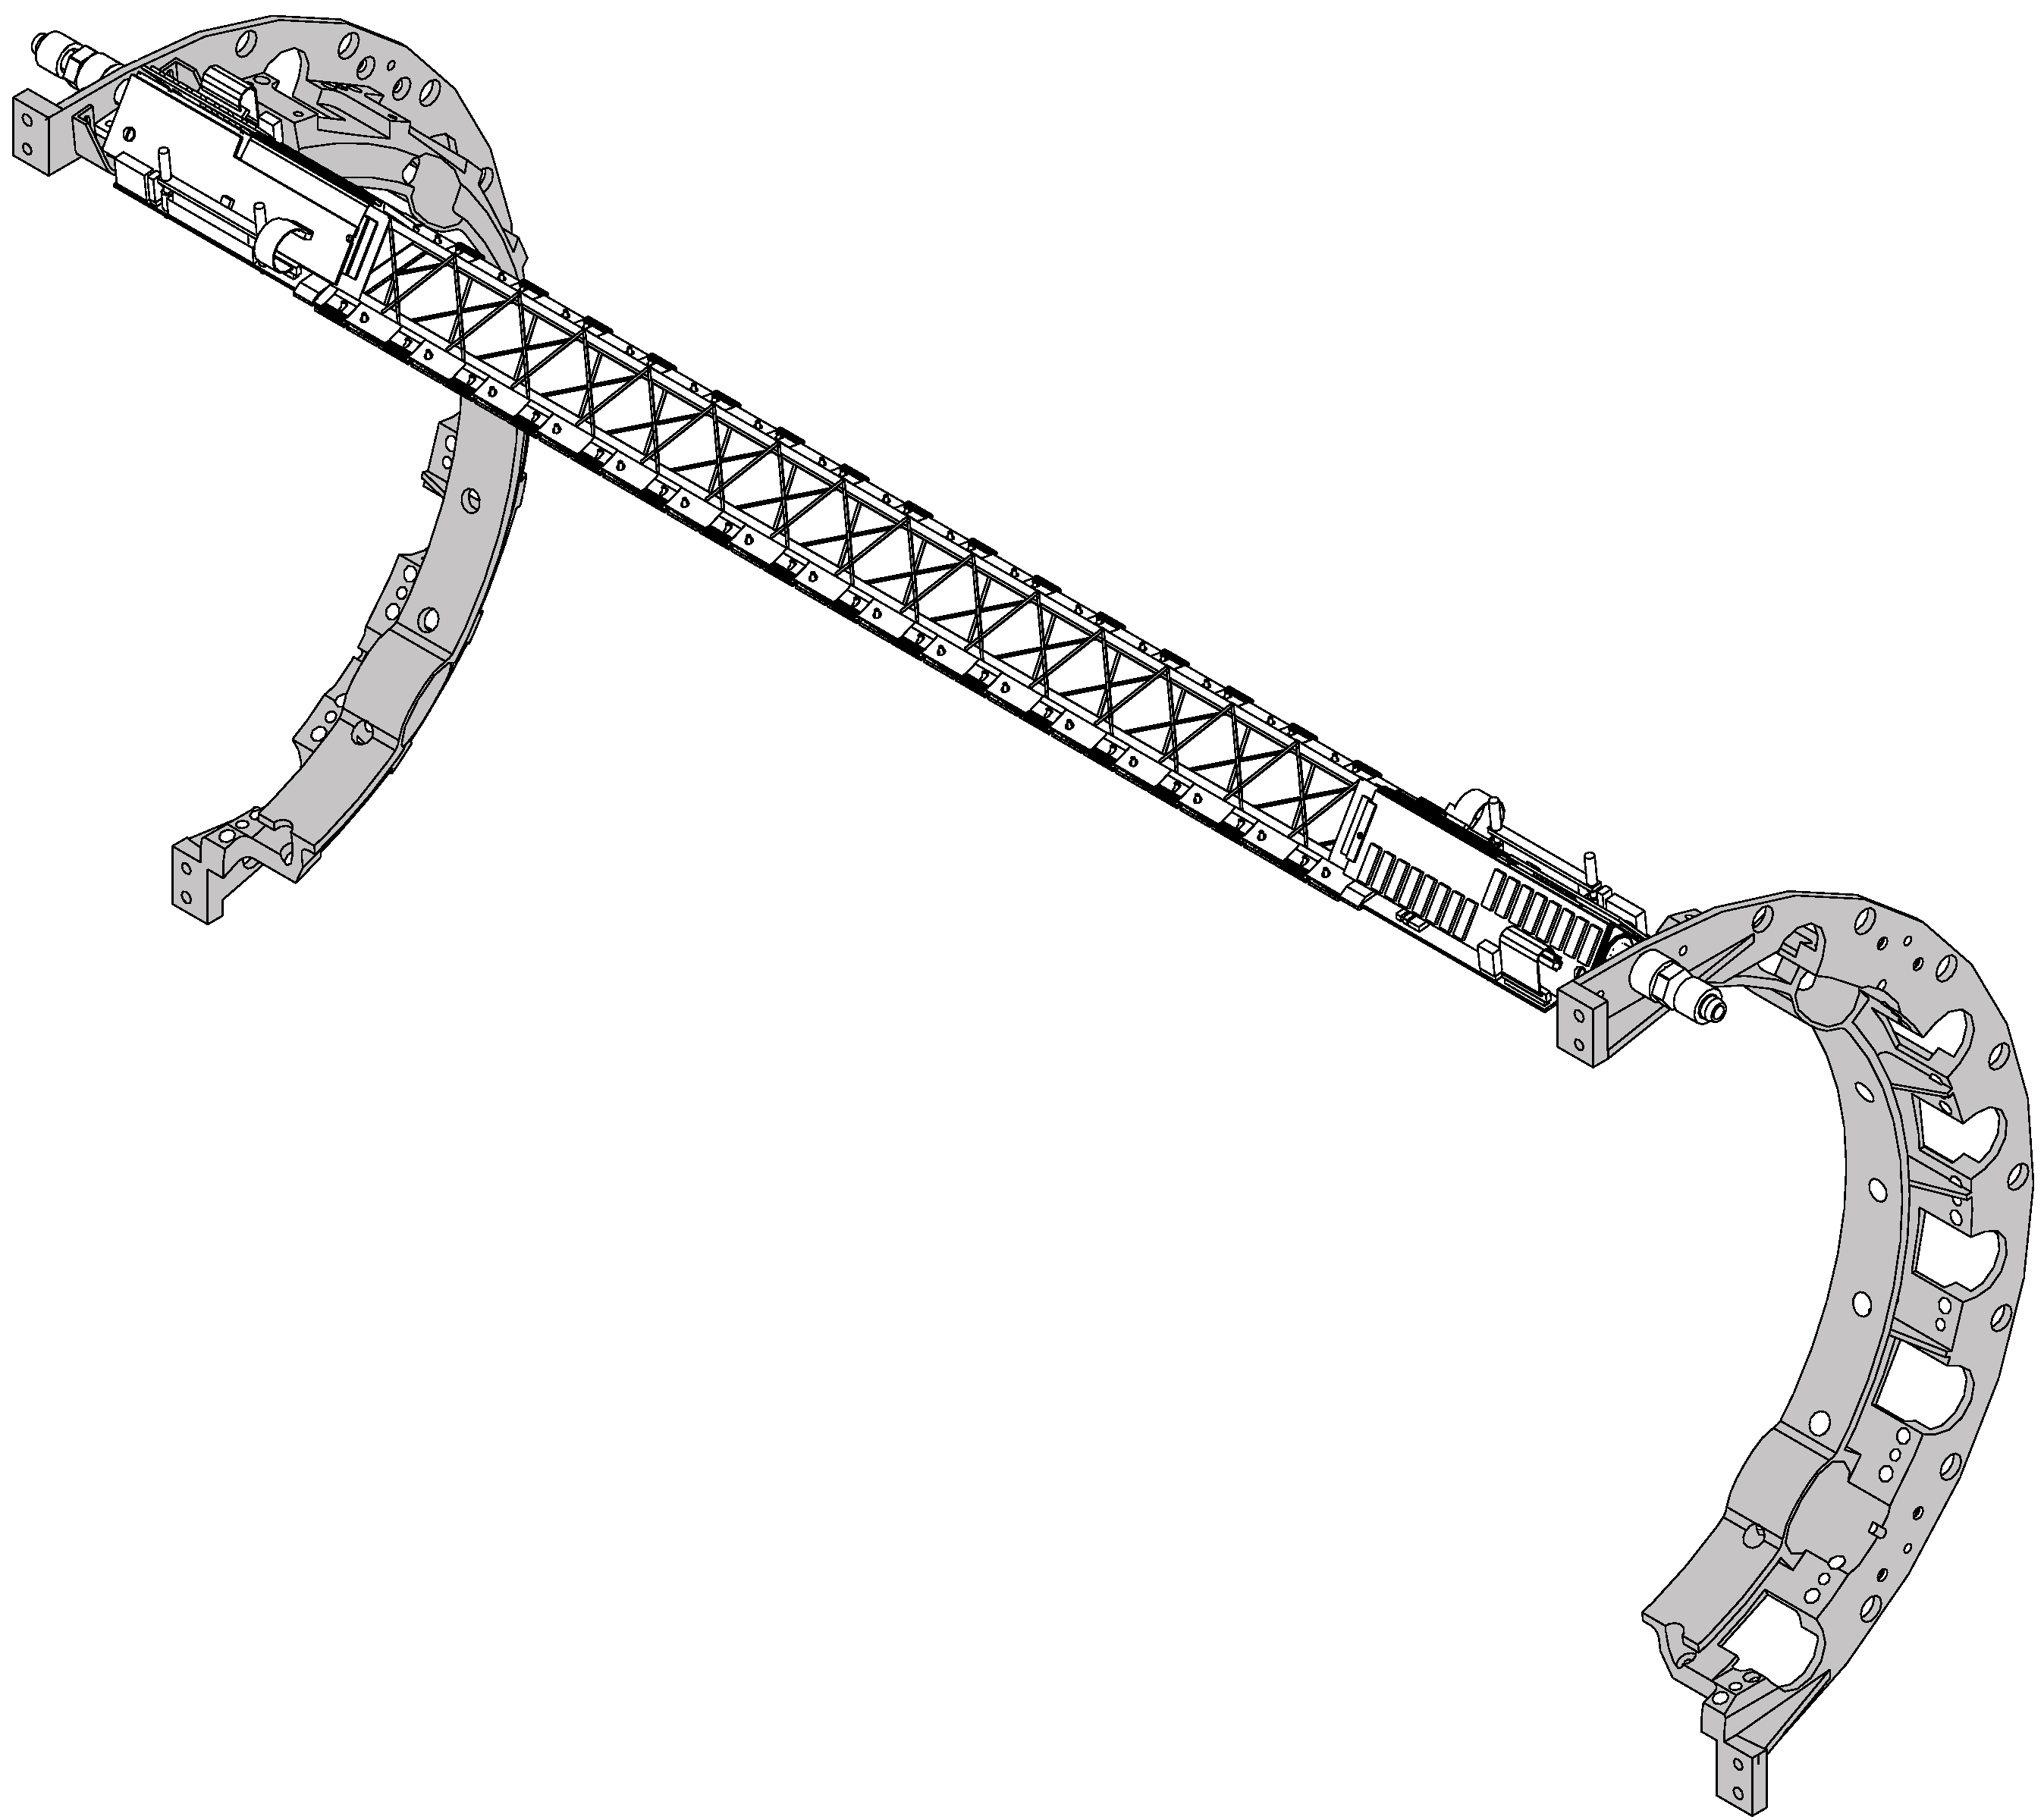
Figure 1 : A half barrel support structure with one ladder
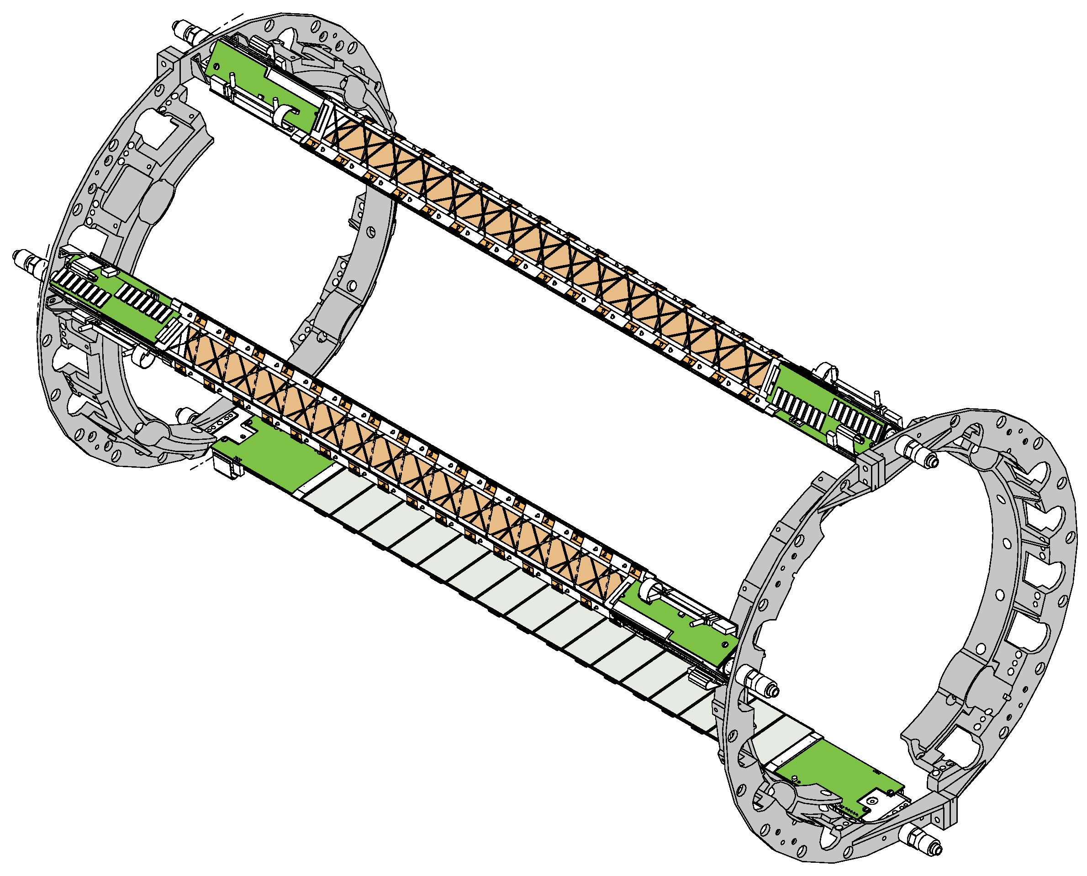
Figure 2 : The two half barrels assembled with 3 ladders installed

A dummy model of a clamshell ring (Figure 3) as been made of resin with preliminary clearance for the SVT cooling tube and electrical cables.
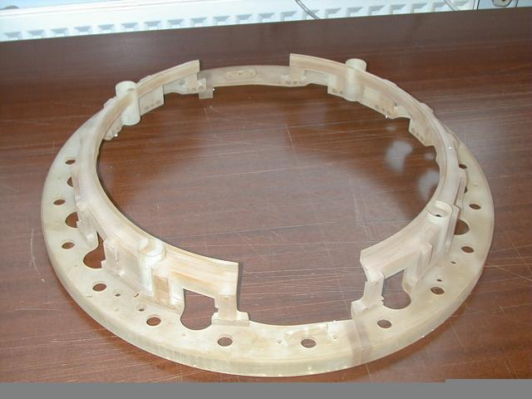
Figure 3 : Dummy model of the SSD clamshell
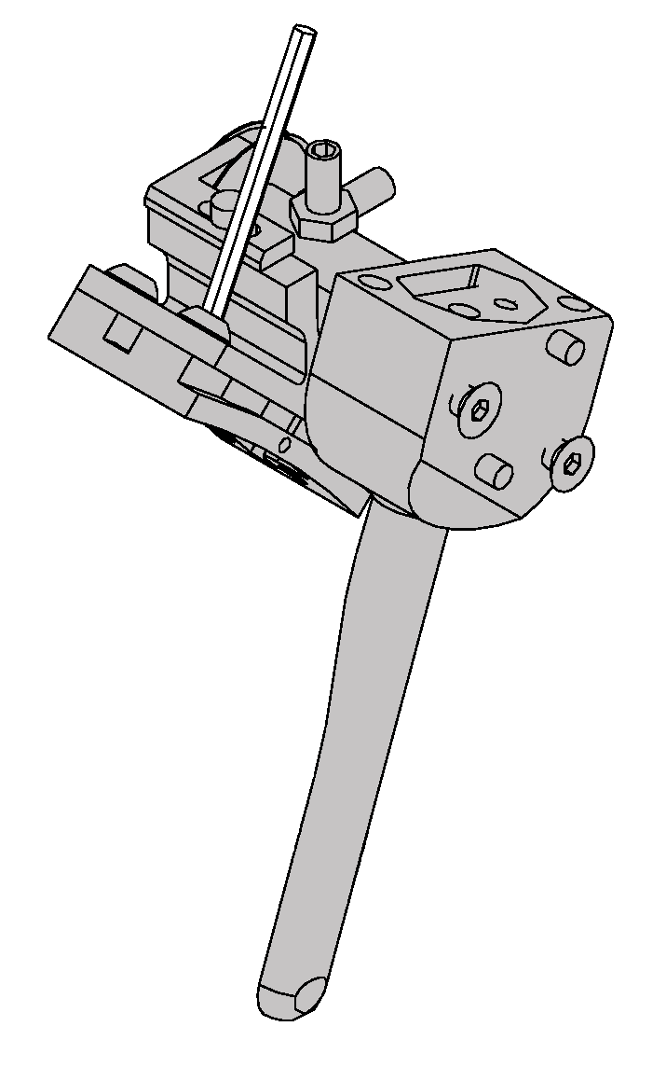
Figure 4 : Bracket equipped with a retractable survey mark. The key in white will be removed
Four brackets (Figure 4) equipped with retractable survey mark will connect each pairs of “C” shape pieces to the cone. Brackets on one side of the clamshell will have a fixed position of the cone while brackets on the other side will be movable for the final positioning of the SSD and to allow deformation of the ladders along the beam axis.
Additional epoxy based pieces (Figure 5) will be attached to the clamshell in order to reconstruct two rings devoted to the cylindrical SSD outer shield.
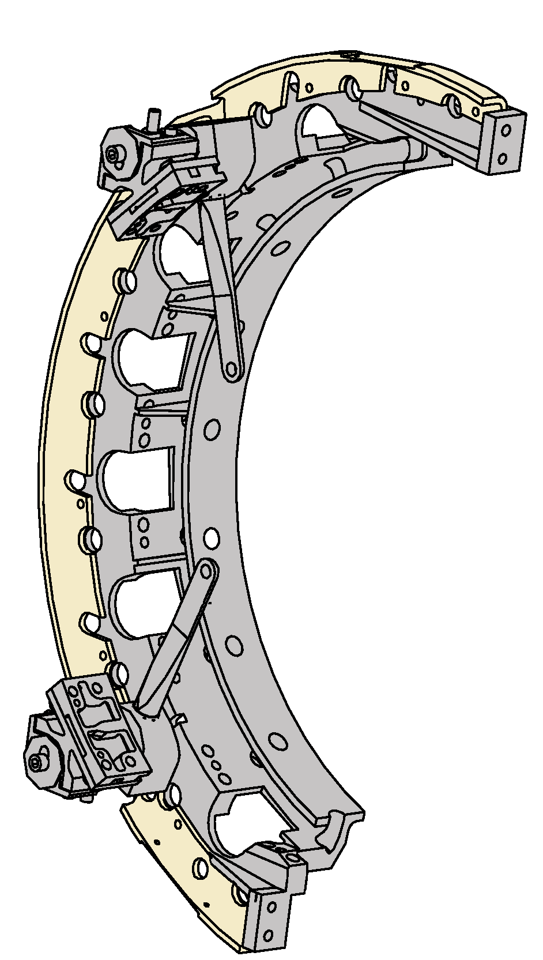
Figure 5 : A half clamshell support structure equipped with two brackets and a epoxy half ring (in yellow) for the external shield

The one ladder support structure
During the summer 2002, one of the SSD ladders will be installed in STAR. A lighter mechanical support has been designed to hold the ladder on the cone and to provide a support for the outer shield (Figure 6). Simplified epoxy rings have been designed for the aluminized mylar shield. Each ring will be connected to the cone using 4 dedicated brackets. One of these brackets will simultaneously hold the ladder and the shield ring.
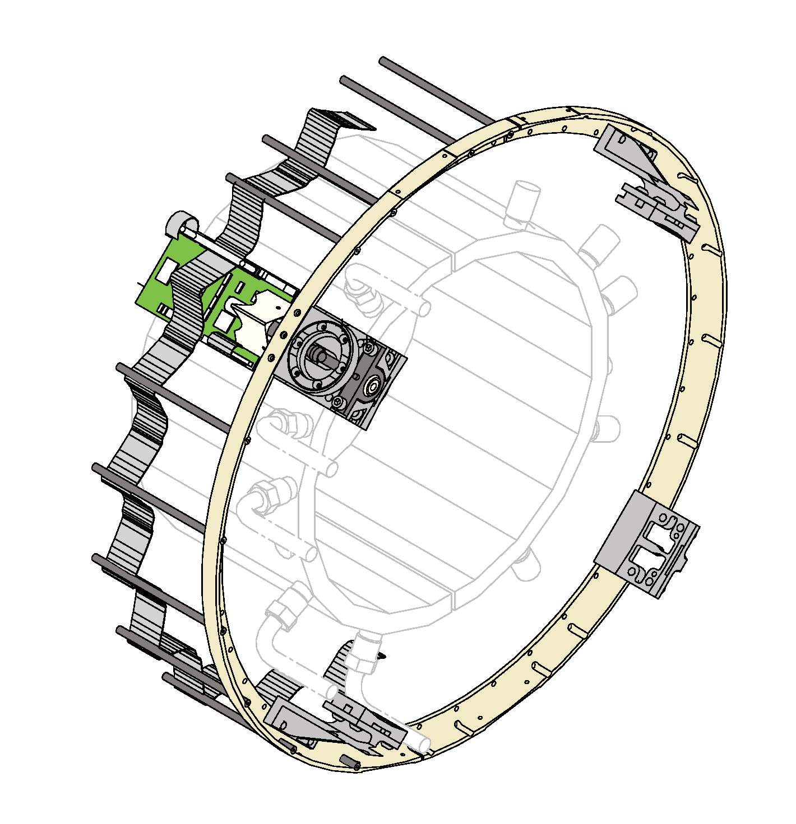
Figure 6 : SSD mechanical support for the summer 2002 installation featuring the shield ring and the connecting brackets

Brackets dedicated to hold the shield rings have been designed (Figure 7). Brackets holding the SSD ladder are composed of several pieces. An intermediate bracket (Figure 8) holds the SSD and is inserted into a knuckle itself attached on the cone. A hole in the middle of this bracket has been made to insert an axle temporary fixed to the cone which will guide the ladder when move down on the cone.

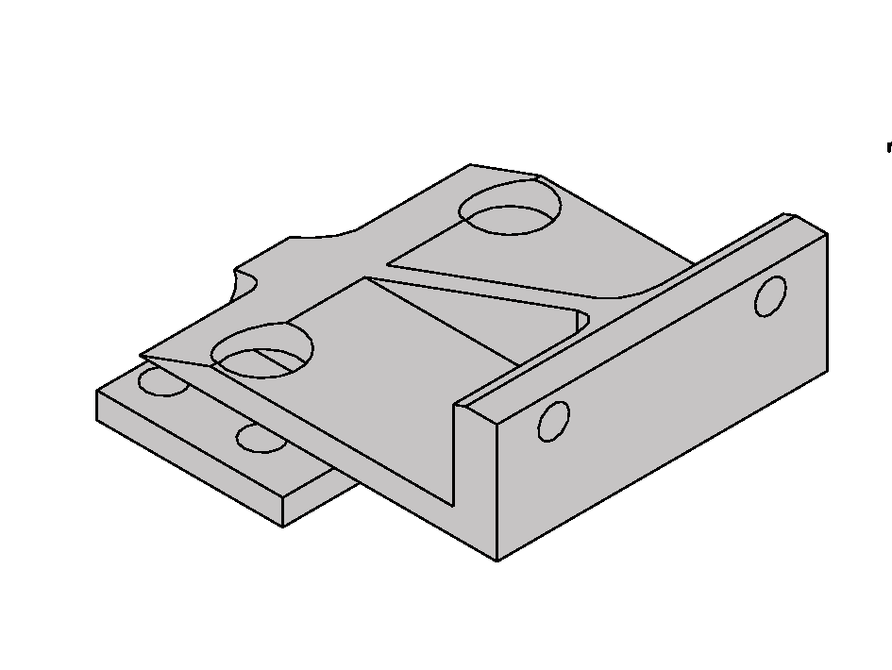
Figure 7 : Bracket supporting the shield ring
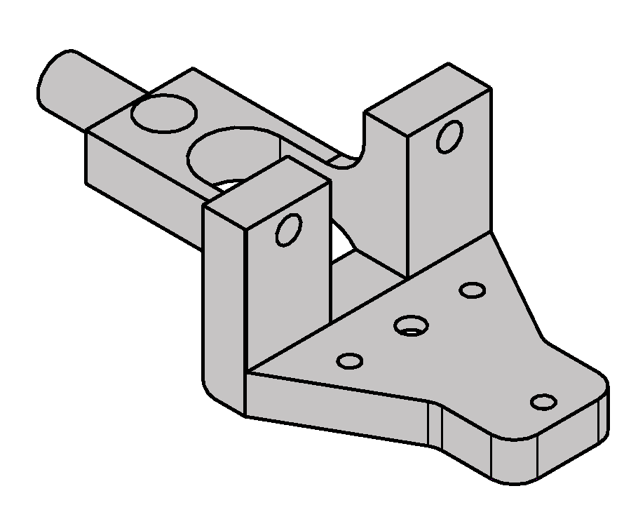
Figure 8 : Intermediate bracket holding the ladder at the right side and inserted into the knuckle on the left side

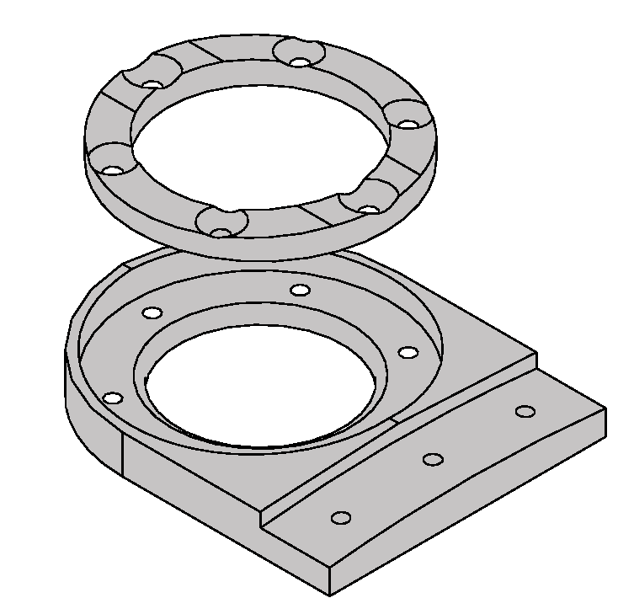
Figure 9 : Piece to extract air from the TPC IFC. The Mylar shield is inserted with a conductive mesh in between the two parts

A specific piece () will be attached to the shield ring in order to provide entrance inside the SSD shield for the air in the TPC IFC used as incoming air for the SSD cooling. The lower part will be attached to the SSD shield ring while the upper part will be used to clamp both the mylar shied and a mesh insuring the electrical continuity.

The SSD ladder installation scenario

The installation of the SSD ladder will proceed in several steps.

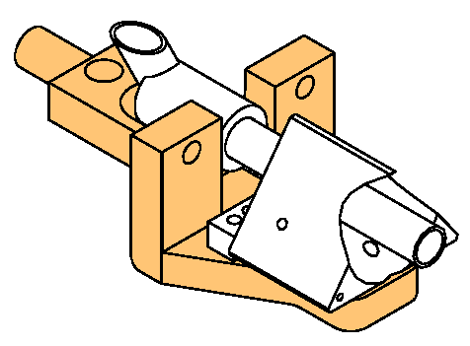
Figure 10 : Step 1 of the ladder installation

Step 1 : The two intermediate bracket are attached to the equipped ladder. Three screws and a positioning pin are used on each side of the ladder

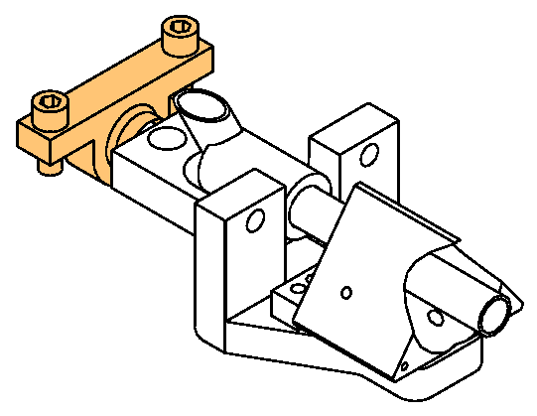
Figure 11 : Step 2 of the ladder installation

Step 2 : The two knuckles are assembled to the intermediate brackets

Step 3 : The 6 shield ring brackets are mounted on the cone. The two "sigma" shape pieces supporting the knuckles are mounted on the cone. The removable pins (axles) used to safely move down the ladder on the cone are attached to the cone.

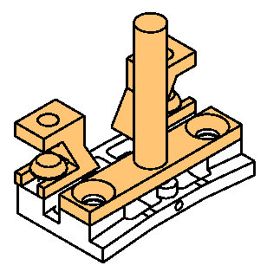
Figure 12 : Step 3 of the ladder installation

Step 4 : Two persons move down the equipped ladder on the cone guided by the two axles.

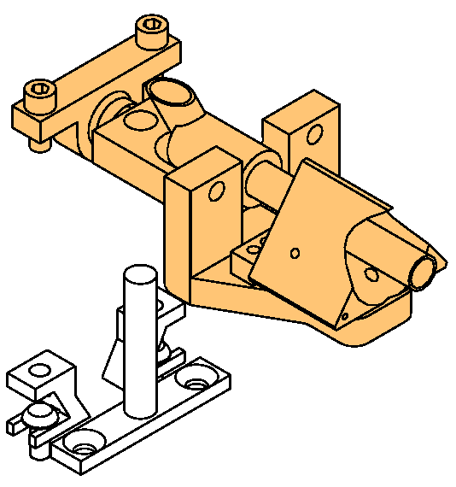
Figure 13 : Step 4 of the ladder installation

Step 5 : The knuckles are screw to freeze the ladder position.

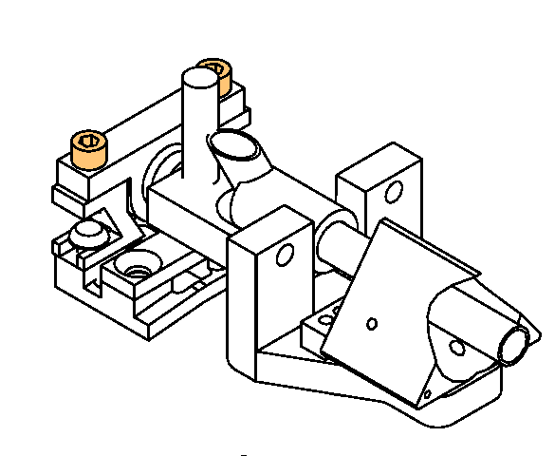
Figure 14 : Step 5 of the ladder installation

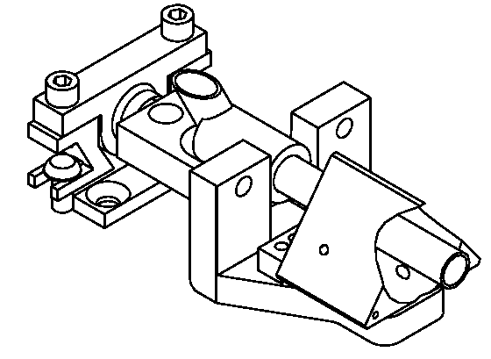
Figure 15 : Step 6 of the ladder installation

Step 6 : The two guiding axles are removed

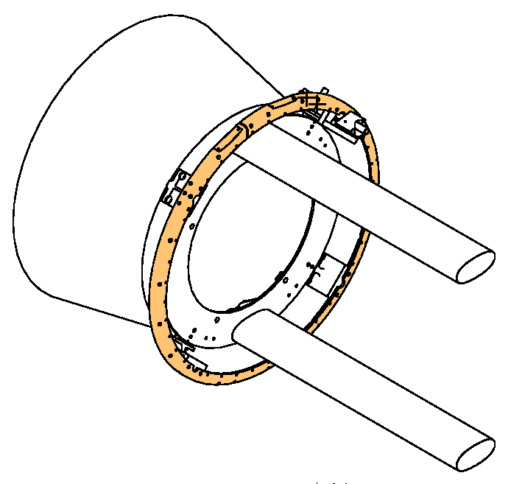
Figure 16 : Step 7 of the ladder installation

Step 7 : The 4 half rings supporting the SSD shield are mounted on the cone.

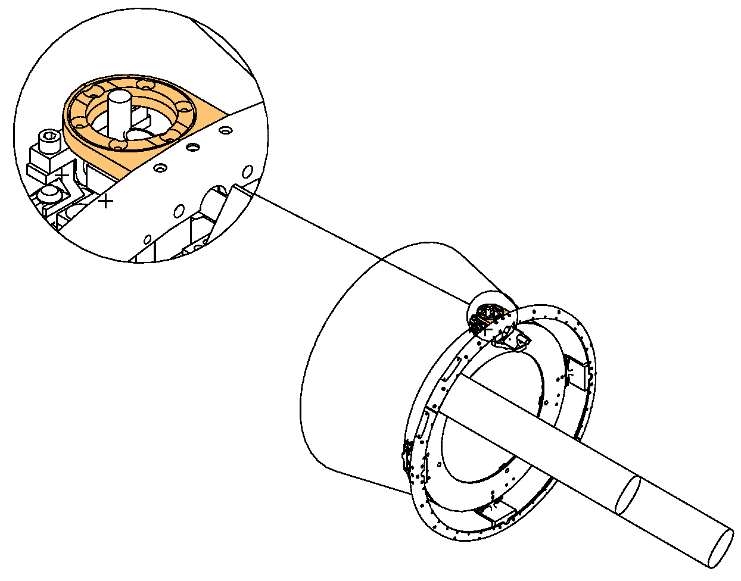
Figure 17 : Step 8 of the ladder installation

Step 8 : If the final cooling system is used, the air flow piece with a metallic mesh is installed on the shield ring. Otherwise, two cooling pipes running on the cone must be plugged at both end of the ladder.

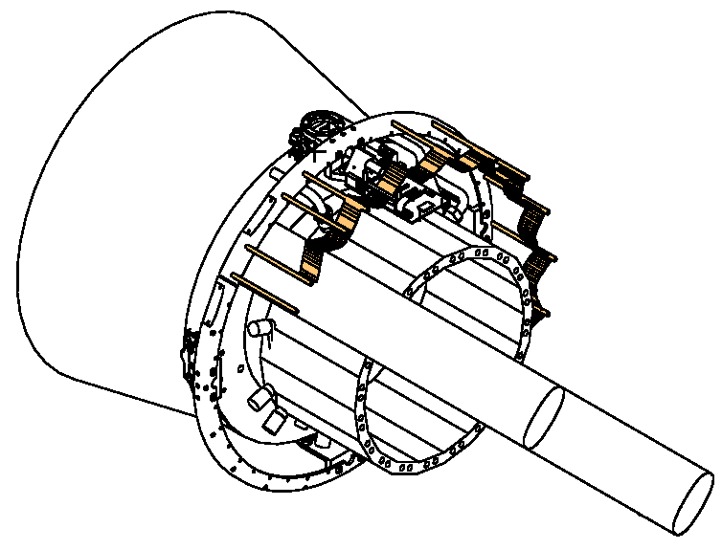
Figure 18 : Step 9 of the ladder installation
Step 9 : Electrical connection of the SSD.

The cables running on the cone are placed inside the shield rings and are maintained in place using electrical collar clamps.

The flat cables linking 10 ladders and connected to the readout board are installed and hold in position using carbon tubes glued to the shield rings.

Step 10 : The mylar shield is installed on the rings.

Mechanical drawings
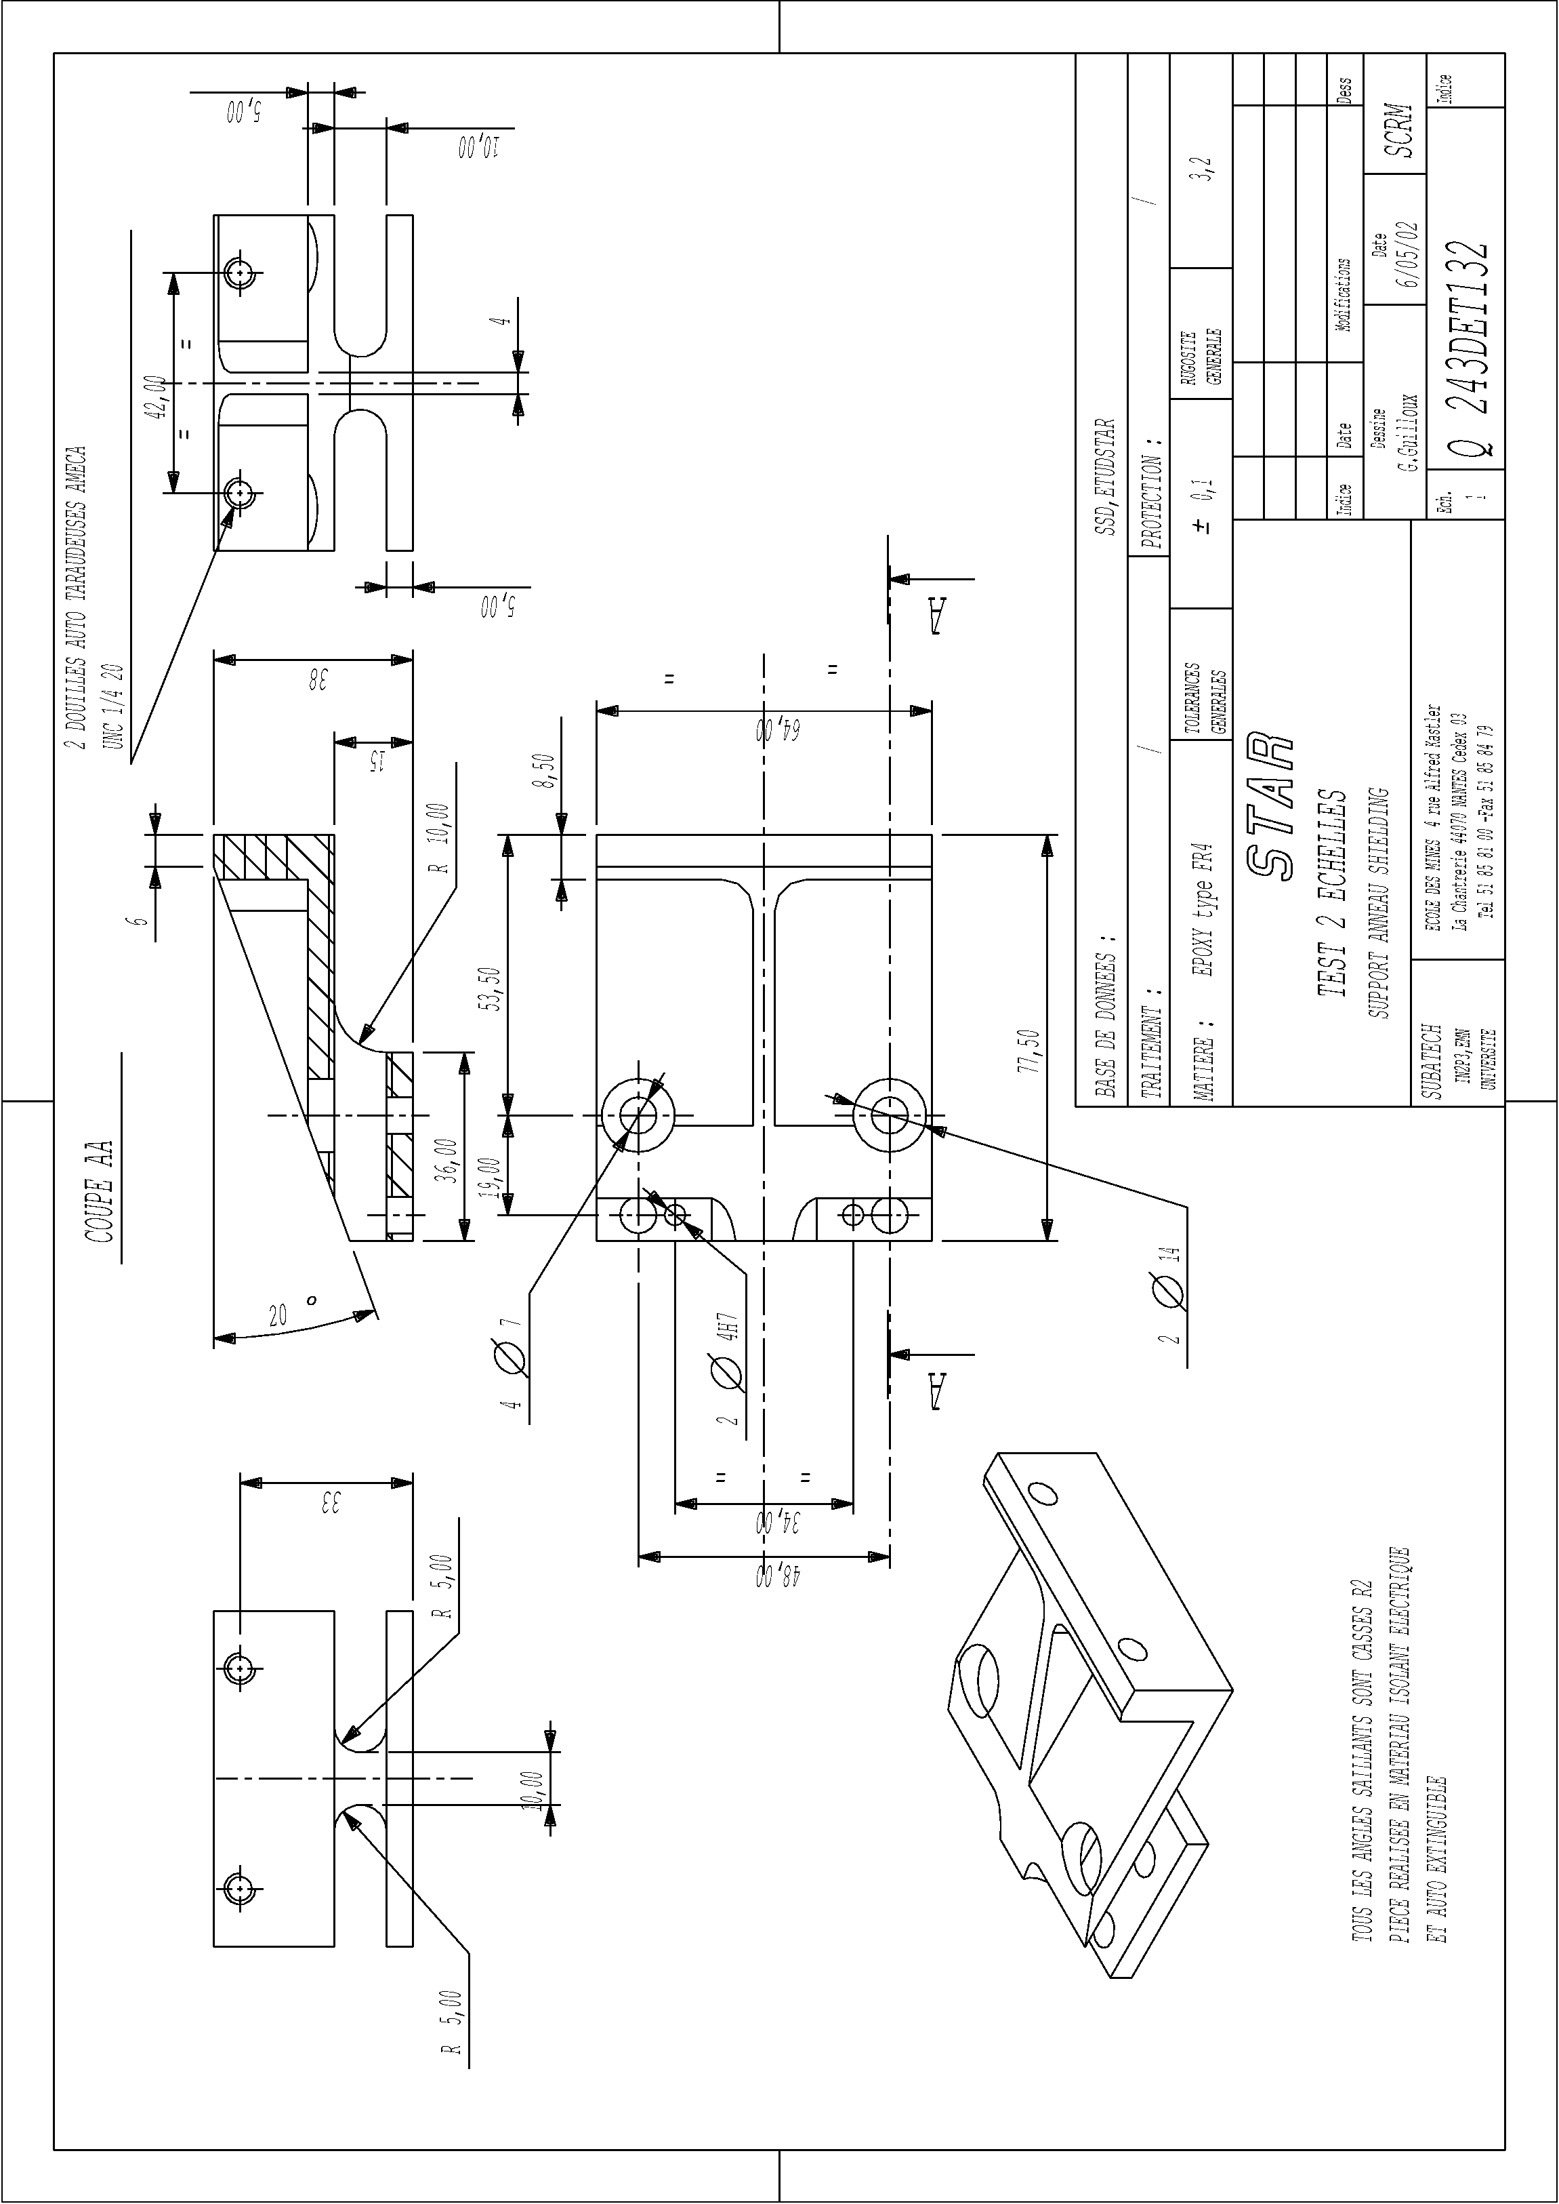
Figure 19 : Drawing (243DET132) of the shield ring bracket
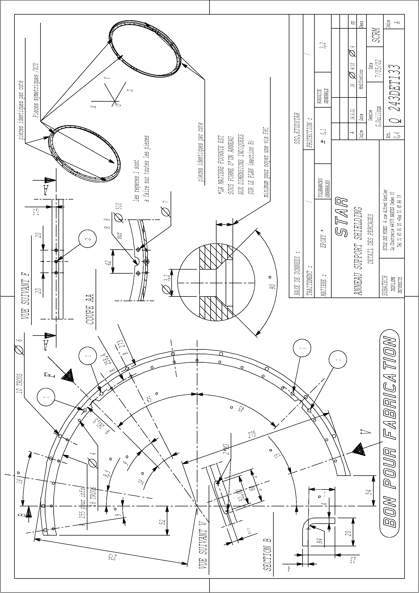
Figure 20 : Drawing (243DET133) of the SSD shield ring

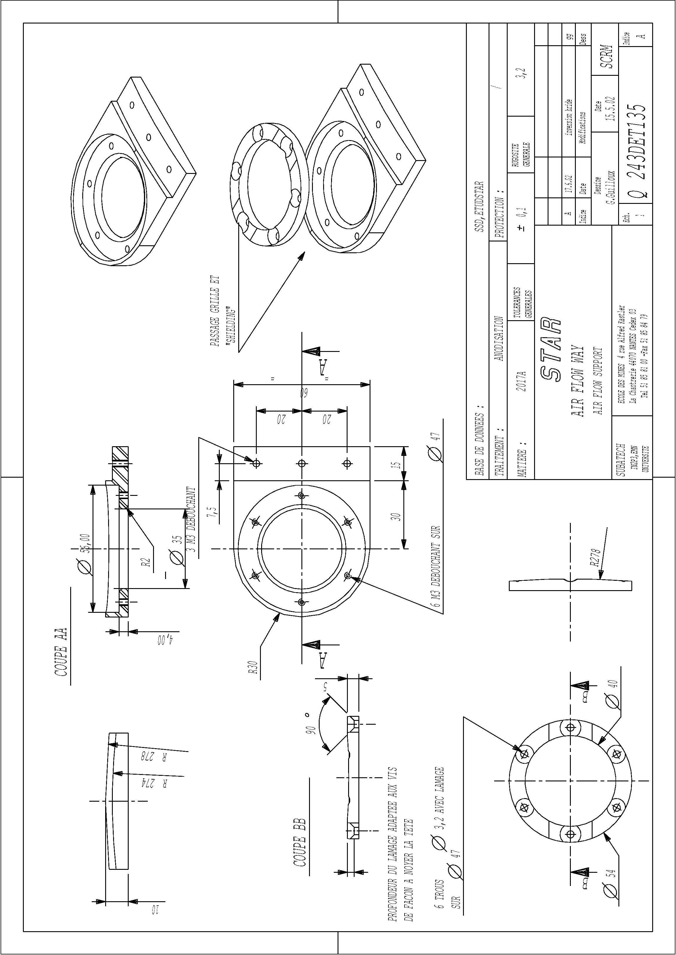
Figure 21 : Drawing (243DET135) of the air flow way

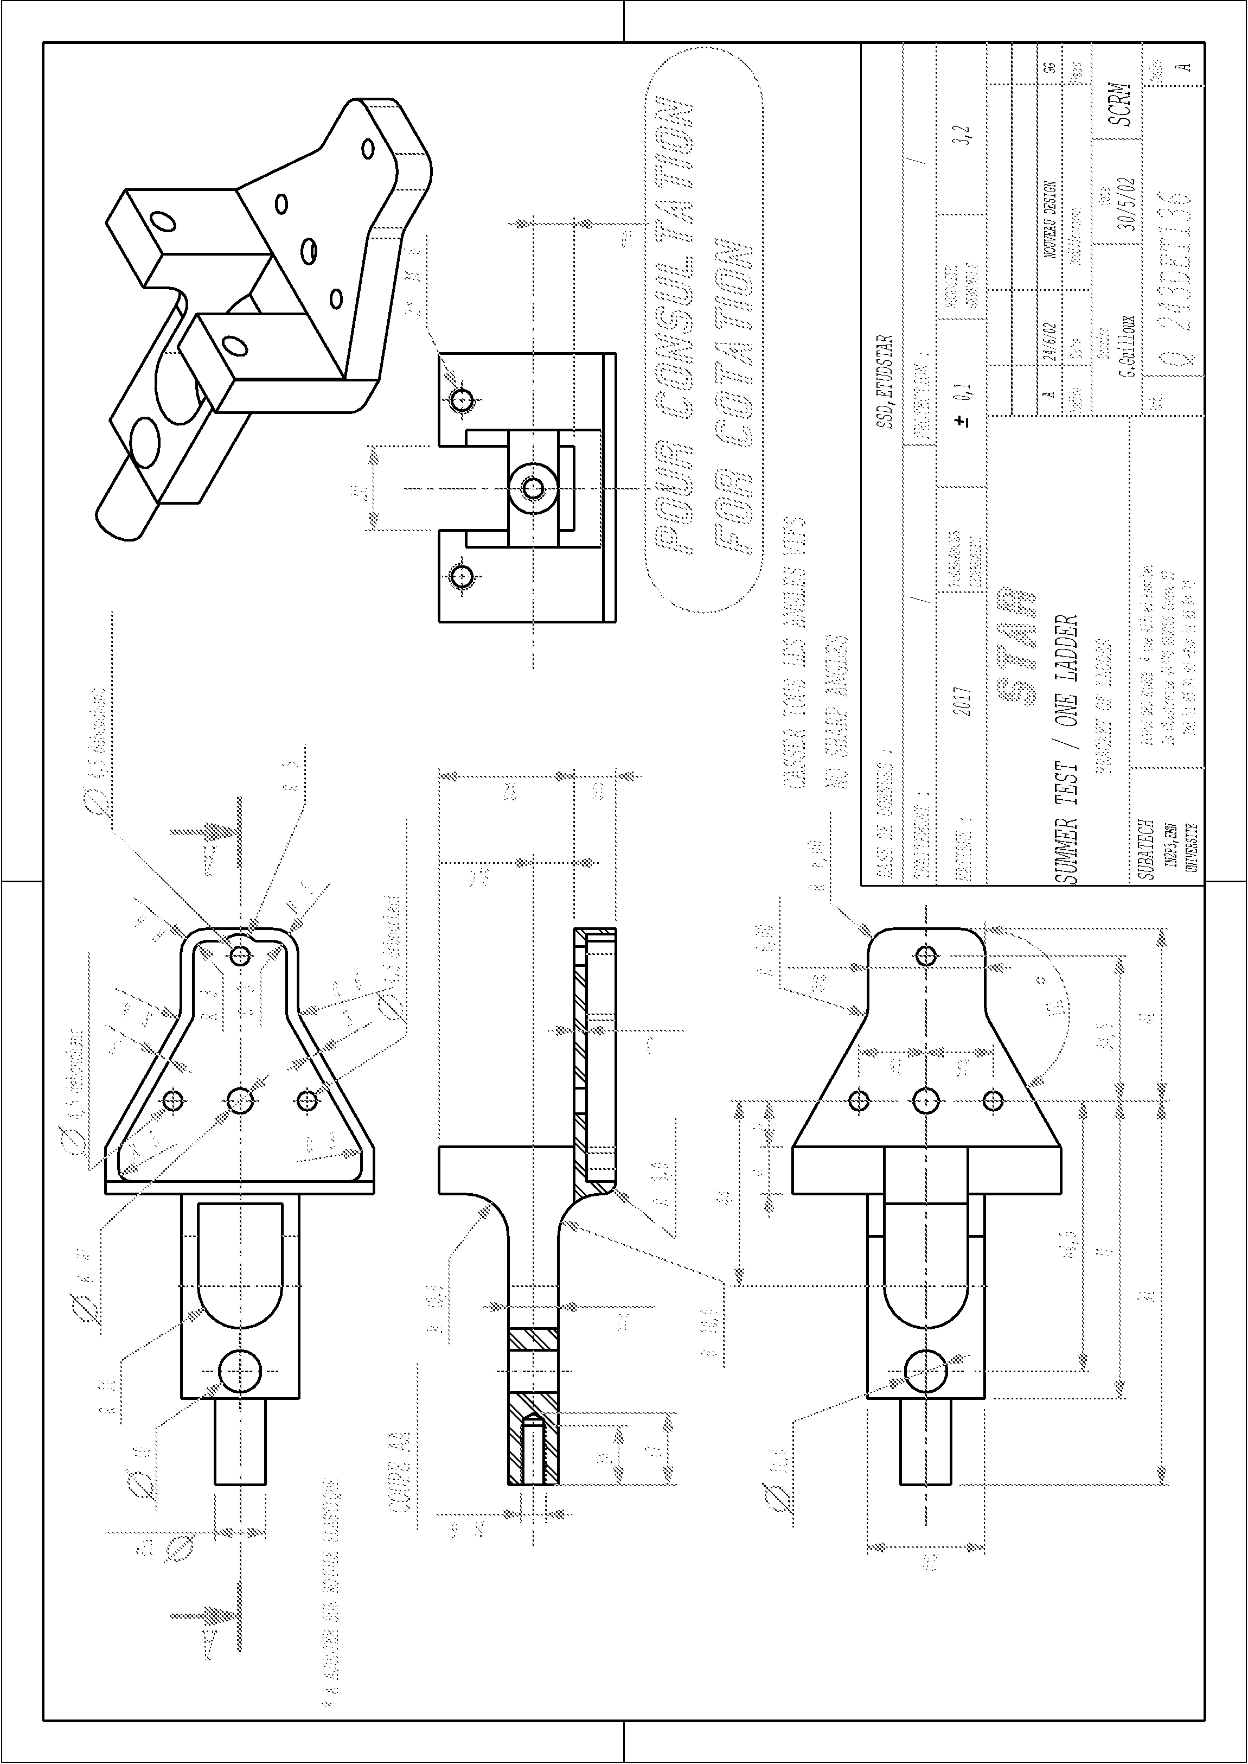
Figure 22 : Drawing (243DET136) of the intermediate ladder bracket

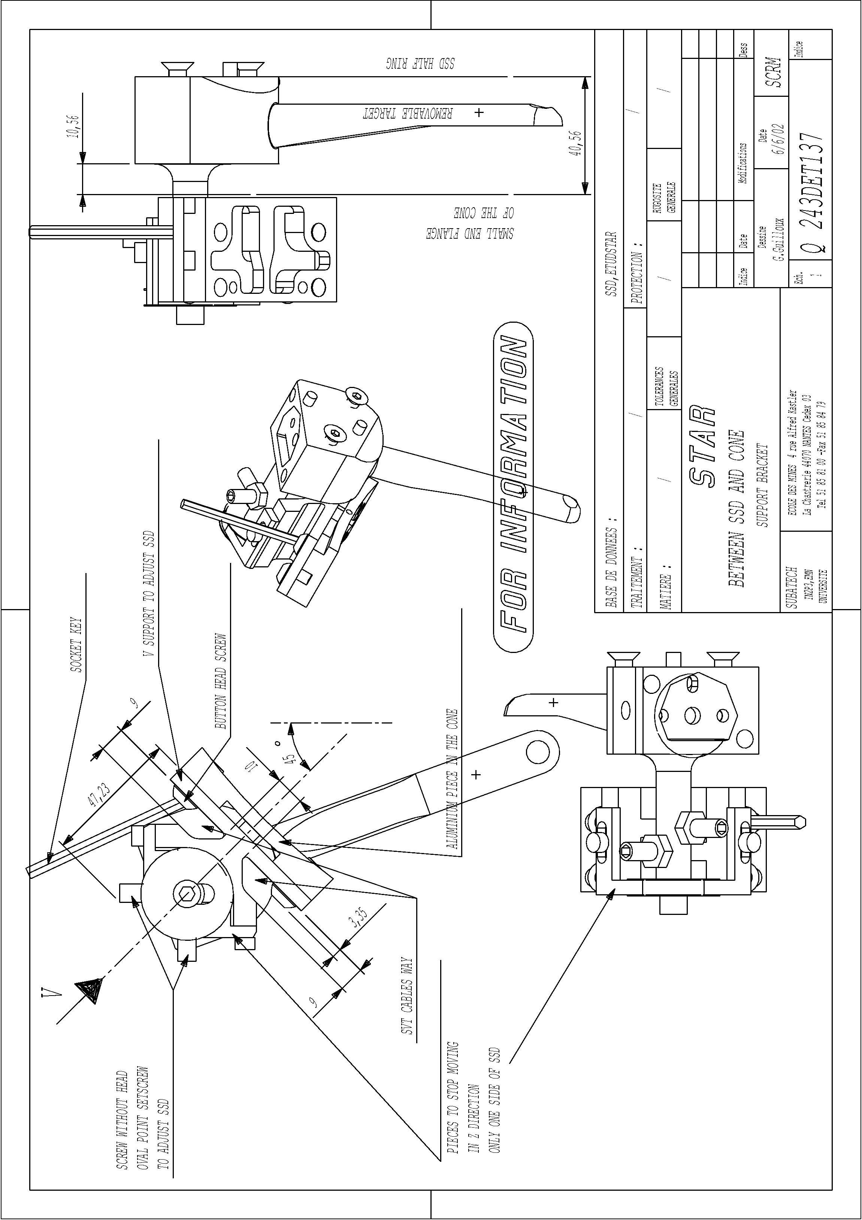
Figure 23 : Drawing (243DET137) of the final SSD bracket equipped with the survey mark

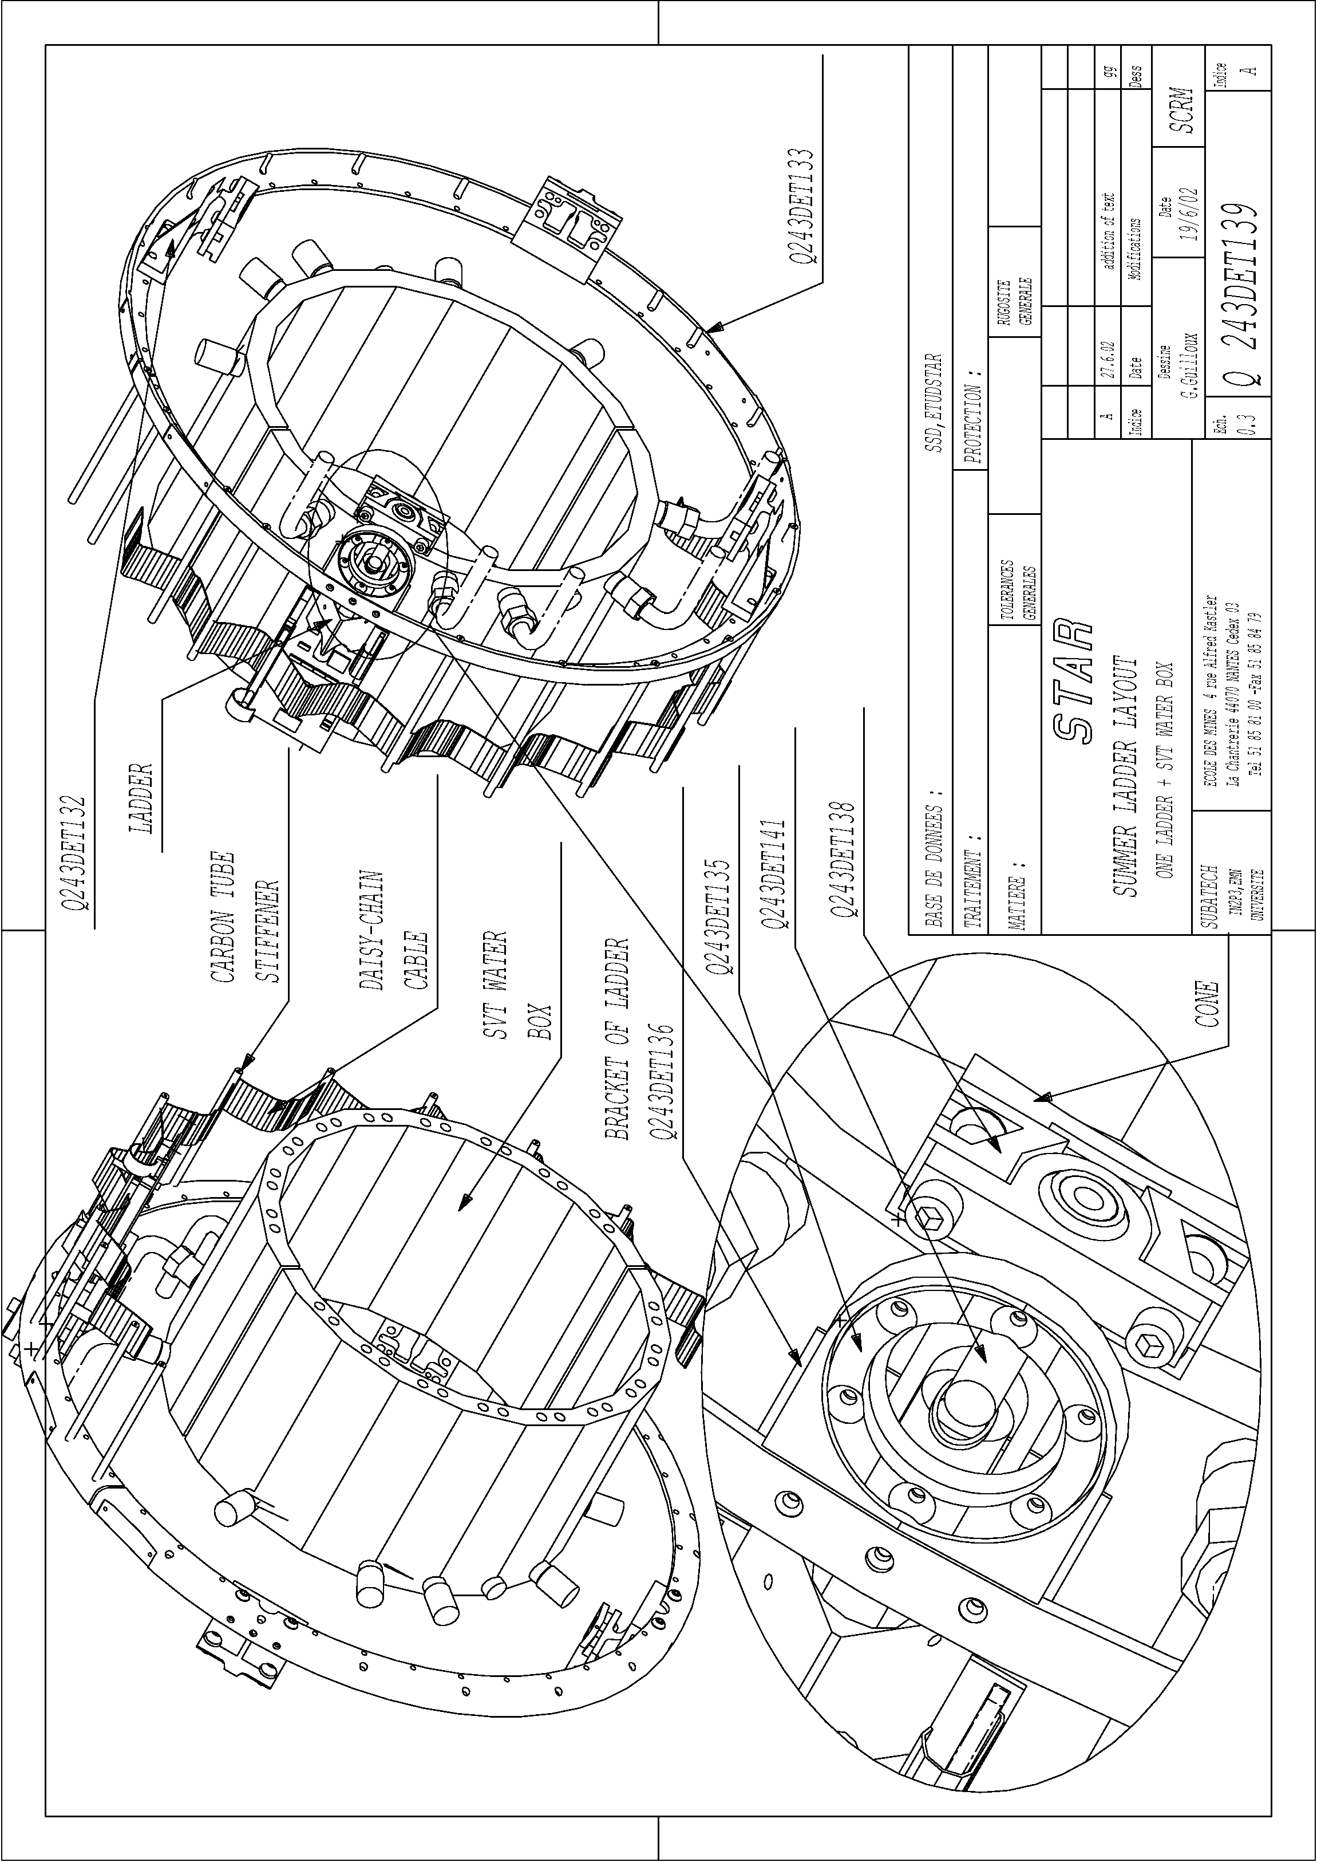
Figure 24 : Drawing (243DET139) of the SSD ladder installed. The middle section of the ladder is not shown while the SVT water boxes are represented

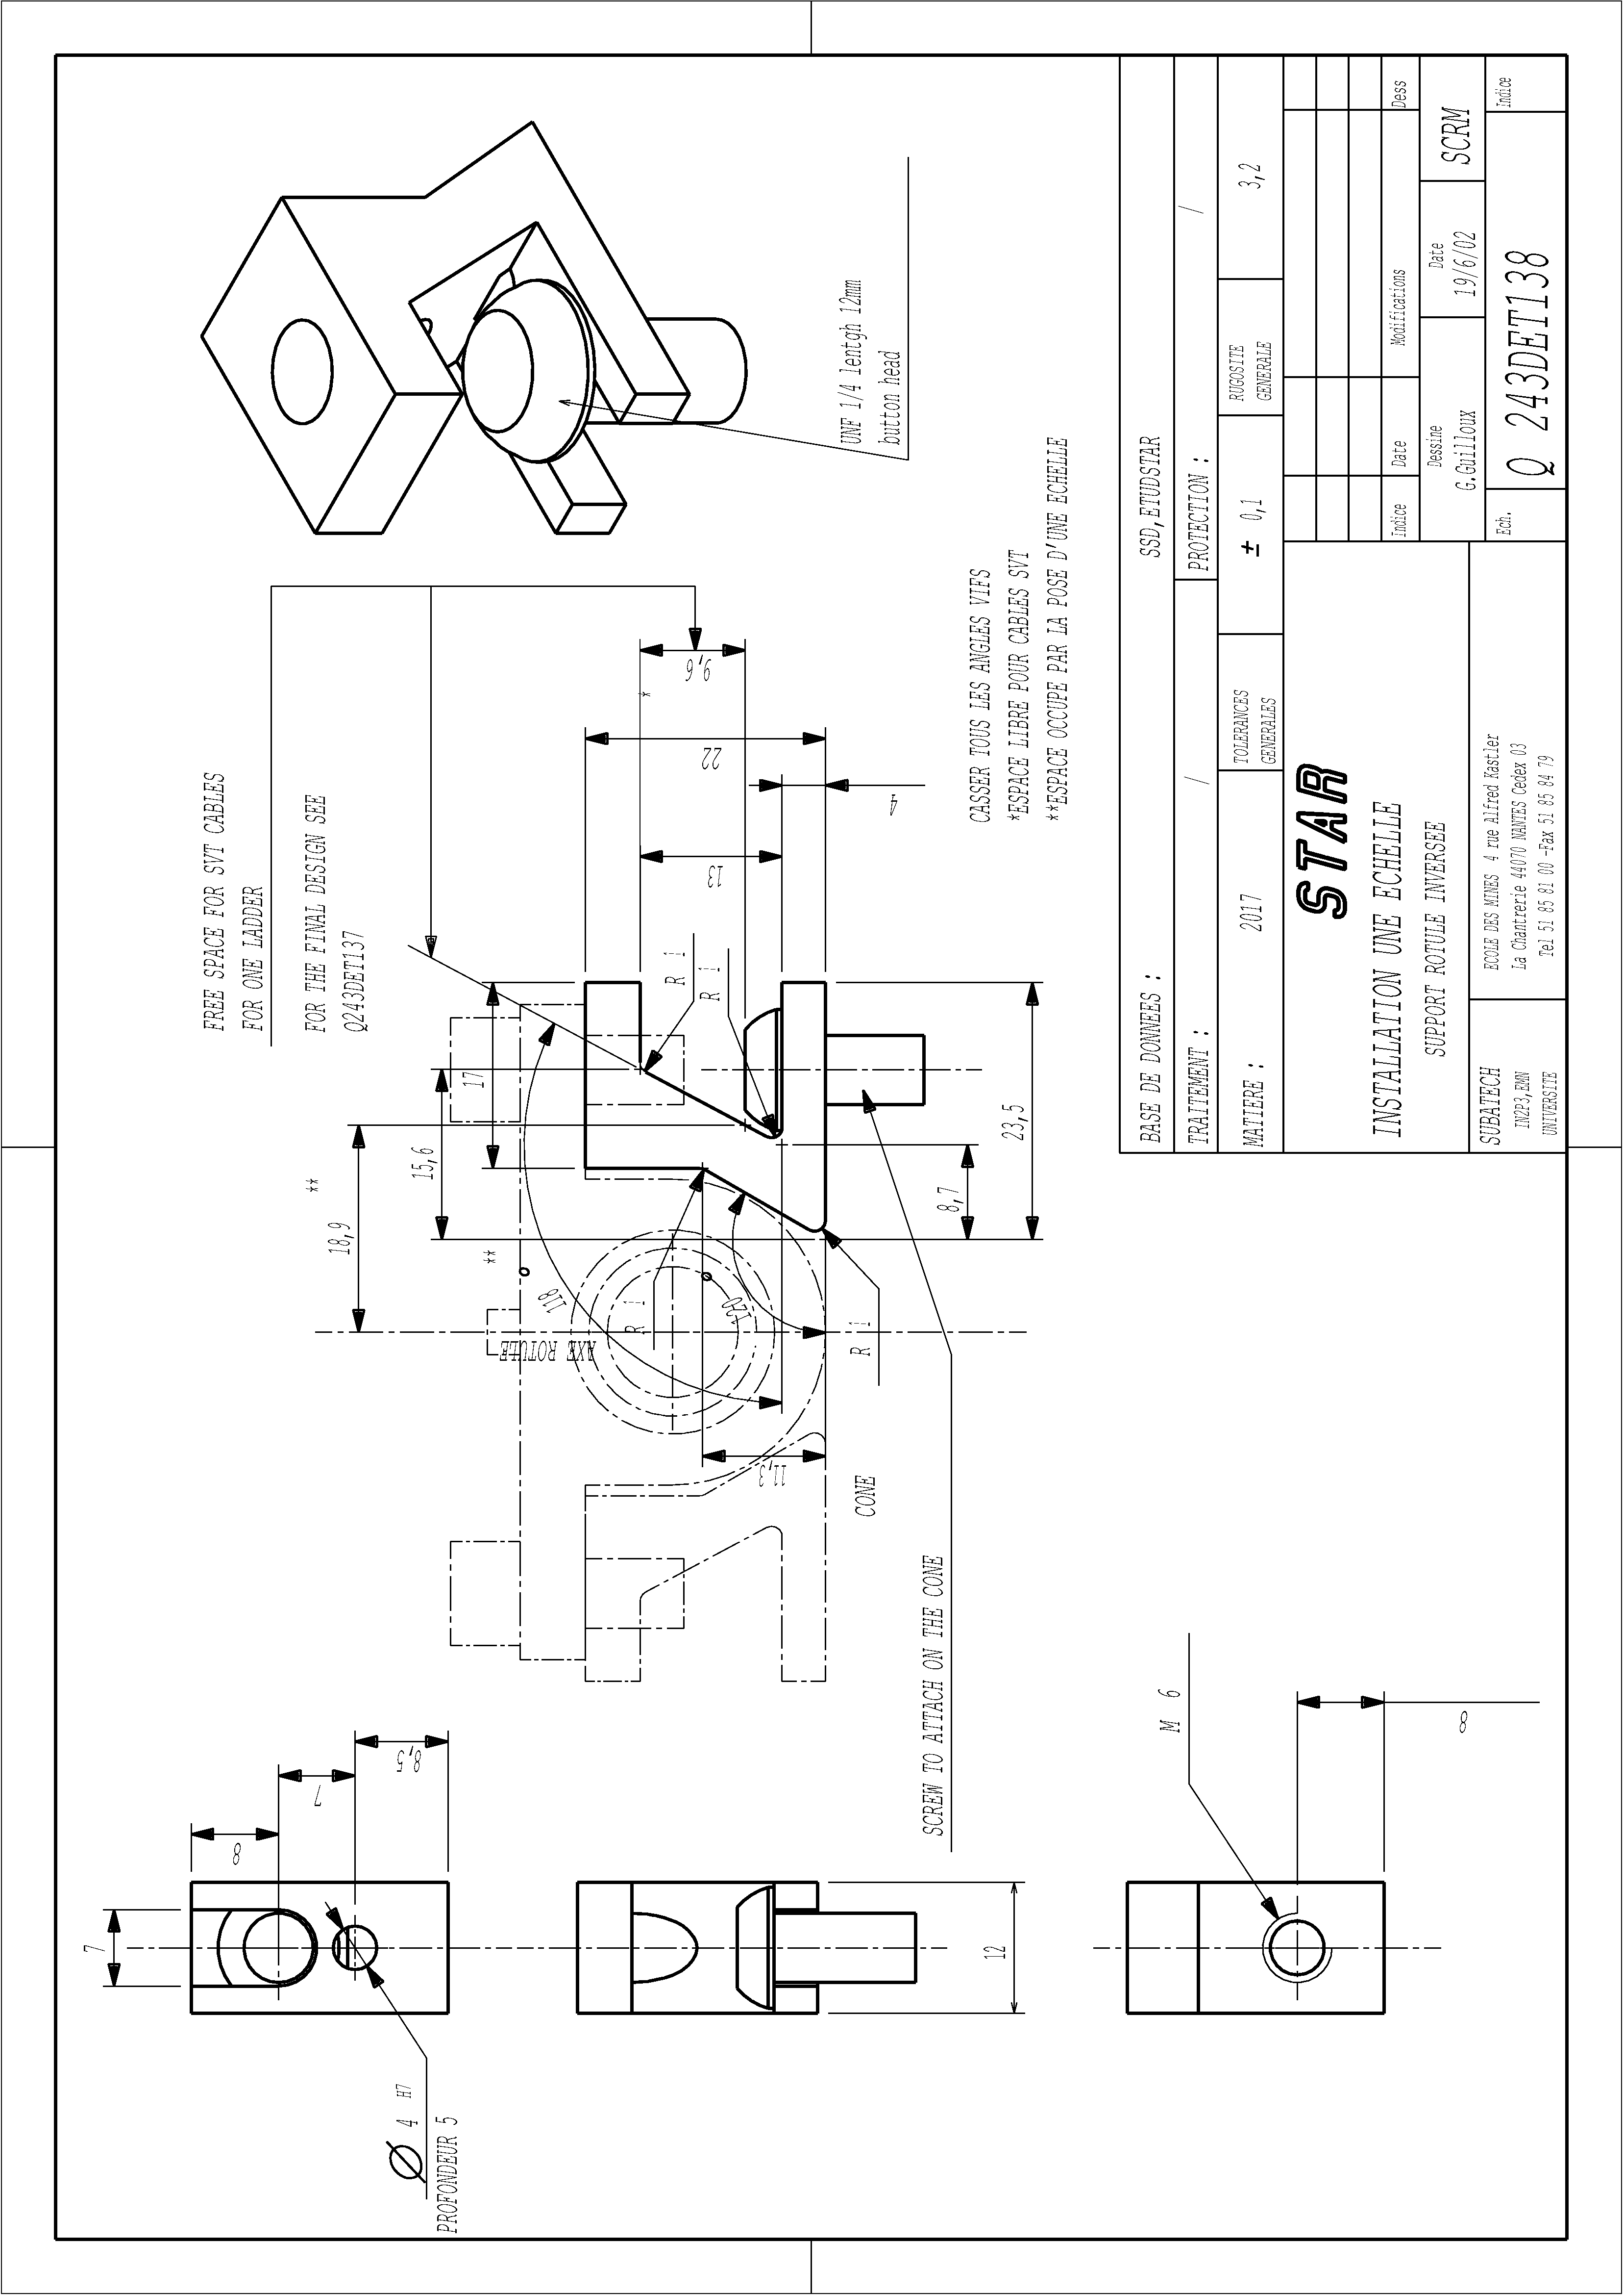
Figure 25 : Intermediate "sigma" like piece (243DET138) holding the knuckle on the cone

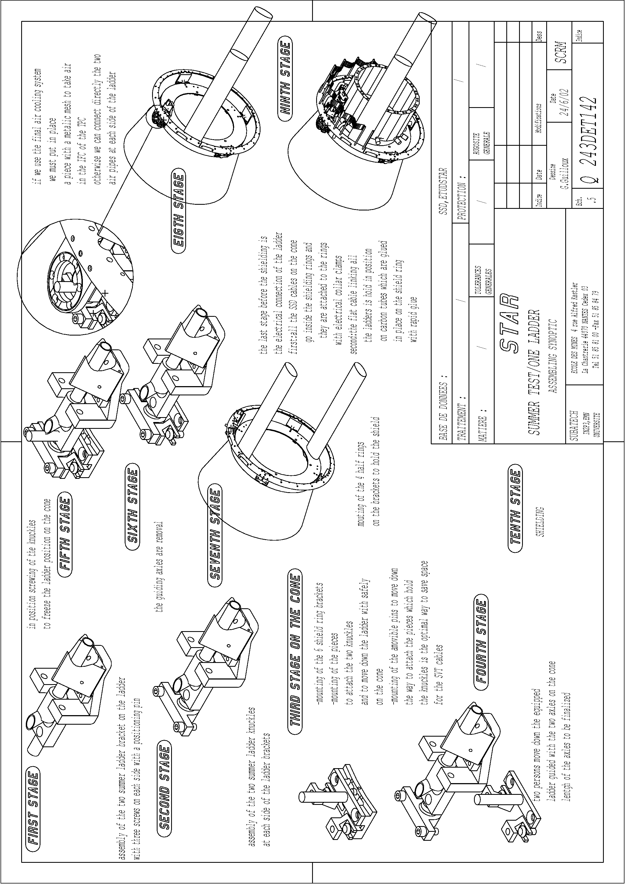
Figure 26 : Drawing scetching the ladder installation

