SSD documentation

SSD General Overview
Version Number : 6
27-june-02
1 General description 3
2 The clamshell structure 3
2.1 The Clamshell structure 3
2.2 The one ladder support structure 5
3 The ladder structure 5
4 The detection module 7
4.1 Description of the module 7
4.2 Electrical aspect 9
5 Radiation length estimates 9
6 Readout chain and control system 9
7 Data Acquisition System 10
8 SSD air cooling system 11
8.1 The cooling of the SSD ladders 11
8.2 The readout board cooling 12
9 Slow control and power supply 12
10 Interlocks 13
11 Barrel Installation 13
12 Online control 13
13 Identified Integration Issues 13

General description
Placed in between the SVT and the TPC, the SSD consists in a barrel with a radius of 23 cm and is composed of 20 space frame carbon beams (ladder) each supporting 16 detection modules (Figure 1). Each module is composed of one double-sided silicon strip detector, two hybrid circuits equipped with analogue readout electronics (see section 2 for detailed description). On both ends of each ladder, two electronics boards are controlling the modules and are converting the analogue signal sent to readout boards located on the TPC wheel. The heat produced by the SSD ladders is extracted by the mean of an air cooling system. The SSD is built into two half barrels allowing a clamshell structure of the ensemble.
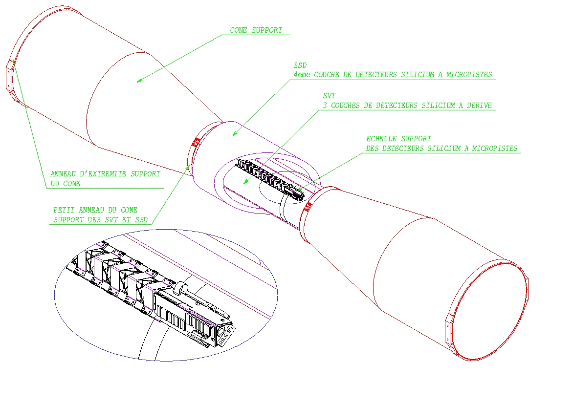

Figure 1 : General view of the SSD

The clamshell structure

The Clamshell structure

The SSD is split in two half barrels each composed of 10 ladders. The mechanical support of each part as a “C” shape (Figure 2). A clamshell structure is thus build allowing to install or dismount the SSD easily. The cylindrical shape of the SSD is obtained once the two half barrels are assembled together (Figure 3). The “C” shape pieces have been designed in order to provide three fixation points to minimize the ladder sagging and to keep available space for the routing of the SVT cooling pipes and electrical cables.

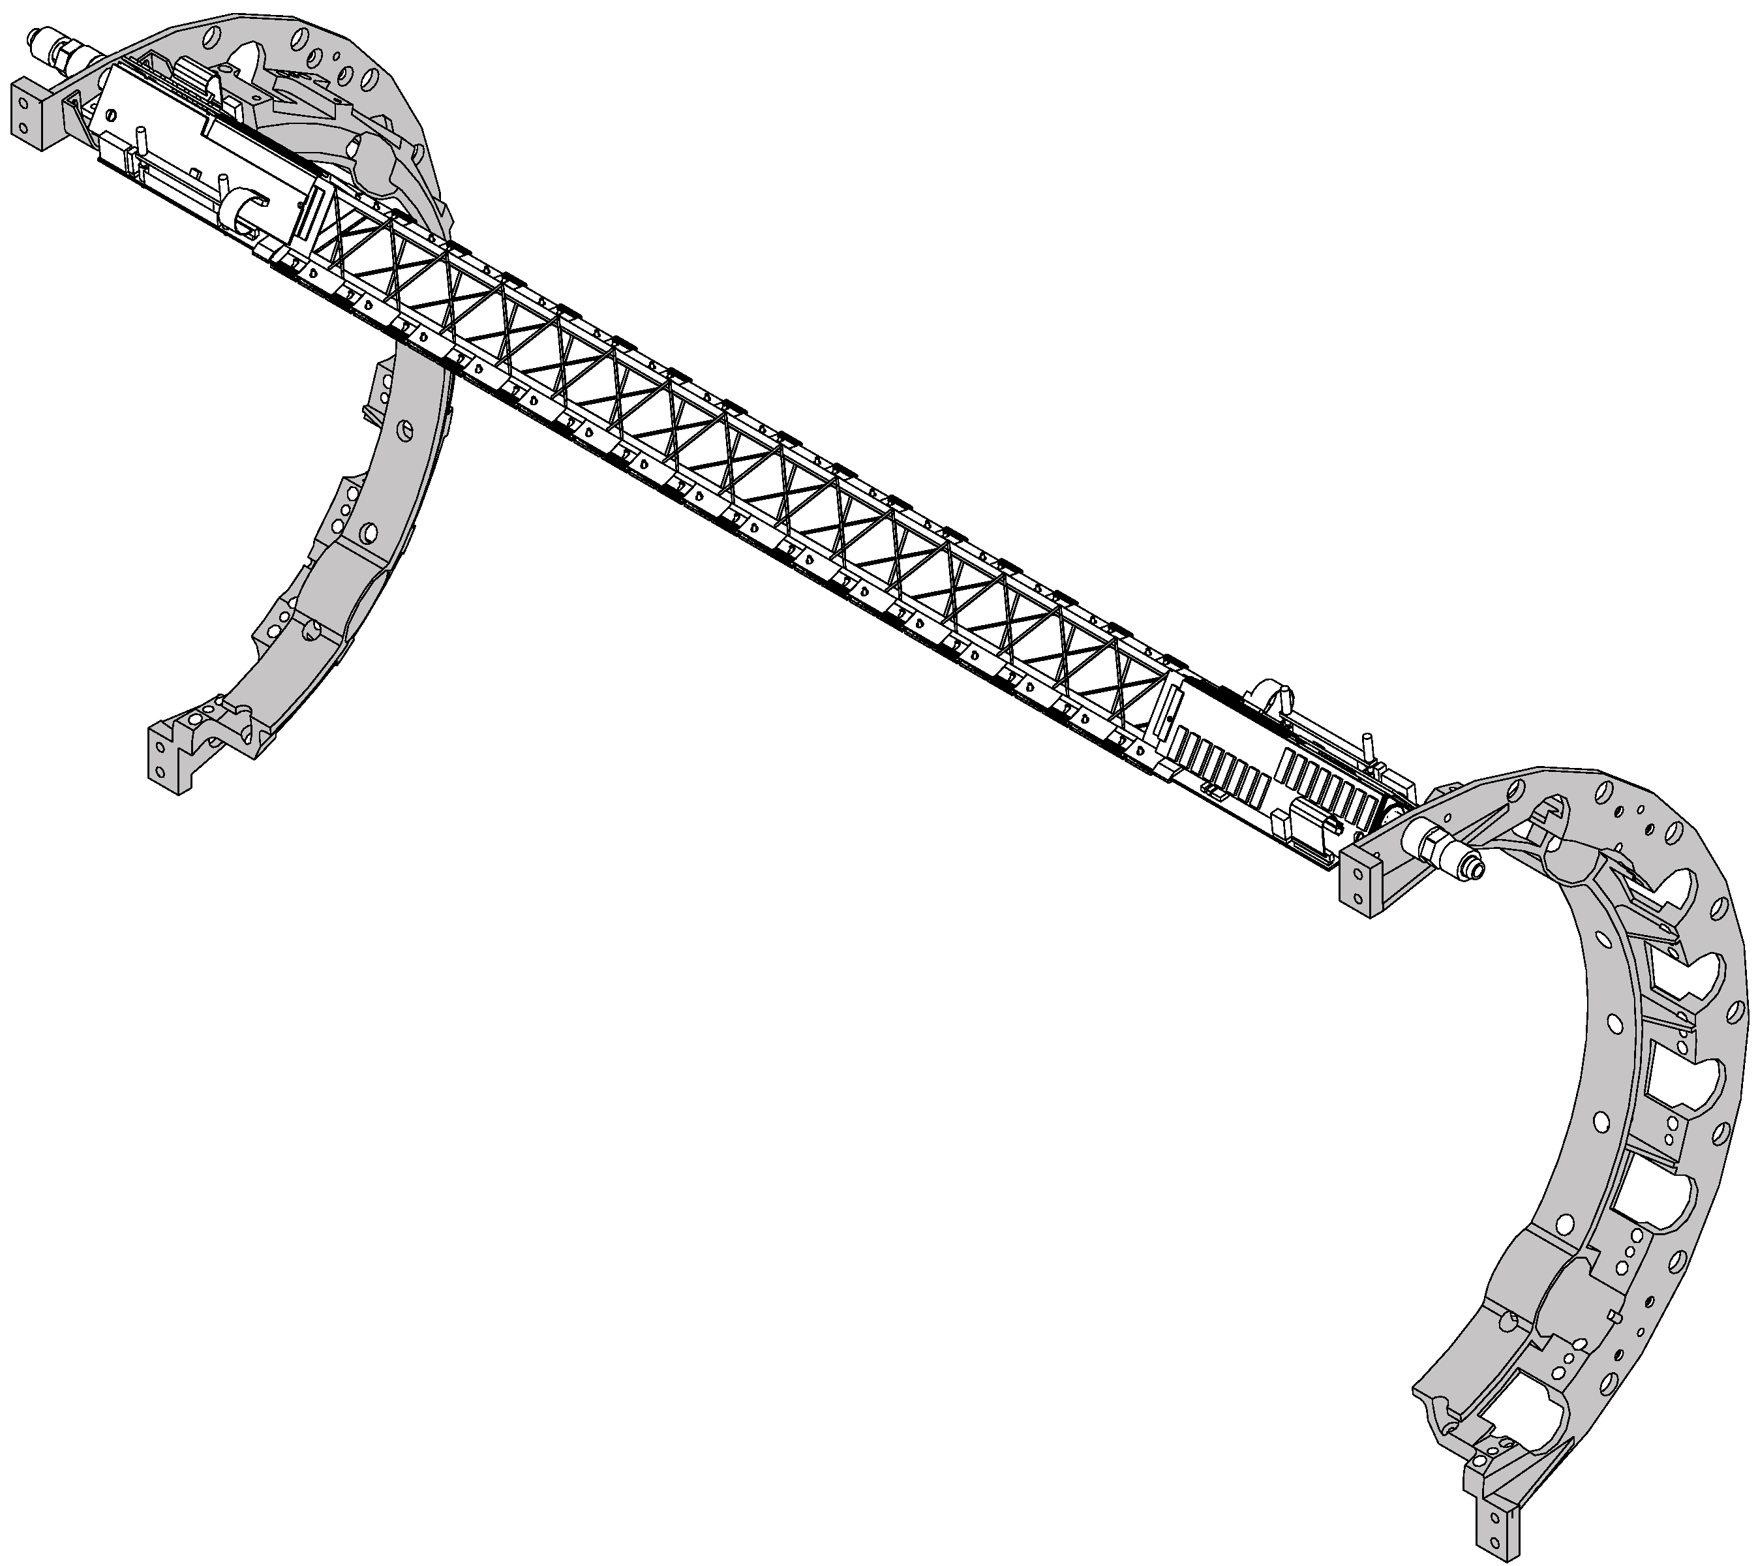

Figure 2 : A half barrel support structure with one ladder
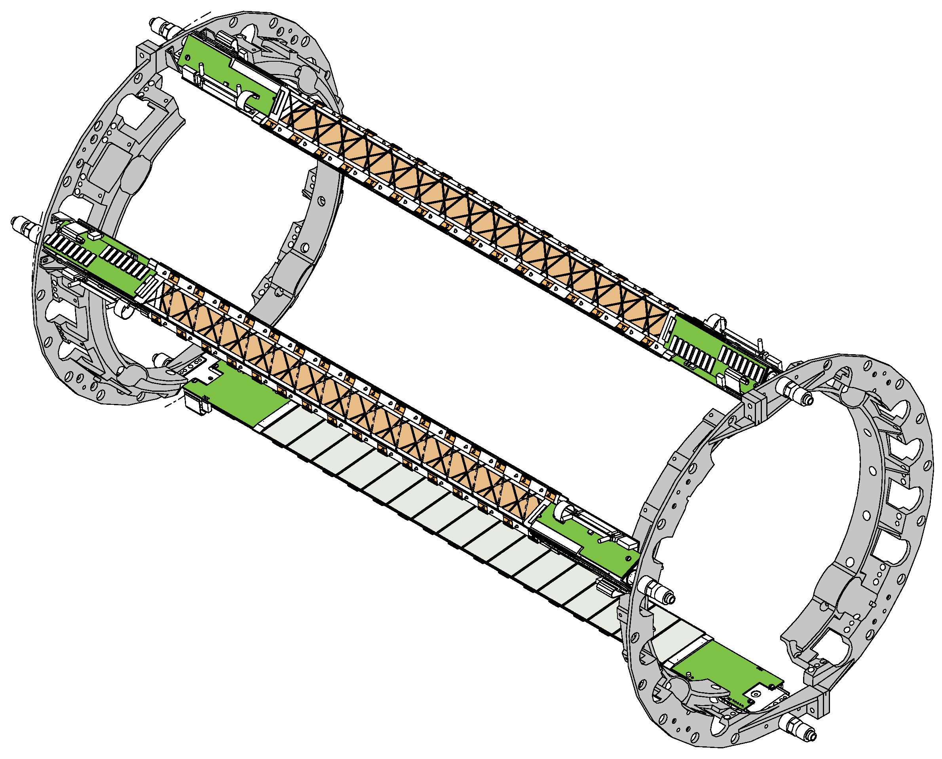

Figure 3 : The two half barrels assembled with 3 ladders installed
Four brackets (Figure 4) equipped with retractable survey mark will connect each pairs of “C” shape pieces to the cone. Brackets on one side of the clamshell will have a fixed position of the cone while brackets on the other side will be movable for the final positioning of the SSD and to allow deformation of the ladders along the beam axis.
Additional epoxy based pieces (Figure 4) will be attached to the clamshell in order to reconstruct two rings devoted to the cylindrical SSD outer shield.
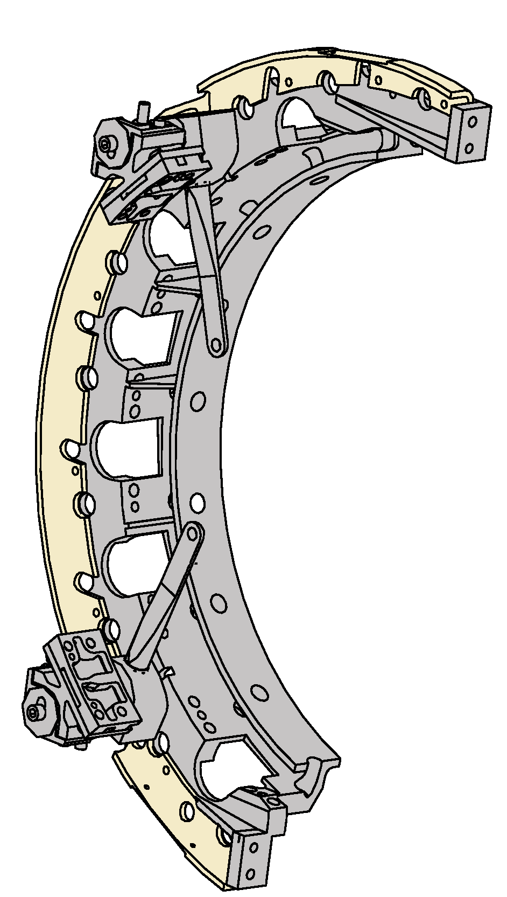

Figure 4 : A half clamshell support structure equipped with two brackets and a epoxy half ring for the external shield
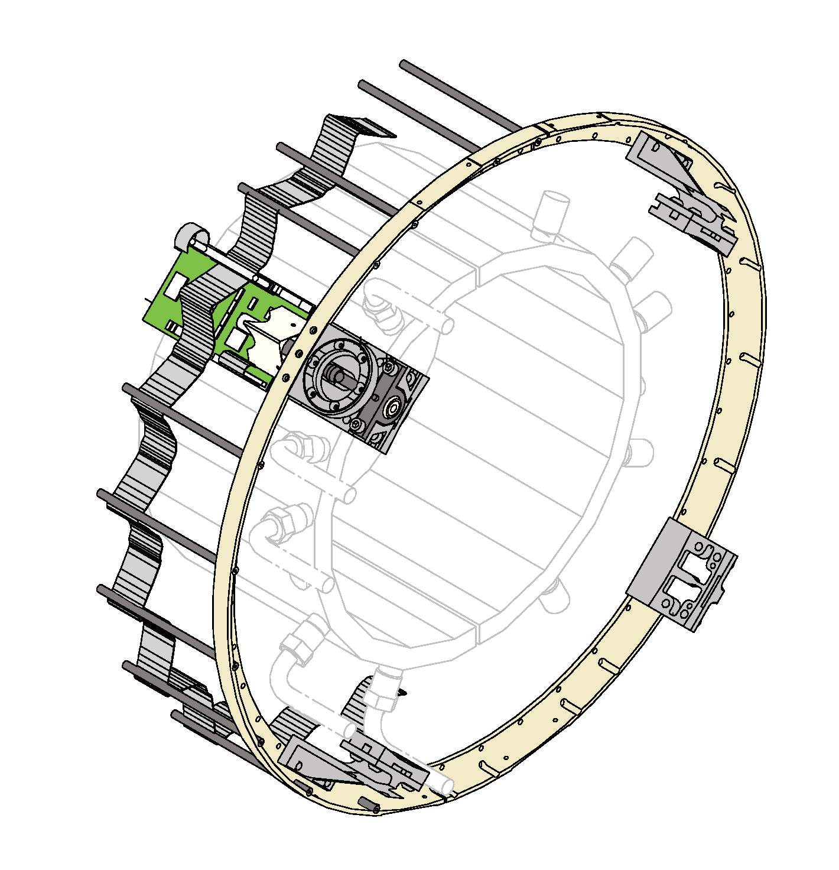

Figure 5 : SSD mechanical support for the summer 2002 installation featuring the shield ring and the connecting brackets

The one ladder support structure
During the summer 2002, one of the SSD ladders will be installed in STAR. A lighter mechanical support has been designed to hold the ladder on the cone and to provide a support for the outer shield (Figure 5). Simplified epoxy rings have been designed for the aluminized mylar shield. Each ring will be connected to the cone using 4 dedicated brackets. One of these brackets will simultaneously hold the ladder and the shield ring.

The ladder structure
Each SSD ladder is composed of the following elements (Figure 6):
- 16 modules aligned along the ladder axis (the beam axis)
- two pairs of ADC board and C2D2 board located at each end of the ladder and dedicate to the digitization and the control of the signals coming from respectively the N side and the P side of the modules
- a low mass carbon fiber beam supporting the modules and the electronic boards,
- additional mechanical pieces to attach the ladder to the clamshell and to connect the ladder to the air cooling tubes
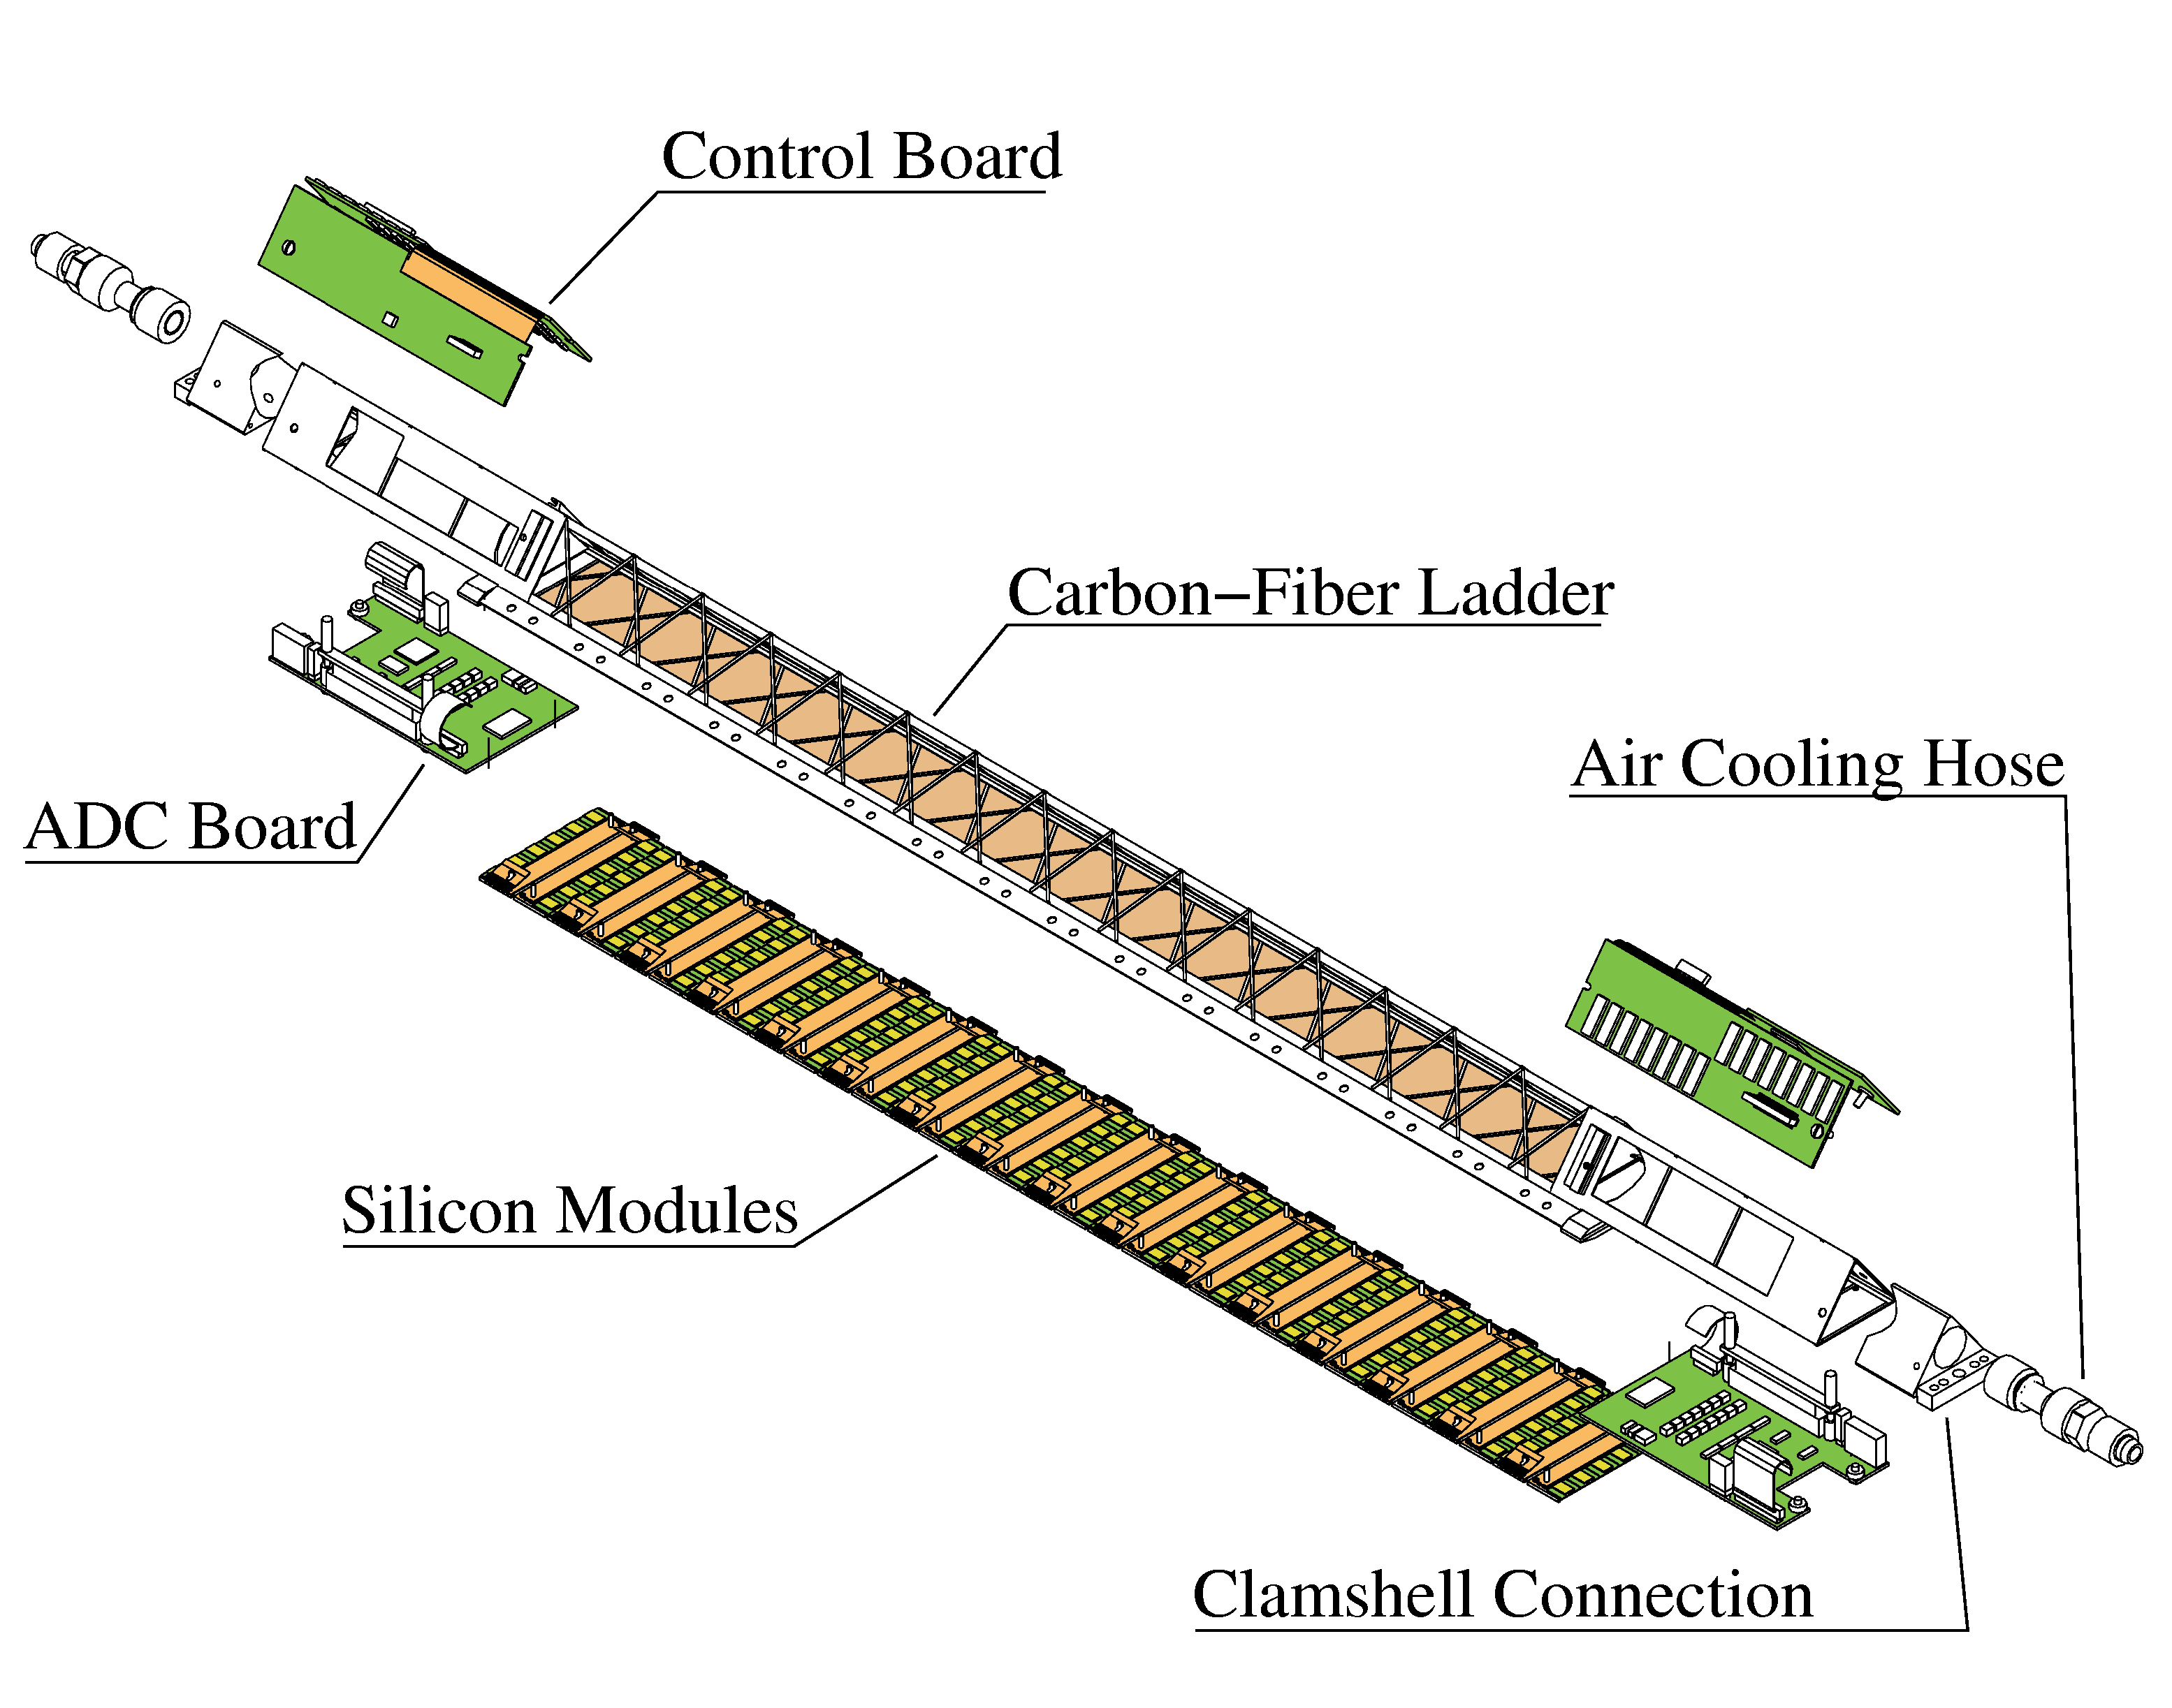

Figure 6 : Exploded view of an equipped ladder

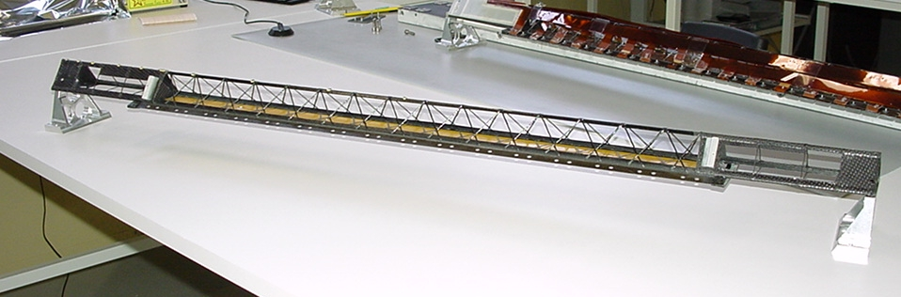

Figure 7 : a carbon fiber mechanical structure of a ladder
The mechanical structure of the ladder (Figure 7) is build into two parts. The longest part as a triangular shape and holds the board at its extremities. The central part of the beam is build by welding a carbon fiber around the triangle corners and provides most of the ladder rigidity. Extra carbon fiber pieces are inserted at the ends this part in order to give additional strength. A second part (Figure 8) still made of carbon fiber is used as an interface piece to hold the module and integrates a kapton film to close the air path near the module.
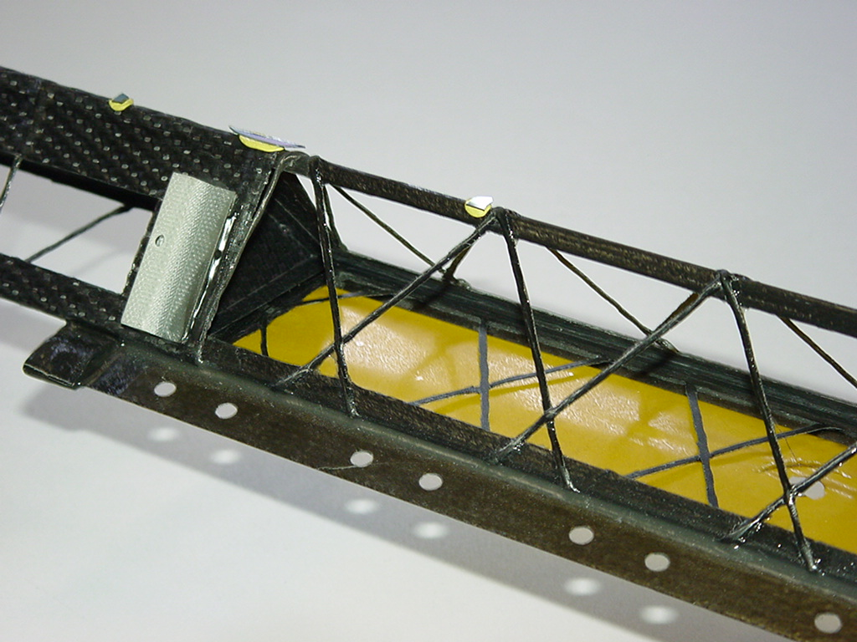

Figure 8 : Detailed view of the ladder mechanical structure

The weight of the bare carbon structure is around 90 g while the load coming from the modules and the electronic boards is around 350 g (9 g per module). The sagging of the ladder under a central load of 200 g has been measured to be of the order of 200 μm . Under realistic load and realistic conditions the sagging of the ladder has been estimated to be below 50 μm.

The detection module

Description of the module

A module is the basic element of the SSD and integrates a silicon wafer and its front-end electronics(, ). Each module is composed of ():

A double sided silicon strip detector:
- size : 42 mm * 75 mm,
- 768 micro-strips per side of detector,
- a pitch of 95μm,
- 35mrad stereo angle between P and N strips.

Two hybrid circuits, each composed of:
- one flexible circuit (made of kapton and copper) glued on a carbon fiber stiffener,
- around 50 SMD components (resistors and capacitors),
- 6 analogue readout chips : ALICE128C,
- 1 multi-purpose control chip dedicated to temperature measurements, low and high voltage monitoring: COSTAR.

Tape automated bonding (TAB) is used for the connection between the strips on the detector and the analog inputs of the ALICE128C chips. This bumpless technology is based on a kapton microcable on which are printed copper strips, the flexibility of the cable allowing the folding of the hybrids circuits on top of the detector in order to make the detection module very compact. Furthermore, this cable plays the role of pitch adaptor between the 95mm pitch of the detector and the 44mm pitch of the chips on the hybrid circuit. The tape is also used to connect the ALICE128C chips to the hybrid circuit.

Once a module is assembled, two low-mass aluminum buses are connected to the flexible hybrids to transmit the signals from and to the module. The bus and the hybrids are glued together using a Z-axis conductive adhesive films. These cables are of various sizes which once glued to a module freeze its position on the ladder (Figure 12).

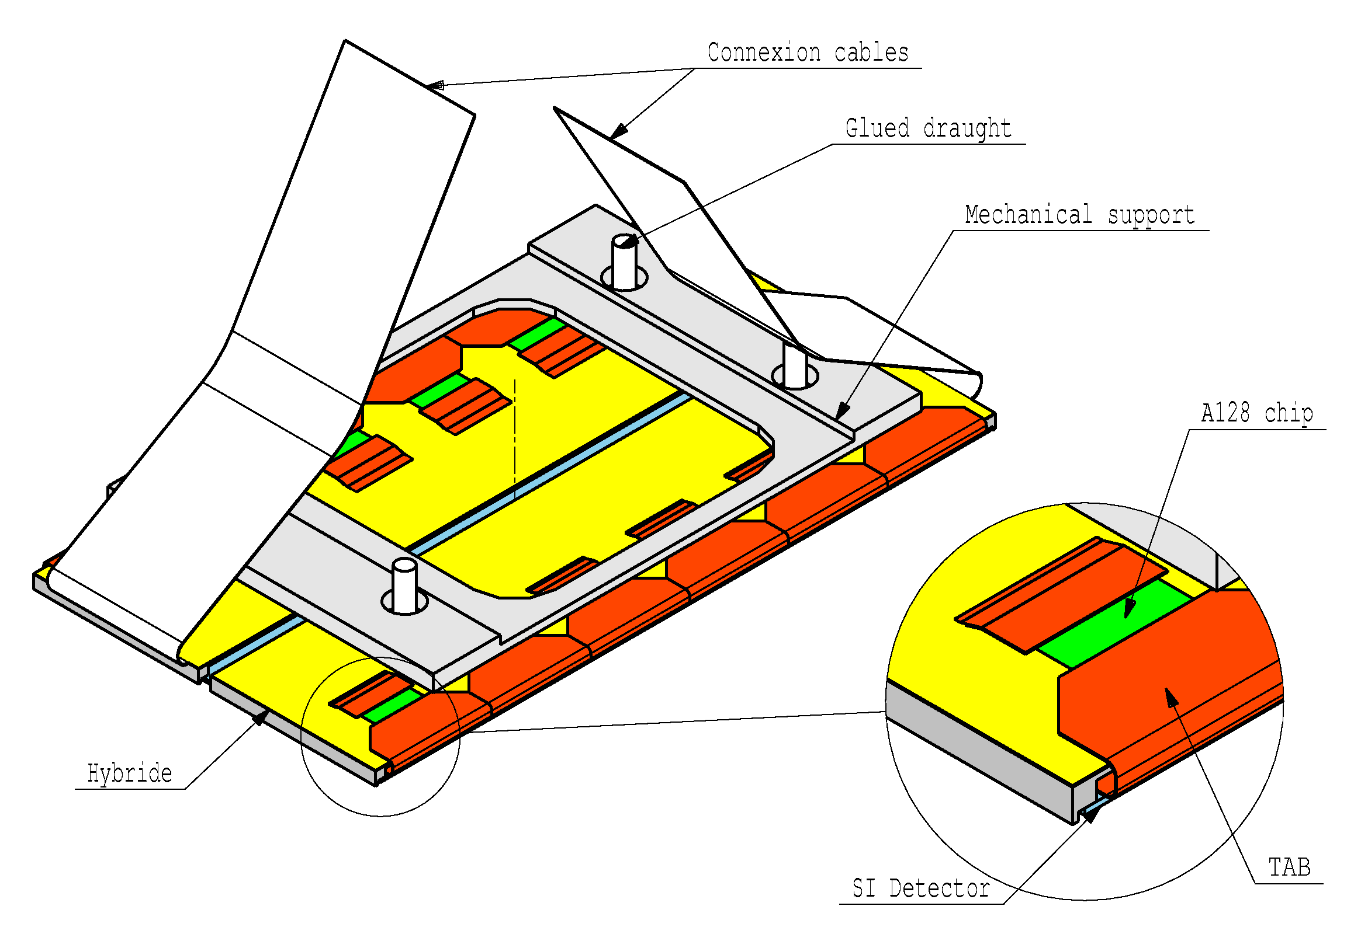

Figure 9 : A detection module

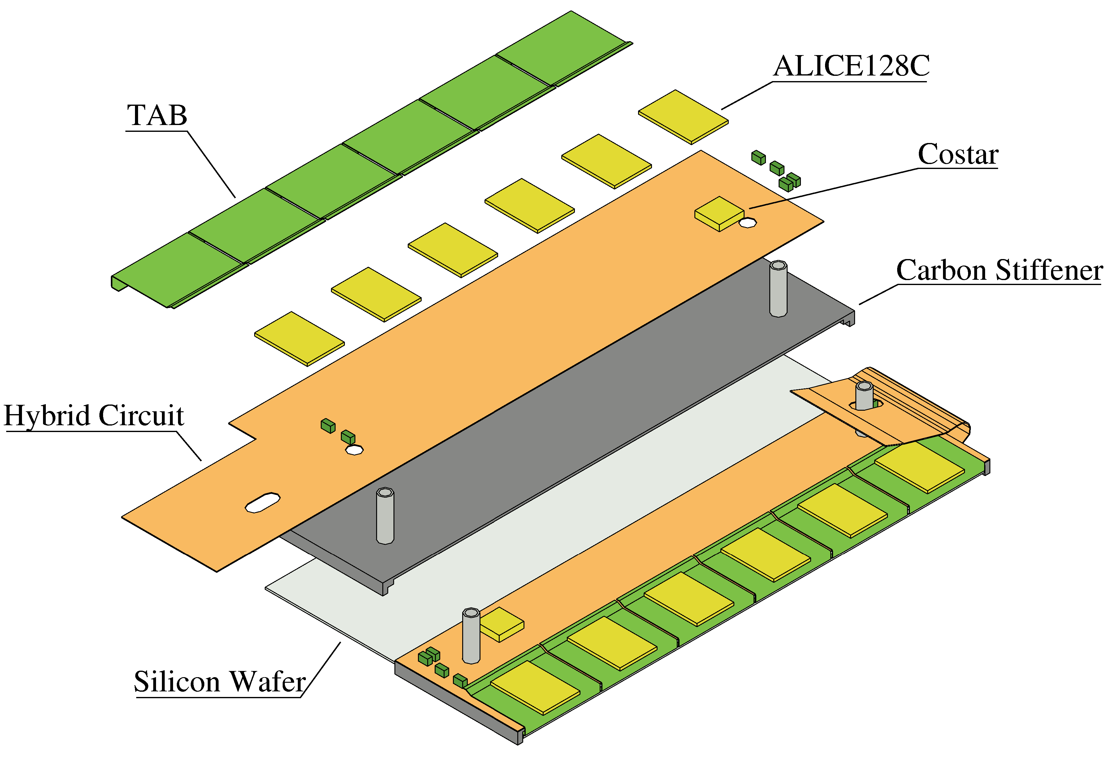

Figure 10 : Exploded view of a detection module

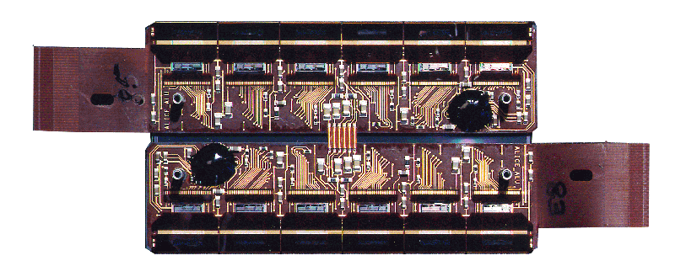

Figure 11 : Top view of a module

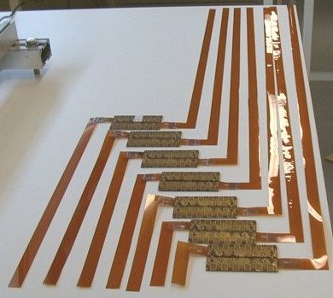

Figure 12 : Dummy modules equipped with aluminum buses

Electrical aspect

The front end electronics is powered at +/-2V referred to a floating ground defined by the depletion voltage of the silicon strip detector which is around 50V. So, one side of the module has the floating ground around 0V and the other side floats around 50V. In any case, during the operation of the barrel installed in STAR, all of the modules are not accessible by people, so there is no chance to be touched by somebody.

Radiation length estimates
The average radiation length of a SSD ladder as seen by a particle crossing it at normal incidence has been calculated and is detailed in the following table :

Components | X/X₀ (%)
Silicon Wafer | 0,32
Hybrids | 0,29
FEE and COSTAR | 0,07
Connections (TAB and buses) | 0,26
Mechanical support | 0,17
Total | 1,11

Readout chain and control system

Electrically the SSD is divided in four subsystems (one P-side and one N-side on each clamshell), which correspond in terms of data to four half of ten ladders. These subsystems are identical. They can be represented as follow :

Initialisation
Monitoring
Test
Optic fiber/data
Trigger command
Slow control
DAQ
Trigger
Readout board
LADDER

1
LADDER

10
LADDER

5

Each ladder is equipped with 16 modules. To control the modules and convert the signal coming from the FEE, two electronics boards sits at each end of the ladder :

- one connection board (Figure 13), mainly dedicated to detect and to switch off the power supply if any latch-up occurs in the FEE of one module.
- one ADC (Figure 13) board which convert the analog signal coming from the modules.

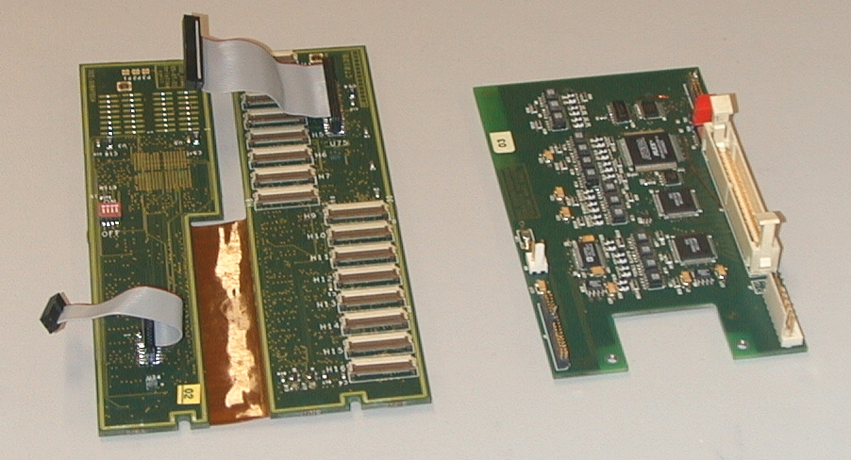

Figure 13 : A connexion board (C2D2) on the left and an ADC board on the right
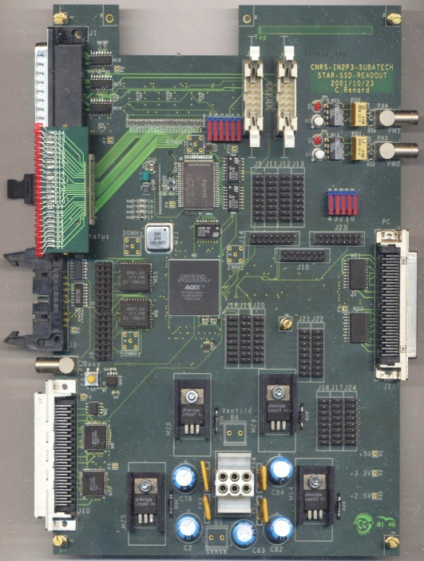

Figure 14 : a readout board

The readout board () is a kind of “hub” in the readout chain and slow control system of the SSD. It is the interface of the barrel and the “outside world” (slow control, trigger and DAQ). The main part of the readout board is in a programmable device. This FPGA decodes the commands issued by the Trigger, plays the readout sequence of the front-end electronics, formats the data before sending them to the DAQ. There will be two Readout boards at each end of the TPC wheel located between the SVT Readout boxes and the Air-Manifold.

The readout process of the SSD is the following :

- When the Trigger card sends a Trigger command, the Readout board freezes the data in the Front-End. It reads all the Front-End channels and sends the data via optical fibre to the Daq Receiver board.
- When the Slow-Control needs to access the Front-End boards, it configures the Readout board so that no trigger can be sent.

Data Acquisition System

The number of channel given by the SSD to the Data Acquisition System is 491520. It is divided in four sectors, two clamshells shared in two (the P-side and the N-side of the silicon strip detector). The electronics seen by one DAQ board is composed of ten ADC boards via the readout board, which corresponds to 122880 channels.

The SSD will use four standard DAQ-TPC receiver boards without any peculiar hardware modifications. In order to an homogenous location of the data in the DAQ board, it has been decided to bind one ADC board (or one side of one ladder) to one STAR Asic letting unused 8 STAR Asics on the receiver board.

The total readout time of the SSD is 7.3 ms.

SSD air cooling system

The cooling of the SSD ladders
The purpose of the cooling system is to evacuate the heat produced in the Silicon Strip Detector layer. We have estimated and measure the power consumption of the different components of the SSD layer which can be separated in two independent parts: The first one is directly connected to the Front End Electronics (Al28 and COSTAR) integrated on the modules, and the second one to the ADC and Connection Boards. The following figures have been measured resulting in a total heat of 16 W per ladder.
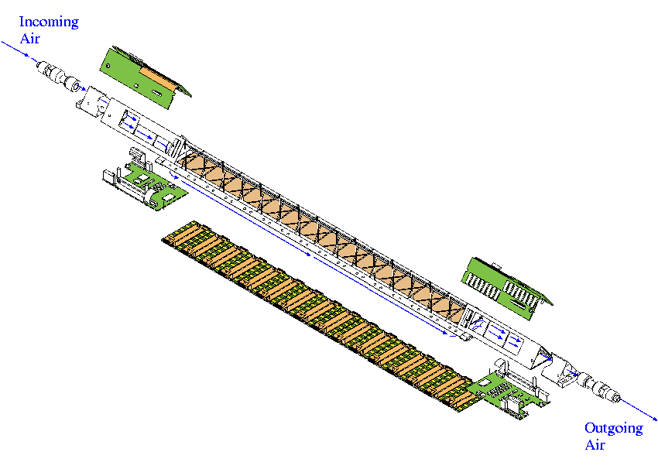

Figure 15 : the air path along the ladder

Thanks to this low heat production, an air cooling system has been chosen for the SSD avoiding the extra material and the risk of leak characterizing liquid fluid cooling systems. In order to maximize the heat removal, the air path as to be forced to pass as close as possible to the heat sources. The air path has been chosen to go from one side to the other side of the ladder. Therefore, the air guide features a triangular shape in the electronic board section and a rectangular shape in the central part of the ladder above the modules (Figure 15). Deflectors have been inserted in the ladder in order to match these two different shapes.

The induced air comes from Inner Field Cage of the TPC, the free volume between the SSD and the TPC. The warmed air is evacuated to the outside of STAR through a flexible hose of around 10-mm diameter.

Figure 16 : Schematic overview of the SSD air cooling system

The air is sucked in alternatively from East to West and from West to East by a set up of Transvector® working on the venturi effect. Un blabla sur le principe du vortec

We have checked that an airflow amplifier can draw-in air in 5 independent ladders. Consequently, we will need to use 4 Transvectors® for the STAR SSD layer.

The readout board cooling

The heat produced by the readout board is removed ...

Slow control and power supply

All the crates necessary for the SSD slow control and power supply are integrated in one rack. In this rack will be:
- 2 CAEN SY527 crates for the power supply.
- 1 VME crate for the Slow Control and Detector Control.
- 1 Distribution crate for the spreading of all the power supplies and control signals to the different parts of the SSD.
- Heat exchangers ,filter and breaker panel.

Typically, the SSD needs four types of power supply:
- Low Voltage (+/- 2V) for the front end chips (ALICE128C and COSTAR).
- High Voltage (~40V) for the Silicon Strip Detectors.
- Low Voltage (5V) for the ADC boards.
- Low Voltage (5V) for the readout and ADC boards.

The figure 1 describes the way these power supplies are connected to the electronics.

Fig. 1 - SSD power supply.

Interlocks

Description of what is done related to the different existing alarms.
Description of internal interlocks (high temperature, cooling failure …)

Barrel Installation

Description of the tooling expected to be used for installation.
Description of the operation.

Online control

Description of the SSD operation (calibration, physics run, initialisation, database used).

Identified Integration Issues

The following integration constraints have been raised during the redaction of the technical proposal:
- integration envelope : SSD should be located between 23 and 27 cm
  - The SSD external radius is xxx cm
- readout time : less than 5 ms
  - The intrinseque readout time of the full SSD is 4,7 ms and reaches 7,3 ms when filling with zero the DAQ ASIC.
- waiting time before readout, 100μs, in order to avoid any noise injection to the TPC while drifting
  - The readout board starts collecting the signal 100 μs after the L0 trigger
- minimizing the number of cables along the cones
  - The air cooling system of the SSD has been designed in order to extract the incoming air in the TPC IFC and consequently to reduce from 20 to 10 the number of cooling tubes running on each cone.
- clamshell structure required in order to be able to remove the SSD without dismounting the beam pipe
  - The SSD has a clamshell structure
- cooling system required in order to remove the heat produced by the electronics and to avoid any disturbance on the SVT and in the TPC inner field cage
  - An air cooling system has been designed and tested to remove the heat produced by the modules and by the boards located on the ladders
- radiation length as low as possible and not above 1%
  - Low radiation length material has been used when possible such as carbon fiber as mechanical support for the modules and for the flexible hybrids on the modules. The estimated total radiation length of a SSD ladder is 1,1 % of X₀
- minimizing the crosstalk from the SSD digital buses to the SVT analogue buses
  - LVDS standard is used for the SSD fast signals
- to be careful with the TPC high voltage by designing the external face of the barrel in a smooth shape with a aluminized kapton shielding.
  - The external shielding of the SSD is attached to two rings installed on the clamshell pieces in order to build a cylindrical shield. The air holes necessary to pick fresh and clean air in the TPC IFC have been designed such as to preserve the smooth shape of the shield.
- SSD data acquisition system compatible with STAR DAQ
  - The SSD DAQ system is using the conventional STAR DAQ system.

