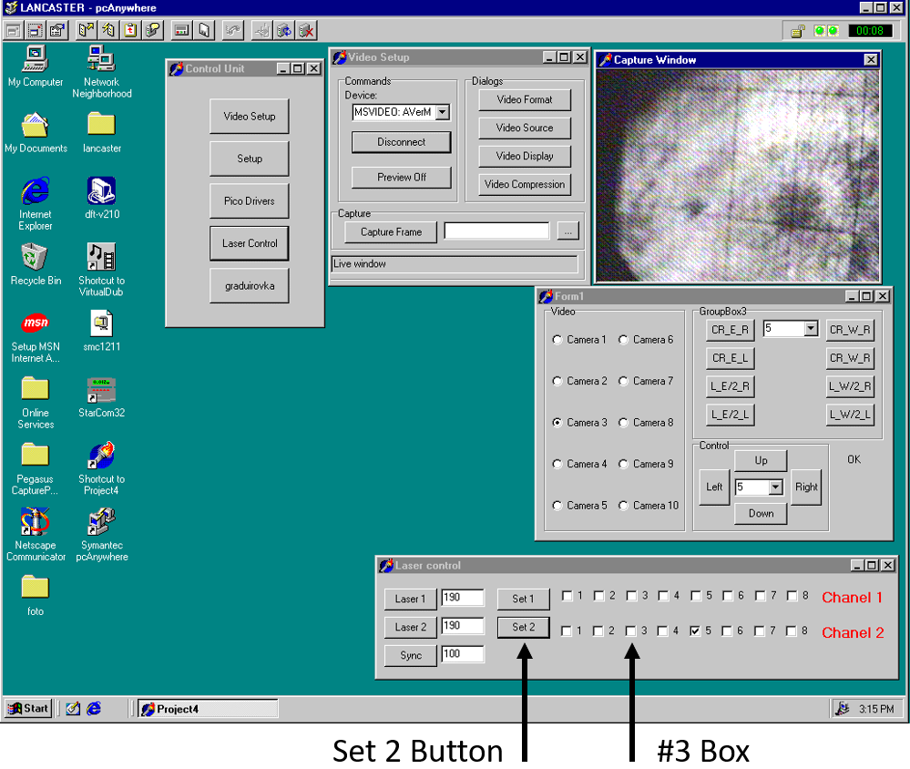
There are many changes to the old manual. So please refer only to this manual and discard the old manuals. If you have any questions or concerns contact experts immediately.
Written By: Blair Stringfellow

Updates by Jim Thomas 07/14/2009
Alexei and Prashanth 04/15/2019
David Tlusty 12/21/2021
Latest Update: 04/01/2022

TPC Laser: Operations Manual For Detector Operators

This page deliberately left blank

TPC LASERS
There are two lasers used for calibrating the TPC (East & West). Turn on both lasers at the same time. The lasers may be turned on and warmed up while STAR DAQ is running a non-laser run.
Laser runs should be taken about one hour after the start of a store and about every 3 to 4 hours afterward (for as long as the store lasts.). See the shift crew instructions for up-to-date recommendations on how and when to do this.
- Turn on the AC power to the lasers
(Note: The lasers overheat if the AC power is left on between runs so turn them on only when needed and turn them off, promptly, after use.)
Go to the Laser Control panel displayed on TpcLaser.starp.bnl.gov. (Near the TPC Control Desktop, but to the right and above it.) Select the “ #3” box in the 2nd row of the Laser Control panel. Then click on the “Set 2” button, twice. (See picture below.)
Important: click the “Set 2” button twice.

- Turn on the laser flash lamps
Go to multiple desktops on Chaplin ( TPC control computer) and click on the “Laser” button to bring up the laser Flash Lamp Control panel. Check that the sliders for “Laser Pause Time”, “Data Enable Time” and “Laser Run Time” are slid fully to the right.

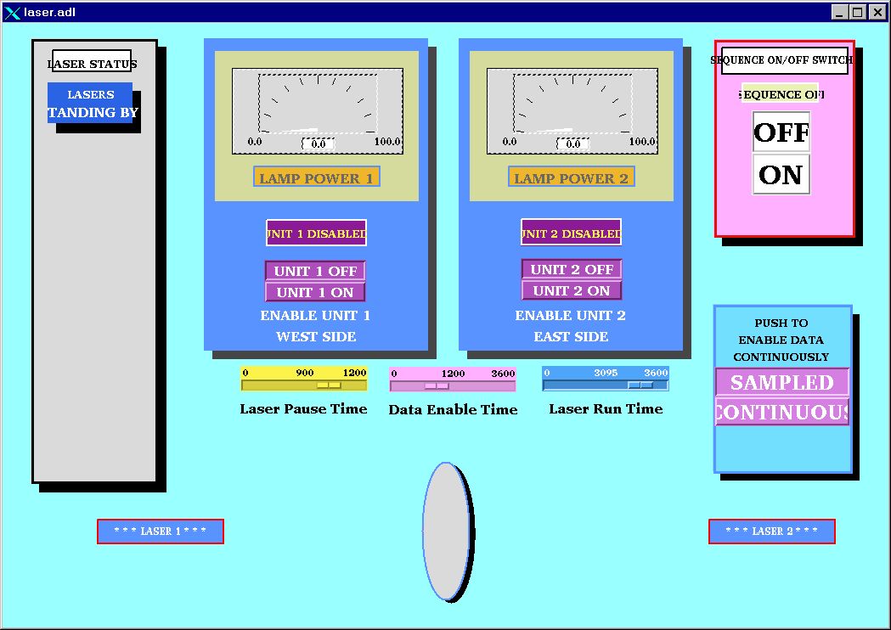

Click the “ON” button in the pink box (upper right) and within a few seconds, click the “Unit-1 On” and then the “Unit-2 On” button in the blue boxes. Wait for both power supplies to come to full power; the needles will go full-scale in about 2 minutes. Note that only the EAST laser will trigger DAQ. When the lasers lamps are finally on, the display will look like this:

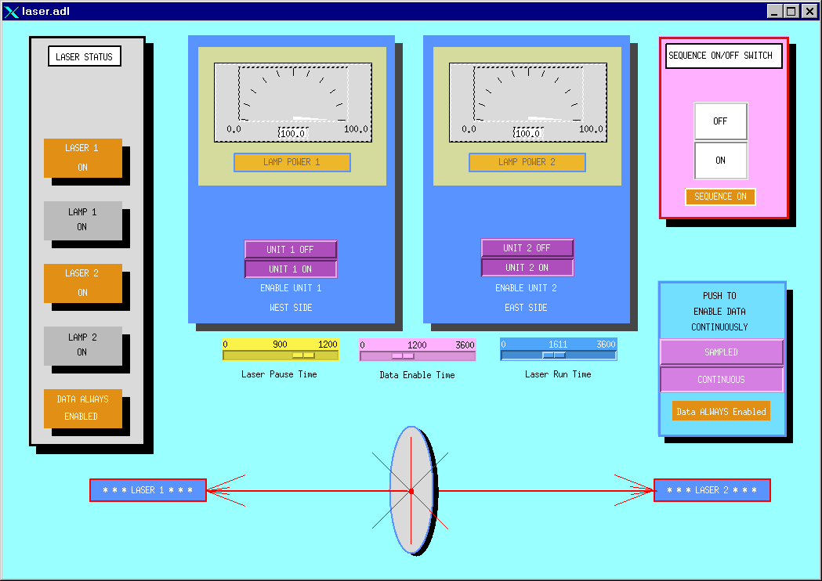

Wait another 3 minutes for the lasers to warm-up. Do not tune the lasers until after the full warm-up period has elapsed.

- Tune the Lasers
A remote camera system allows you to view the East and West laser spots. Go back to TpcLaser.starp.bnl.gov near the TPC control computer and find the “Form 1” window.
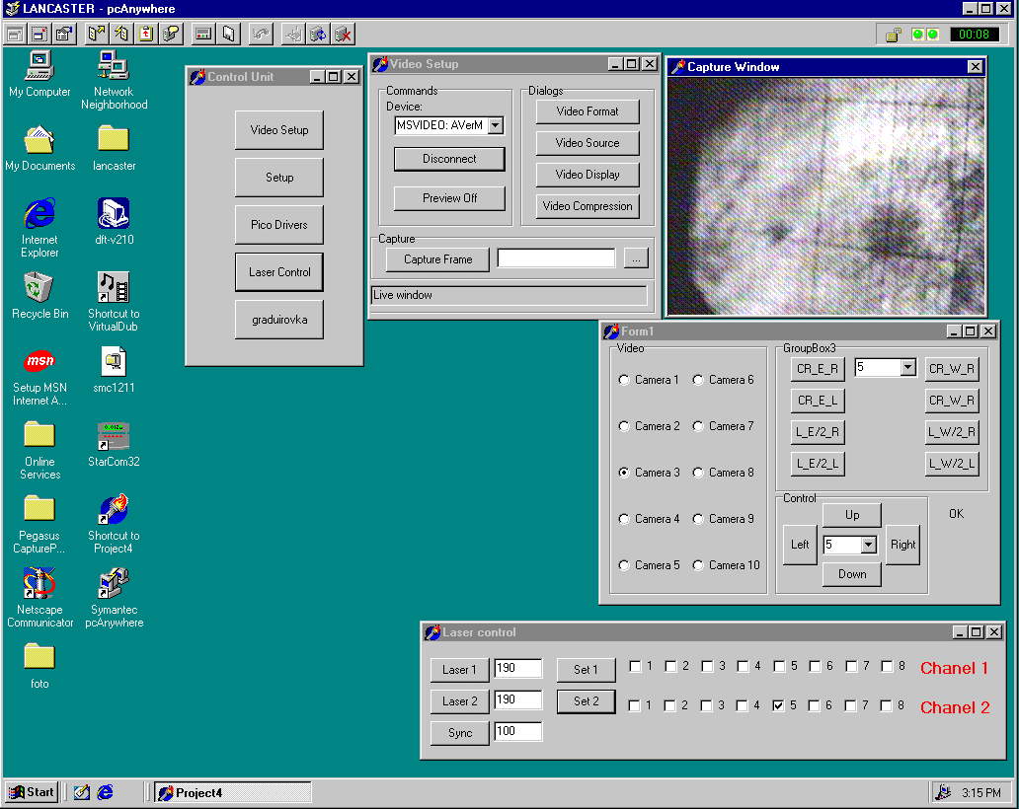
Various cameras can be selected in the “FORM1” window:
Cameras 1 & 2 = West laser aimed at the TPC
Cameras 3 & 4 = East laser aimed at the TPC
We will use cameras 1 and 3.
CAUTION: Do Not click on any other controls in the Form 1 window, or in the “control unit” or “Video setup” windows.

When the lasers are running and warm, a synchronized bright spot will be visible in the “Capture Window”. Select Camera-1 to see the West laser spot and a select Camera-3 see the East laser spot. Lack of a spot in either camera means the laser is not working (perhaps it didn’t power up properly) or it is very poorly tuned.

Tune the laser spot for maximum intensity by selecting Camera-1 and clicking the [L_W/2_R] or the [L_W/2_L] buttons (2nd column to the right in GroupBox3). Wait 2 seconds between clicks. Start by going to the right with [L_W/2_R] using as many as 10 or 15 clicks (but not more than 50). Keep going until you find the maximum intensity or, if not, try going left using [L_W/2_L] to find the peak.

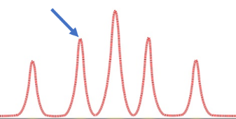
The Laser spots have multiple maxima and so you may be starting on a secondary maximum when the laser is first turned on … keep tuning past the first peak you find and then come back after you are convinced you have found the primary peak.

Next: tune Camera-3 for maximum intensity. Select Camera-3 and click on the [CR_E_R] or the [CR_E_L] buttons (1st column on the left in GroupBox3). Start by going to the right with [CR_E_R] and follow the same maximization procedure as for Camera-1.

Start a laser run with Run Control. Either a dedicated Laser run, or interleaved with Physics triggers is OK. Normally, we take laser triggers during a physics production run. A production run may be started while the lasers are warming up, or after the lasers are warm, but ensure that the laser trigger box was enabled before the run started.

Take data. Cycle back to Camera-1 and keep tuning the laser spot every 30 seconds (or so). As the laser warms up, Camera-1 usually needs a few clicks to the left with [L_W/2_L] to stay on top of the peak. Two or three clicks is usually sufficient. Repeat for Camera-3 but now try a few clicks left with [CR_E_L] or right with [CR_E_R] … whatever is required to maximize the laser spot intensities. Make sure you associate the correct camera with the correct buttons.

Keep tuning until the STAR DAQ screen shows 4000 Laser events have been collected and then turn off the lasers. You do not need to stop the run if you are running a production run.

- Turn off the laser flash lamps and turn off the laser AC power
Turn the lasers off by clicking “Unit-1 Off” and then “Unit-2 Off” in the laser Flash Lamp Control panel. Wait for both power meters drop to zero (about 2 minutes). Then click the “OFF” button in the Laser Sequence window (pink box). A “Lasers Standing By” message should appear in the grey box on the far left of the screen. Wait for it. Finally, move to the TpcLaser.starp.bnl.gov computer and the turn the laser AC power off by un-clicking box #3 and pressing “Set 2”, twice.

Ask the shift leader to unclick the laser trigger box on Run Control if you are running a physics-production trigger; do not stop the run. If you are running a dedicated Laser Run, then simply stop the run; no other changes.

- (Optional) Starting the Laser Control Panel – if it is not already on
Go to the TpcLaser.starp.bnl.gov computer (near the TPC Control Desktop, but to the right and above it).

On TpcLaser.starp.bnl.gov, double click the “Symantec pc-Anywhere” icon. After the program starts, double-click on the “TPC Laser” icon.

Login using Username: BRANDIN, Password: ANDREY.

This brings up the TPC Laser Control Panel.

This page deliberately left blank

Back Cover

