EEMC manual BNL, 08.12.2003
Andrey Brandin, Alexei Lebedev

A special trigger board installed near EEMC laser to operate lamp and Q-switch. This board is a copy of TPC laser and designed to operate the laser with 10 Hz and synchronize Q-switch with RHIC clock. TTL level RHIC clock was taken from output 4 on EEMC TCD (called E-Tow) by cable from south platform to laser cave in the RHIC tunnel.
Ground scheme for platform and laser are different (laser power is “dirty” power). We used special coupler chip from NVE Corporation, model IL710 to decouple ground for laser trigger board and TCD. Board has an internal mode 10Hz rate and external, when RHIC clock is present. Internal mode could be used to work with laser, while RHIC clock is not available. Schematic is presented at Fig.1.
Fig.1. Trigger board for EEMC laser.

Control PC is installed near EEMC laser to operate trigger board and provide control for the laser. This computer (called host PC) could be remotely operated by special software, called Symantec pcAnywhere. This soft provides an image of host computer with a full ability to operate mouse and keyboard of host computer. In our case host PC installed near the laser. There are two remote PC, installed in the control room: STAR-UTILITIES at magnet station and ASTAIRE. STARP.BNL.GOV at TPC station. On desktop of both PCs small icon
as a shortcut for this software is installed. After activation of this icon another window, called pcAnywhere will appear on remote PC desktop (Fig.2).

Fig.2. The view of remote PC with pcAnywhere activated.

On this window a set of links with several host PCs are shown: EMCLASER, TPClaser, VideoPC, est. Activate an icon, called emclaser. To proceed with connection please type user: EMCLASER (not EEMC!!!), password ANDREY. Desktop of Control PC will appear (Fig.3). In case if there no gray window in the desktop, called EEMCLASER an icon called Project 1 should be activated. After this all buttons in the gray window except LASER ON and LASER OFF should be pressed to initiate settings for trigger board. It is a good practice to activate buttons always when a connection with Control PC was established.

Fig.3. The view of Control PC (host computer) with trigger board activated.

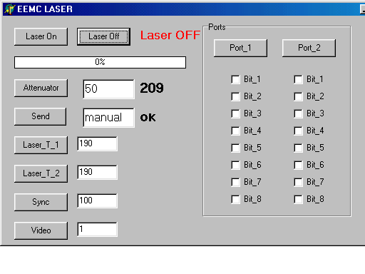
To start laser button “LASER ON” should be pressed. Automated sequence will switch lamp, established external trigger and will rise the voltage on lamp. At some point lamp voltage will reach the maximum. To stop the laser a button “LASER OFF” should be pressed. Attenuator could change output laser power. Maximum power provided at 255 counts. Required number should be typed in the window, reading appeared on the right side of this window. Next window was designed to send manual commands in case if automated procedure failed.
Laser_T_1 and Laser_T_2 windows show the delay (in microseconds) between lamp and Q-switch trigger. SYNC window designed to operate CCD camera, if it is necessary in the future. Port_1 and Port_2 columns were designed to provide TTL levels for relays, moving mirrors or shutters. After calibration run with EEMC laser connection with Control PC should be ended and another Symantec session should be activated. For ALSTAIR PC it is TPC laser, for STAR-UTILITIES it is VIDEOPC. In both cases user is BRANDIN, password is ANDREY. When connection will be established, further corrections in these sessions should be fixed according to manuals how to operate TPC laser or REMOTE VIDEO SYSTEM.

