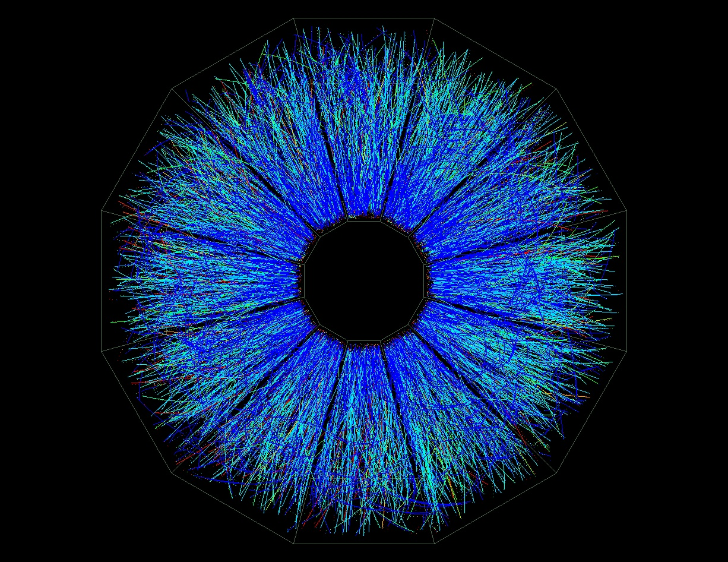

**RHIC Beam Use Request**

**For Runs 15 and 14**

**The STAR Collaboration**

**Version 1**

**February 2014**

1. How to write this document 3

2. Executive Summary 4

3. Highlights from STAR Science Programs 4

4. Run-14 Performance Report 4

5. Run-15 BUR request on p+P and p+A collisions 4

6. Run-16 Request 4

7. Detector and Upgrades relevant to BUR 4

# How to write this document

Please use this style file. Lets discuss a couple of things we should agreed on

* All citations will be at the end of the document using endnote, here is an example [[[1]](#endnote-1)]. Here is how you do this click on insert, select footnote, on the menu click endnote and there you go.
* The text is supposed to be justified to both sides
* Figure, table and equation numbering are numbered through the document. Example is here: Figure 1.
* We use cross-references to reference tables, equations and figures in the text.
* Please don’t hardcode any cross references to chapters, sections, tables, figures, equations or

This is normal text and now comes an example of a figure and its caption. After a line break the text gets intended as the beginning of this line. This is a cross reference to a chapter to do it correctly type chapter and insert cross-reference and this is the cross reference to Figure 1. We do the same for equations. All cross references are inserted as hyperlinks so you can click on it to jump to the respective item.

|  |  |
| --- | --- |
|  | Figure : at this moment in time we number figures through the document without chapter numbers. Note that figure and caption are contained in a 1 column, 2 row table. Picture in row 1 and caption in row 2. This allows expanding it to a 2 column tables (or more) for side-to-side plots. To format and align it is often better to switch on borders. |

Below an example of two figures side-by-side using a 2x2 table. Even if the figures would have a different size the captions would be vertically aligned.

|  |  |
| --- | --- |
| Macintosh HD:Users:ullrich:Documents:EIC:WhitePaper:WhitePaperInWords:tex:figures:figures_eA:xq2plane-xA-EIC.eps | Macintosh HD:Users:ullrich:Documents:EIC:WhitePaper:WhitePaperInWords:tex:figures:figures_helicity:x-q2-poldata.eps |
| Figure : another figure. Upper row, left column. Caption is in it’s own row. | Figure : yet another one. Caption is always aligned |

All variables are please in italics and if we use equations lets please use the internal WORD-equation editor. And here comes an example for an equation. $a=b+d⊗ \frac{s}{ν}$

To reference this equation we will use cross-referencing like for tables, pictures, chapters and so on, if needed. I think this is all which needs to be followed to make it easy to get different topics together.

# Executive Summary

# Highlights from STAR Science Programs

# Run-14 Performance Report

# Run-15 BUR request on p+P and p+A collisions

|  |  |  |  |  |
| --- | --- | --- | --- | --- |
| Run | Energy | Time | System | Goal |
| 15(2) | √sNN=200GeV  √s=200GeV | 5-week  12-week | p+Au  1) p+p  2) transverse  6 weeks  3) longitudinal  6 weeks | Study saturation physics,  pA-ridge and heavy ion  reference, L=300 nb-1  1) Heavy ion reference data  L=90 pb-1, 500M M.B.  2) Study transversity, Sivers  effects  L=40 pb-1, 60% pol.  3) Study g(x)  L=50 pb-1, 60% pol. |

Table : STAR Beam Use Request for Runs 15 and 16

# Run-16 Request

# Detector and Upgrades relevant to BUR

1. [] Endnote example [↑](#endnote-ref-1)