It was stated that our last meeting could have been more productive. I myself find that when I have an idea, that in my opinion is the best thing sins sliced bread, it gets ignored. This may be partly because I am unable to communicate that idea properly. So I have come up with this document. The document contains my thoughts on the AJHDL:
-----------------------------------------------------------------------------------------------------------

The basic model for any job / request can be seen below. If you take a data set and run some task on it and get another data set.

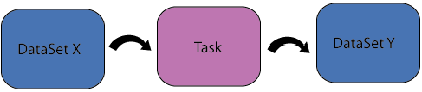

The end product of any pairing of a dataset and a task is another dataset. In our model (SUMS) the data set was referred to as the job / request. In our new schema where many jobs can be defined perhaps it may be better to call all requests datasets, as this is the end product anyway.

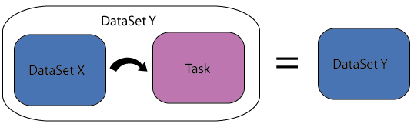

Now lets look at the bigger problem drawn below. Tasks A,B,C and D are started simultaneously. They work on the respective data sets A,B,C and D. The output of tasks B,C and D are merged to produce data set E. Data set E is give to task E to produce Data set G. If Task A finishes before task E then tasks B,C,D,E are killed. If task E finishes before task A then task A is killed.

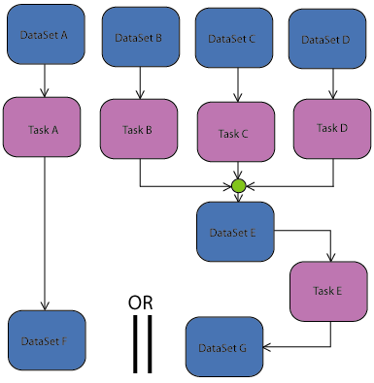

When writing this schema I find it easier to refer back to sums as a point of reference as to what is do-able and what is not, and how to bend the new schema in such a way as to make the new benefits work in real life. I believe each task needs a definition of when it is complete, some request may require that all the jobs finish before moving on to the next task, however in a 1000 job request it is unrealistic (in real life) to think that 100% of the jobs will finish, so may die, be killed, fail, ect. This is why there has to be a definition of what constitutes completion. I think each task should have a “start execution when” type of tag and an “upon completion” tag. Inside these tags the user should be able to start more tasks and kill some tasks. These tasks are going to need some type of condition, in order so they can tell when there jobs are done. This condition will most likely need to be able to look at the file system, to tell if the task is done.

Instead of writing this schema as just XML, Lets write it as java Serializable XML. So instead of writing:
<task> </tast>
we would write :
<object class="task”> </object>

The benefits are:
1) Seamless conversion, of XML to java object and java objects to xml.
2) An industry standard preexisting parser known to be bug free.
3) An industry standard preexisting base schema that can be extended.
4) A well defined path for added new syntax.
5) The ability of the user to interchange objects.
6) No schema validation needed (It’s built in, and grows as you add classes)

Negatives:
- The lines are a bit longer / more wordy.
- A lot of sums code would need reshaping, however that’s true now as well, this would just provide the excuse.

Here is an example taking into account all that I have talked about as to what the JDL may look like : (see next page)

As discussed before this is called a data set and not a request, of course the data set will not exists until the task(s) inside it are run. This data set (stepOneDat) could be the dataset for another one of these blocks.

The user needs the files for his jobs grouped and split in a very special way, they have there oun class that is not part of the JAR but sits somewhere in the class path. Inside the <> the users class makes up it’s own syntax. In terms of getting fastest run time how we split is just as important as where we dispatch.

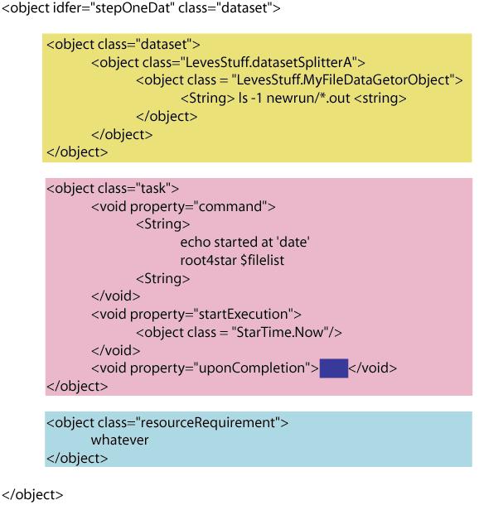
This is the data set it takes to make stepOneDat
The user doesn’t want to use the default, file catalog class provided with the default libs of SUMS he once again rolls his own.
The starExecution property holds a class that tells this dataset when to start running. It could be right away, or when something else is done, or never
The uponComletion property knows hen the job is done according to the uses definition. It states what other jobs should be started or killed.
We talked about these in the first meeting. However we fail to take into account that the next job will need to inherit some of these properties (the ones that belong to the final data set), the rr’s that belong to the task can be discarded.

