SSD Cooling System

This document gives a brief description of the SSD air cooling system and some guidance on how to turn it on and check its status.

PAY ATTENTION, TURNING POWER BREAKERS IS NOW FORBIDDEN FOR UNTRAINED PERSON.

The SSD cooling system
The SSD is cooled down by the mean of an air flow induced at one end of every ladder and sucking the fresh cooled taken from the TPC inner field cage through the full volume of the ladder. The air flow is produced by an compressed air running into air flow amplifiers called vortec. The compressed air is produced by a dedicated compressor located in the second floor of the STAR assembly building. A schematic drawing of this system is the following :

Compressor
Filter
magnet
magnet
poletip
poletip
TPC
Airflow amplifier (Vortec)
Air manifold (1 to 6)
Compressed air (120 psi)
Induced air
Valve
Gauge

The compressed air is produced by a compressor and is going immediately trough a filter on the second floor of the room at the East side of the Assembly building. At this level they are 2 manual valves. One is between the compressor and the filter and one right after the filter. There is a manual gauge just before the second valve. The air compressed air is then running trough a copper pipe up the on side of STAR in the Wide Angle Hall.

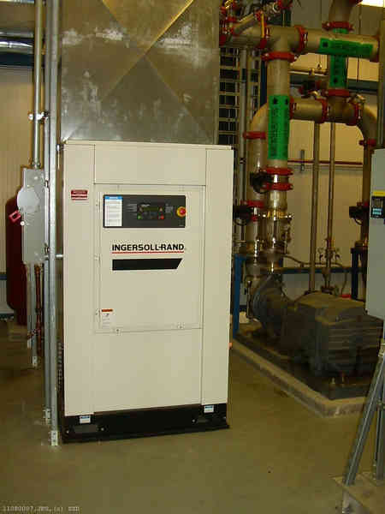
SSD Compressor
Compressor main power breaker
Compressor screen

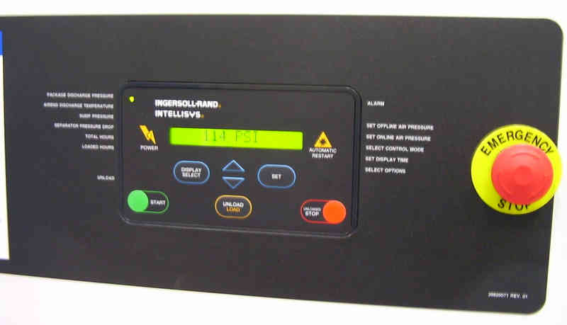
Compressor start button

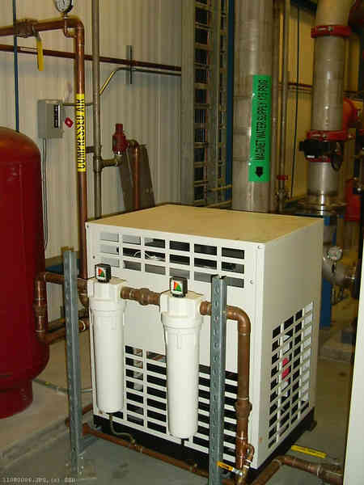
SSD Filter
First manual valve
Second manual valve
Manual gauge
Filter power breaker

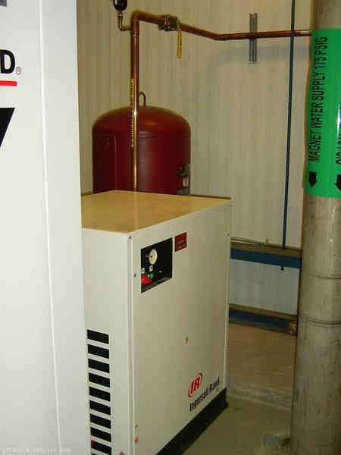
Front view of the filter
Filter ON/OFF button

From the North-West side the copper pipe is approaching STAR. At this point, there is an electronic valve and an electronic gauge. After the gauge, the flexible hose is connected to the copper pipe to serve the West side of STAR while the copper pipe is running parallel to STAR to reach the East side. The hoses are connected to manual gauges and valves that should be open and then to the vortecs.

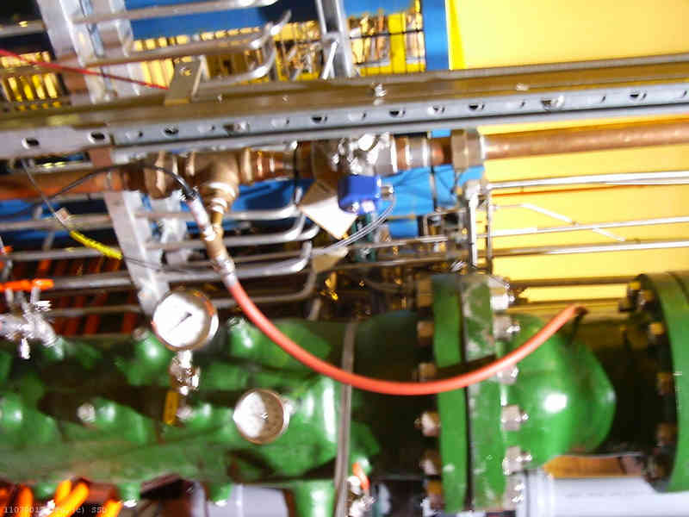
Electronic valve
Electronic gauge
Copper pipe serving the East side
Flexible hose serving the West side

How to turn on the SSD cooling system
BE AWARE THAT YOU ARE NOT ABLE TO TURN POWER BREAKERS BY YOURSELF ANYMORE
This means that step 3 to 5 are forbidden to you. Call Bill Christie or try to find Bob Soja to do that.

- Check that the electronic valve is open. The valve is controlled by the SVT slow control. The procedure to control the valve status is describe in a file on the ch3linux machine. Check the file SSDvalve.help in the directory /home/ssd/Docs. Be careful since important SVT hardware is remotely controlled by the same system.
- Go to the Assembly building room. Make sure that the two manual valves are open. They are usually open (the handle should be parallel to the pipe)
- Turn on the filter power breaker
- Turn on the filter (turn the red button)
- Turn on the compressor power breaker
- Check the compressor status (a message like “ready to start”)
- Start the compressor (press the green start button)
- Check the compressor status (the pressure should rise and stabilize around 120 psi with some oscillations)

Something is wrong with the cooling system

If the temperature reading and/or the compressed air pressure indicated on the slow control windows are not normal (typically the pressure equal to 15 psi) something is wrong with the cooling system.

The first thing to check is the electrovalve status. Its default state is closed so if something happened to the electrical apparatus controlling this valve, the valve will close itself.

If the valve is open, then they are good chances that the compressor itself is in a bad state (the manual valves between the compressor and the rest of the cooling system are usually open).

- Check the compressor status on the small display. If the compressor is ok, it should indicate a pressure close to 120 psi. If this is not the case, the compressor must be reinitialized.

- Try to do a “stop” by pressing the red button near the display. If it works, try a “start” and check the message on the display and the pressure growing.

- If the compressor fault is severe, pressing the “stop” button does not help. On must power cycle the compressor. For that, one must switch up/down the compressor power breaker. Turn it off, wait a few moment and turn it on again.

- When the display says something like “ready to start”, press the green “start” button. The pressure reading should rise on the display and on the gauge located after the filter.

- If it does not work, do not insist. Ask the Operation group (Ralph Brown) to have a look at the compressor. In the mean time, leave the SSD completely OFF.

