SSD Documentation

Air cooling system
Version 2
27-june-02

1. STAR-SSD design 3
2. SSD Air cooling system 3
2.1. Power consumption 3
2.2. The air path in the ladder 4
2.3. Air flow amplifier 5
3. Cooling tests 6
3.1. Cooling test setup 6
3.2. Results of temperature measurements. 8
4. Conclusion 9
5. Technical documentation and drawings 11

STAR-SSD design
The evacuation of the heat produced by the electronics in large detectors is critical in order to establish a correct and stable behaviour of the sensors and the associated electronics. For the Silicon Strip Detector of the STAR experiment, tests have been performed using the first SSD ladder in order to quantify and validate the efficiency of an air cooling system.

The SSD (Silicon Strip Detector)of STAR is an assembly of 20 carbon fiber ladders in a barrel shape. Each ladder is equipped with 16 double-sided silicon micro-strips detectors (320 modules in the whole). Each strip is connected to its own charge amplifier channel. This means nearly 4000 “A128C” integrated circuits. These latter are made of 128-channels charge amplifiers with low noise and low power consumption. At each ladder end, we have 2 electronic boards (one “ADC Board” and one “Digital Control Detector Connection Connection Board” : C2D2) used for analogue to digital conversion of the signal and for wire connections to send signals to the data acquisition system. For a full description of the STAR SSD layer, please refer to “Proposal for a Silicon Strip Detector at STAR” [1].

Figure 1: Layout of a SSD detection ladder.

SSD Air cooling system

Power consumption
The purpose is to evacuate the heat produced in the Silicon Strip Detector layer. We have estimated the power consumption of the different components of the SSD layer. We can separate the phenomenon into two independent parts: The first one is directly connected to the Front End Electronics (Alice 128C), and the second one to the ADC and C2D2 Boards. (See Figure 1). Table 1shows an estimation and a measure of the power used by FEE. Table 2 presents results of measurement for the power consumption of the ADC and of the C2D2 Boards .

F.E.E. POWER | Number of elements | Predicted Power | Measured Power  Ladder 0
Alice 128 | 12 per Module | 44 mW
Costar | 2 per Module | 44 mW
Detection Module | 16 per 1adder | 616 mW
TOTAL FEE |  | 9.8 W | 10W
Table 1 : Estimation and measurement of the power used by the FEE

Electronics Boards | Number of elements | Predicted power | Measured power
ADC Board | 2/Ladder | 1,0W/card
C2D2 Board | 2/Ladder | 2,0W/card
Total Electronic Boards/Ladder | x | 6 W | 6 W
Table 2 : Estimated and measured power of the ADC and connection boards

Total FEE | 10 W
Total Electronic Boards | 6W
Total for LADDER 0 | 16 W
Table 3 : Power Consumption of the LADDER 0

A Silicon Strip Detection Module (assembly of one double-sided silicon detector and 2 hybrids bearing FEE) produce less than 0,4 mW of heat per channel, mainly in the Alice 128C Front End chips [2]. The other passive components (capacitors) release a negligible amount of heat. A COSTAR chip is used for the slow control (monitoring of current, potential and temperature of the hybrid circuits). The COSTAR has approximately the same power consumption as the A128C chip (around 340 μW/cm²).
Given the low power dissipation per unit area in the detection surface (16 mW/cm²), a cooling system using air has been developed and designed for the SSD. For the two ends of a ladder (ADC + C2D2 Boards) the problem is different: the density of released energy per unit area is 4 times bigger than for FEE. Fortunately, this zone is not in direct view of the SVT. It is very important to evacuate to the outside of the SSD the largest part of the produced heat in order to interfere as less as possible with the thermal equilibrium of the Silicon Drift layer “SDT” [ref. SVT].

The air path in the ladder
As a consequence, each ladder can be cooled by air circulating throughout a rectangular section in its own carbon fibre structure. This alternative includes the use of one part of the ladder section as an air pipe. It is necessary to use a single-side board for the FEE (hybrid). Therefore, Alice128 chips are on the outer part of the hybrid frame (in view of the TPC). A thin Kapton® film ensures the air layer thickness (4.5-mm on top of the components) thickness. Each ladder is finally wrap up in a thin Mylar cooling shielding (see picture 5). The electronic boards are installed on the ladder ends with the components inserted in the ladder and viewing the inside of the triangular section. Deflectors inserted inside the ladder upper part and integrated to the ADC board supports allow the transition from the rectangular section to the triangular section.
In case of air a leak, in order to prevent warmed air to go inside the SVT and to alter its good working conditions, we use a low-pressure air circulation created by aspiration. In any case, heated air will be removed from the central part of STAR detector.
The induced air comes from IFC, the free volume between the SSD and the TPC. The warmed air is evacuated to the outside of STAR through a flexible hose of around 10-mm diameter. (see figure 2)

Figure 2 : Sectional schematic of the cones bearing the SSD layer; Principle of the SSD air cooling system : Air is sucked in alternatively from East to West and from West to East by a set up of Transvector® . Dry and clean air comes from the Inner Field Cage.

Air flow amplifier

An air amplifier called Transvector® and manufactured by VORTEC [1] produces the airflow. The Transvector uses the impulse principle to achieve amplified airflow. When compressed air enters the Transvector®, it fills a chamber that has only one exit path - a 0.051mm orifice. As the air is forced out of the orifice, it accelerates and collides with surrounding air entraining a great volume of free ambient air (please refer to the sectional drawing of the Transvector®). The result is a large volume of input and therefore output air in return for a small amount of compressed air. The induced airflow is the cooling airflow that travels through the ladder. A Transvector® can draw-in air for 5 ladders at a rate of 1 litre/s. (Characteristic table). It aspirates heated air out of the ladder through a round hose (10-mm diameter). Two airflow amplifiers will be located at each end of the cones on the pole tip. Precisely on two phenolic brackets (see pictures in Technical Information).
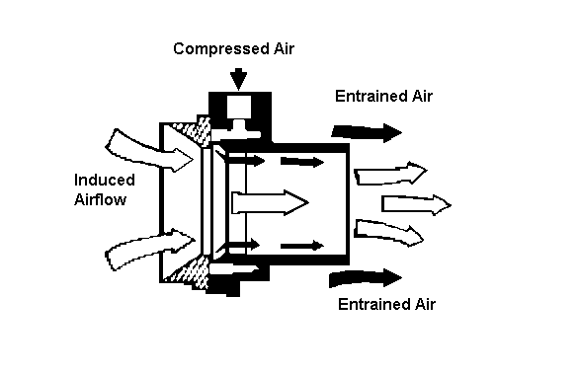
Figure 3: Airflow amplifier principe

[1] VORTEC Fenwick, Dpt AMA Produits Industriels, St Ouen France. ITW VORTEC, Cincinnati, Ohio USA.

Cooling tests

Cooling test setup
We used a set up of thermocouples to measure temperature in several places of the LADDER 0. The data acquisition is performed by a National Instruments acquisition system (FieldPoint®+LabVIEW®).[2] The LADDER is placed in a box in order to reproduce very confined conditions. Consequently, the ladder is only cooled down by the airflow, and not by the ambient air of the room.

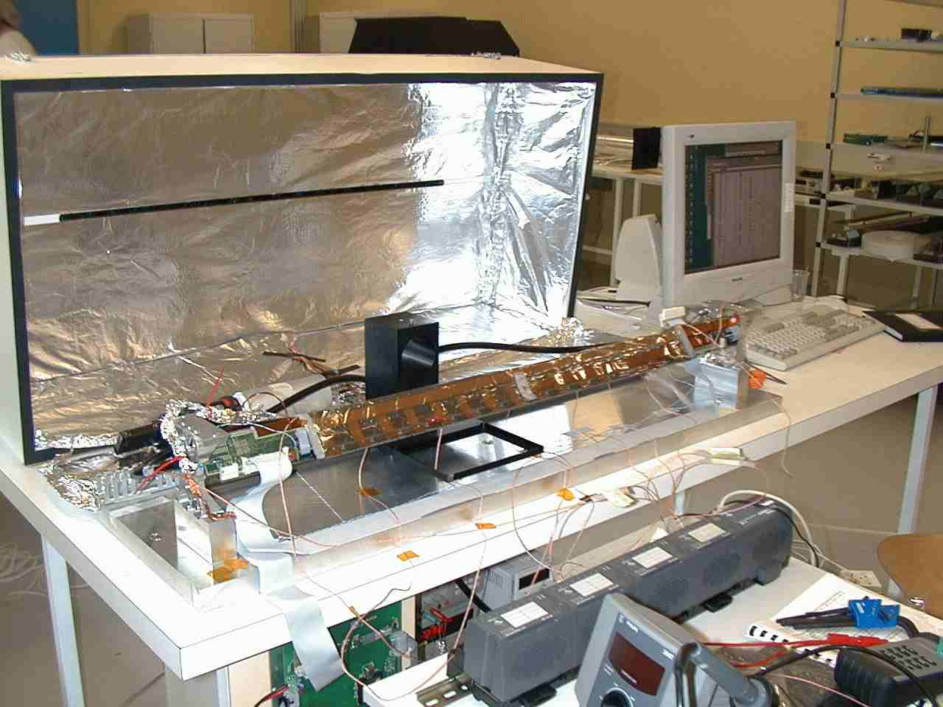
Figure 4: Picture of the LADDER 0 in the test Lab
Major part of the thermocouples is directly glued over the components for the ADC and C2D2 Boards . Some are also in contact with silicon detectors (just separated by the Mylar cooling shielding). For the air temperature measurement, thermocouples are placed directly in the air path, at the entrance and at the exit of the ladder. We have performed the test with 6.5 bar of transvector compressed air supply. However a Transvector® can work very well at 8 bars and therefore increase the airflow in the ladder by 20%. We have checked that an airflow amplifier can draw-in air in 5 independent ladders. Consequently, we will need to use 4 Transvectors® for the STAR SSD layer. We also measure each hybrid temperature given by the COSTAR Chip.

[2] FieldPoint® FP-1000/1001 user manual (National Instruments). LabVIEW® user manual
(National Instruments).

Figure 5 : details of the glued end of the Mylar cooling shielding
Figure 6 : Detail of the Mylar cooling shielding
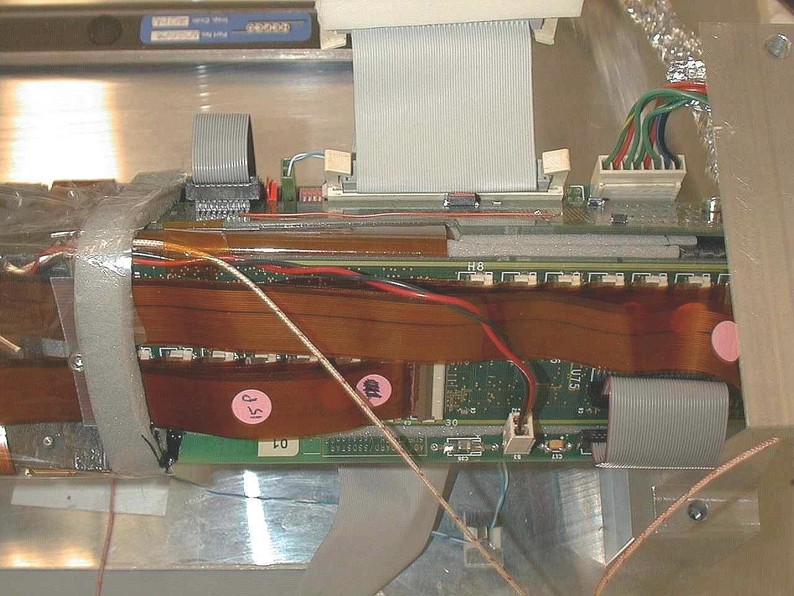
Figure 6 : details of the glued end of the mylar shield
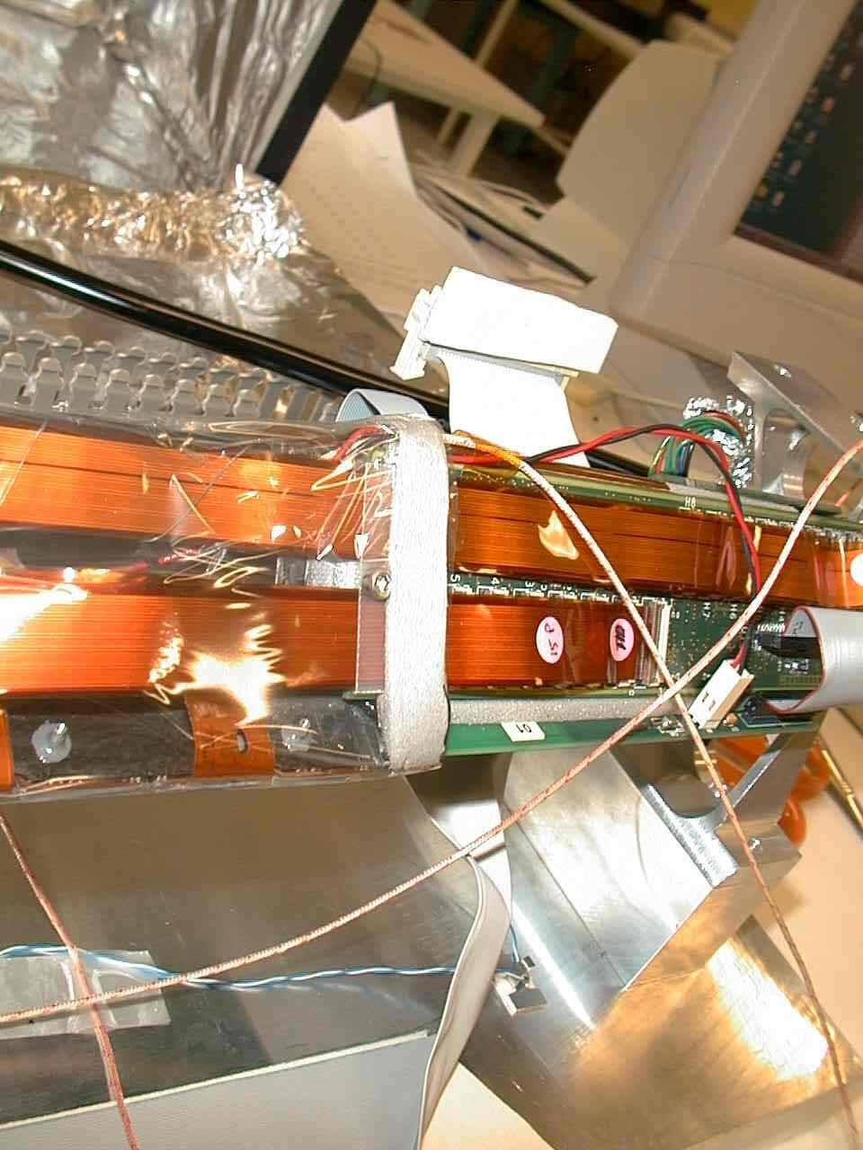
Figure 7 : details of the glued end of the mylar shield
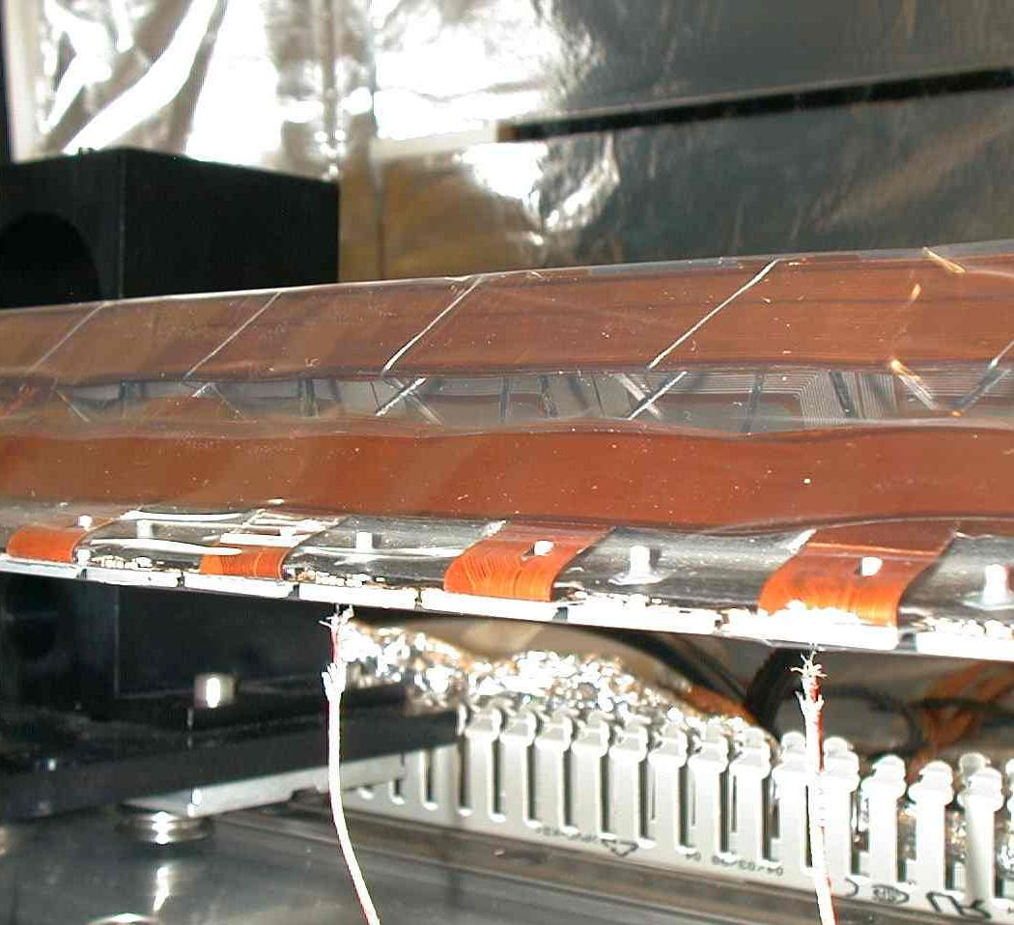
Figure 8 : Details of the mylar cooling shield

Results of temperature measurements.

Test Conditions :
- Ladder 0
- Pressure air supply 6.5 bar
- Input air temperature 19 º/Celsius

Thermocouples used for temperature measurement are named as follows :
- 5 thermocouples in contact with silicon detectors on the P side) : detector 16 , 14, 11, 8, 5, 3
- Thermocouples in the air hose : air in, air out
- Thermocouples on the ADC board : ADC
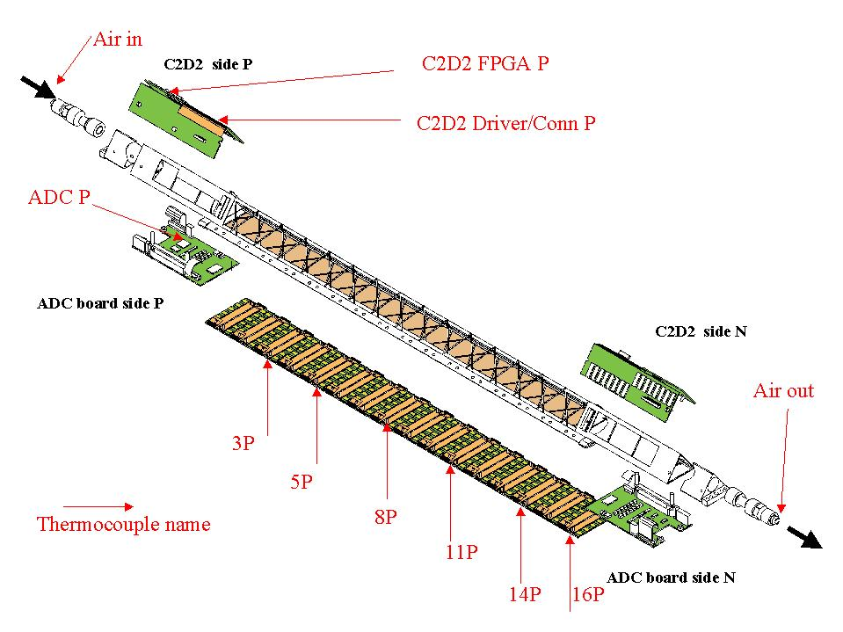
- Thermocouple on C2D2 : FPGA , DRIVER/Conn

 | SIDE P | SIDE N
ADC | 42.8 ºC | 46.5ºC
C2D2 FPGA | 34.8ºC | 36.5ºC
C2D2 DRIVER/conn | 45.2ºC | 45.4ºC
Table 4: Mean electronics temperatures measured on the LADDER 0 with cooling off

 | SIDE P | SIDE N
ADC | 33.1ºC | 33.2ºC
C2D2 FPGA | 33.7ºC | 30.7ºC
C2D2 DRIVER/conn | 27.6ºC | 24.5ºC
Table 5 : Mean electronics temperatures measured on the LADDER 0 with cooling on
Figure 9 : Example of ADC and C2D2 board temperature evolution during 2 hours. The electrical power was switched off after 1,8 hour while the cooling remained on

First of all, we measure the temperature of the COSTAR chip with cooling on (Figure 9).
Air in : ~19 ºC
Air out : ~29 ºC

Th name | Si detector Temperature | COSTAR Temperature(ºC)
3P | 27.8 | 35.3
5P | 32.9 | 32.5
8P | 30.9 | 37
11P | 30.2 | 37.5
14P | 28.7 | 34.9
16P | 25.1 | 32.3
Table 6 : Mean Temperatures measured on the LADDER 0 with the air cooling system on

Conclusion
In order to know if the temperature of boards and modules has any influence on SVT and on TPC, we added a thermocouple in the test b. It was at the level (above and below) of the cards. We can see the temperature evolution during the test on figure 7 (Air in the box). The temperature gradient is below one degree. That means that a simple Mylar® film shielding can insulate other STAR detectors from SSD layer, principally SVT that is very temperature sensitive and dependant.

For the LADDER 0 : the temperature is maintained between 32 and 37 °C for the FEE COSTAR (Table 6) . The silicon detectors temperatures are below 31°C (Table 6). The wafer leakage currents increase with the wafer temperature but we have checked that this has a minor impact in terms of electronic noise. ADC and C2D2 Boards temperatures are below 34°C (Table 5). This latter is completely acceptable for the electronic functionality.

After this full cooling test, we have confirmed that it is possible to cool down by air the STAR SSD layer with a good efficiency. A precise determination of the heat extracted by the air is difficult since its would require an accurate measurement of the air speed profile in the outgoing tube section. We should however note that stabilized temperatures are reached without a significant increase of the ambient temperature in the test box.
Moreover we have made tests with incoming air at 19 °C, in STAR the IFC air temperature is around 24 °C. It means that we should expect a global temperature shift of the same order.

Technical documentation and drawings

Air cooling supply

- 1 EP-50SE rotary screw compressor
- Dimensions : L 53 in, W 42 in, H 72 in
- Weight : 1800 lbs
- Power : 37 kW
- Voltage : 460 V / 60 Hz
- Noise level : 85 dBA

- 1 refrigerated dryer TMS80
- Dimensions : L 35 in, W 27 in, H 42 in
- Weight : 407 lbs
- Power : 1.26 kW
- Voltage : 230 V / 1 phase / 60 Hz

- 2 filters oil remover IRP 385
- Dimensions : H 25.5 in, diameter 6.1 in
- Weight : 14.3 lbs

This equipment will be located in the second floor mechanical equipment room where the “Modified Chilled Water” system is located.

Drawing of the VORTEC

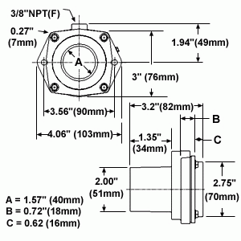

The 4 transvectors will be installed on the magnet pole tip (2 per end of the magnet).

TRANSVECTOR
VORTEC

VORTEC
Pressure
gauge
Compressor

Slow Control

Electro-valve
Electro-valve
filter
Interlock
High pressure hoses
Manual Valve
East Poletip
West Poletip
Air from the SSD
VORTEC compressed air supply
Test of aspirated air system (year 2000 test)

The test we have performed concern the pressure drop produced by the VORTEC. It is not easy to exhaust air in a small and variable section; the pressure drop increases when the area of the section decreases. We have measured the pressure and the temperature along a Ladder model.
Fig. 10: Measured pressures along the model: with a 5-bar Transvector® air supply pressure.

- Temperature of incident airflow: 20°C
- Transvector® air supply pressure: 5 bars
- Pressure drop (exit of the ladder):
–12 mbar
- Air speed along the ladder : < 0.5 m/s (No structure vibration problem)
- Airflow: ~ 1 litre/s

ReadOut card
5 air hoses
already on the cone
VORTEC
6 to 1 hose distributor
Cooling hose of ReadOut card
High pressure air
5 air hoses
already on the cone
6 to 1 hose connector
hose /vortec connector
VORTEC
High pressure air
Outgoing air
1/2 of the cooling system
Outgoing air
Design of the SSD cooling system located on the Poletip

VORTEC
Filter & Manual pressure reducer

Valve electrically operated
Pressure sensor
High pressure pipe in plastic
Low pressure pipe coming from the TPC wheel

High pressure pipe coming from the compressor
6 to 1 connector

The specification of each device is the following :
- Pressure sensor : 0 to 10 bars, output signal 4-20mA (WIKA 9321263)
- Valve : pressure max 16 bar, control signal 24V DC (LUCIFER E321G39)
- Plastic high pressure pipe : diameter 1.5 inch
- Transvector + filter + valve : model T3 (VORTEC 953)
- Low pressure hoses : diameter 70mm , material type PVC
- 6 to 1 distributor : adapter from 6 hoses to a big diameter one, design and made at Subatech see next drawing
