SSD documentation

SSD Ladder
Version Number : 4
27-june-02

Authors : L.Martin (for the cut and paste)

1 SSD Ladder design 3
2 The carbon fibber beam 4
3 Detailed material budget 8
4 Radiation length budget 8

1 SSD Ladder design

Each SSD ladder is composed of the following elements (Figure 1):

- 16 modules aligned along the ladder axis (the beam axis),
- two pairs of ADC board and C2D2 board located at each end of the ladder and dedicate to the digitization and the control of the signals coming from respectively the N side and the P side of the modules,
- a low mass carbon fiber beam supporting the modules and the electronic boards,
- additional mechanical pieces to attach the ladder to the clamshell and to connect the ladder to the air cooling tubes.

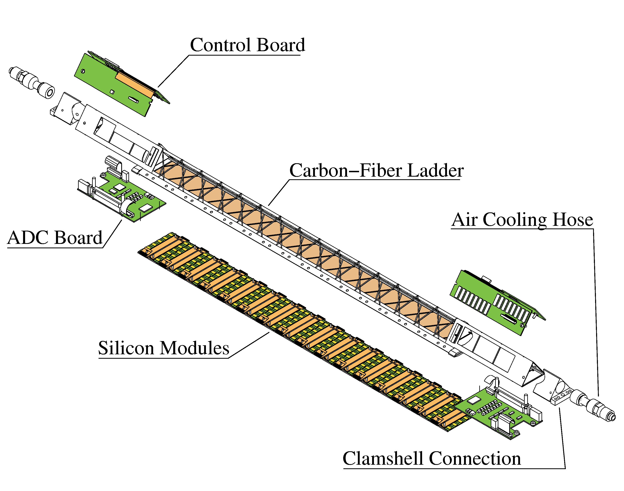
Figure 1 : Exploded view of an equipped ladder

2 The carbon fibber beam

The mechanical structure of the ladder (Figure 2, ) is build into two parts. The upper and longest part as a triangular shape and holds the board at its extremities. The central part of the beam is build by welding a carbon fiber around the triangle corners and provides most of the ladder rigidity. Internal stiffeners are inserted at the ends this part in order to give additional strength. A second part (the bottom part) still made of carbon fibber is used as an interface piece to hold the module and integrates a kapton film to close the air path near the module. Figure 4 and Figure 5 show details of the ladder beam.

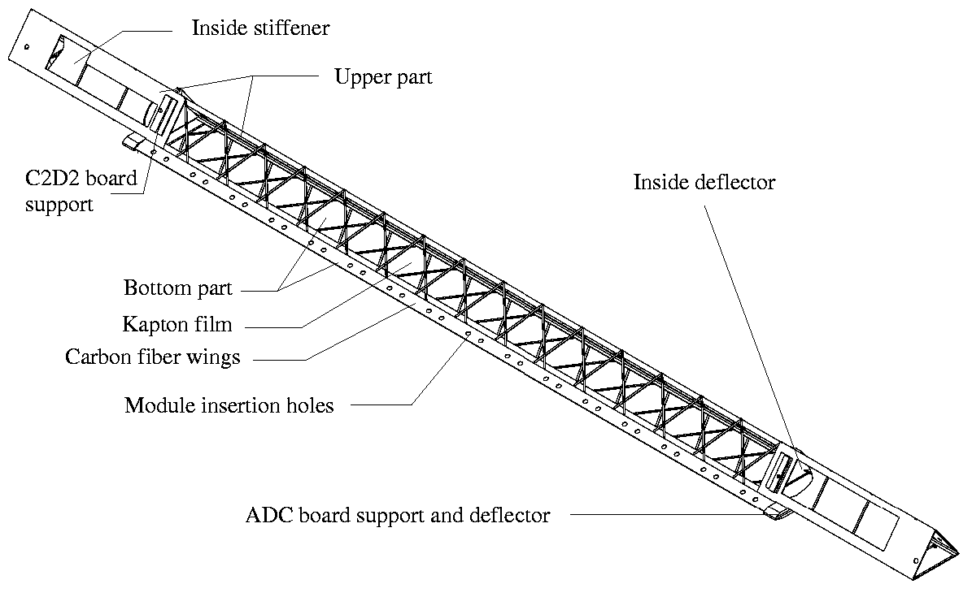
Figure 2 : Components of the ladder support structure

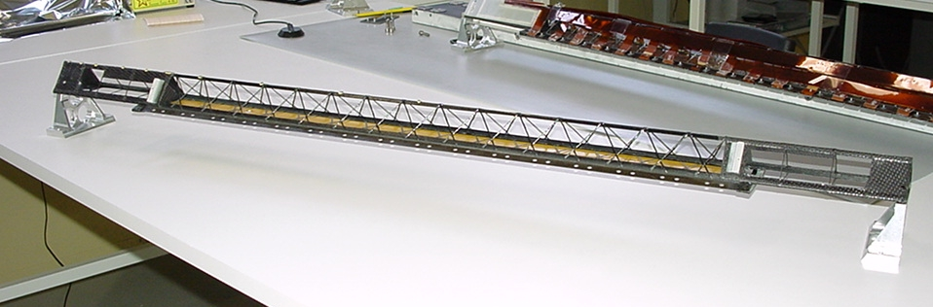

Figure 3 : a carbon fiber mechanical structure of a ladder
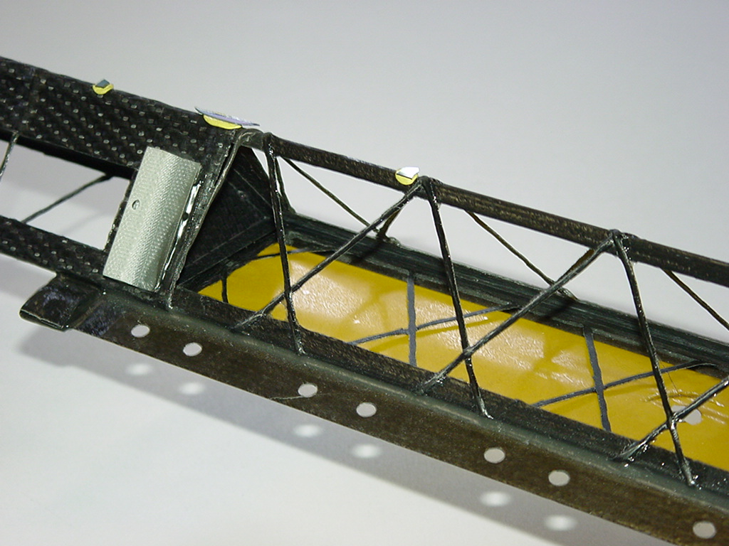
Figure 4 : Detailed view of the ladder mechanical structure

The weight of the bare carbon structure is around 90 g while the load coming from the modules and the electronic boards is around 350 g (9 g per module). The sagging of the ladder under a central load of 200 g has been measured to be of the order of 200 μm . Under realistic load and realistic conditions the sagging of the ladder has been estimated to be below 50 μm.
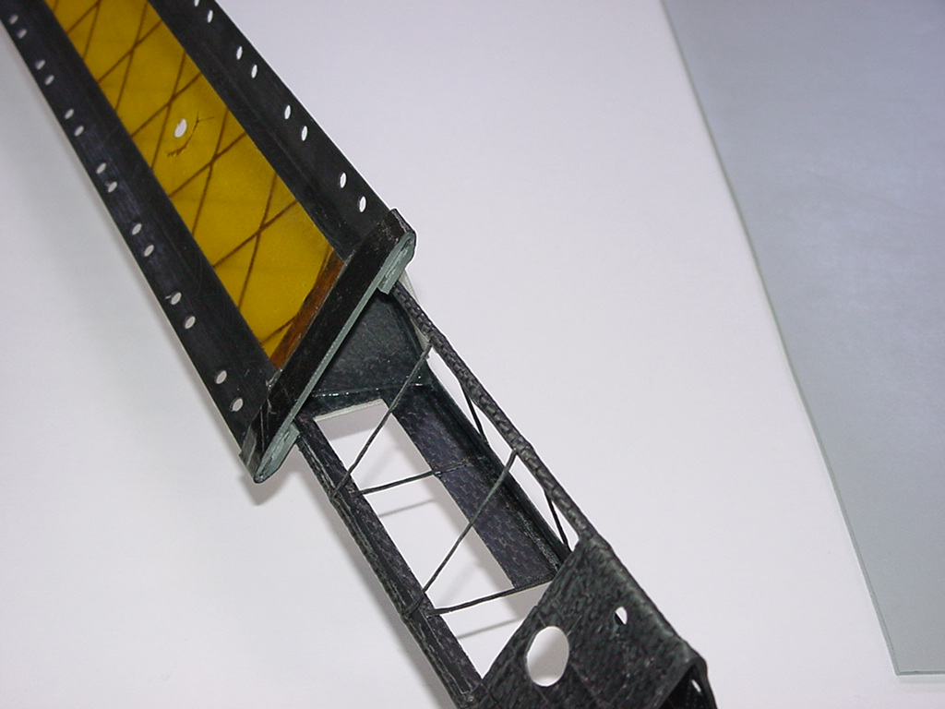
Figure 5 : Detailed view of the end ladder beam showing the bottom part (the kapton film is in yellow) and one end of the upper part

A fully equipped ladder has been assembled which will be installed in STAR. The following pictures show complete views (, ) and partial views ( , , , ) of the ladder.
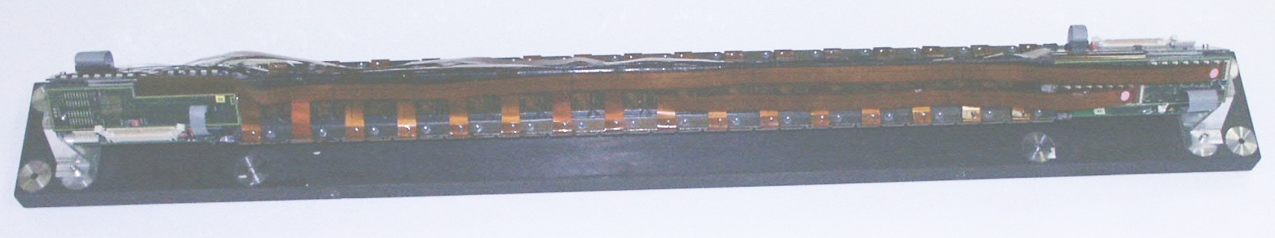
Figure 6 : Top view of the equipped ladder
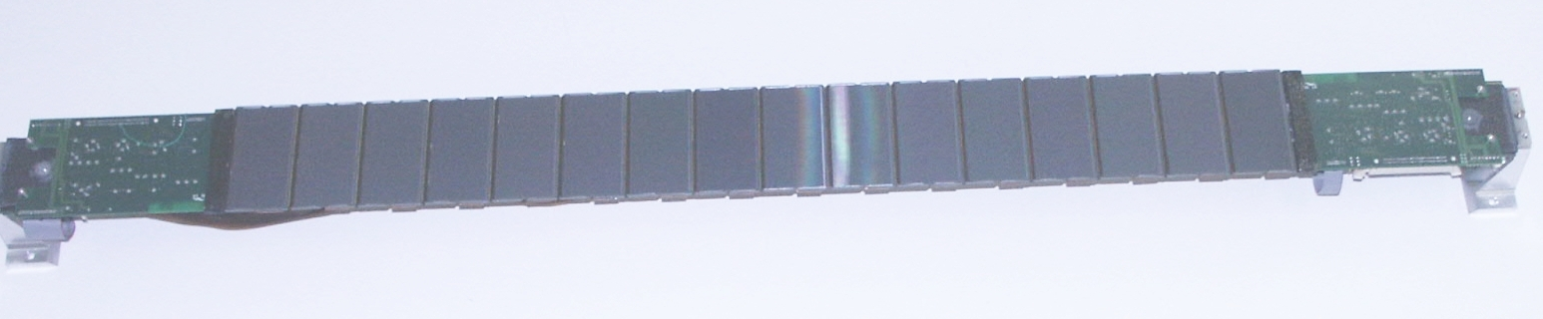
Figure 7 : Bottom view of the equipped ladder

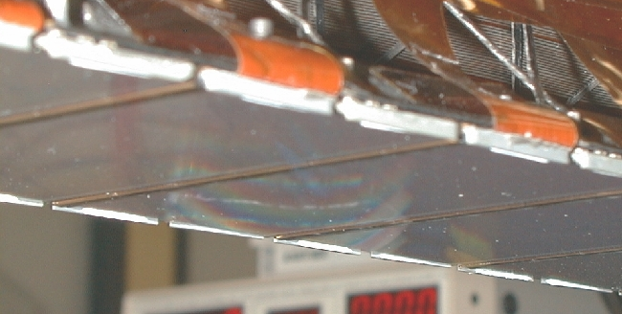
Figure 8 : Detailed bottom view of the ladder showing some silicon wafers

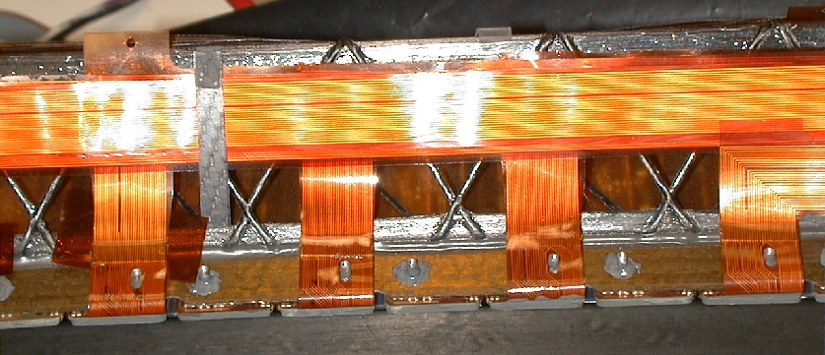
Figure 9 : Detailed top view of the ladder showing the aluminum buses connected to the hybrids and running along the ladder
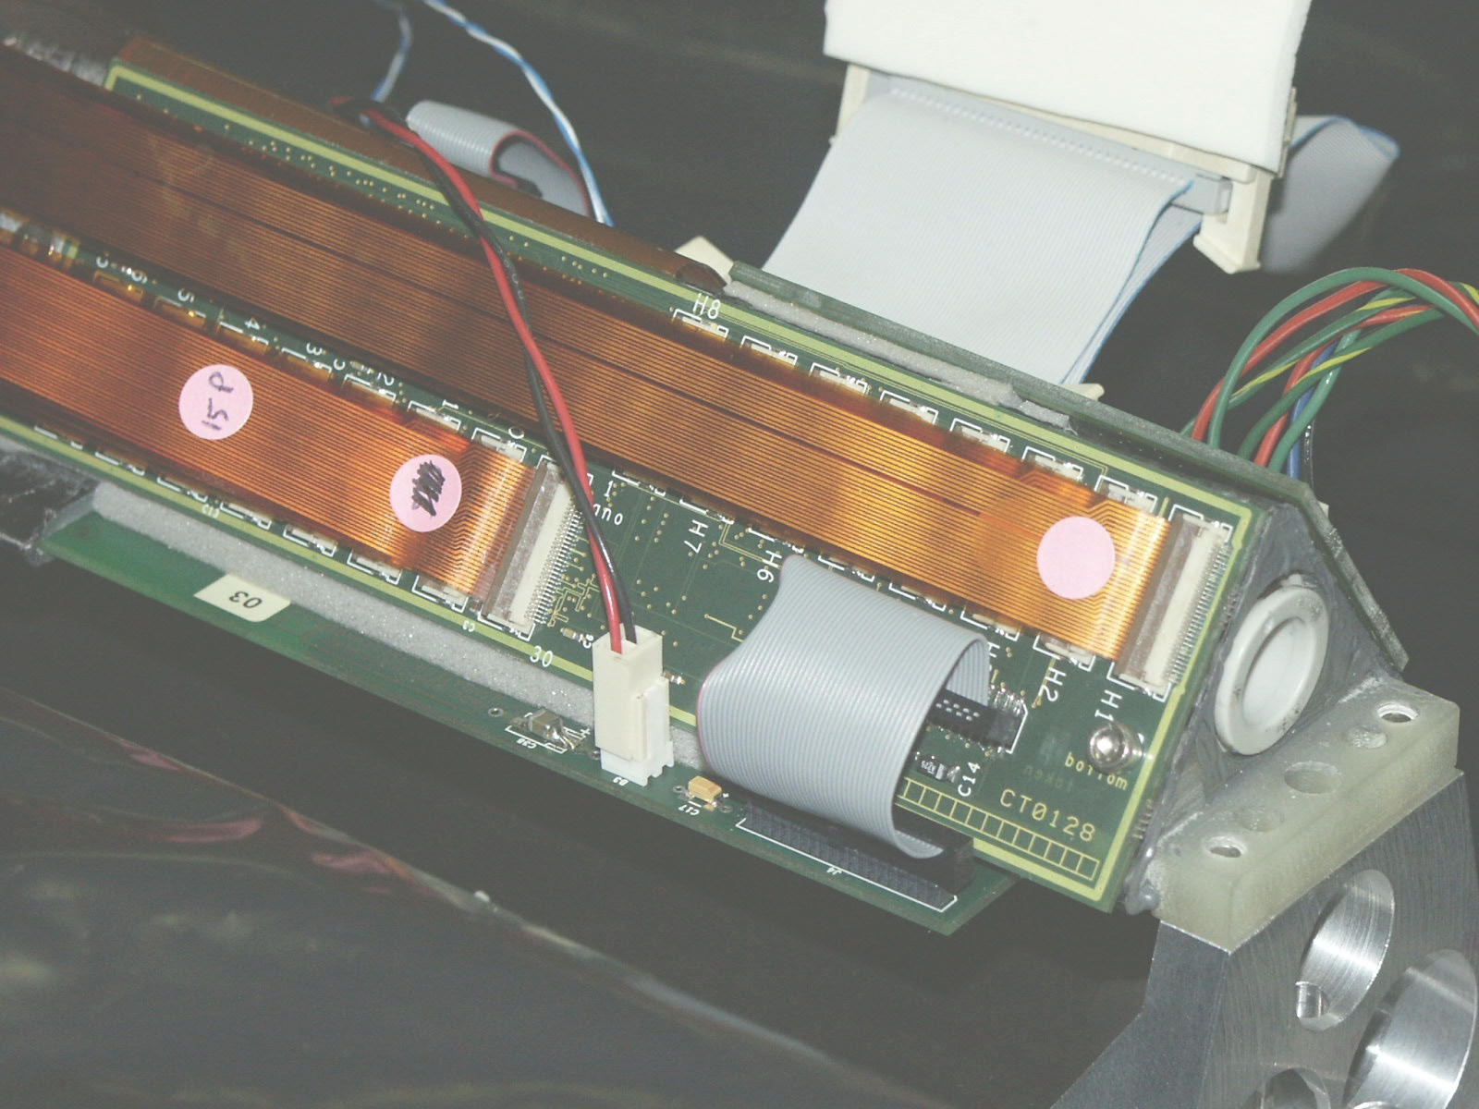
Figure 10 : Detailed end view of the ladder. The C2D2 board is on the top with the buses connected while the ADC board is partly visible at the bottom. The mechanical interface (dirty white) is shown on the right with the air hose connector inserted.

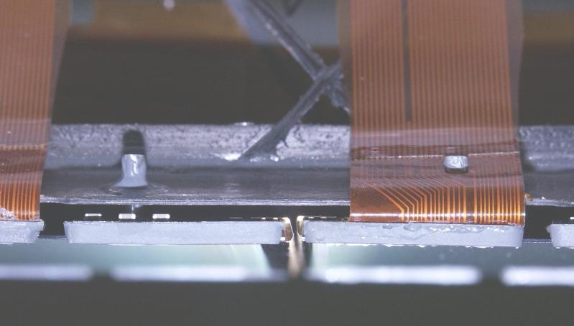
Figure 11 : Detailed front view of the ladder showing the ladder-module interface. The central bottom part shows the interface between two modules and the TAB tape going from the wafer to the A128 chips.

3 Detailed material budget

The SSD ladder can be split in the following components using the specified material :
Equipped

Module |  |  |  | *
Ladder | Upper part | Upper part |  | Carbon epoxy fiber
Ladder | Upper part | Inside Deflector | Deflector | Carbon epoxy fiber
Ladder | Upper part | Inside Deflector | Glue | Araldite 2013
Ladder | Upper part | Inside stiffener | Stiffener | Carbon epoxy fiber
Ladder | Upper part | Inside stiffener |  | Araldite 2013
Ladder | Upper part | C2D2 board support |  | Glass epoxy fiber
Ladder | Base | Wings |  | Carbon epoxy fiber
Ladder | Base | Central part |  | Kapton
Ladder | Base | ADC board support |  | Carbon epoxy fiber/ Glass epoxy fiber
Ladder | Glue |  |  | Araldite 2013
Glue |  |  |  | Araldite 2013
Boards | ADC board |  |  | Glass epoxy fiber/  Copper/ Standard electronic components and connectors
 | C2D2 board |  |  | Glass epoxy fiber /  Copper / Kapton / Standard electronic components and connectors
 | Bottom Insulation foam |  |  | PVC
Cables | Module to C2D2 cable |  |  | Kapton/Aluminum
 | ADC to ADC cable |  |  | PVC/Copper
 | ADC to C2D2 cables |  |  | PVC/Copper
Cooling | Connectors |  |  | Polyacetal
 | Shielding |  |  | Mylar
* See the SSD Module Material Budget

4 Radiation length budget

The following table detailed the radiation length budget for a particle crossing the ladder in the active area at normal incidence. The normalized radiation length is calculated by weighting the intrinsic radiation length of a component by its surface to the wafer surface ratio.
The total radiation length is around 1,05% which is close to the target figure (1%). The TAB tape and the module aluminum pins produce very large intrinsic radiation lengths but localised to very small areas. The "connections" sector gives a significant contribution which is mainly due to the overlapping aluminum buses.

