Request for a SSD envelope modification
Lilian Martin for the SSD group - 17 January 2003

In this document the motivations for a modification of the SSD integration envelope are detailed. In the first part, the current SSD design is described. The reasons for this modifications are detailed in the second section while the proposed new SSD design and envelope are presented in the third part. A summary and the figures are grouped in the last section.

Current SSD design and envelope

SSD design
The SSD is made of 20 ladders (equipped with 16 modules and a pair of control and digitisation boards) mechanically supported by two clamshell rings themselves attached to the SVT/SSD cone (Figure 1).

The SSD wafers are at a radius of R_{wafer} = 230 mm from the beam axis and are tilted by 6° to allow wafer overlap from one ladder to its neighbours (there is no wafer overlap along the beam axis) . The wafers are mechanically supported by carbon-fiber based ladders. Their maximal radial extension is R_{ladder} = 276 mm (Figure 2).

The clamshell structure is based on a “C” shape pieces which feature mounting points for the ladders, mounting points for the cone and several apertures dedicated to the SSD cooling hoses and more specifically to avoid any interference with the SVT cooling tubes (Figure 3).
The external shield (aluminised Mylar sheet) of the SSD is attached to the SSD clamshells (by the mean of additional pieces forming a ring) and extends to the SVT/SSD cone. With the shield ring, the clamshell radial extension matches that of ladder.

The heat produced in the SSD ladders is removed by using an air cooling system. The hot air is extracted at one end of the ladders and requires some cool and clean air as input at the other end. Specific pieces have been designed to be mounted on the SSD clamshell to open air hole in the SSD shield and to use the air in the TPC inner field cage without weakening the Mylar shield. These pieces are equipped with a metallic grid in order to keep a continuous conductive shield (Figure 4).

SSD envelope
The SSD external envelope is cylindrical in the active area (roughly from z=0 to the small rings of the cone) and is defined by the SSD external shield. Its radius is currently equal to R_{envelope} = 276 mm. At higher z, the SSD envelope follows the cone geometry and merges with the SVT envelope (Figure 5).

SSD installation scheme
The mechanical structure of the SSD (two halves) is similar to the SVT structure and designed for a similar installation scheme. The two clamshells are first installed at a suitable location and then simply translate in one direction to their final location to finally be coupled and attached to the cone. A dedicated tooling has been developed for this installation (Figure 6). Once the clamshells are in position, the ladders are cabled (power, signal, cooling), the cooling pieces are attached to the clamshells and finally the external shield is put in place.

Conclusions from the integration tests and the ladder installation

Clamshell integration test
Dummy full scale model of the SSD clamshell have been produced and brought to BNL for integration tests during the summer 2002 after the SVT has been installed (Figure 7).

Although in place the clamshell does fit and does not generate any conflict with the SVT, we concluded that it can clearly not be installed as it was foreseen. During the horizontal translation, the clamshell gets in contact with several SVT water fittings (the ones at the top and bottom of the SVT water manifold).
These fitting were originally made of aluminium and have been replaced by smaller plastic based fittings prior to the SSD clamshell integration test (Figure 8). Their replacement (for the second time) has been discussed and investigated with the SVT group. New fittings have not been identified which would be able to feature a better geometry (a different elbow for example) and to guarantee a perfectly leak free connection to the water manifold.

The parts of the SSD clamshell which interfere with the SVT are the mounting points of the SSD ladders. The mounting points are in fact made of three connection points with the ladders which guarantee a minimal sagging of the ladder. Their thickness has been reduced to the smallest tolerable value and any further reduction would weaker the ladder support.

The SSD clamshells can not be installed according to the original plans. Trying to keep the two-halve structure would lead to increase the ladder radius and consequently would increase the geometrical inefficiency of the barrel. One should note that increasing the ladder radius implies to increase the clamshell radius in order to keep enough material to insure the same strength.

Ladder installation test
Prior the SVT shielding installation, the SSD ladder has been put once in place on the cone. Whereas the installation itself did not lead to any particular difficulty, the ladder cabling revealed that there was not enough room left for the SSD cables between their emerging point from the cone and their final location on the ladder to route them at the correct location without crossing the SSD envelope boundary. The SSD electrical cable path can be accommodated and/or relatively packed but the cooling efficiency would strongly suffer if the air cooling hoses are squeezed or strongly bent.

This situation got obviously worst when the SVT shield has been put in place and followed by the final SSD ladder installation (Figure 9). For this year, only 1/20 of the SSD cables have been used and we did our best to keep the unused cables within the SSD envelop. Still we were not able to connect the air hose dedicated to the ladder and we had to use one of the other hoses which had a smoother route from the cone to the ladder.
One should mention that the SVT group has spent a significant amount of time in routing and packing their cables on the small ends of the cones and they obtained an area much compact that the previous year. Despite this effort, there is not enough space left for the SSD cables to rout then at their nominal location. At some specific spots for example, the SVT water fittings are fully using the available space.

The SSD cables can not be routed at their location without violating the SSD envelope.

Discussions at BNL on the SSD shield and the air holes to the IFC
During the last summer, the SSD group discussed with the SVT group and Howard Weiman about the ladder and the SSD barrel installations. The proposal to make holes in the SSD external shield was discussed. Based on the fact that a smooth and regular surface is the best condition to prevent sparks to develop from the IFC, the current proposal (see above) was evaluated as difficult to produce without creating stiff slope changes of the surface (possibly the cause of field singularities) and breaking the shield conductivity. Several ideas were proposed such as a full cylindrical grid instead of discrete holes or their relocation further away from the interaction point where the TPC field is smaller.

The current proposal to take a fraction of the IFC air for the SSD cooling is not satisfactory and requires an alternative solution.

New SSD design and proposed envelope

The SSD design
In order to be able to install the SSD without increasing the wafer radius, the two-halve structure has been abandoned in favour of a four-part structure (Figure 10). The parts are asymmetric and are equipped with 7 or 3 SSD ladders. Two parts supporting 7 ladders each are installed on the left and right side of the beam axis whereas two parts equipped with 3 ladders each are inserted on the top and the bottom to complete the barrel.
The 7 ladder pieces can be brought in place by a horizontal translation without interfering with the SVT water fittings. They are attached to the existing mounting points on the cone (the tooling developed for the previous structure may be recycled to install these new pieces). The 3 ladder pieces are then installed by a vertical translation and attached to the 7 ladder pieces previously installed.

The advantages of this new SSD structure are two-fold :
- The interference areas with the SVT are reduced and allow us to slightly decrease the SSD wafer radius in order to reduce the geometrical inefficiency and to increase the ladder to ladder overlap which is desirable for the software SSD wafer alignment. The position of each SSD ladder has been updated leading to a specific location (radius and orientation) for each ladder (Figure 11). The three top and bottom ladders have a slightly bigger radius than the average resulting from a compromise between the ladder to ladder overlap and interference with the rods of the cone.
- Groups of 3 or 7 ladders will be assembled in France and the new structure will give us more flexibility in the case of a gradual installation of the SSD in STAR. Depending on the ladder production, we can anticipate a partial installation of 3, 7, 10, 13, 14 or 17 ladders before completion of the full barrel.

The SSD envelope
In order to cope with the amount of cables and connectors in the small end cone areas and to be able to connect the SSD cables and cooling hoses to the ladders, we propose to increase the external SSD envelope in the active area R_{envelope} to 318 mm which will stay constant from one cone to the other (Figure 5). A fully cylindrical shield will be built in order to have a smooth and continuous surface which is the best to prevent electrical discharges to develop from the IFC to the SSD.
The SSD external shield will be supported by the SSD clamshell structure, its radius will be increased accordingly. Consequently, the SSD clamshell parts will recover some extra strength.
The end parts of the SSD external shield which will be attached to the cone will not be completely closed and will be used as entrance for the input air taken within the IFC (Figure 12). Small rectangular or circular holes will be made in the shield near the cone. Short hoses will be attached to the cone, connect to the ladder ends and near the holes produced in the SSD shield.

Summary of the proposed modifications and figures

Items | Old Proposal | New Proposal
Wafer radius from the beam axis | R_{wafer} = 230 mm | R_{wafer} = 226, 228 and 230 mm
Barrel Structure | 2 × 10 ladders | 2 × 7 ladders  2 × 3 ladders
Clamshell and envelope radius | R_{envelope} = 276 mm | R_{envelope} = 318 mm
Input air holes | R = 276 mm  Z = 566 mm | R = 318 mm  Z = 950 mm

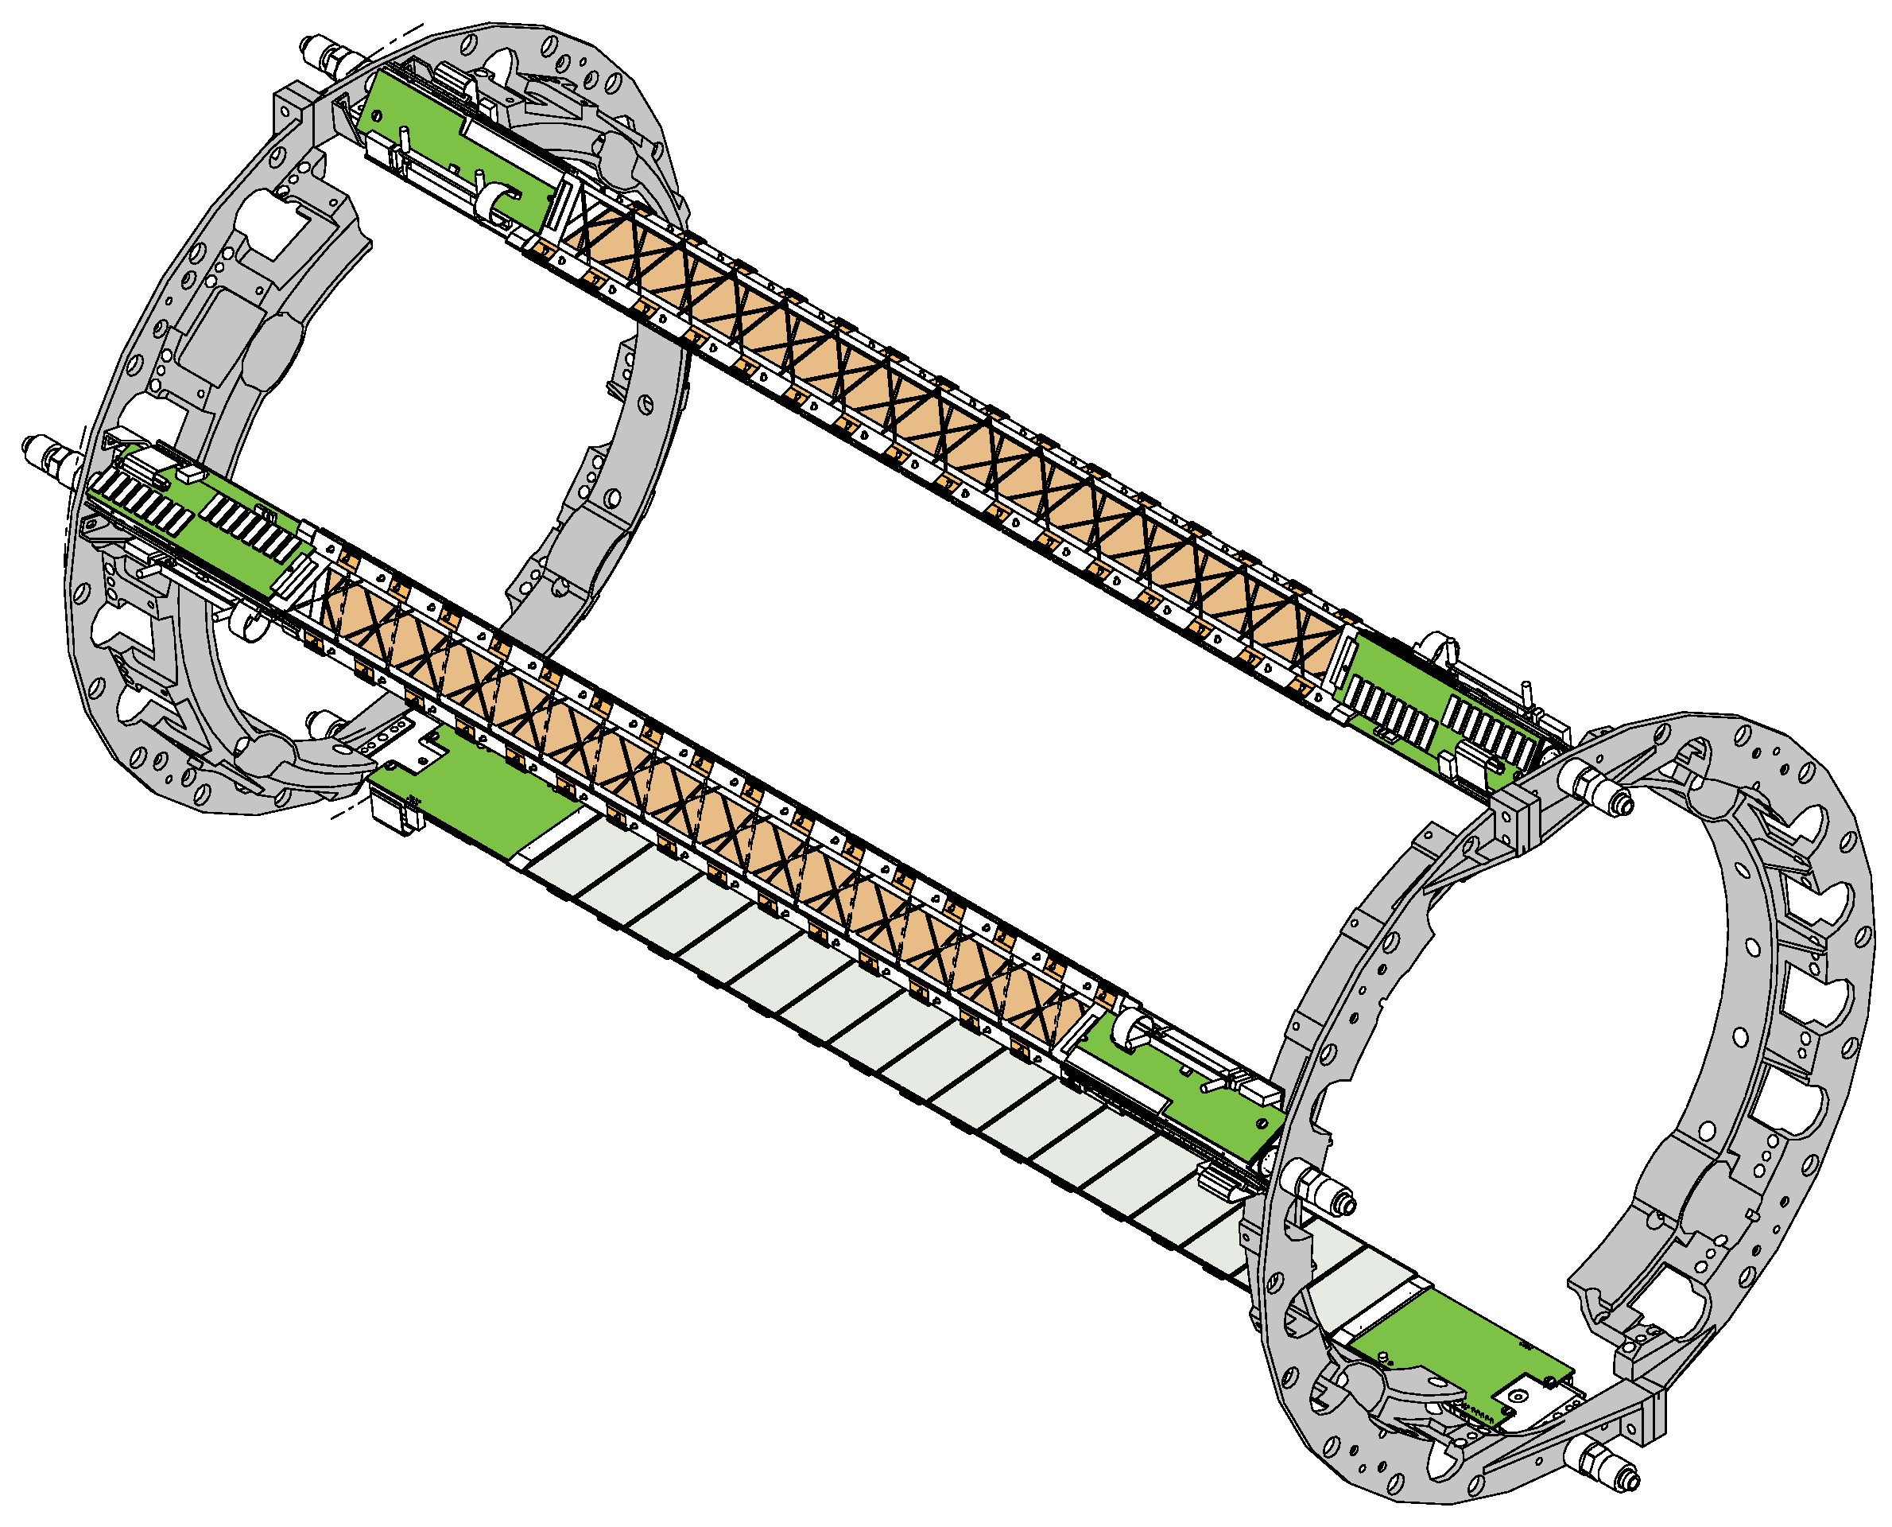
Figure 1 : The SSD clamshells (equipped with only 3 ladders)

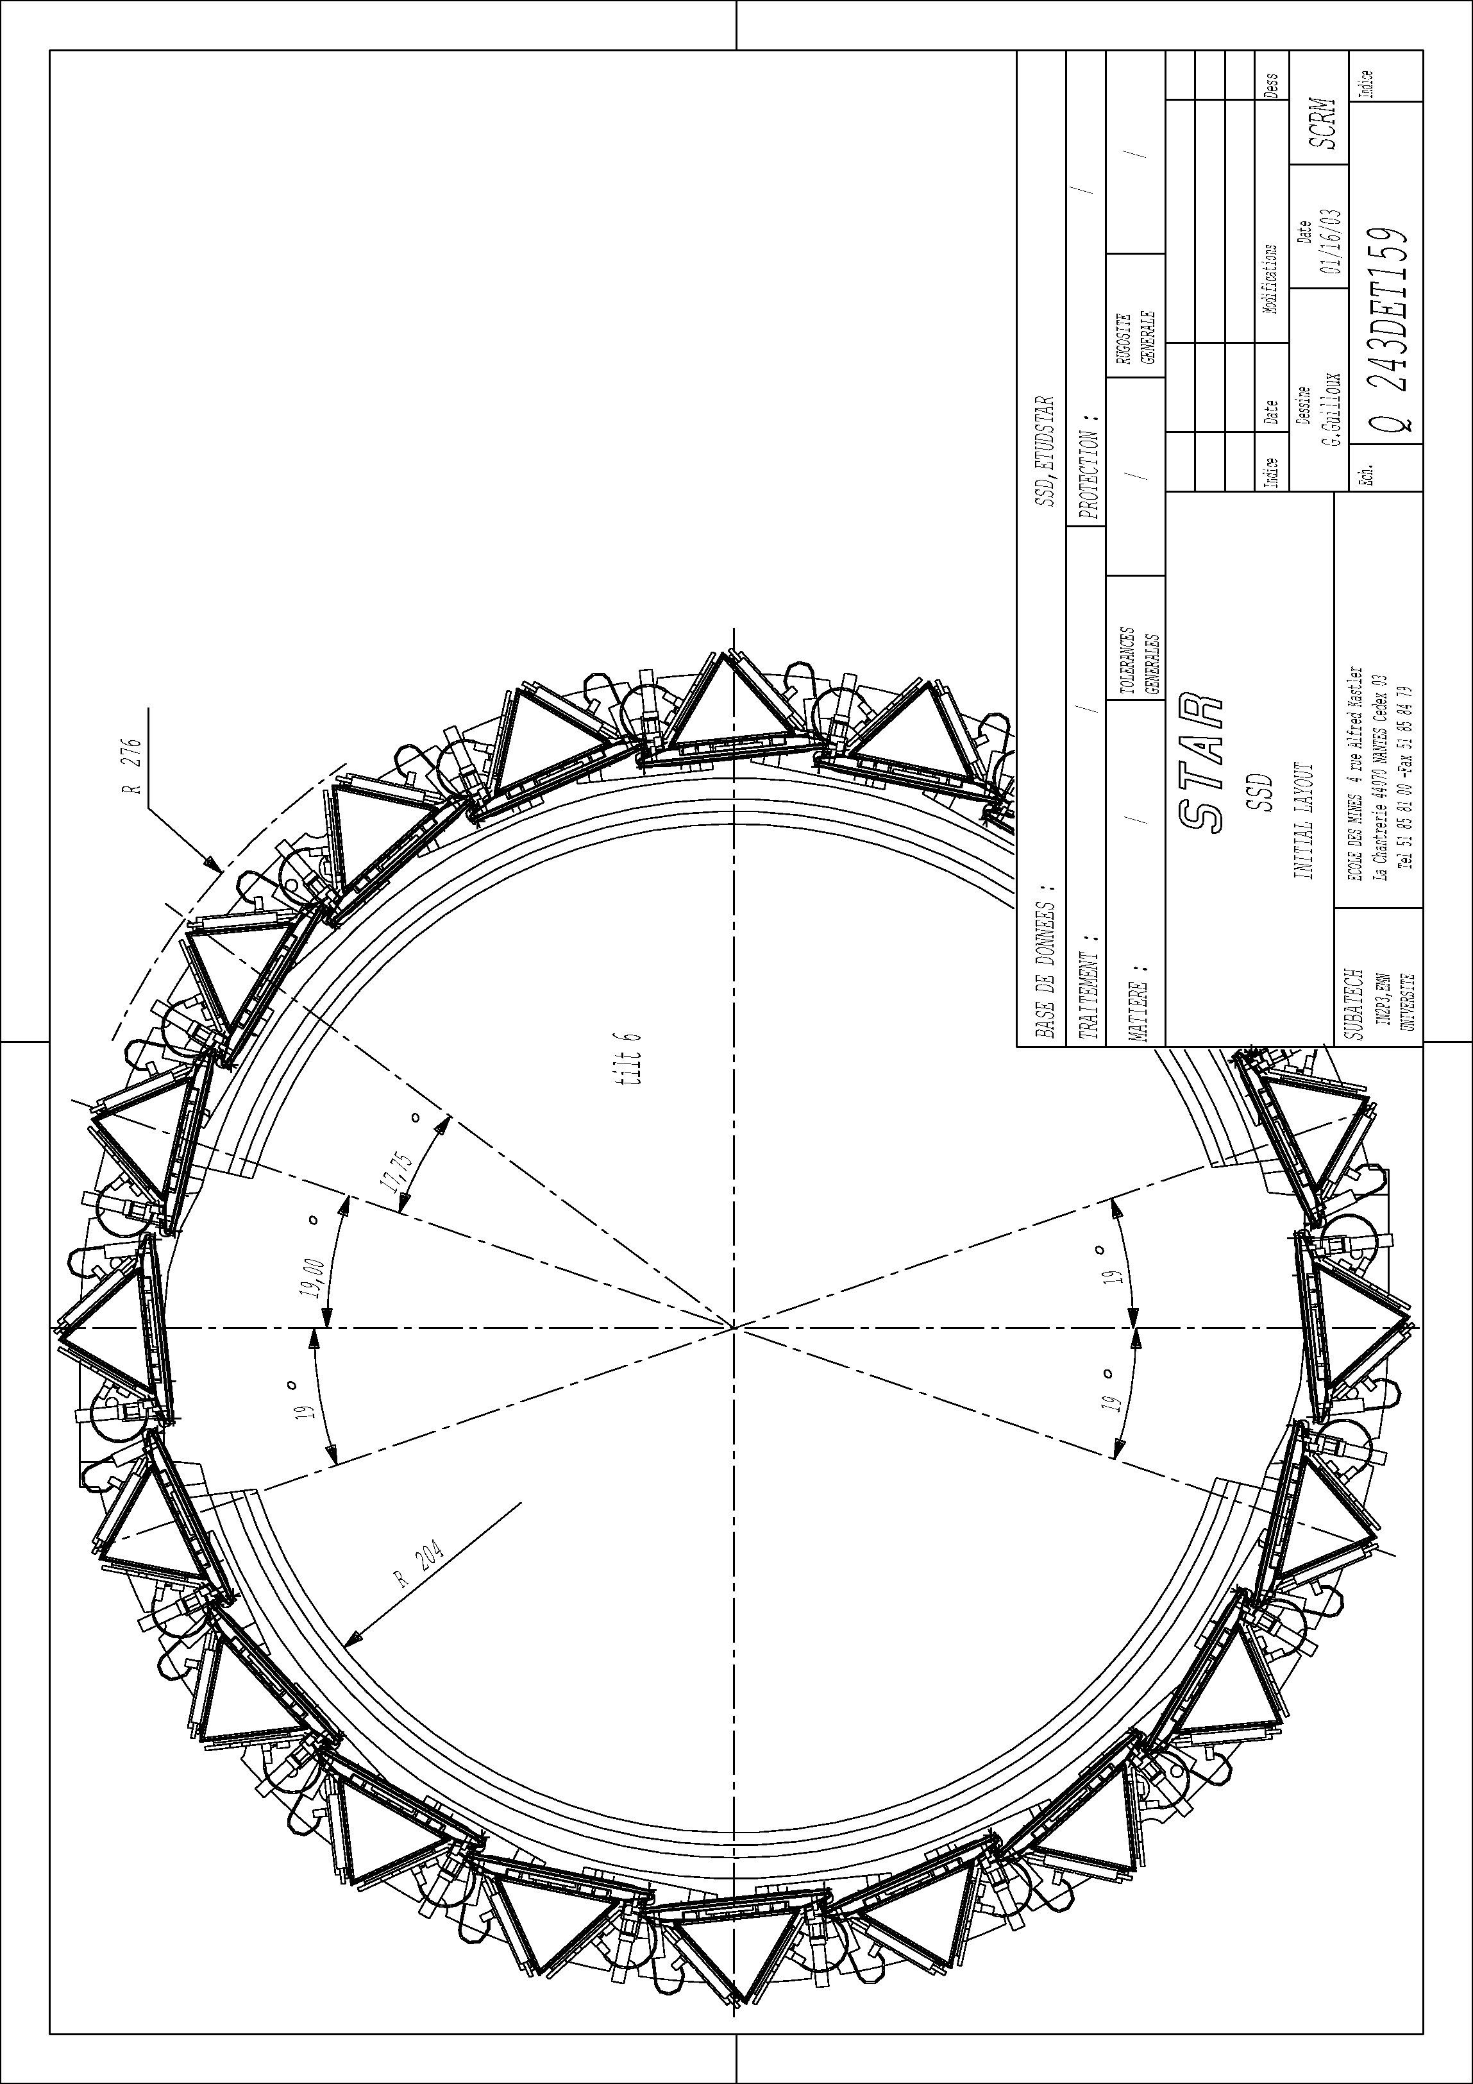
Figure 2 : Drawing of the SSD in the x-y plane featuring the two clamshells equipped with 20 ladders
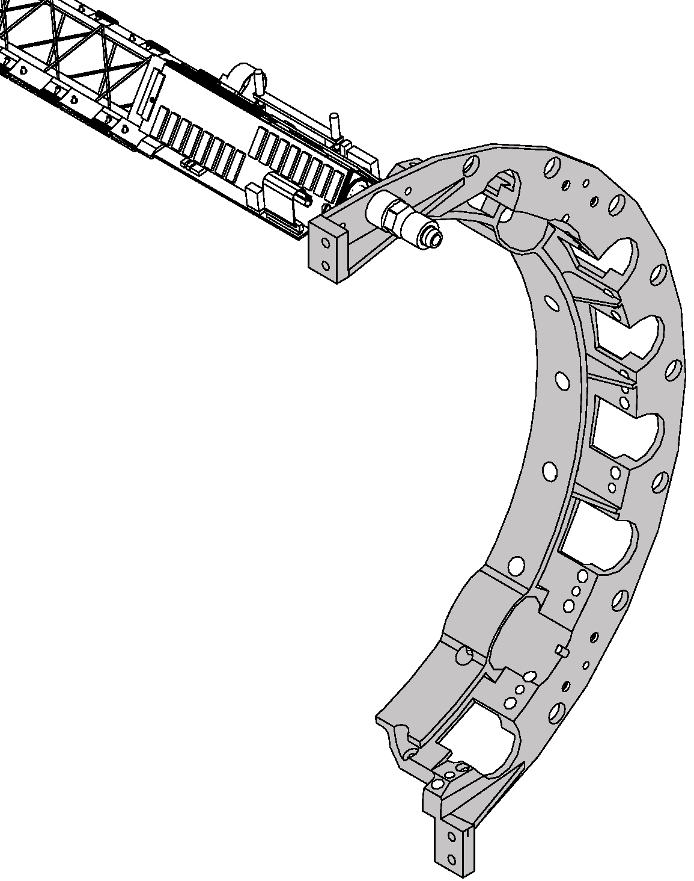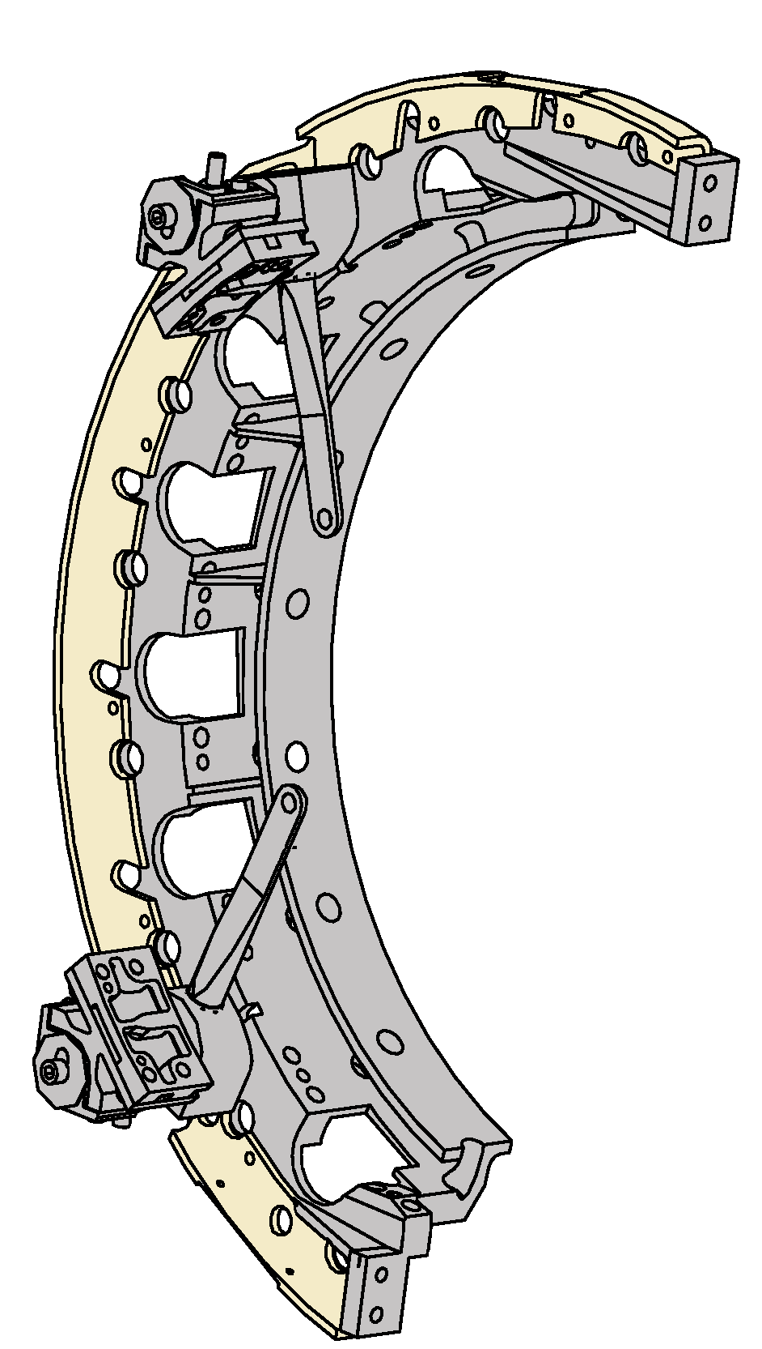
Figure 3 : Schematic views of a "C" shape piece of the clamshell structure : equipped with a ladder (left) and equipped with the additional ring (in yellow) supporting the SSD shield and the survey marks (right)
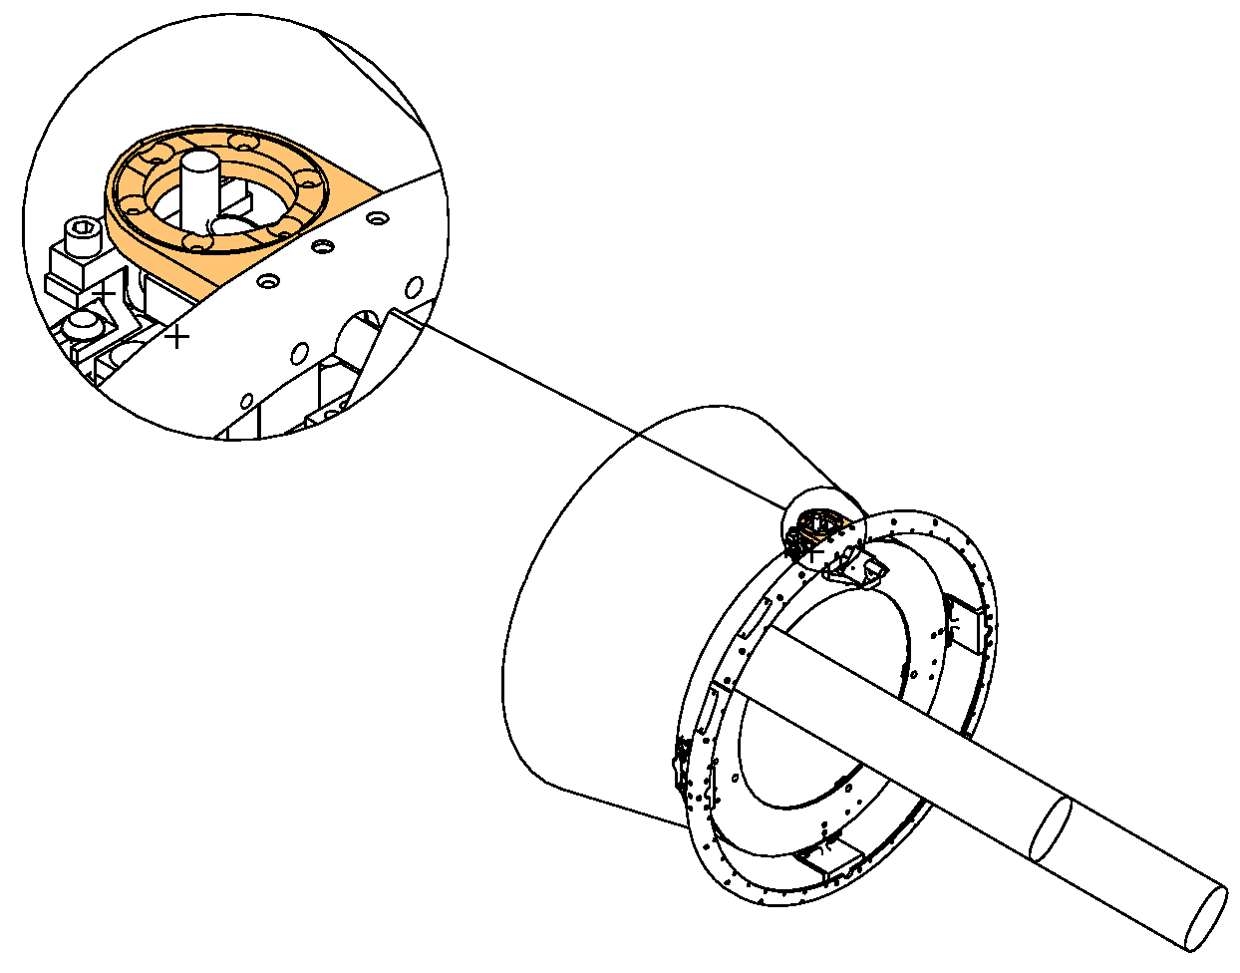
Figure 4 : Schematic view of the pieces (without the metallic grid) develop to make holes in the shield and to allow the IFC air to be use as input for the ladder air cooling
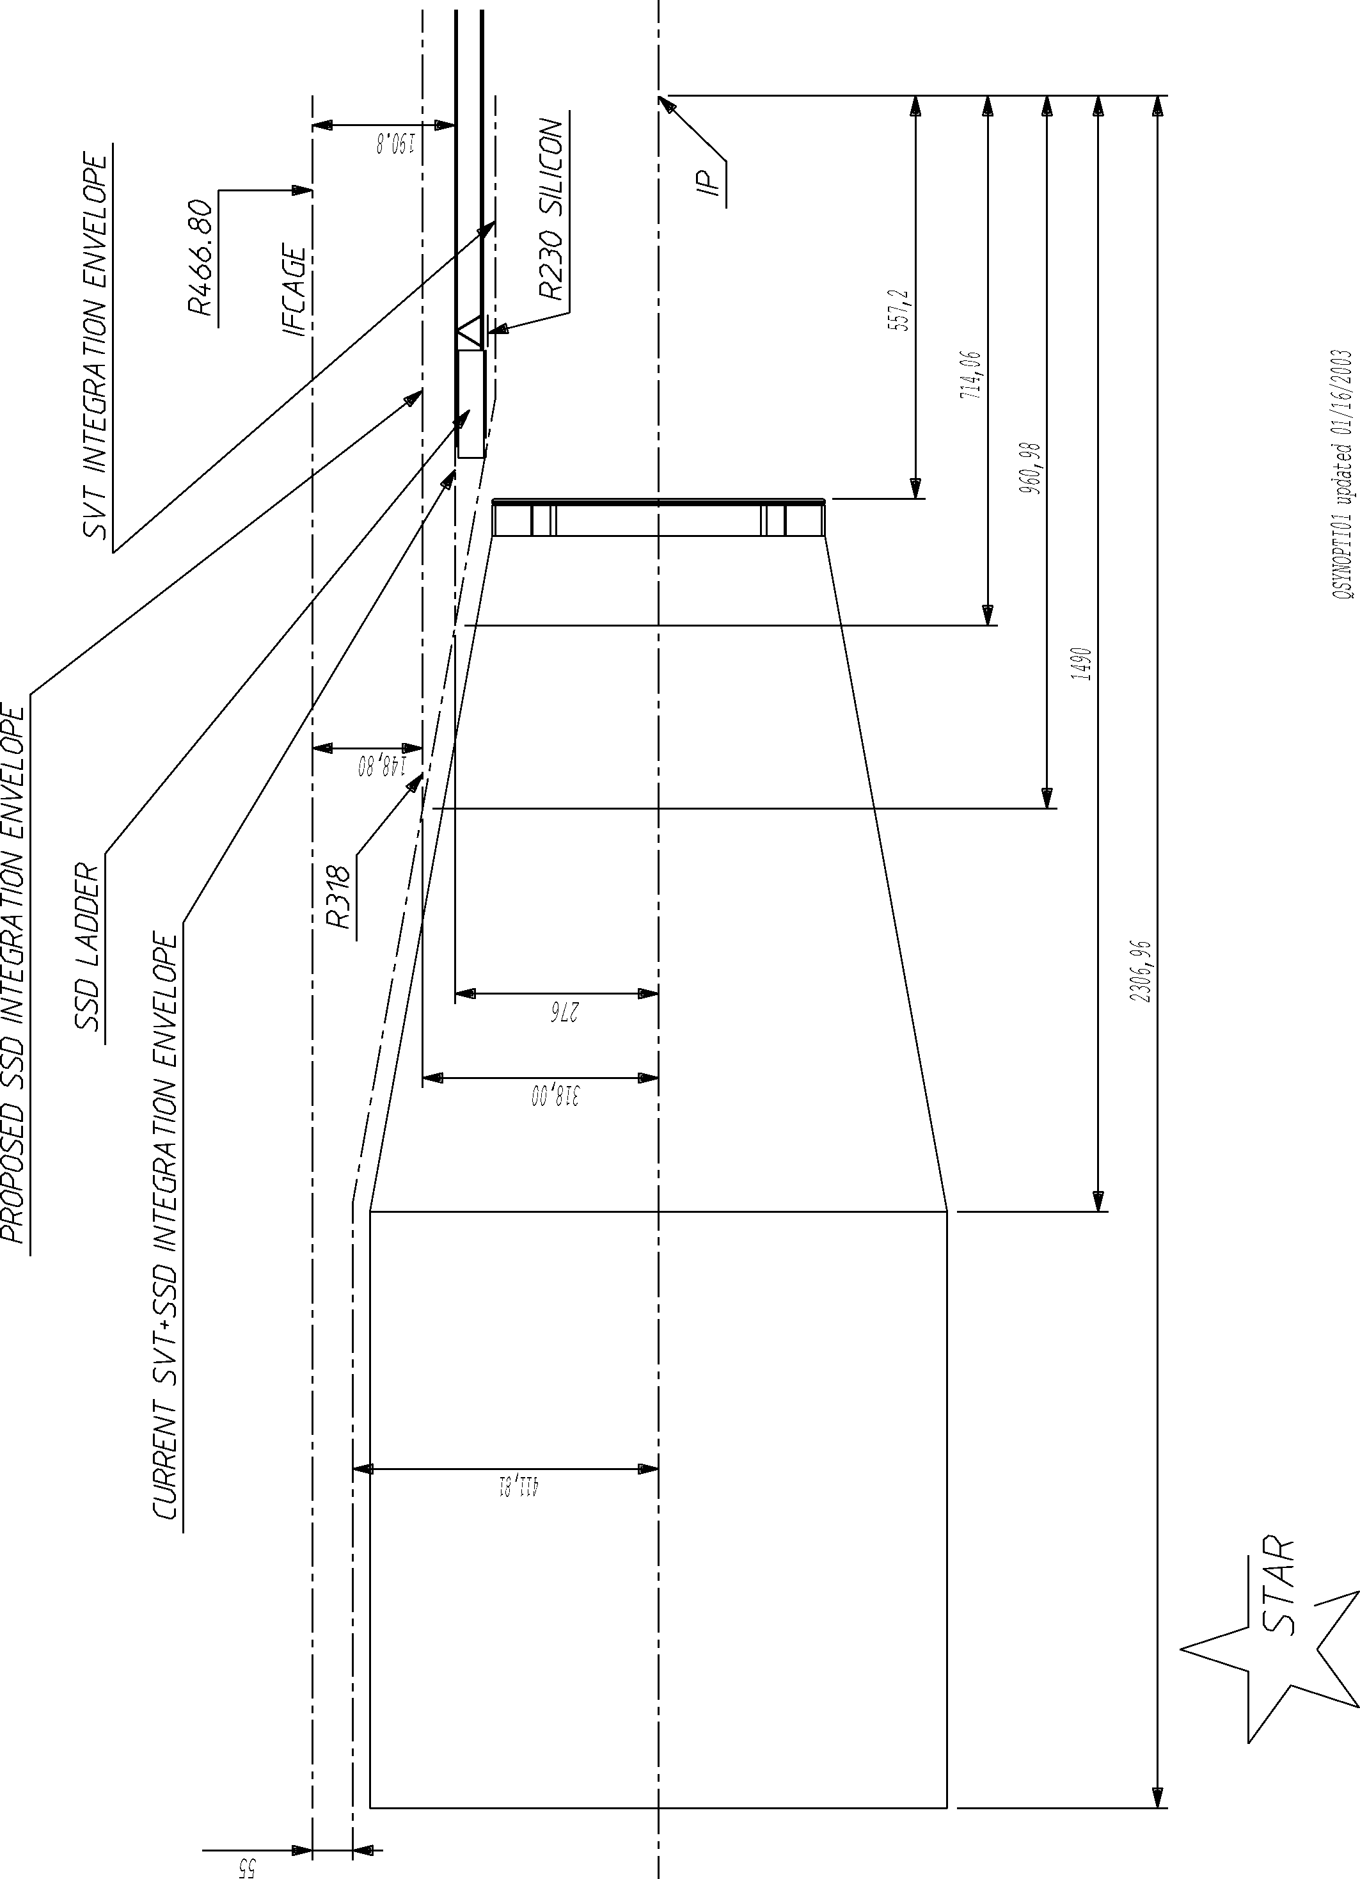
Figure 5 : SVT and SSD integration envelopes in between the cones and along the cones
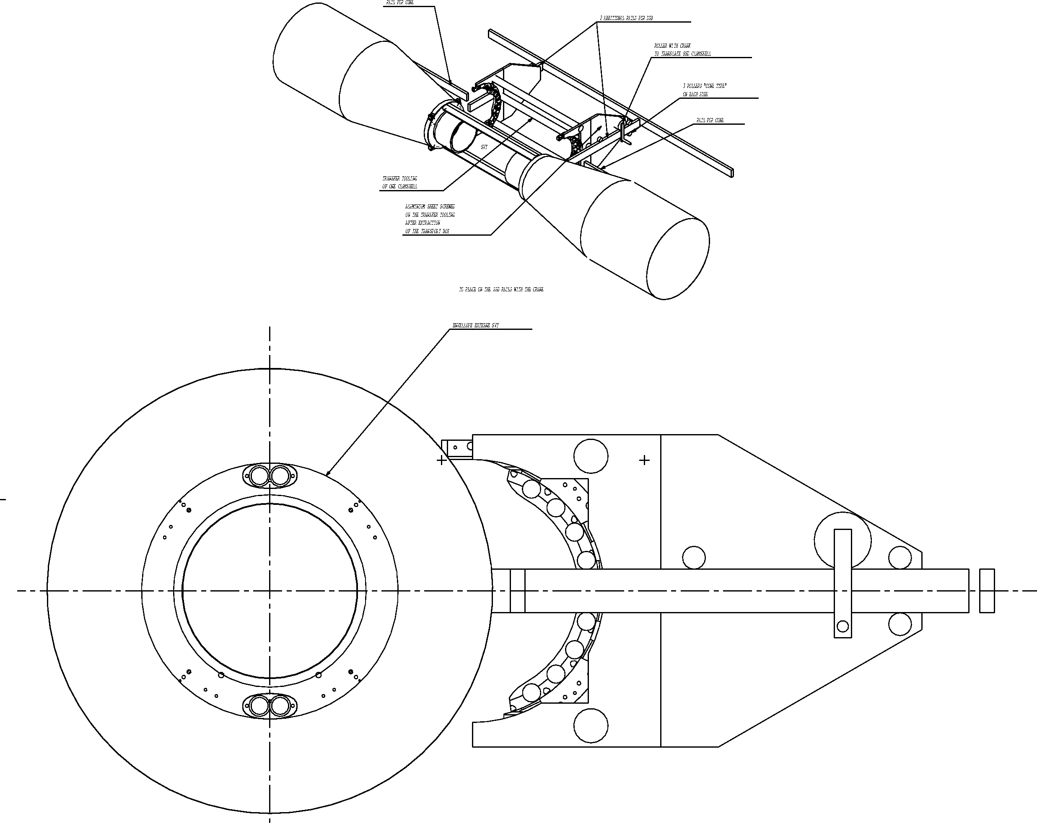
Figure 6 : Schematic views of the tooling developed to install the SSD half clamshell on the cone
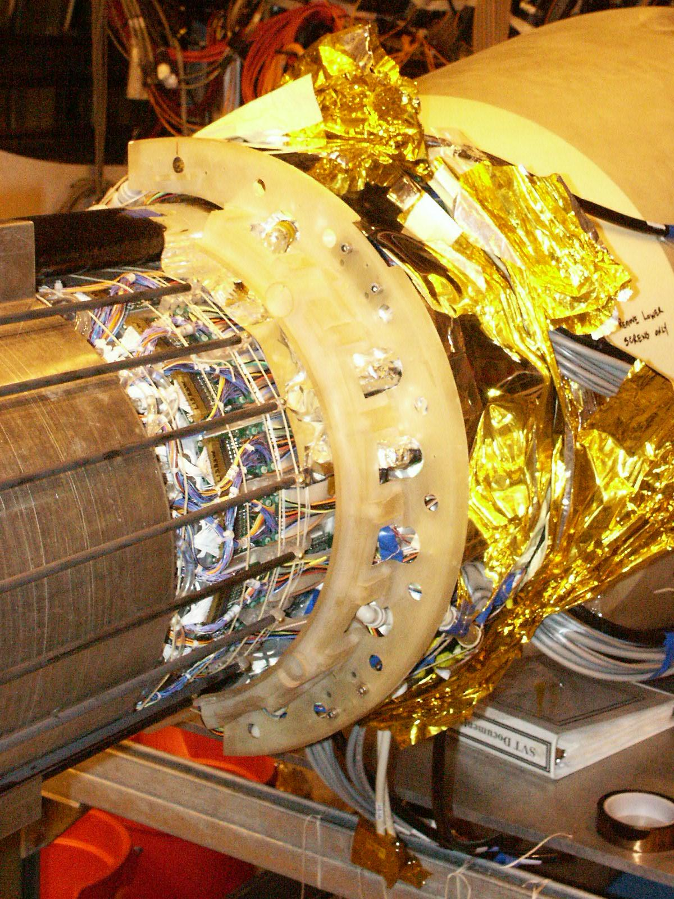
Figure 7 : The dummy SSD clamshell installed on the cone
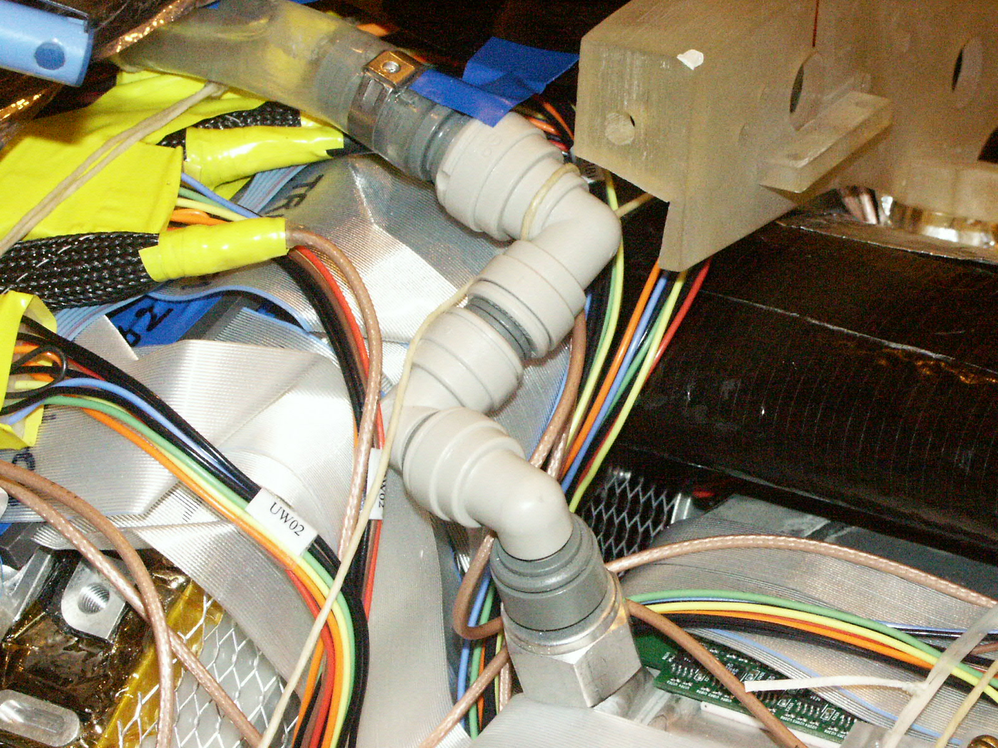
Figure 8 : Closer view of the dummy clamshell (top right) and of a SVT water fitting (center)

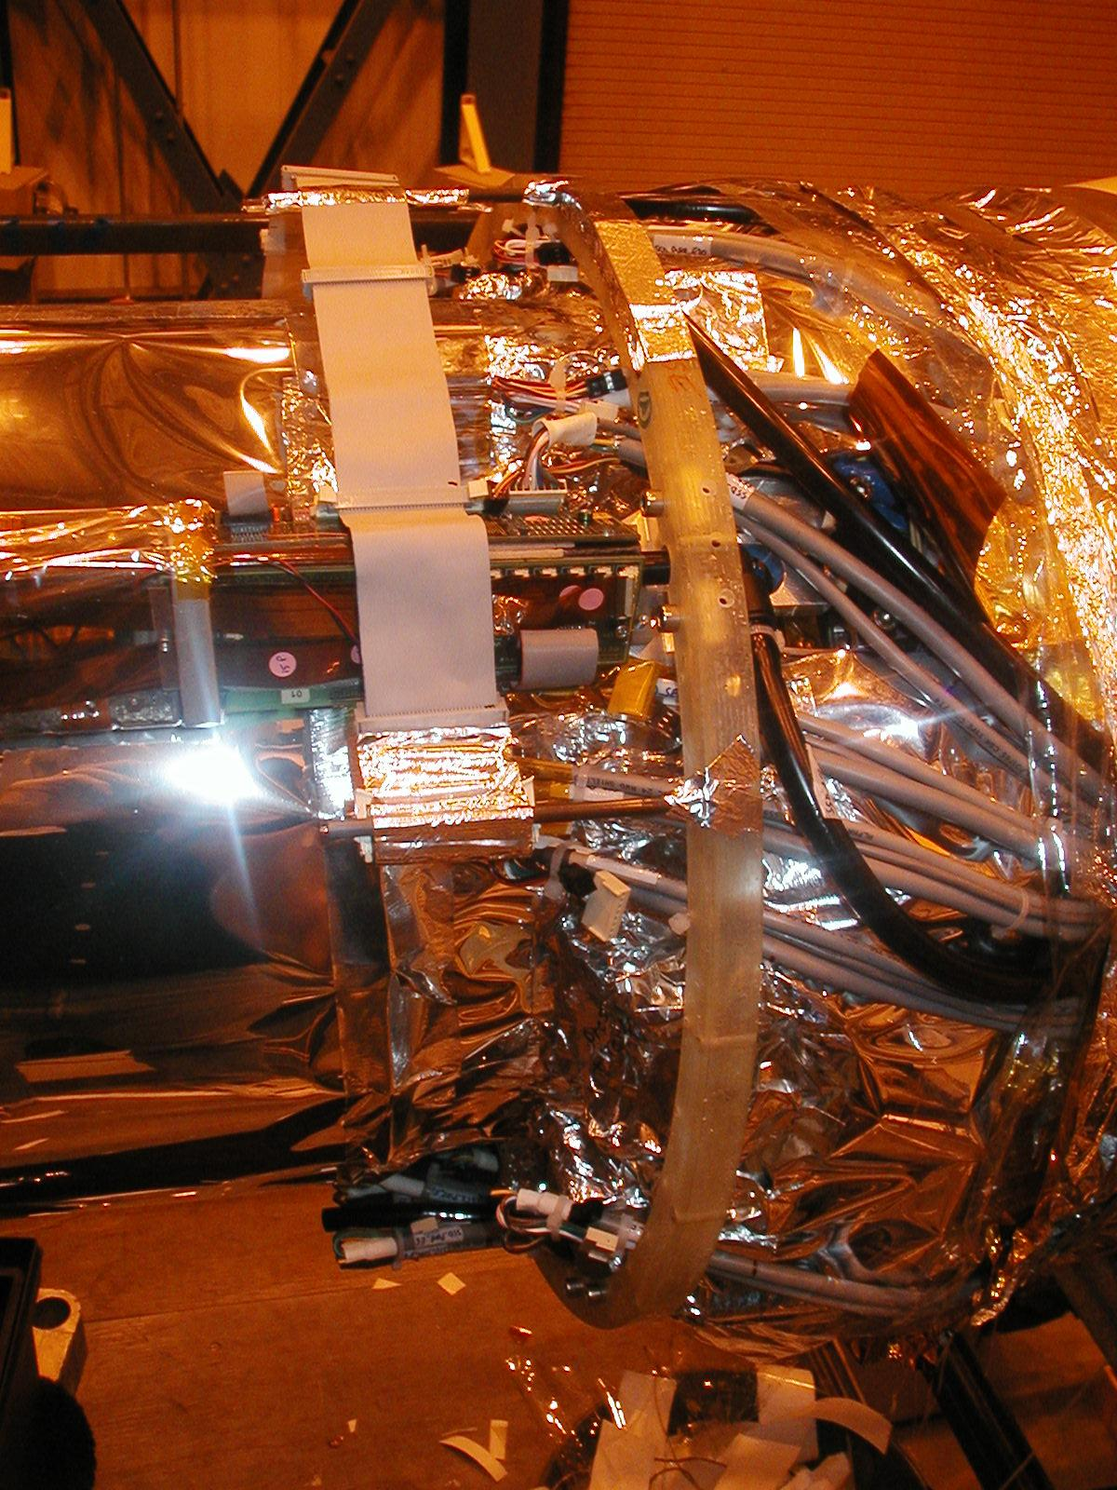
Figure 9 : Routing of the SSD cables on the cone after the SVT shield and SSD ladder installation (left). The glass fiber ring (center) is a temporary support used to attached the external shield. The SVT shield is completed and only the SSD cables are visible (right).

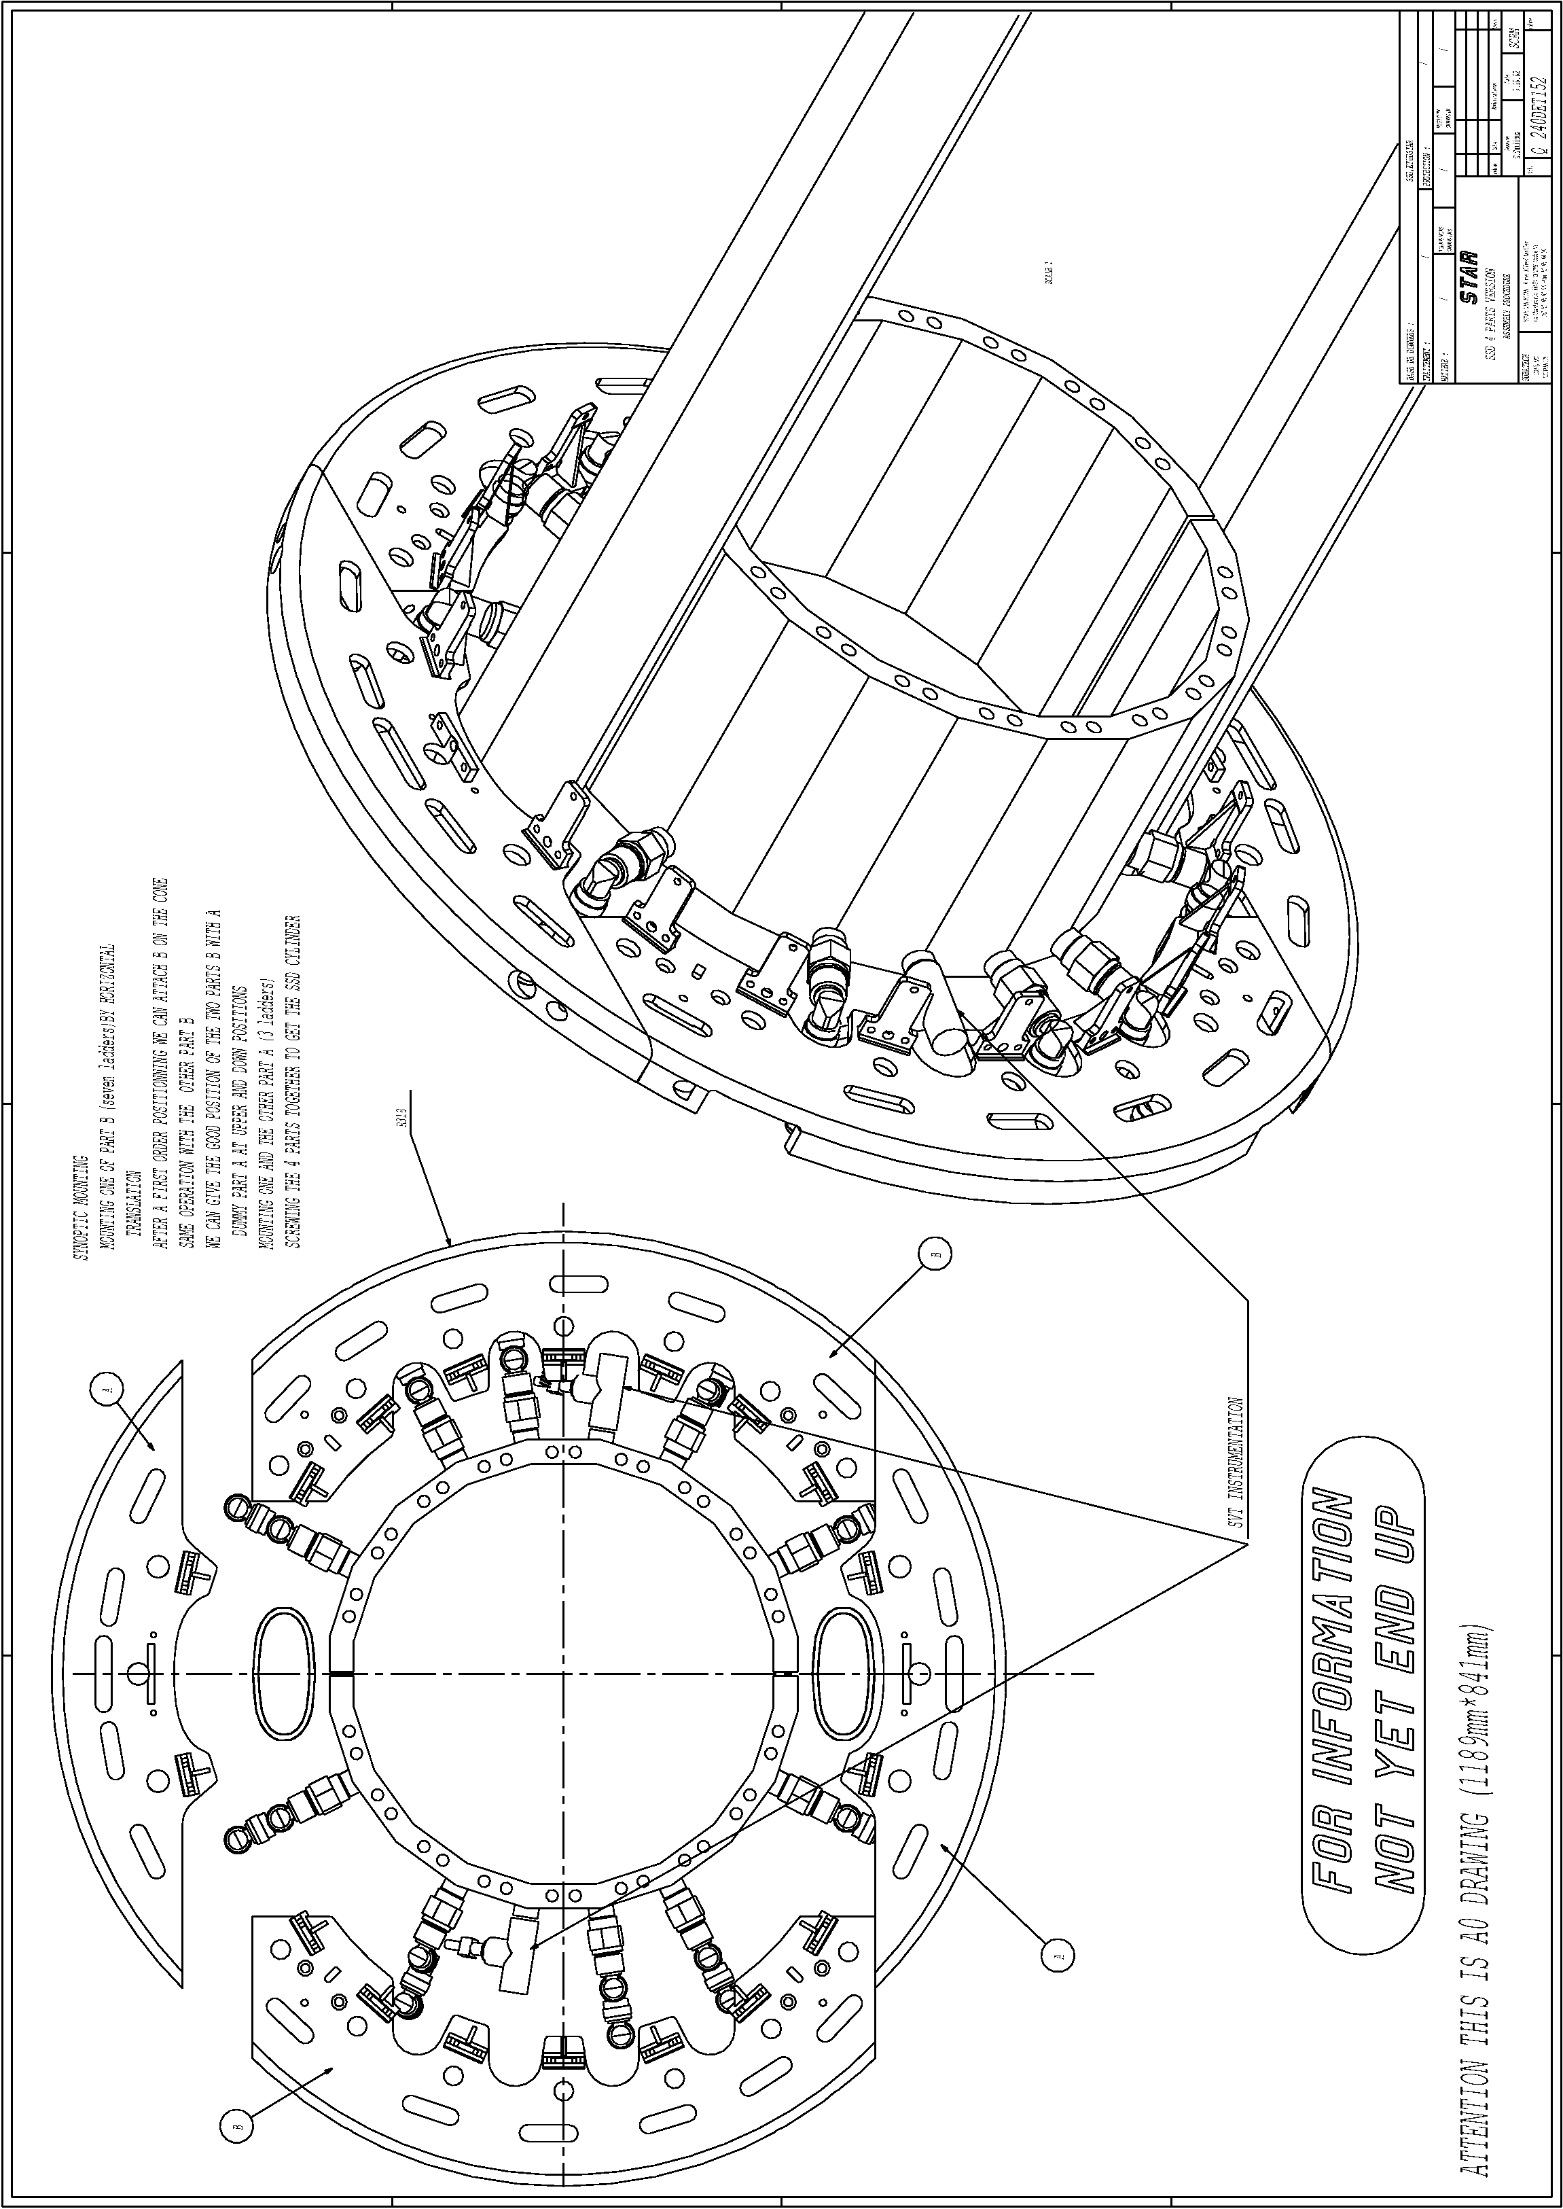
Figure 10 : the new SSD mechanical structure featuring four parts

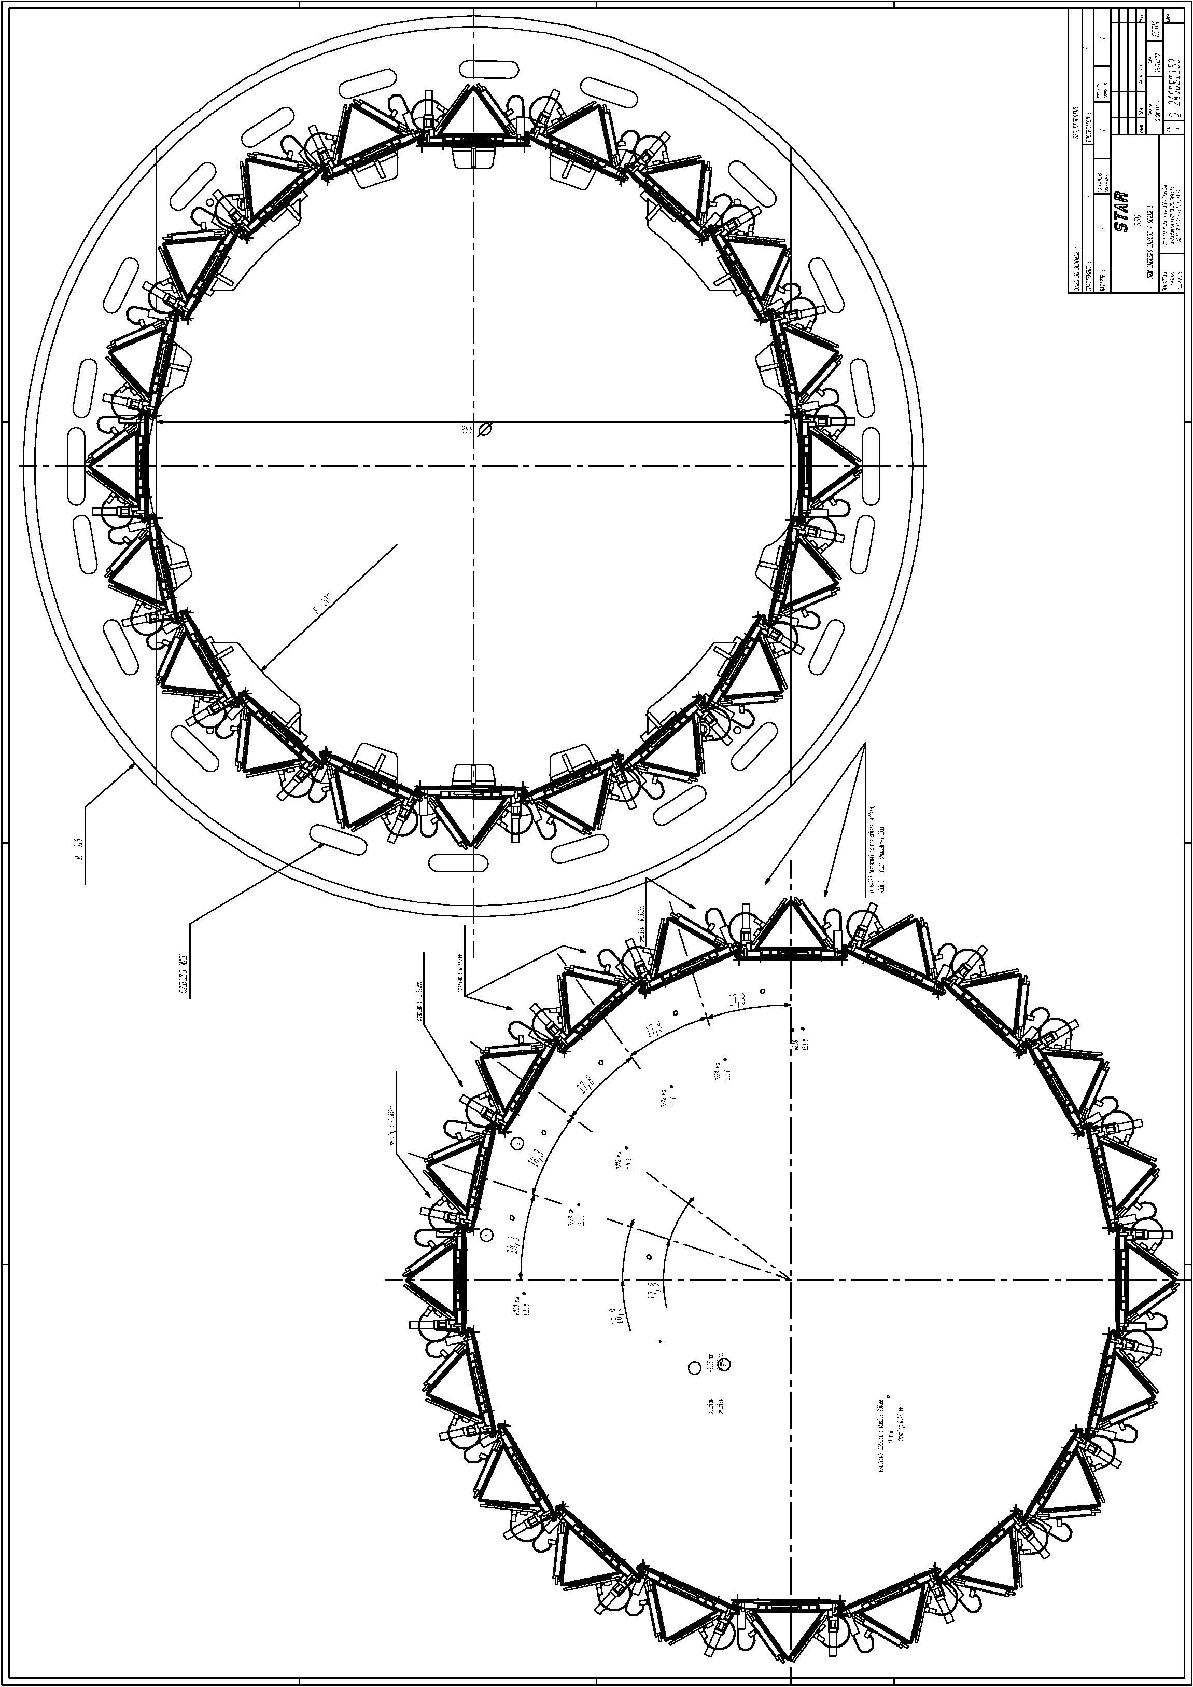
Figure 11 : The new design of the SSD ladders on the new clamshell (top) and with the position and orientation (bottom)
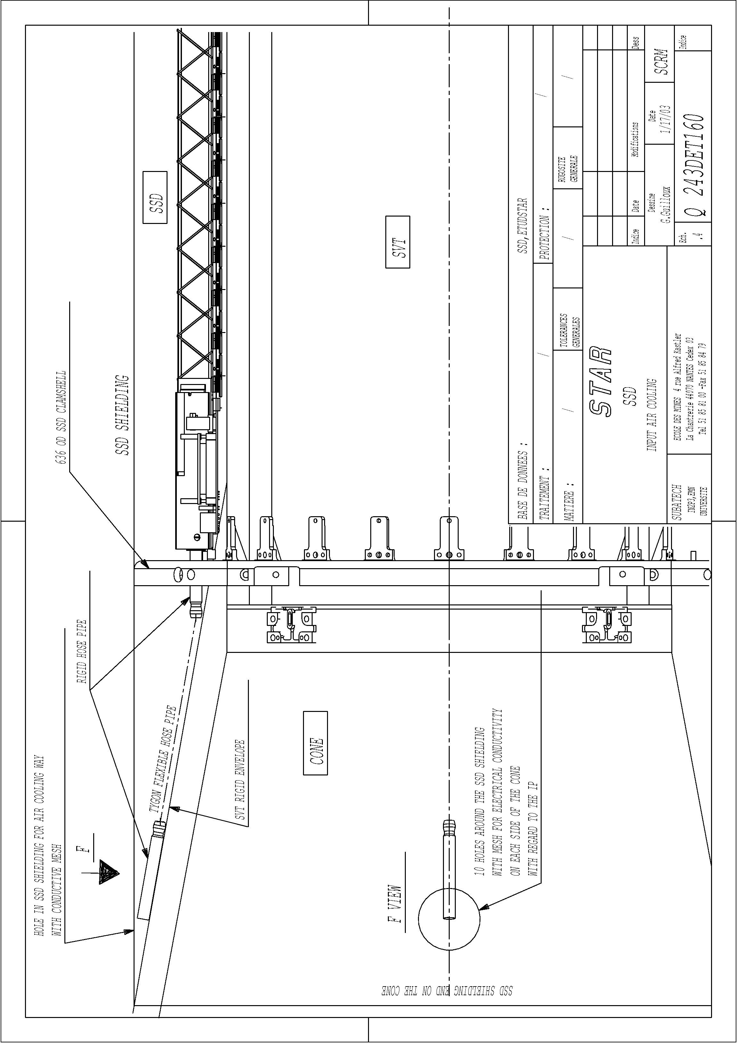
Figure 12 : Location of the SSD cooling hoses on the cone used to take input air from the IFC

