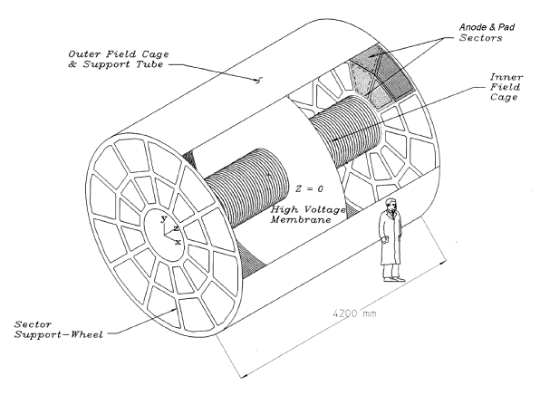
Written By: Blair Stringfellow

Updates by Jim Thomas 07/14/2009
Alexei and Prashanth 04/15/2019
David Tlusty 12/21/2021
Latest Update: 04/01/2022

There are many changes to the old manual. So please refer only to this manual and discard the old manuals. If you have any questions or concerns contact experts immediately.
TPC & Laser: Short Operations Manual For Detector Operators

Table of Contents
1. Rules of Operation 3
1.1. FEE’s (Front End Electronics) 3
1.2. HV 3
1.3. Frequency and method for Pedestal Runs 3
1.4. Frequency and method for Laser Runs 4
2. Operations of TPC Subsystems 5
2.1. Boot & setup of Control Computer 5
2.2. VME Crates & Processors 6
2.3. Interlocks 9
2.4. RDOs and its FEEs 10
2.5. Gated Grid 14
2.5.1. Main Operations 14
2.5.2. Start the Gating Grid IOC or the GUI (if they aren’t already running) 14
2.5.3. Sector Mapping and Control of Individual Channels 15
2.5.1. Special Operations (for Experts Only!!) 16
2.6. Cathode HV & Field Cage Currents 17
2.7. Grid Leak Wall (GLW) 22
2.8. ANODES 23
2.8.1. Calibrating the Anode Currents 24
2.8.2. RESETTING TRIPS 24
2.8.3. TPC Anode CAEN: Power Supply Monitoring & Wake Up Procedure 25
3. TPC LASERS 26
4. ALARMS 30
4.1. TPC GAS ALARMS 30
4.2. TPC WATER ALARMS 30
4.3. TPC ALARM HANDLER 31
5. TPC State Table for Various Conditions 32

Rules of Operation

FEE’s (Front End Electronics)
The TPC FEE’s are cooled by the TPC water skid (nominal temperature = 75⁰ F). The temperature is monitored by a computer program which periodically reads out 120 thermistors mounted on the FEE and RDO cooling manifolds. These temperatures are displayed in a GUI available from the top level TPC GUI. These temperatures are also watched by the TPC alarm handler (alarm = 80⁰ F).

If the overall average reads > 80⁰ F, power down the FEE’s until the cooling problem is solved.

The TPC water skid exchanges heat with the STAR Modified Chilled Water (MCW). To maintain the TPC at 75⁰ F, the MCW must typically be < 64⁰ F. A problem with the TPC cooling water temp can usually be traced to a MCW problem. Note also that the FEE’s are interlocked to the TPC water skid – a loss of flow will automatically turn off the FEE’s.

Because of an uncertainty about induced currents associated with the magnet, we also have to:

Turn off FEE’s when the magnet is being ramped up or down.

HV
Ultimate responsibility for the safe operation of the TPC rests with the Detector Operator! For this reason, the final authority for turning on (and off) the HV also rests with the detector operator. To protect the TPC, the most important rule is:

The anode HV is to be kept OFF UNTIL RHIC has stable beams stored and cogged. There are NO exceptions to this rule except by explicit permission from the experts. See the STAR Detector States diagram for the latest information on how and when to set the Anode and Cathode HV.

We have seen both field cage spark downs and multiple anode trips that were clearly beam induced. This can happen at any energy and any intensity. Note that this means turning ON the HV AFTER the beams are stored AND turning OFF the HV BEFORE the beams are dumped. It is detector operator’s responsibility to encourage the shift leader to always give advance notice of a beam dump.

Frequency and method for Pedestal Runs
It is recommended to take a pedestal run at least once per day. See the STAR Detector Readiness Checklist for the most up to date recommendations.
- FEE’s ON
- Gated Grid ON
- Cathode HV ON or OFF
- Anode HV OFF
- Grid Leak Wall (GLW) ON

Frequency and method for Laser Runs
Laser runs are used to check the TPC drift velocity. To turn on the laser, see the Laser Operations section of this manual. The DAQ rate for a normal laser run should be 10 Hz, triggered by the free running laser. You can confirm this at DAQ monitor by checking L0 frequency is at 10 Hz for the laser trigger. The TPC’s operating parameters (HV) are the same for laser runs and physics runs. The TPC drift velocity is automatically calculated online from event pool events. The result shows up in the online histograms (see below), drift velocity is 5.45 cm/μs. Typically, ~4000 laser triggers are sufficient to calculate drift velocity.

https://online.star.bnl.gov/daq/export/daq/

Laser runs can be done in two modes:

1. Local Clock laser run
When there is no beam, lasers can run for testing using the ‘laser_localclock’ configuration, which runs the laser at 10 Hz.

2. Interleave laser run
The laser runs should be taken at the beginning (usually the second run) and end of the store (can be the last run). The Period Coordinator/expert may define a different schedule so check with your shift leader or the Period Coordinator for an update on this schedule. If you want to include the laser in the next run, prepare the laser toward the end of the current run, usually five minutes before end of the current run. For long stores (typical of pp) take a laser run every ~4 hours after the first one.

Operations of TPC Subsystems

Boot & setup of Control Computer
All operations for the TPC are controlled from the PC Chaplin- sc2.starp.bnl.gov located in the STAR control room. To get started, log on to Chaplin (username and password posted in the shift leader’s notebook). Start the TPC top level control GUI by issuing the command “tpc_top” or “tpc_top_fixed” on a terminal. The startup screen looks like this:
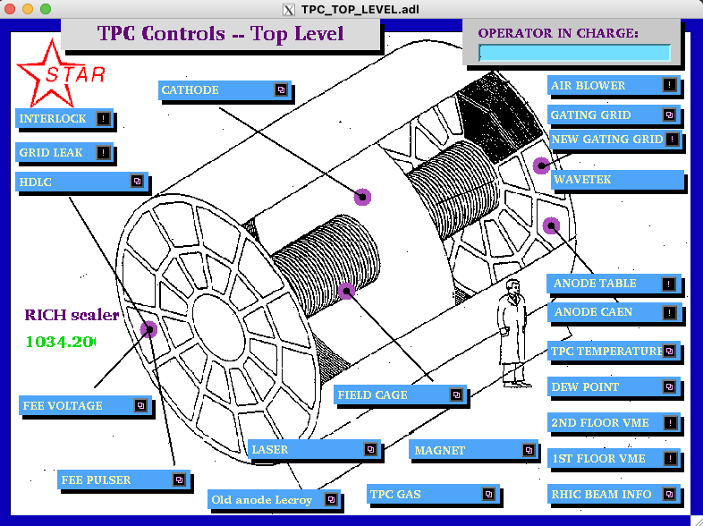To simplify the controls for the various subsystems, Chaplin is set up to run 9 virtual desktops, each labeled for a specific function: (The precise order, shown below, may be different.)

1. Anodes
2. Cathode and field cage
3. Gating grid
4. FEE’s
5. Laser
6. Gas system
7. Interlocks
8.VME status
9. Other: GLW
You can switch between desktops by clicking on the appropriate tab in the tool bar in the bottom corner of the screen. If you are starting from scratch, you will have to move the different GUIs to the appropriate desktops. See the procedure “How to Start TPC Controls.doc” for an explanation on how to do this. The document should be saved on Chaplin’s desktop (or alternatively it is stored on the TPC Operations page as a “How To” note.)
http://www.star.bnl.gov/public/tpc/tpc.html

VME Crates & Processors
All TPC functions are controlled using VME CPU’s which are located in VME crates on the 2nd floor of the south platform. These crates can be remotely turned on/off using slow controls. To check the status of the crates, click on the “VME Status” desktop tab and select “2nd floor VME”. This will bring up the VME control GUI:
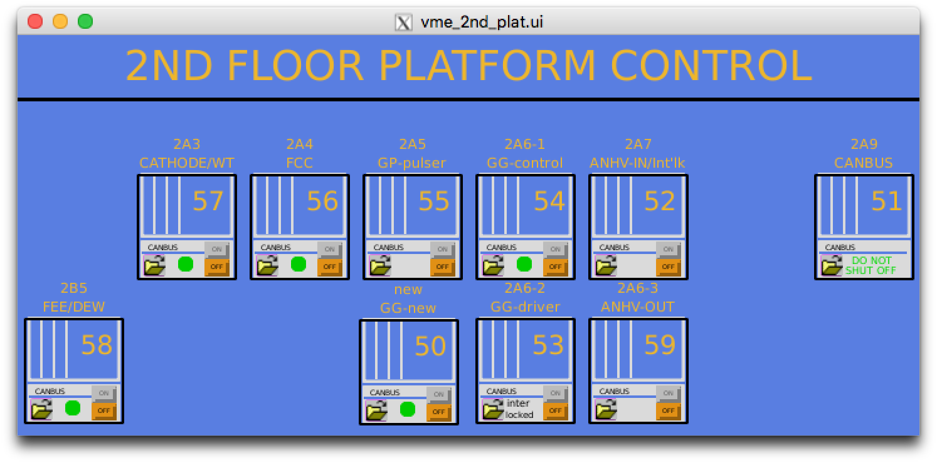

Note that the crates are labeled by function, Canbus number and rack number. Crate 51 is for slow controls and should not be powered off. The green dot indicates that the crate is powered on (thus, #55 is off). To turn a crate on (or off), click and hold on the purple button, drag down and release. This brings up the control GUI for that crate as shown below:
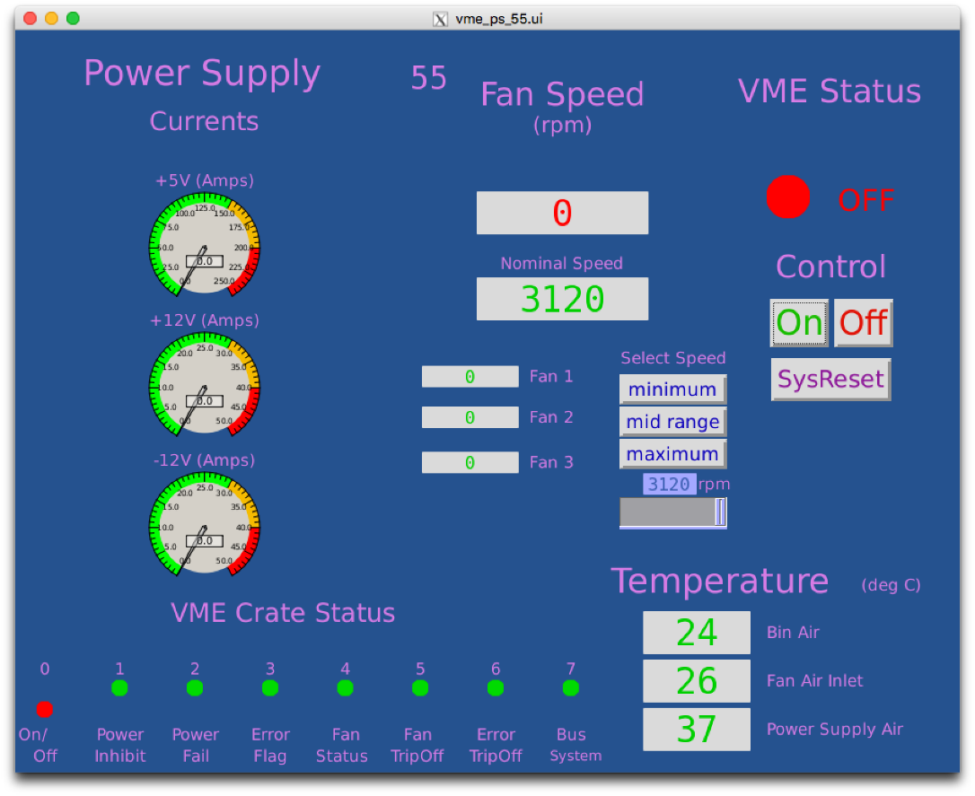

To turn the crate on, click the “ON” button. The fan speed, voltages, currents, and temperatures will be indicated. Make sure the fan speed is equal to nominal speed (3120 in the above figure). Kill the window when it is done. Before proceeding, make sure all crates for the TPC are ON.

VME PROCESSORS:

Typically, there is one VME processor for each TPC control task, and one CPU per crate (Some crates may have two processors). These processors run VxWorks and boot from the main slow controls computer (sc3.starp.bnl.gov). There are two connections for each CPU, one via ethernet and one through a terminal server. Remote login over ethernet is reserved for the slow controls expert. If problems develop with a CPU it can be rebooted by three different methods:

1. Push the sysreset button on the crate’s control GUI – this reboots all processors in that crate.
OR
2. Cycle the power on the crate. (Not recommended, but sometimes necessary.)
OR
3. Login via the terminal server as follows:
On any machine on starp network (for example sc2.starp.bnl.gov), open a terminal and type telnet scserv xxxx and enter ↵, where xxxx is the port number for the processor(see below). After you are attached to the processor, hit enter↵. You should see a shell prompt for the IOC. To reboot, press ctrl + x. This may take sevaral miniutes, and you should see reboot messages. After the reboot, exit the session by typing “CTRL + ]” simultaneously to get back to the telnet prompt. Type quit and return to get back from telnet. Type exit to logoff. If the reboot is not sucesssfull or any other issues come up, call the slow controls expert.

ALWAYS release the terminal server sessions when you are done!

When a VME processor reboots, a grey MEDM Message Window will pop up with the message “network connection lost”. Also, the relevant GUI will turn white until the processor finishes rebooting.

The current VME CPU’s and port assignments are as follows:

 | Subsystem | Port | Crate | Rack
1 | Field Cage Readout | 9001 | 56 | 2A4
2 | Cathode HV | 9005 | 57 | 2A3
3 | Anode HV (CAEN) | separately runs on softioc4 (No VME)
4 | Autoramp – Cathode & Anode | softioc on barbados2 in DAQ room
5 | Ground Plane Pulser | no VME/ no telnet | 55 | 2A5
6 | Gated Grid | 4096 | 50
7 | FEE Power supplies | 9004 | 58 | 2B5
9 | Interlock/TPC temperature | 9012 | 52 | 2A7
10 | Old – Gating Grid | 9002 | 54 | 2A6
11 | Old - Anode | 9006 | 52 | 2A7

Interlocks
The interlock status for the TPC can be checked from the control room by selecting the “Interlock” button on the top level GUI. (This is a representation of the Allen-Bradley (AB) panel which is located in Rack 4 of the gas mixing room.) The panel looks like this:
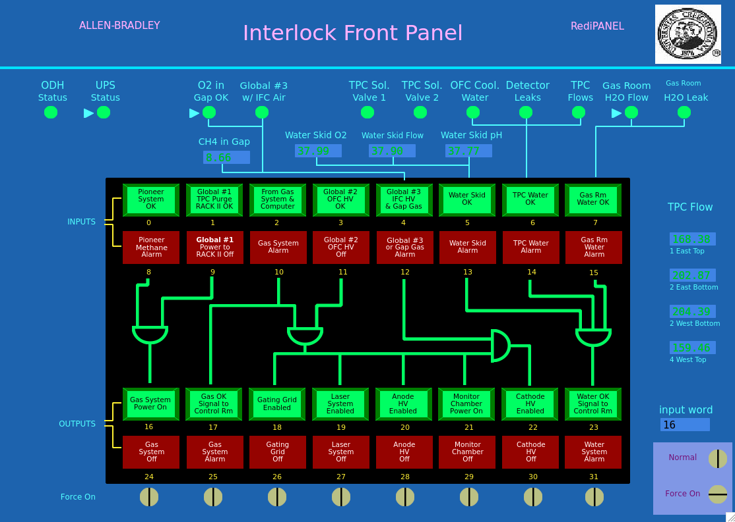
The round lights across the top and the top row of rectangular lights are status lights for the inputs to the interlock panel. The bottom two rows of rectangular lights show the status of the outputs to the various subsystems of the TPC. Under normal circumstances, ALL lights should be green. In the above example, the gas system is on, and so all systems can run.

Note that if, during a run, one or more of the inputs changes from OK to “not OK”, the AB PLC will take automatic action to shut down the affected subsystem or HV.

If one or more of the inputs changes from OK to “not-OK”, then the outputs will latch off and most TPC system cannot be operated without intervention from an expert or a trained detector operator. See the document “How to recover after a gas alarm.doc”. This document explains how to recover from a simple gas alarm condition. More complex gas alarm conditions require intervention by an expert. The procedure for recovery should be saved on CHAPLIN’s desktop and is available on the TPC operations web page http://www.star.bnl.gov/public/tpc/tpc.html.

RDOs and its FEEs

To operate the TPC RDOs and its FEEs, go to desktop 4 and select “FEE Voltage” on the top level GUI. The FEE control GUI looks like this:
RDOs of a single super-sector
iTPC (inner) RDOs
TPX (outer) RDOs

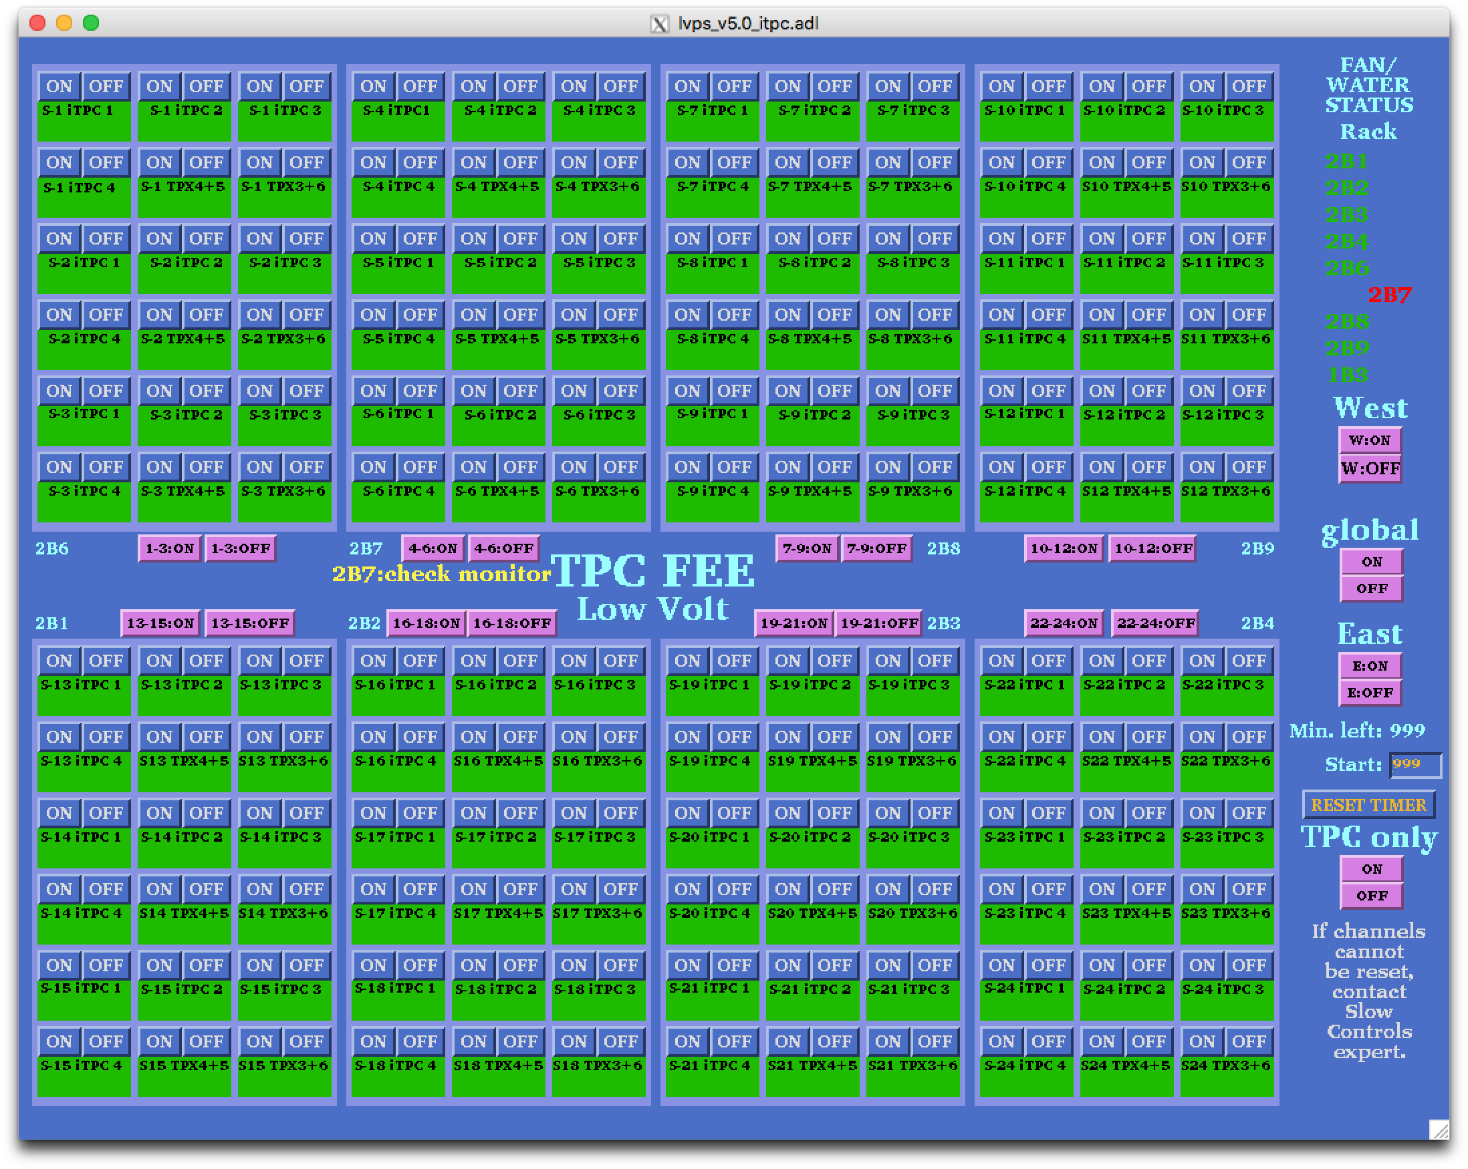

Each super-sector (inner + outer sector) has eight RDOs and each RDO has its own FEEs. Inner sector RDOs are numbered from iTPC 1 to iTPC 4 and outer sector RDOs are numbered from TPX 3 to TPX 6. In the figure, above, the red dashed-lined box shows all the RDOs for the first super-sector. For the inner sectors (iTPC), each RDO has its own power supply, which means one button for each RDO. The White dashed-line box shows the iTPC RDOs. One can turn on/off each iTPC RDO independently. But for the outer sectors, TWO RDOs are powered by a single power supply. RDOs 4 and 5 are coupled together and RDOs 3 and 6 are coupled together. Black dashed-line box shows TPX RDOs. So turning on/off of single power supply will indeed turn on/off two RDOs.

To turn on all the RDOs and its FEEs click on the “global” ON button. Each of the RDOs will turn green in turn. There are also power buttons for each RDO as well as for each rack.

Power cycling an RDO
For example: if you see error message “ITPC: sector 17, RDO 1 failed: Powercycle this RDO manually with Slow Controls & restart run.” in the DAQ monitor, detector operators should power cycle the corresponding RDO manually (in the above example it would be iTPC sector 17 RDO 1).

To do this:
- First stop the run, retry to start the run. If it complains again go to next step.
- Identify the problematic RDO from the error message. Pay particular attention to iTPC vs TPX.
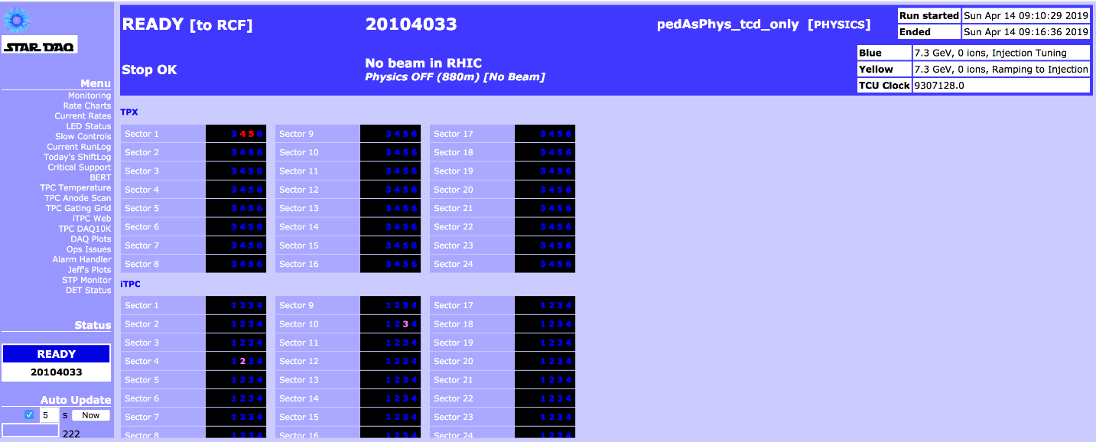
- Turn off the corresponding RDO from the FEE control GUI (shown above). Wait 30 seconds, turn it back on. You can check the status change in the “LED Status” tab in the DAQ monitor. For example, the figure below shows LED Status when Sector-1 TPX (outer), RDOs 4 and 5 are turned off.

- Now start a new run again. If it fails, stop the run and start a new run.
- If it fails again redo steps 3 and 4 again.
- If the above steps fails, continue to mask off the corresponding RDO as described below.

Masking/Unmasking RDOs
RDOs can be removed from data taking by masking it off, or put back in for data taking, if the issue with particular RDO has been fixed.
- Identify the problematic RDO, pay particular attention to iTPC vs TPX.
- In the main run control GUI (in the run control PC) click “Edit Configuration”. This will bring “Run Configuration” GUI.
- In the Run Configuration GUI, click “Details” button next to “DAQ_RUN_name”. This will bring DAQ GUI.
- In the DAQ GUI, click TPX or iTPC depends on the problematic RDO.
- For the TPX:
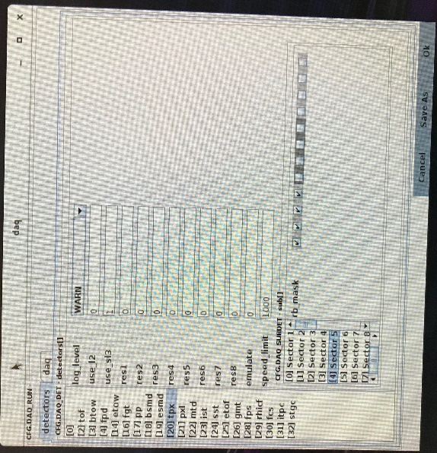
  - Here is an example of the DAQ GUI, which shows TPX sector 5 is selected

  - There are 12 check boxes next to rb_mask. For TPX, check boxes from left to right 3 to 6, corresponds to RDOs 3 to 6. In the above example you can see RDOs 5 and 6 are un-checked, which means those are masked.
  - If you want to mask or unmask a RDO click out or click in corresponding check box. Do not turn off the RDO in the FEE GUI.
- For the iTPC:
  - Here is an example of the DAQ GUI, which shows iTPC sector 4 is selected
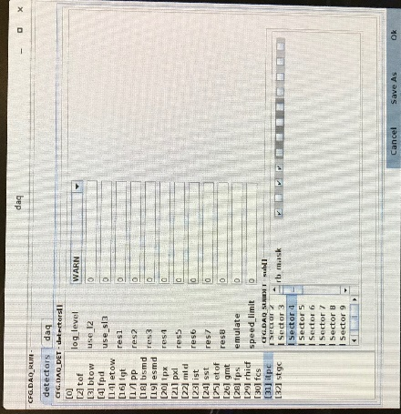

  - There are 12 check boxes next to rb_mask. For iTPC, check boxes from left to right 1 to 4, corresponds to RDOs 1 to 4. In the above example you can see RDO 2 is un-checked, which means that is masked.
  - If you want to mask or unmask a RDO click out or click in corresponding check box. Do not turn off the RDO in the FEE GUI.
- If an iTPC or TPX RDO is masked or un masked, reboot iTPC/TPX in the run control.

iTPC and TPX DAQ PCs
iTPC DAQ PCs |  | TPX DAQ PCs
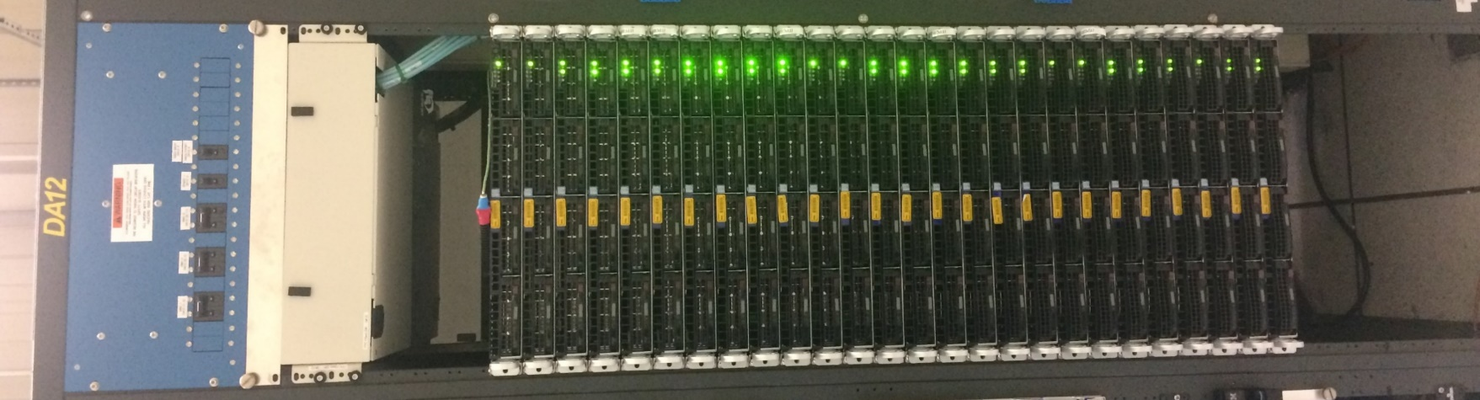 | 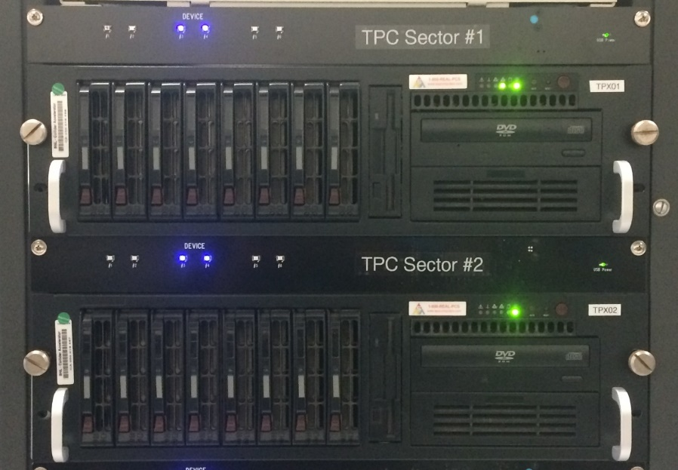  DAQ PCs 1 to 24 are connected to RDOs 3 & 4 of single outer sector. The two blue lights are ON when the DAQ is in standby (Other lights should be off). When running no lights will be on.
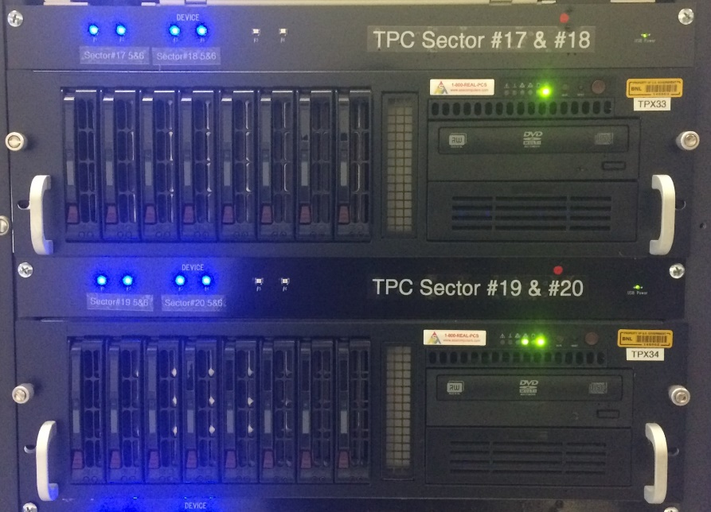
PCs 25 to 36 are connected to RDOs 5 & 6 of two outer sectors. Since there are four RDOs involved you will see four blue lights are ON when the DAQ is in standby (Other lights should be off). When running no lights will be on.

Gated Grid

Main Operations
The Gating Grid will mostly operate in “Normal Mode”. Click on the “Normal Mode” button to go to the normal mode of operation. This means the Gated Grid is closed by default and opening the gate will be triggered by a signal from the TPC TCD. Normally the GG HV is ON and the sectors will be green (as shown below). The HV is controlled by the “HV ON” and “HV OFF” buttons.

There is an “Activity” LED button in the lower left corner of the GUI (see above). If the activity monitor is blinking (3 seconds magenta followed by 7 seconds blue) then the IOC is operating normally. If it stops blinking, then the communication between the IOC and the hardware is broken and the IOC needs to be restarted. Usually, failed communications will trigger a “NOT CONNECTED” alarm (white square) in the alarm handler and the GG sectors will go black, as shown on the next page. If there is a communications failure, the restart the IOC.
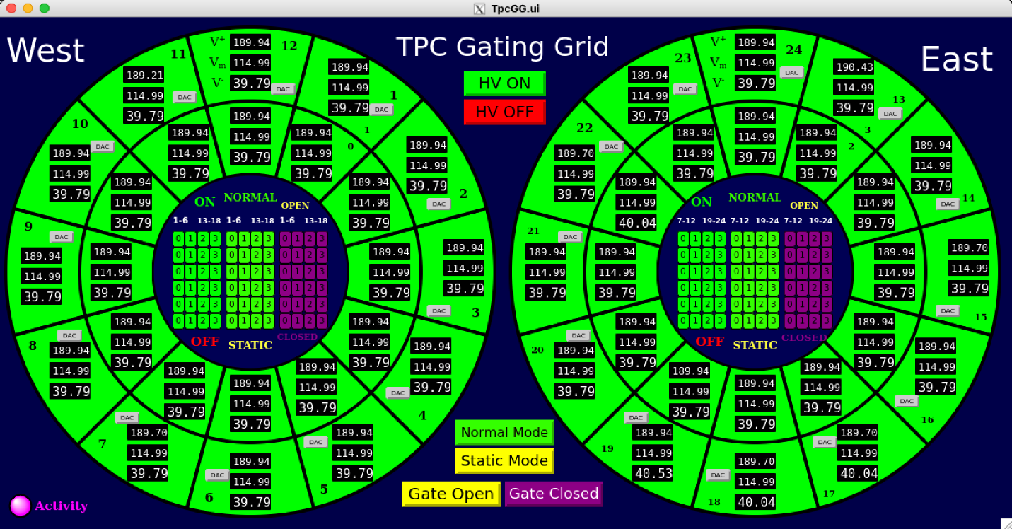
Main TPC Gating Grid GUI showing that the GG is ON and in Normal Operation Mode.

Start the Gating Grid IOC or the GUI (if they aren’t already running)
- Check if the IOC is running: type screen -ls in a terminal on daqman.starp
If you don’t see TPCGG (Detached) in the list then:
  - cd to /home/evpops/tlusty and type ./startup.py
  - check again (if you don’t see the TPCGG (Detached) call the expert)
- If you do see TPCGG (Detached) in the list then:
  - The GG GUI is accessible from SC3.STARP using the Tpc_Top controls menu. Click on the exclamation point next to the button labelled “New Gating Grid”. This brings up the GG GUI.
Note that tpc_top is usually running in the TPC slow controls area (sc2.starp), but a new copy can also be accessed by typing tpc_top on a terminal on sc3.starp (login as ‘sysuser’).
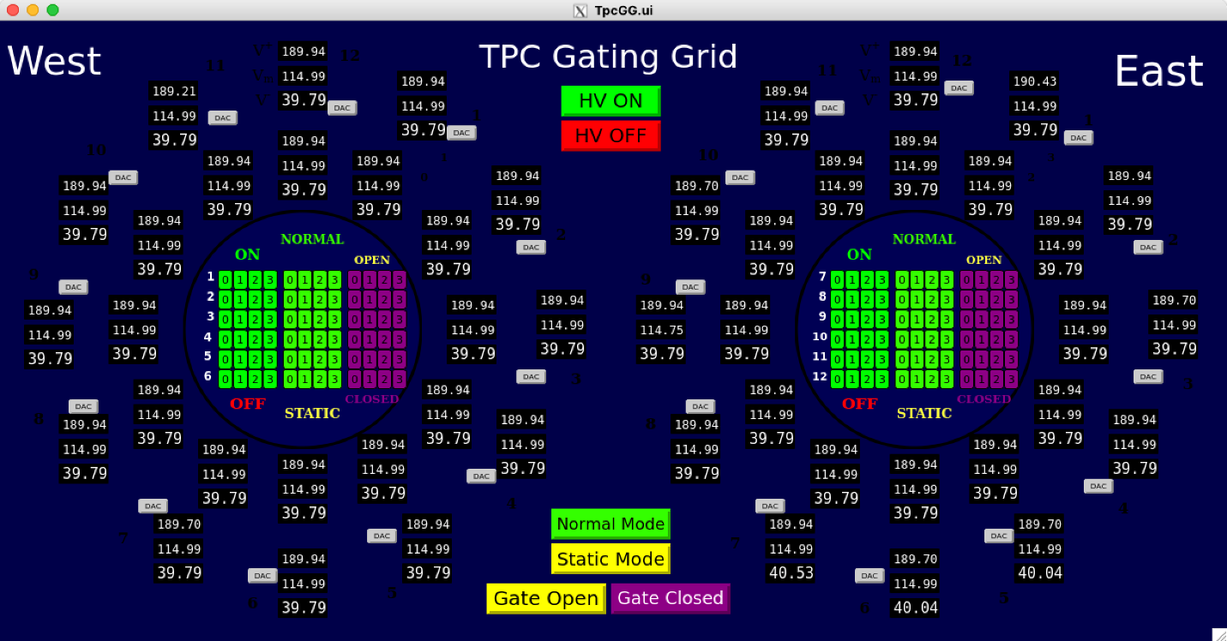
Main TPC Gating Grid GUI when there is a communications problem between the IOC and the GG hardware. Restart the IOC or call an expert for help.

Sector Mapping and Control of Individual Channels
Each sector can be controlled by the individual buttons shown in the figures, below. Sector numbering follows the numbering of the TPC Anodes (West 1-12, East 13-24, Inner & Outer). The individual controls also display their status by color. To determine the status of a channel, refer to the color of the labels “ON”, “OFF”, “NORMAL”, “STATIC”, “OPEN”, and “CLOSED”.

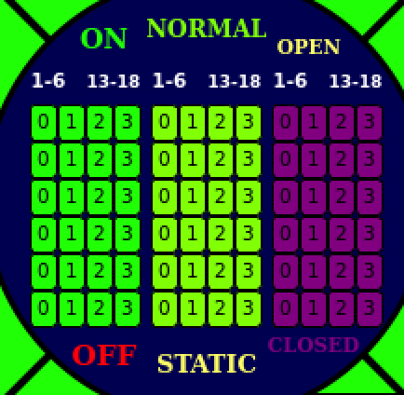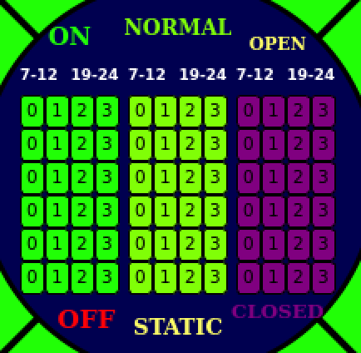
Main TPC Gating Grid GUI showing that the GG is ON and in Normal Operation Mode.

Note that the buttons for “HV ON”, “HV OFF”, “Normal Mode”, “Static Mode”, “Gate Open”, and “Gate Closed” also affect the status of these individual buttons.
The numbers on the individual control buttons represent the ports used for communication:
Port 0 ⇄ West inner sectors
Port 1 ⇄ West outer sectors
Port 2 ⇄ East inner sectors
Port 3 ⇄ East outer sectors

Normal Mode operation opens and closes the GG in sync with the TPC trigger. The small white numbers sitting above the individual control buttons identify which sectors are controlled by each button (e.g. the column below “7-12” control sectors 7-12).

Special Operations (for Experts Only!!)
Experts sometimes need to manually test the Gating Grid system. Click on the “Static Mode” button to permanently open or close the Gating Grid. When in static mode, the gate can be opened or closed by pushing the “Gate Open” or “Gate Closed” buttons. The groups of 24 buttons (located inside the arcs on both the West and East side) will turn yellow in static mode and the sector arcs on the GUI will turn either yellow (if the gate is open) or maroon (if the gate is closed).

Setting the voltage for individual channels can be done by clicking on the “DAQ” button in each sector and a pop-up menu will appear. To set a new value for a channel, simply write the new DAC value in the “write DAC” cell and push the Enter/Return key. The change in voltage should be visible in < 10s and in DAC in < 20s. Each channel requires 3 voltage settings: Hi, Middle, and Lo. These values are to be determined by a TPC expert and set by an expert, only.

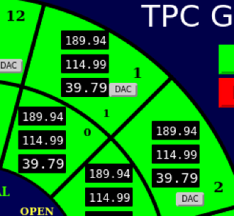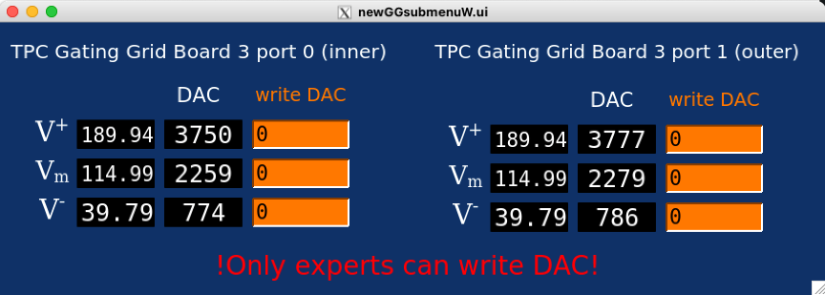
Setting voltages on individual channels - click on “DAC” button which will pop up menu (right) where you can set the voltage by writing its DAC value.

Cathode HV & Field Cage Currents
AUTORAMP MODE
Check the STAR Detector State diagram for the most up to date information on how and when to ramp the Cathode HV.
For conservative operation: The cathode HV should not be turned ON until the RHIC beams are stable at collision energy and it should be ramped to ZERO before the beam is dumped.

- To turn on the cathode HV using auto-ramp mode, first go to the Cathode Desktop tab and click on “Cathode” to open the GUI. Also click on “Field Cage” to open the field cage current read back screen.
- The cathode GUI control looks like this:
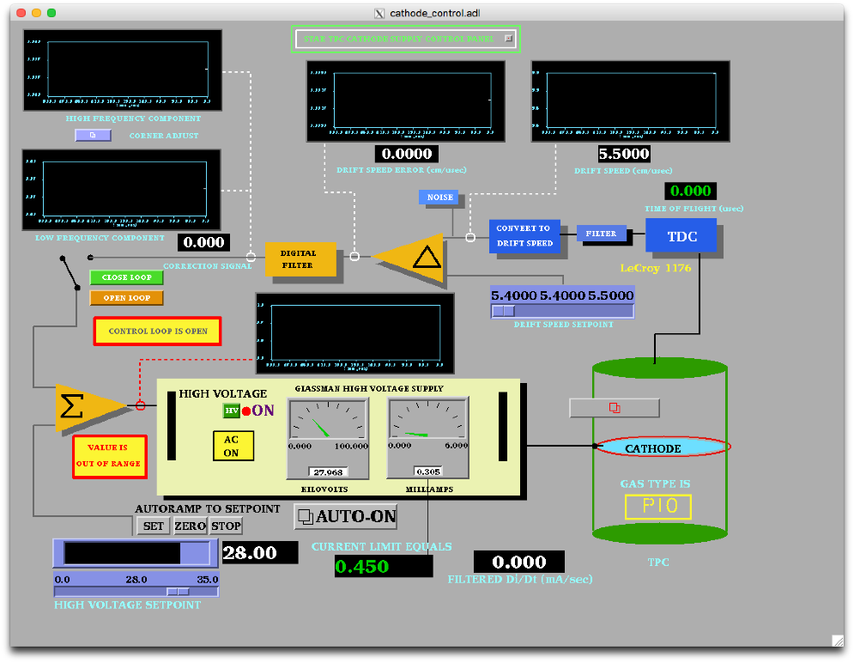
- Make sure the High Voltage Setpoint slider switch is set to 0 and then click the HV button to enable the HV output (if HV is off). When the HV is enabled, the light will go Red. Note that it is not possible to turn the HV back off again by pushing this button!
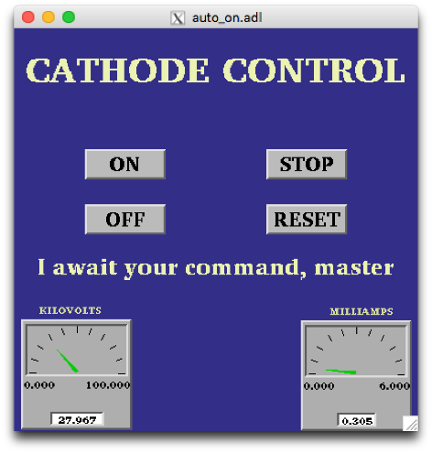
- Make sure that the RHIC beam is stored, cogged and stable before proceeding.
- Click on the “Auto-On” button. This brings up this GUI:
- Click the “ON” button.
The program will then automatically do the following:
Ramp to 10 kV
Check that the four field cage currents are all equal.
Ramp to 20 kV
Again check the currents
Ramp to final HV (currently 28 kV)
Check the currents
The full process takes ~6 minutes.
If the currents are not equal, the program will stop and ramp the HV to 0. The operator can also stop the autoramp at any time by clicking on “STOP”. Clicking “OFF” ramps the HV back to 0.

If at any time,
- The auto-ramp reports a problem
- The currents are not equal for IFC and OFC (difference above 100 nA) in the Field Cage GUI (in this case delta field will be in red)
run the voltage to 0 and call an expert!

Additional notes about the auto-ramp GUI:
The auto-ramp GUI can be used to quickly turn on/off the cathode. When the auto-ramp processor is ready if will display a message “I wait your command, master”. If it displays a problem, you can press the Reset button and then Off button depending on your need. For example, during a cathode trip, in the cathode GUI set point may show 28 kV, but Glassman High Voltage Supply may show zero voltage and current. If the auto-ramp program stops working call slow control expert, meantime cathode can be ramped up/down using manual control defined below.

MANUAL MODE
The HV can also be set manually as follows:
- Enable the HV output as described above.
- Drag the slider switch to the desired HV (this should be done in 10 kV steps, max).
- Click on “SET” above the slider bar and the voltage will ramp up. You can stop the ramp by clicking on “STOP” and go back to 0 by clicking on “ZERO”.
- When the HV stops ramping, check the field cage GUI, shown below:
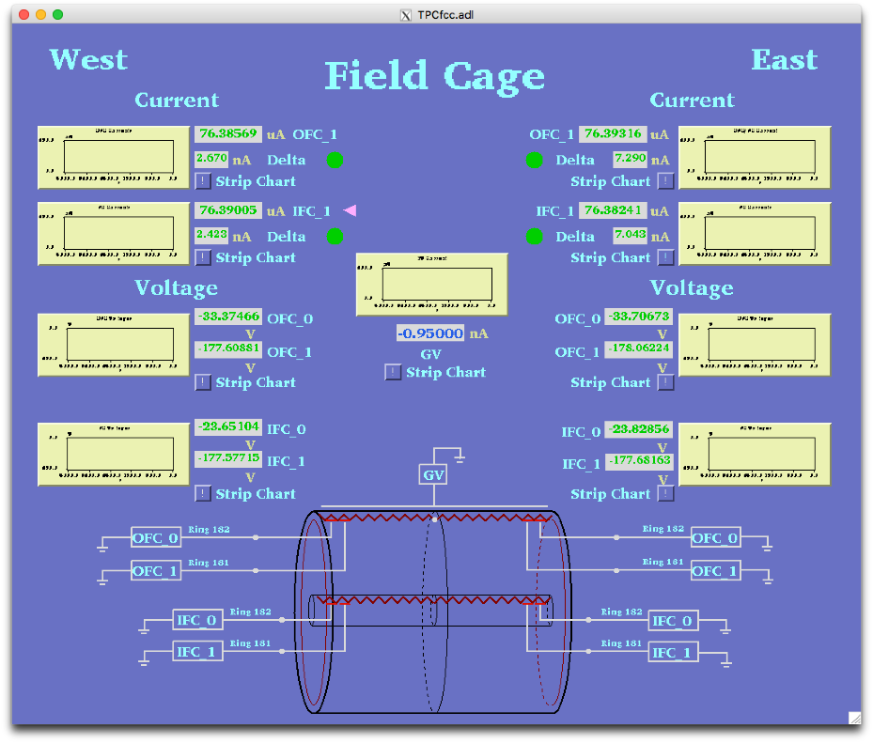
The program reads the 4 field cage resistor chain currents, the current going to the ground shell (GV current) and the voltage on the next-to-last and last stripes. It also checks that all four resistor chain currents are equal within 100 nA (Delta green lights.)
- After the HV stops ramping, confirm that the currents are equal before ramping further.
- Once the HV is set to the final value, the currents are monitored by the alarm handler. If there is an HV alarm, immediately ramp the cathode to zero and call an expert.

Typical Field cage currents and voltages at 28.0 kV nominal.

OFCW 76.555 µA OFCE 76.553
IFCW 76.547 IFCE 76.552

WOFC_0 -33.43 V EOFC_0 -33.74
WOFC_1 -177.21 EOFC_1 -177.66
WIFC_0 -23.774 EIFC_0 -23.779
WIFC_1 -177.58 EIFC_1 -177.47

If the TPC has a short circuit across one of the resistors in the field cage, then you may see different values than listed above. Deviations to 0.4 μA indicates a short between 2 strips in field cage. Check with your shift leader or a TPC Expert to see if the readings are normal.

HV Trip & Interlocks
The Glassman HV is enabled by an output from the TPC Allen-Bradley interlock system. The main AB system and indicator panel are in the gas mixing room. There is also a readout of the panel available via slow controls from the top level TPC GUI. The HV enable can be dropped for multiple reasons: smoke or fire on the platform, methane detected by the platform methane sniffer, no air flow through the IFC region, TPC gas system problems or shutdown, or methane detected in the outer TPC insulation volume. In this case the green “Cathode HV enable” indicator on the AB panel will go out and the red “Cathode HV off” button will light and the HV will be disabled. To restore the HV:

- Find the source of the alarm and clear the problem.
- Once the alarm condition has been cleared, go to the gas mixing room and push the green “Cathode HV Enabled” button – it should light up if the reason for the alarm has been cleared. Note that the interlock will NOT clear by itself – interlocks stay latched off until operator action is taken.
- On the Glassman GUI click on the interlock reset button:

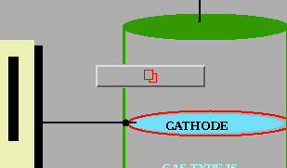
- This brings up the interlock panel – sometimes a red box will pop up also telling you to “check the interlocks”. Click on “Reset Interlocks” and kill the window.
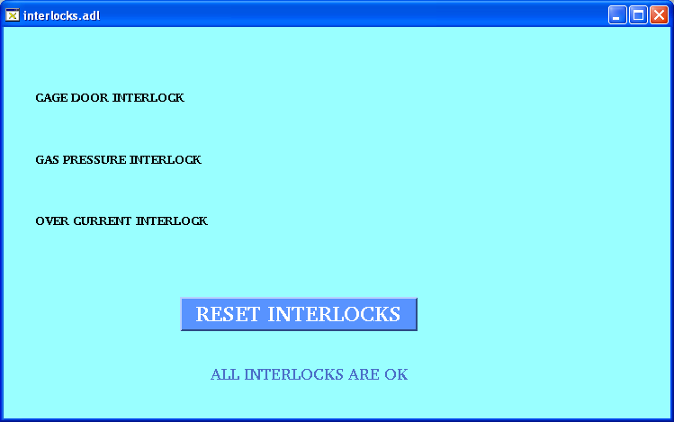
- On the main Glassman GUI check if the High Voltage indicator is off or on – if off, click on the green HV button to re-enable the HV. You should then be able to raise the HV again.

Rarely, due to a bad RHIC abort, the cathode HV will trip on current overload. (the trip limit is 0.450 milliamps). To clear this trip you need to bring up the super-secret, operators only GUI. On the main Glassman GUI find the small button labeled “STAR TPC Cathode Supply Control Panel” near the top of the main GUI:
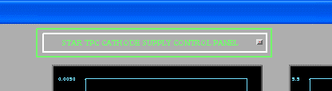

This brings up the settings page:
Most of the settings on this page refer to the unused feedback mode. The one setting that might be used is for the current limit set point (set at 0.450). To reset a current trip, push the Glassman HV Enable “Reset” button and then push the “Enable” button.

Close this window and check the main Glassman GUI. If the HV indicator is off click the green HV button to re-enable the HV. You should then have control again. After a current trip, check the field cage currents at 2 kV to make sure there was no damage to the structure.

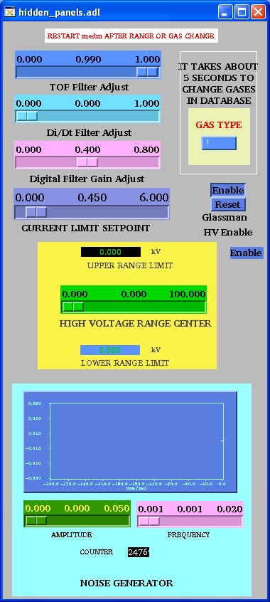

Grid Leak Wall (GLW)
This is a simplified version of the GLW operations procedure for non-experts. In general, the GLW should be ON all the time. Following figure shows GLW GUI when it is on:
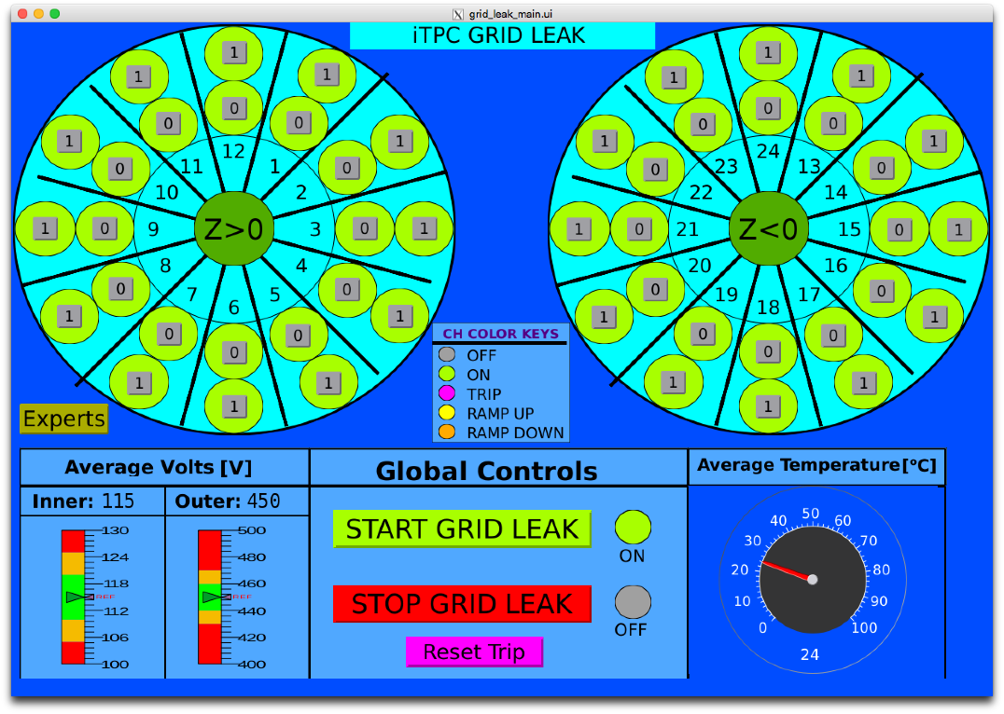
To turn it on: click the ‘STAR GRID LEAK’ button. To turn it off: click on the ‘STOP GRID LEAK’ button. Usually, the Inner electrode (“0” on the GUI) is set to 115 V and outer electrode (“1” on the GUI) is set to 450 V. The voltages and currents can be monitored on following web page:
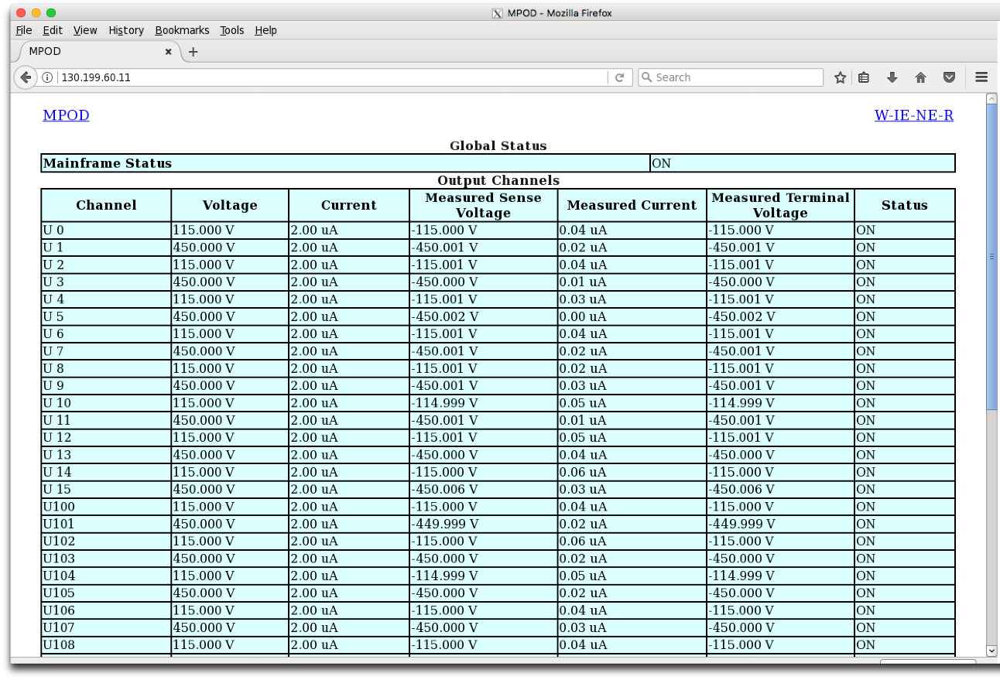

ANODES
Before turning on the anodes make sure RHIC has stored, cogged and stable beams! Check the STAR Detector States diagram for the latest information regarding when to turn the Anodes on.
To turn the anodes ON, using the auto-ramp program:
- Go to desktop # 1 and click on “ANODE CAEN” on the top level GUI. This brings up the Anode GUI.
- If you see any white spots in the GUI, it means the communication is lost to the GUI. Please call the Slow Control experts to restore the communication immediately.
- When the shift leader approves to turn on, the anodes can be ramped to physics operating voltage (Inner = 1070, Outer = 1390) by clicking ‘Ramp to full voltage’ button. Check with your shift leader or a TPC expert for the current operating voltages. Some channels may have different operating voltages (for example sector 20 channel 5). Identify those channels for troubleshooting.
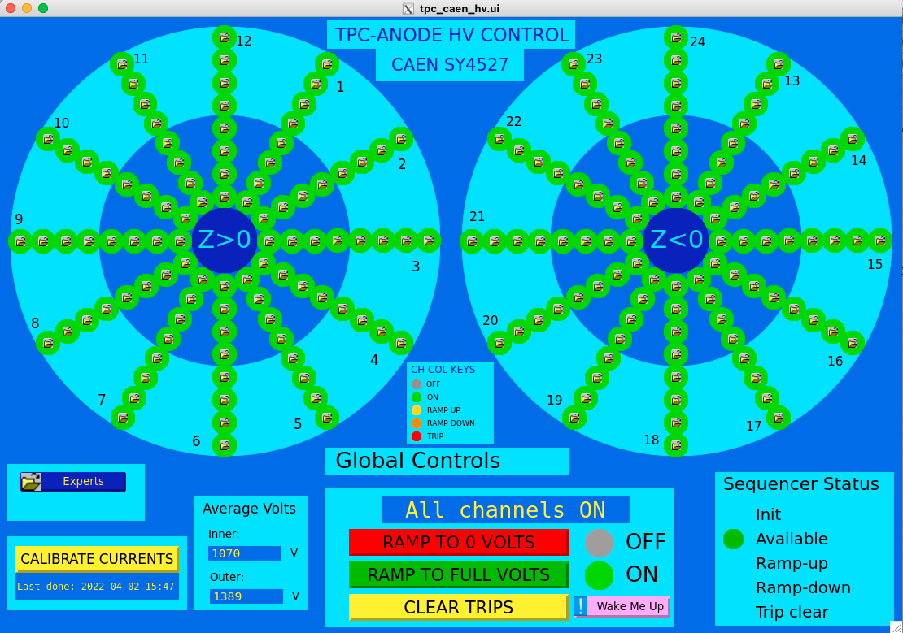
The Ramp procedure takes about ~5 minutes. Look here for the current status. “All channels ON”, in the status box, means the anodes are ramped and ready to take data.
- When the Global controls are not busy, the operator can stop the process by clicking ‘Ramp to 0 voltage’. This will ramp the voltage back to 0. Busy status will look like this:

- To turn the HV off, click on the red “Ramp to 0 Volts” button on the main anode GUI. When the anodes are off you will see a message “Everything OFF” in the status box.

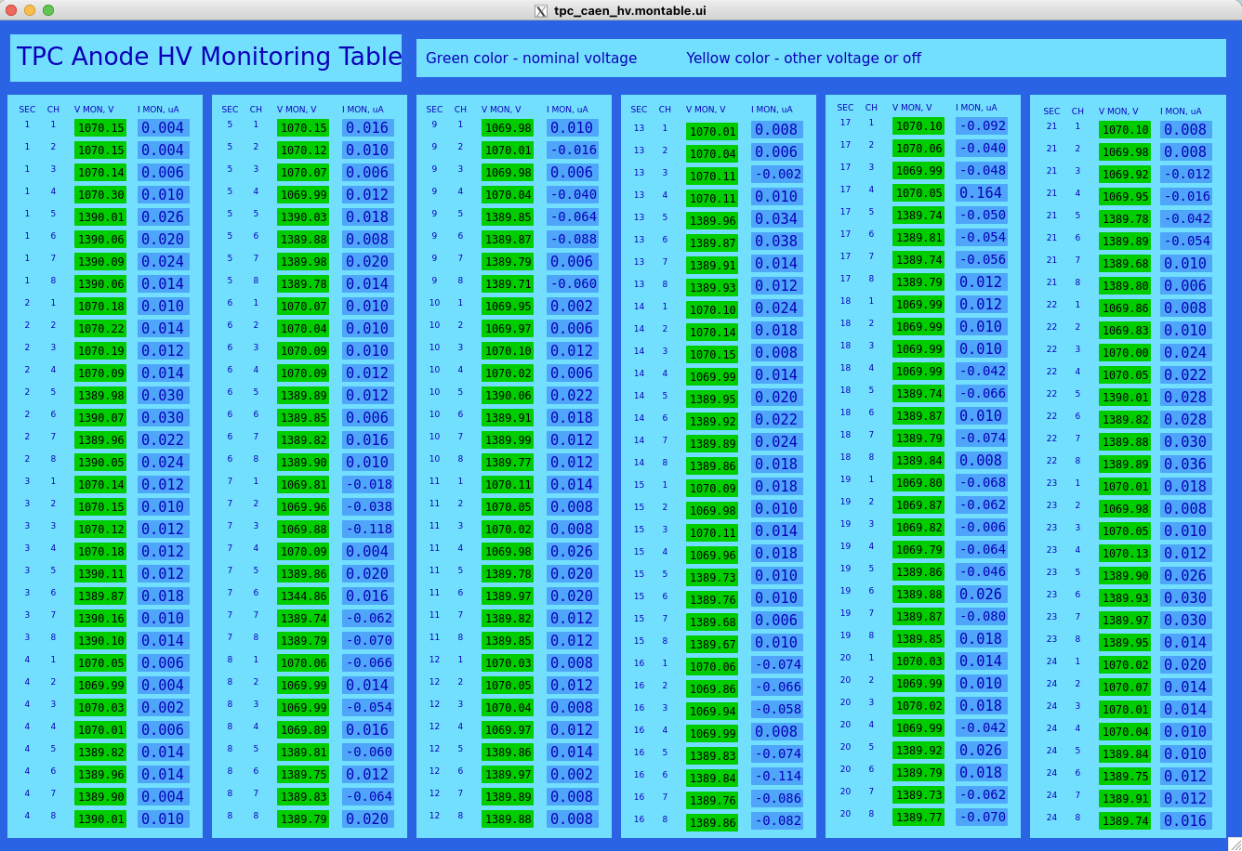
The TPC Anode High Voltage Monitoring screen. It can be accessed from the top level GUI.

Calibrating the Anode Currents
When there is NO beam and Anodes are OFF, calibrate the anode currents. Before the calibration in the east and west TPC-HV configuration GUI you will see for most of the channels “I,MON”, the measureured currents are negative. To calibrate click the “Calibrate Currents” button. This will take about 10 seconds. When it finished it will indicate the cutent date and time. Confirm the TPC-HV configuration table all currents are zero. It is fine to have few channels off zero. If you see many channels off zero, do the calibration again. If you still see problems, make shiftlog entry and move to next step in the daily procedure.

RESETTING TRIPS
Occasionally in an event of excess curent, one or many anode channels may trip (> 2 μA). These trips can be random or beam induced. There will be a TPC alarm. First, STOP the run. Then proceed to reset tripped channel(s).

The trips can be cleared by using the yellow “Clear Trips” button on the TPC HV Control GUI. This button is used for single or multiple trips. The action clears the trips and ramps the channels to physics operation voltage. Wait until the tripped channels turn green, to start a run. If the trip happens during ramp down, wait until the tripped channels are cleared and begin to ramp, then click “Ramp to 0 Volts”. Please make a note in the shift-log on which channels are tripped.

In certin cases trips can not be reset using the “Clear Trips” button. In this case, the detecor operator has to clear them manually and individually. To clear the trip manually, click on the the individual control button for the tripped channel in the main anode GUI. This brings up the channel status panel:

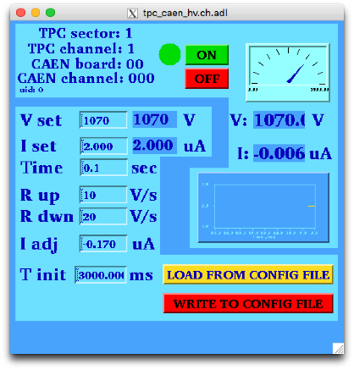
- Turn the channel off with the OFF button.
- In “V set” field, enter 12 and hit return.
- Turn the channel on using the ON button.
- Wait till the channel reaches 12 V and
the status circle becomes completely green.
- Click “LOAD FROM CONFIG FILE button”,
it will set the nominal high voltage.
- Wait till the channel ramps to the nominal
voltage and the status circle becomes
completely green, close the channel GUI.

Do this for all the tripped channels.

TPC Anode CAEN: Power Supply Monitoring & Wake Up Procedure
The CAEN is the power supply for the TPC Anodes. If the CAEN-ANODE-HIGH-VOLTAGE alarm is active, or the IOC is frozen, then push the pink “Wake Me Up” button on the HV control screen. This should clear the alarm.
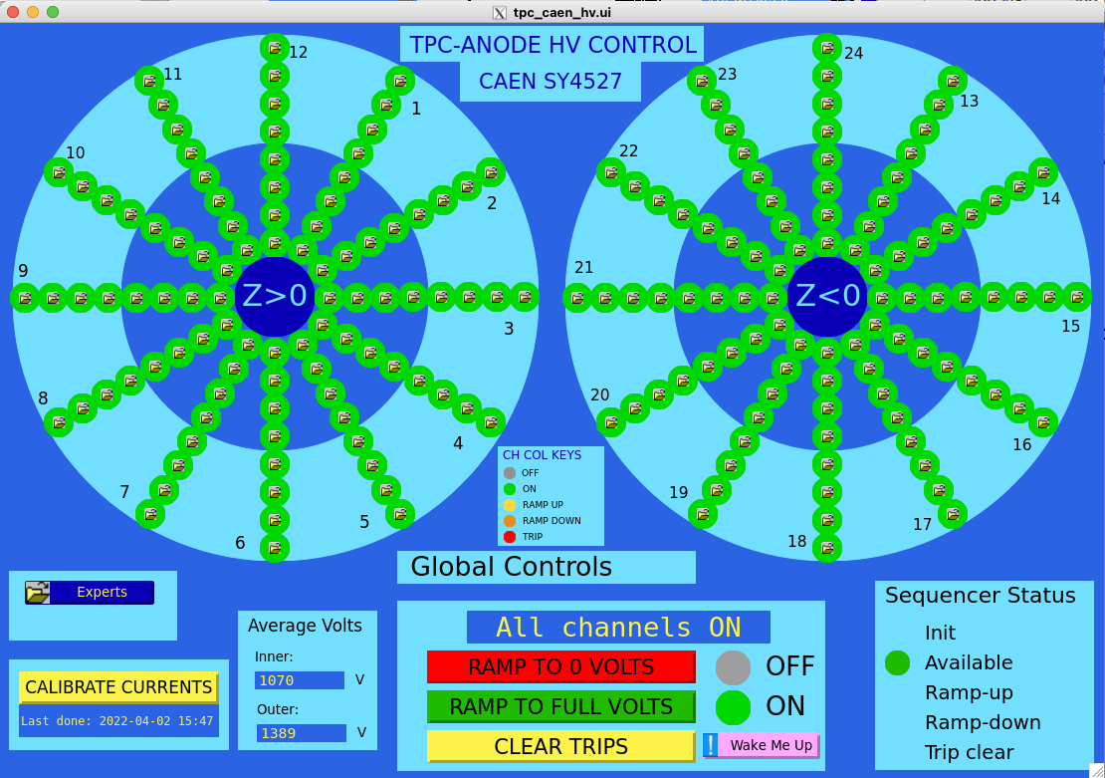
Also, when the alarm is active, pay particular attention to the charge per pad plots and event sector plots in the JEVP plots. Because an anode trip may have happened during this time and unnoticed due to the CAEN IOC being frozen. If this is the case stop the run. Do the above steps, then clear the trips and go back to data taking. If you have any concern please call an expert.

TPC LASERS
There are two lasers used for calibrating the TPC (East & West). Turn on both lasers at the same time. The lasers may be turned on and warmed up while STAR DAQ is running a non-laser run.
Laser runs should be taken about one hour after the start of a store and about every 3 to 4 hours afterward (for as long as the store lasts.). See the shift crew instructions for up-to-date recommendations on how and when to do this.
- Turn on the AC power to the lasers
(Note: The lasers overheat if the AC power is left on between runs so turn them on only when needed and turn them off, promptly, after use.)
Go to the Laser Control panel displayed on TpcLaser.starp.bnl.gov. (Near the TPC Control Desktop, but to the right and above it.) Select the “ #3” box in the 2nd row of the Laser Control panel. Then click on the “Set 2” button, twice. (See picture below.)
Important: click the “Set 2” button twice.

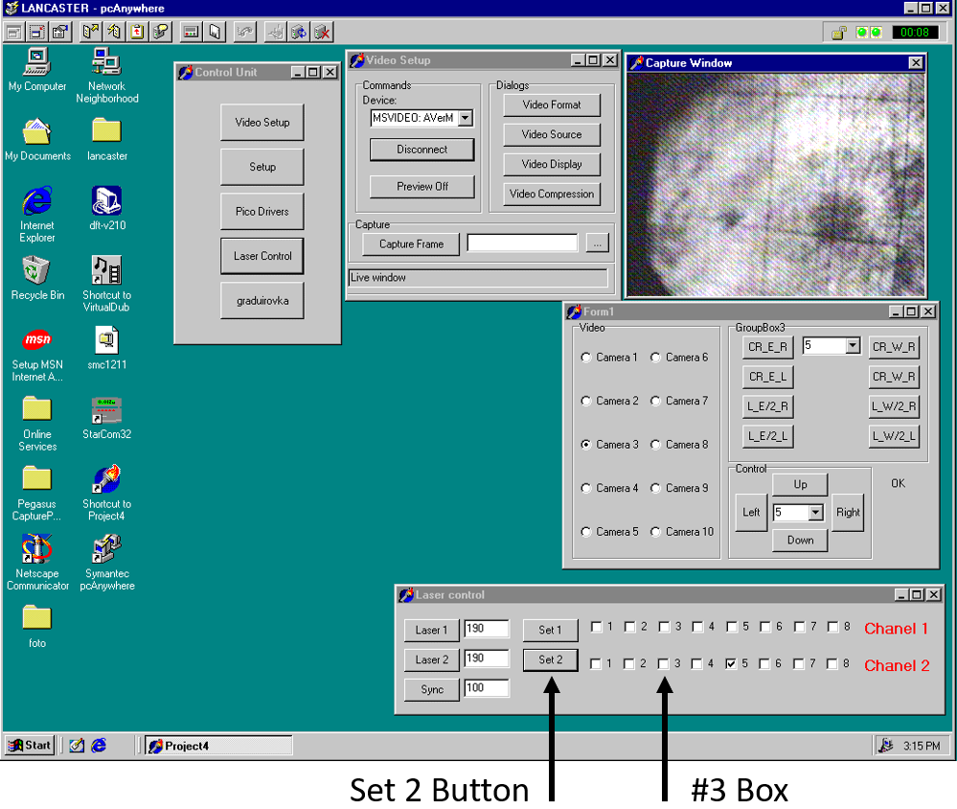

- Turn on the laser flash lamps
Go to multiple desktops on Chaplin ( TPC control computer) and click on the “Laser” button to bring up the laser Flash Lamp Control panel. Check that the sliders for “Laser Pause Time”, “Data Enable Time” and “Laser Run Time” are slid fully to the right.

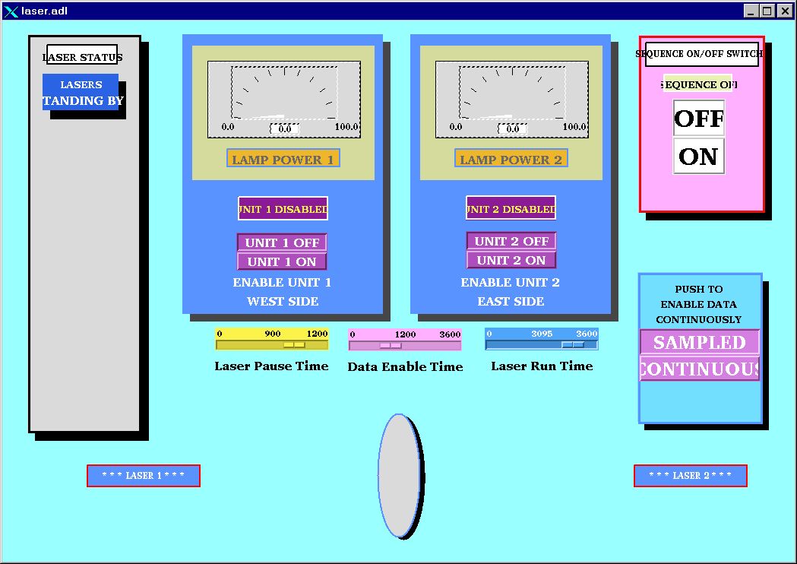

Click the “ON” button in the pink box (upper right) and within a few seconds, click the “Unit-1 On” and then the “Unit-2 On” button in the blue boxes. Wait for both power supplies to come to full power; the needles will go full-scale in about 2 minutes. Note that only the EAST laser will trigger DAQ. When the lasers lamps are finally on, the display will look like this:

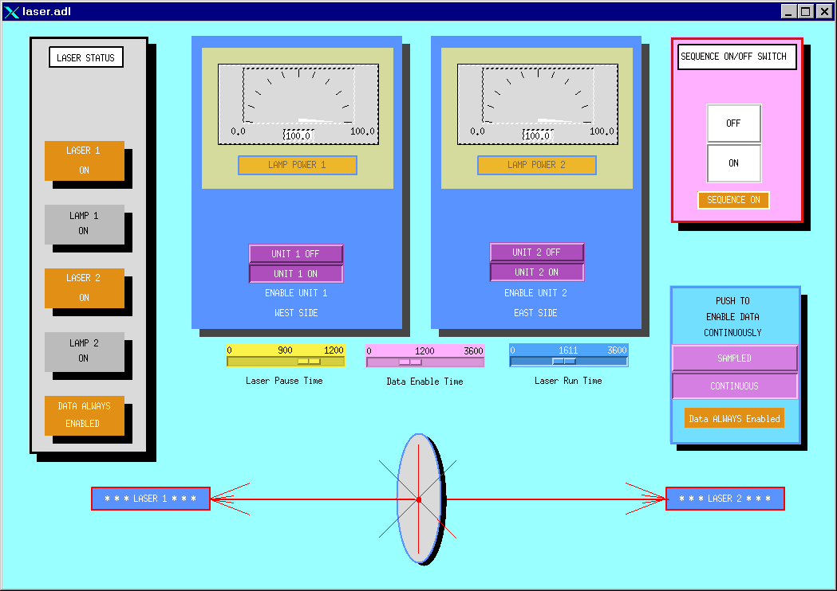

Wait another 3 minutes for the lasers to warm-up. Do not tune the lasers until after the full warm-up period has elapsed.

- Tune the Lasers
A remote camera system allows you to view the East and West laser spots. Go back to TpcLaser.starp.bnl.gov near the TPC control computer and find the “Form 1” window.
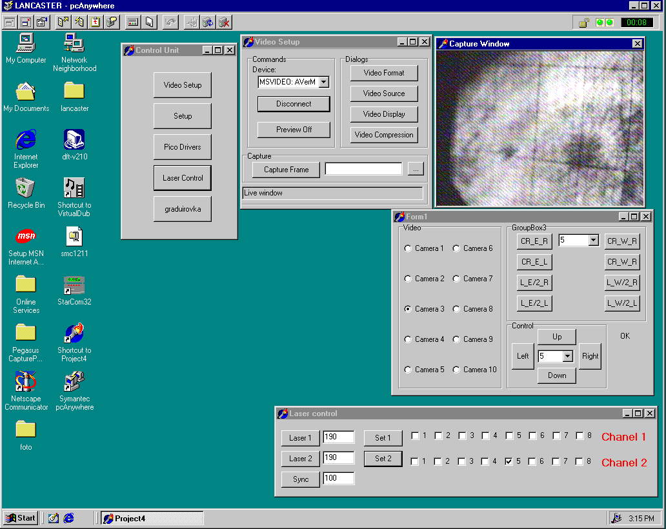
Various cameras can be selected in the “FORM1” window:
Cameras 1 & 2 = West laser aimed at the TPC
Cameras 3 & 4 = East laser aimed at the TPC
We will use cameras 1 and 3.
CAUTION: Do Not click on any other controls in the Form 1 window, or in the “control unit” or “Video setup” windows.

When the lasers are running and warm, a synchronized bright spot will be visible in the “Capture Window”. Select Camera-1 to see the West laser spot and a select Camera-3 see the East laser spot. Lack of a spot in either camera means the laser is not working (perhaps it didn’t power up properly) or it is very poorly tuned.

Tune the laser spot for maximum intensity by selecting Camera-1 and clicking the [L_W/2_R] or the [L_W/2_L] buttons (2nd column to the right in GroupBox3). Wait 2 seconds between clicks. Start by going to the right with [L_W/2_R] using as many as 10 or 15 clicks (but not more than 50). Keep going until you find the maximum intensity or, if not, try going left using [L_W/2_L] to find the peak.

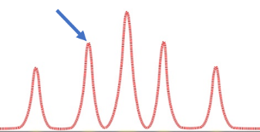
The Laser spots have multiple maxima and so you may be starting on a secondary maximum when the laser is first turned on … keep tuning past the first peak you find and then come back after you are convinced you have found the primary peak.

Next: tune Camera-3 for maximum intensity. Select Camera-3 and click on the [CR_E_R] or the [CR_E_L] buttons (1st column on the left in GroupBox3). Start by going to the right with [CR_E_R] and follow the same maximization procedure as for Camera-1.

Start a laser run with Run Control. Either a dedicated Laser run, or interleaved with Physics triggers is OK. Normally, we take laser triggers during a physics production run. A production run may be started while the lasers are warming up, or after the lasers are warm, but ensure that the laser trigger box was enabled before the run started.

Take data. Cycle back to Camera-1 and keep tuning the laser spot every 30 seconds (or so). As the laser warms up, Camera-1 usually needs a few clicks to the left with [L_W/2_L] to stay on top of the peak. Two or three clicks is usually sufficient. Repeat for Camera-3 but now try a few clicks left with [CR_E_L] or right with [CR_E_R] … whatever is required to maximize the laser spot intensities. Make sure you associate the correct camera with the correct buttons.

Keep tuning until the STAR DAQ screen shows 4000 Laser events have been collected and then turn off the lasers. You do not need to stop the run if you are running a production run.

- Turn off the laser flash lamps and turn off the laser AC power
Turn the lasers off by clicking “Unit-1 Off” and then “Unit-2 Off” in the laser Flash Lamp Control panel. Wait for both power meters drop to zero (about 2 minutes). Then click the “OFF” button in the Laser Sequence window (pink box). A “Lasers Standing By” message should appear in the grey box on the far left of the screen. Wait for it. Finally, move to the TpcLaser.starp.bnl.gov computer and the turn the laser AC power off by un-clicking box #3 and pressing “Set 2”, twice.

Ask the shift leader to unclick the laser trigger box on Run Control if you are running a physics-production trigger; do not stop the run. If you are running a dedicated Laser Run, then simply stop the run; no other changes.

- (Optional) Starting the Laser Control Panel – if it is not already on
Go to the TpcLaser.starp.bnl.gov computer (near the TPC Control Desktop, but to the right and above it).

On TpcLaser.starp.bnl.gov, double click the “Symantec pc-Anywhere” icon. After the program starts, double-click on the “TPC Laser” icon.

Login using Username: BRANDIN, Password: ANDREY.

This brings up the TPC Laser Control Panel.

ALARMS

TPC GAS ALARMS
In case of a TPC gas alarm (the box on the post between the windows looking into DAQ room):

- Hit the acknowledge button on the alarm box in the control room. This silences the local alarm.
- Go to the gas mixing room – hit the acknowledge button located next to the TPC Allen Bradley PLC panel in rack 4
- Call an expert – the list is posted in the mixing room.
- The expert will tell you what to do.

For a major gas alarm all the TPC HV will trip off automatically. For a minor alarm the HV will stay on and the run can continue.

TPC WATER ALARMS
In case of a TPC water alarm:

- Hit the acknowledge button on the alarm box in the control room. This silences the local alarm.
- Go to the gas mixing room – hit the acknowledge button located next to the TPC Allen Bradley PLC panel in rack 4
- Call an expert – the list is posted in the mixing room.
- The expert will tell you what to do.

For a major gas alarm all the TPC HV will trip off automatically. For a minor alarm the HV will stay on and the run can continue.

TPC ALARM HANDLER
TPC parameters are monitored by the slow controls alarm handler running on sc2.starp.bnl.gov.
The alarm handler monitors the following TPC parameters and gas system alarms:

- Anode trips
- Excessive Anode currents (any channel)
- Cathode HV not on (must be > 25 kV)
- TPC FEE temperatures < 80 F
- Temperature in the WAH < 82
- Dewpoint in WAH < 62
- Inner and Outer Arcnet links active
- Field cage currents equal
- All gated grid voltages at nominal
- Inner Anode current sum (all channels) < 10 µA
- Outer Anode current sum (all channels) < 4 µA
- Anode HV – check whether any channel is not equal to demand voltage.

The alarm handler reads the status of these parameters every few minutes and will sound an audible alarm if something is out of range. Silence the alarm first, and proceed to investigate.

The alarm buttons are color coded:

White labled with ‘V’: Invalide data alarm
Red lable with ‘R’: Major alarm
Yellow lable with ‘Y’: Minor alarm

An alarm condition will automatically clear and revert back to green on the next read cycle if the reason for the alarm has been fixed. Please refer slow control manual for further details about the alams.

In the event of TPC gas or water alarm, alarm box mounted on the controle room – DAQ room window will lit and audiable alarm will sound. If this alarm is stady and on for more than three miniuts, call TPC experts immediately.

TPC State Table for Various Conditions

Typical State Diagram for operating the STAR TPC – See the official Detector State Diagram in the control room that is updated for each run each year.

Pedestal Run: Anodes OFF
Cathode On/Off (but not ramping)
Gated Grid On
FEEs On
GLW On

Physics Run: Anodes On at full voltage
Cathode On at full voltage (28 kV)
Gated Grid On
FEEs On
GLW On

Laser Run: Same as Physics Run but with Lasers On

Pulser Run: Anode OFF
Cathode Off/On
Gated Grid On
Fees On
GLW On
Clock in Local (not RHIC clock)

Magnet ramp up or down:
Anodes OFF
Cathode Off
Gated Grid Off/On
GLW Off/On
FEES OFF

Take a laser run 1 hour after the beginning of each store. Take ~ 3000 events and check the drift velocity in the online histograms.

This page deliberately left blank

Back Cover

