July 6th, 2009

Complete Shutdown of the TPC gas system and set up of summer N2 purge

Assumes gas system is in 100 lpm Argon purge mode (ie no methane in the chamber) and that you have executed the “Procedure to stop circulation and start Ar purge”.

- Using the PC GUI, open SV11 and SV12.
- Using the PC, set the flow for FM3 to zero (slider) and click on “set flowmeters). Confirm that flow through FM3 goes to zero.
- On rack 2, close MV6 (manual valve for FM3)
- Reduce the Ar regulator pressure (PCV 5 on the wall) to ~ 18 PSIG
- Close the Ar inlet valve MV30 at the manifold on the wall. This allows N2 to flow into the Ar line.
- Adjust the N2 pressure regulator (PCV2) and the flowmeter valve for FI-5 so that the N2 pressure increases and the flow is set to the arrow on the flowmeter - this is the standard shutdown maintenance flow for the TPC.
- Confirm that the power for the purifier is off (TIC1 on Rack 2 should be off and the purifier control on the GUI should be red. If purifier is still on, turn it off.
- Close SV4, SV3 and SV1 using the PC. (SV2 should already be closed). This closes off the purifier-dryer loop.
- Using the PC, stop small compressor SC2. Turn off M4 (top of Rack 2)
- Using the PC, stop small compressor SC1 and close SV6, SV7, SV8 and SV17.
- Inside Rack 3, close the inlet valve first, then the outlet valve on oxygen analyzer M1 (do NOT allow the meter to be pressurized!)
- Inside rack 3, unplug the small compressor SC3. Close the inlet valve then the outlet valve for oxygen analyzer M5.
- Turn off M1, M5, and methane analyzer M3.
- At rack 1, turn off the power for the three Hastings mass flow controllers. (Turn the rotary switch on the front of each meter to off.)
- Remove the side panel of Rack 1.
- Inside rack 1, turn off the power for the hardware alarm box, the SCXI crate and the temperature controller MUX box.
- Unplug the water meter (M2).
- Make sure the PID controller power supply (bottom of Rack 1) is off.
- Put all side panels back on.
- On the PC, kill the gas system control program and shutdown the PC. (If automatic software updates are pending, reboot once, then shutdown).
- Turn off the breaker at the top of Racks 1, 2 and 3 (use appropriate PPE). DO NOT turn the breaker for Rack 4 off - it powers the TPC interlock system and stays on all the time.
- At the bottom of rack 2, make sure that the breakers for BC1 and BC2 are off.
- Turn off the “power to gas system” button on the AB interlock panel.

The next section is for the gap gas system:

- At rack 4, open MV52 and close MV54 (selects fresh gas instead of return gas.)
- Turn off M6 (oxygen meter) and unplug M7 (water meter).
- Turn off the pump (toggle switch on front panel - Rack 4).
- Confirm that there is ~ 10 lpm through FI51 - this is the summer maintenance flow for the insulation gap.
- The N2 comes from Rack 3 - FI 10 at the bottom of that rack should also have 10 lpm flow.

Gas Pad:

Double-check the gas pad. Everything should be clean, neat, and explosive gases off.

Argon tank – Order new gas when the pressure drops to 30 inches. Full = 120 inches. This will be approximately every 2 months during the run. Every 3 months in the summer.

Methane – Order methane as needed. Use silver tanks. Red tanks are for emergencies, only. Vent the methane line whenever you install a new bottle or six pack by cracking the joint. Swith MV26 as required. Methane should last 2 weeks under normal conditions.

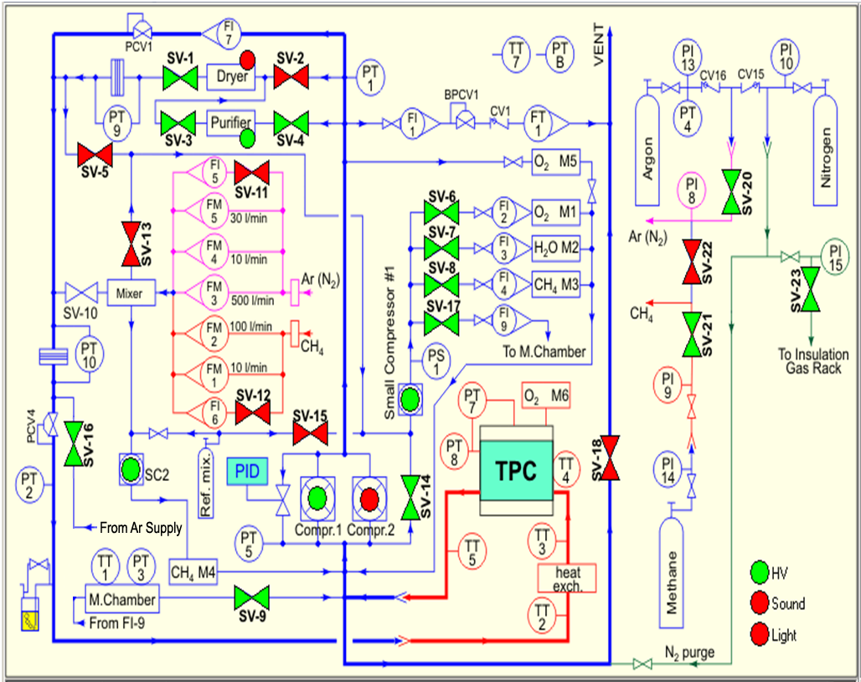
Figure 1: Gas System Schematic Diagram: Normal Circulation Mode Shown

