Unanticipated shutdown and recovery of the TPC gas system. valid 7/14/2009

Gas Room (631) 344-3122 TPC Desk in Control Room (631) 344-8243
Alexei Lebedev Cell (631) 255-4977 Jim Thomas Cell (510) 759-4936

If you have a gas alarm and you hear a recurring sound in the gas room that sounds like a person hammering on the pipes, look to see if M4 is oscillating. If so, go to the gas room computer and close SV21 immediately. This will close off the methane supply lines.

Recovery From a Re-circuation Fault

This procedure is meant to get the system back to a state where you can start a high flow P10 purge or the normal P10 recirculation mode, depending on how long the system was shut down. See the discussion at the end of this document for more information.

1. Silence the alarm (if not already silenced by the shift crew).
2. Block the hardware alarm box (enter 79, then "block alarms).
3. On the PC control screen, disable alarms. Also look at the gas system log window on the computer for clues to what might have happened.
4. If the system was shut down by SGIS then make sure SGIS is cleared and the problem fixed. Turn on the power for Rack 2; if it is off. If it is off then go to the TPC AB alarm panel and push the left-most green button on the lower row of buttons. This should turn the power back on Rack 2 by energizing the solid state relay on the wall of the gas room. You should hear the small compressors start up, and see the temperature controller for the purifier light up etc. While you are at it, check that the power is on for all 4 racks. Use appropriate personal protection to turn breakers on/off.
5. On the PC control make sure BC1 is set to "off" (i.e. red).
6. Open SV13 and close SV14. This makes SC1 sample fresh gas.
7. The Ar mass flowmeter should still be set to the recirculation value (16.0 lpm) - confirm this. If not, set it to the canonical value using the PC.
8. Close SV11 and SV12 to stop the purge flow. Confirm again that the mass flowmeter is giving 16.0 lpm
9. Close SV22 (cross-connect valve) and open SV21 (methane). Wait a bit and confirm that you have methane flow on the methane mass flowmeter (~1.55 lpm). Watch for variation of flow meters and it should be stable.
10. Check and open, if necessary, SV23 to allow nitrogen flow to the gap (it may be closed to protect the TPC. It closes when we have a PT-7 low alarm … the pressure between gap and TPC chamber goes out of range and then shuts to prevent N2 into TPC).
11. Wait a bit more and confirm that M4 and M3 read ~ 10% and M1 reads < 10 ppm.
12. Look at the dB plots around the time of the shutdown to see what might have happened while you wait for the methane content to rise inside the TPC.
13. At this point the system is stable and flowing P10 again. Go to the “Procedure to put TPC gas system into normal operation (recirculation mode)”. Skip the initial steps of this procedure (but check that all conditions are true) and start at about bullet 13. Note that you will have to lower the orange lower limit line on PI7 to zero so you can reset the interlock (red button on rack 2) and start BC1; when needed.
Once you get to normal recirculation mode, you can leave the system in this configuration and the methane concentration will slowly recover to its nominal value (10%) over a period of several days.
14. Or, alternatively, you can proceed to the instructions for starting the high rate P10 purge flow (100 lpm) by using the high flow mass flowmeters etc. The high rate P10 purge will recover the methane concentration in about 6 hours.
Go to the “Procedure to start high flow P10 purge in the TPC”. Once this procedure is complete, and the high rate purge flow has started, check the return gas for the methane content and O2. To do this: open MV9 all the way, turn on the PID controller, leave SV18 open and start BC1. Make sure that SV14 is open and SV13 is closed (if they are not already in this state). Once you have a stable readings for CH4 and O2, turn off BC1, turn off the PID controller, and close MV9. The methane level you measure at the beginning of the purge will tell you how long you'll need to purge before restarting recirculation. Clearly, the longer the system was shut down and on Ar purge, the longer it will take to get going again. (It takes about an hour for every 0.1% below 10% if FM3 is set at 11.2).
When you are back to P10, start the system like you normally would with normal P10 makeup flow using the “Procedure to put TPC gas system into normal operation (recirculation mode)”. Don’t forget to unblock the hardware alarm box.
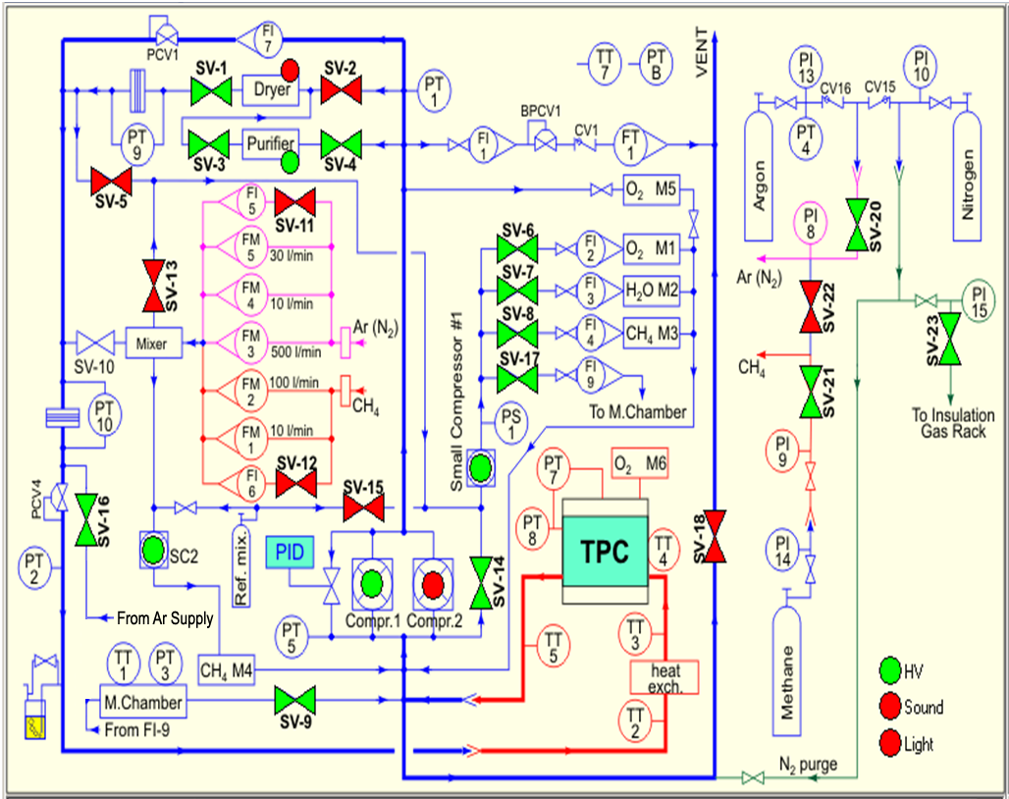
Figure 1: Gas System Schematic Diagram: Normal Circulation Mode Shown
Additional thoughts and notes from BCS 2/24/2009

I'll try and cover some of the past unplanned shutdowns of the system and the recovery procedure I used. The most probable reasons for shutdown are a valid (rare) or false shutdown signal from SGIS, a rapid RISE in the atmospheric pressure, excursions in the methane percentage above or below the alarm limit, an increase of O2 in the return gas above 80 ppm, pressure imbalance or oscillation in PT5 or PT8.

SGIS shutdown:

SGIS will send a kill signal for various reasons (high methane in the hall is the major one). This signal is passed to Jim's AB interlock system and turns off the AC power for rack 2. This shuts down BC1, SC1 and 2, the purifier, shuts off the methane (SV21) and starts the Ar purge through FI5. The chamber is in safe mode since SV18 is open and the purge flow keeps the O2 from increasing. Clearly, the methane percentage in the chamber is being spoiled from the time the shutdown occurred, so the longer the system is in this state, the longer it will take to recover to P10.

Atmospheric rise or fall:

The most common shutdown is due to a rapid rise in the barometric pressure. It is a characteristic of thunderstorms that roll through BNL that the barometric pressure will fall until the front arrives and then there always seems to be a rapid rise - the most violent I remember was ~ 3 mbar rise in < 5 minutes. The system is referenced to barometric pressure (PTB) and tries to stay 2 mbar above PTB. Unfortunately, in recirculation mode we are only putting a maximum of ~ 16 lpm of fresh gas in (if none is going out F1 or F1a) and this is not sufficient to maintain 2 mbar above PTB if the rise in PTB is too rapid or goes on too long. I'm assuming this is what happened when you had a storm last Sunday, 2/22. If you look at the dB for PTB and PT8 during that time you should see what I've just described. If the rise is too great and PT8 falls too much the system will alarm and shutdown BC1, open SV18, close the methane and start the Ar purge. Power to rack 2 will stay ON, however, so the small compressors and the purifier will stay on.
(Note that an attempt was made last year by Leonid, Peter and I to have the PC control program sense the drop in PT8 and send a command to increase the fresh flow to 30 lpm until PT8 recovered. Unfortunately, when this was tried, there was a lag in the slaved methane flowmeter which is slaved to the Ar one and the fresh gas mixture deviated quite a bit from 10% - this also caused an alarm that shut the system down. So, at the moment. we have no automatic protection against these rises - pray for no thunderstorms!)

However, the system IS protected against a rapid drop in PTB. Normally, the TPC vents gas through F1 or F1a during recirculation mode. If PTB drops rapidly it could happen that F1 is not enough and PT8 will start to rise. In this case Leonid added a red-line gauge (I believe PI4) that will open a valve that vents more gas to the stack. This will continue until the pressure drops back below redline and the normal recirculation process takes over again. Since this was installed I have not seen a shutdown due to PTB fall.

Methane excursions or O2 rise

These alarms will also cause the system to shutdown - the alarm limits are listed on the truth tables posted in the gas room. If either M4 or M3 goes too high or too low or the O2 goes above 80 ppm the system will shutdown - essentially BC1 will stop, SV18 will open, the methane is stopped (SV21) and the Ar purge is started. Everything else stays on (I believe). There are various obvious reasons for these alarms (running out of gas, methane analyzer malfunction, leak etc.) Note that when the methane bank is getting low there will be an informational alarm (no action) from PI14, at around 100 PSIG. Usually if I planned to swap banks when I came in the next morning I would warn the overnight shift that they might get an alarm - this saves getting called at 3 AM. 100 PSIG of methane should last 12 hours or more.

Pressure imbalance or oscillations in the PID controller

Usually, once the recirculation is started and the PID system is correctly adjusted the system will operate very stably. It even copes with high winds, although the excursions from the set point become somewhat greater. It can happen, however, that the system will go into rather violent oscillations, with rapid swings in the pressure before BC1 that is the reference for the PID controller (PT5). This happened to me last year after we had run smoothly for weeks(!?). I spent some time fiddling with the system, but never found a smoking gun as to why it has decided to become unstable. I finished out the run by further adjusting the PID parameters in order to decrease the gain and damp out oscillations - the system response became slower, so lazy excursions from the set point became the norm, but the oscillations did stop. I should point out that Leonid and I differed somewhat on the PID setup - his engineering instincts wanted a "properly" tuned system but I just wanted some peace and quiet.... You can find your own way in this parameter space.
If the oscillations are not too violent the system can usually recover itself without shutting down, but if the PT5 variations are too great it will trip the limit and shut down.

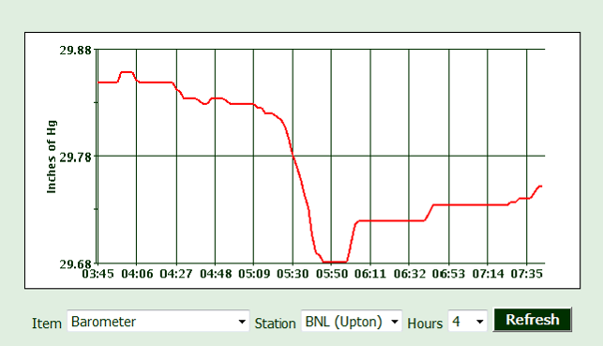
TPC shutdown during pressure rise at 6:05 AM
