Valid 7/11/2009
How to startup the TPC control screens on the Main console (usually Chaplin.starp.bnl.gov, lower left)
- Check that Exceed is running. If not, re-start it from the start menu or quick launch tab.
- Select desktop number 1
  - Look in lower right hand corner and click on “1” (from selection of 1-9)
- Open putty and log on to sc5.starp.bnl.gov
  - Select sc5.starp.bnl.gov
  - Hit “Load” button
  - Hit “Open” button
- Login as ‘sysuser’
  - Password is in the Shift Leaders log book
- Type ‘tpc_top’ in the sysuser@sc5 terminal window
  - TPC Controls – Top Level window control program will start
  - Shrink the terminal window
  - Note that medm window may already be shrunk. This is OK but note where it is because you will have to close it in order to stop tpc_top.
- Open “Anode” window from the TPC Controls – Top Level window
  - Slide the anode window over to the right hand display
- Switch to desktop 2 … Red and Black window at top of page should say “Cathode”
  - Open cathode window from the TPC Controls – Top level window
  - Slide the cathode window over to the right hand display
- Repeat for Gating Grid[3], FEEs[4], Laser[5], Gas System[6], Interlocks[7],VME Status[8], Other[9]
- The TPC control system is setup properly. Operate the TPC controls as required. See the TPC Manual and notebook for details. Also see the Laser Manual (loose leaf pages in plastic sleeves)

Note: the TPC Control Screens can be run from any computer with an X window manager. In particular, it can be run from Chaplin, Astaire, or Sirius. Use any system that works. Default is Chaplin.

How to startup the TPC Alarm Handler (usually on Sirius.starp.bnl.gov, upper right)

- Select desktop number 1
  - Look in lower right hand corner and click on “1” (from selection of 1-9)
- Click on the “Shortcut to Alarms_group” icon (which should already be on the desktop)
  - If the icon is missing, you can make a new one. It points to c:\alarms\alarms_groups.exe
- The alarm handler is ready to run. Operate the alarm controls as needed.

Note : the TPC Alarm Handler can be run from any computer where it is installed. It is installed on Sirius, Astaire and Chaplin; however, only one instance of the alarm handler should be running at a time. Do not run multiple copies on multiple machines. The Alarm Handler is usually left running on Sirius.
How to start Electronic Postit Notes – TKEasyNote

If the program isn’t already running, start TK8 Easynote. It allows you to create an electronic postit note. The notes can be saved and they will re-appear after startup … but they may only appear on desktop #1. To move a note to a different desktop, close all unwanted notes by clicking on the ‘x’ in the upper right hand corner of each unwanted note. Then go to the new desktop and click the TK8 icon in the quickstart tray (lower right hand corner) and select “open closed notes”. Arrange these notes on the new desktop, and repeat this process until all notes are on the proper desktops.

Post these notes on the Anodes screen (usually desktop #1)
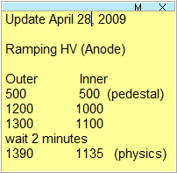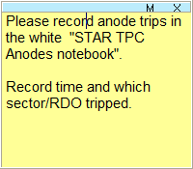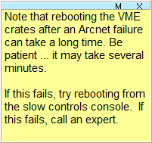
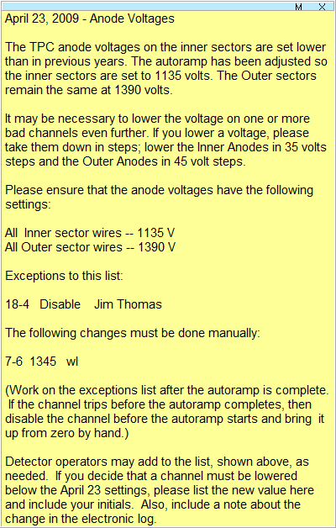

Post these notes on the Cathode Screen (usually desktop #2)
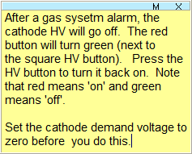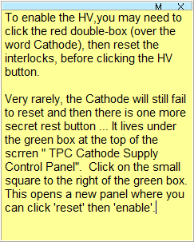

Post these notes to the GG Screen (usually desktop #3)
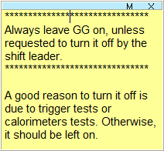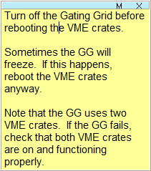

The FEE screen may have various notes. For example: “Be sure to turn off the FEE supplies when ramping the magnet up or down” or “Turn off S6-N5 until further notice”. Also, put a note with the StripGas display screen on the auxiliary TPC screen (to the right).
