Methane analyzer calibration AL 02.18.2009, Rev 03.02.09
The gas system has 2 methane analyzers to measure the methane concentration in the TPC gas. They are labeled M4 (for fresh gas) and M3a (return gas from the TPC). Their performance strongly depends on the pressure and ambient temperature. (An Excel spread sheet is available on the STAR TPC web page to help calibrate the meters and produce graphs for daily use.) The calibration constants for M3a and M4 should be determined before each run and anytime you suspect the calibration has been lost (not more than once/month). Choose a day with stable barometric pressure, the preferred number is 1010 mbar on PTB, which is in the middle of the TPC operating range. For other pressures there is a formula from Leonid Kotchenda:
CH4(true) = CH4(reading) + 0.012% * (Pc-P) + MeterOffset
where CH4(reading) is the current reading from the analyzer, P is the barometric pressure at the current time and Pc is the barometric pressure at the time of calibration.
Calibration is best performed with high Ar flow and for each analyzer separately. The procedure begins with Zeroing each meter. For M3a open SV13, close sv5, sv15, sv14. For M4 open mv17, close mv17a. When Ar flow is established, go to the analyzer, check the flow meters feeding the analyzers, for M4 it is FI2a(rack 2), for M3 it is FI4(rack 3). When the readings have stabilized (about 20 minutes), press ZERO, then CAL buttons. Zeroing will proceed.
To calibrate methane content we have 2 bottles with certified methane-argon ratio - P10 and P20, but exact numbers are 10.2% and 19.9% of methane in Ar. Both bottles are sitting on the gas pad outside the gas room. P10- 40 liters P20- 20 liters, both connected to a 3 way valve. Open the valves on the bottles, then manual valves MV43a, MV43b, the pressure reducers are already adjusted for ~12 PSI: see gauge on ¼” line coming to gas room.
Open the 3-way valve for P20 first, confirm ~12 PSI. Go to the gas room. On rack #1 go to the right hand Hastings meter, choose channel 4 (labeled REF P10) and request flow ~ 3.0 l/min. To calibrate M3a open sv15, close sv5, sv13, sv14, mv17a. Check flow on FI4. During calibration O2 (M1) could be high due to oxygen buildup through long ¼” line. Wait 20 minutes for the readings to stabilize. The readings for O2 should go to ~ 3-5ppm. When the readings are stable, Press SPAN, than CAL buttons. ATTENTION!! Only P20 calibration gas should be used for SPAN calibration, not the P10 gas!! Write numbers in logbook. Sometimes actual readings don’t coincide with a number from reference bottle and this offset needs to be accounted in Leonid’s formula. Open SV14, close SV15.
To calibrate M4, reduce the flow on the Hastings Meter down to ~ 1.0 l/min. Open mv17a, close mv17 on the back of rack2. Check flow on FI2. Proceed with a span calibration as was done for M3: see previous paragraph. When the calibration is finished, about 20 minutes, check and proceed if it is not already done: open SV14, close sv15, open mv17, close mv17a. These operations will restore flow for fresh gas to M4 and return-gas from the TPC to M3a.
Repeat proceeding operations, described earlier, with a fresh Ar to remove P20 from lines and verify ZERO for both M3 and M4.
Open 3-way valve to P10 bottle. Repeat calibration procedure for M3 and M4. Do not Zero or Span the meters with the P10 gas. At this point you are just checking the readings on M3 and M4 and comparing it with the canonical value of 10.2% for the bottle. Put a note in logbook.
Always, if possible, follows a chain: pure Ar-ZEROING ⇒ P20-SPAN ⇒ pure Ar-check ZERO ⇒ P10 check reference gas. Each step takes about 20 minutes to get an accurate reading.
If re-calibration needs to be done during the run (with TPC gas circulating), all alarms should be blocked. On alarm box press 79 on keyboard and press * button- it will block hardware alarm. At this point the lower row of LEDs will be red. Go to the gas system PC and press “Alarms disabled” button. This action will prevent all gas alarms (so don’t forget to re-enable them, later.)
After a calibration in circulation mode ⇒ remove the lock from alarm box ⇒ press 79 and # , on gas system PC enable alarms, press appropriate button “Alarms disabled” and label on button will change to “ Alarms enabled” with a recording in the log. It should say “ALARMS enabled”.
On gas pad close valves on P10 and P20 bottles. Also close the valves installed after pressure reducers. Put 3-ways valve in P10 position.
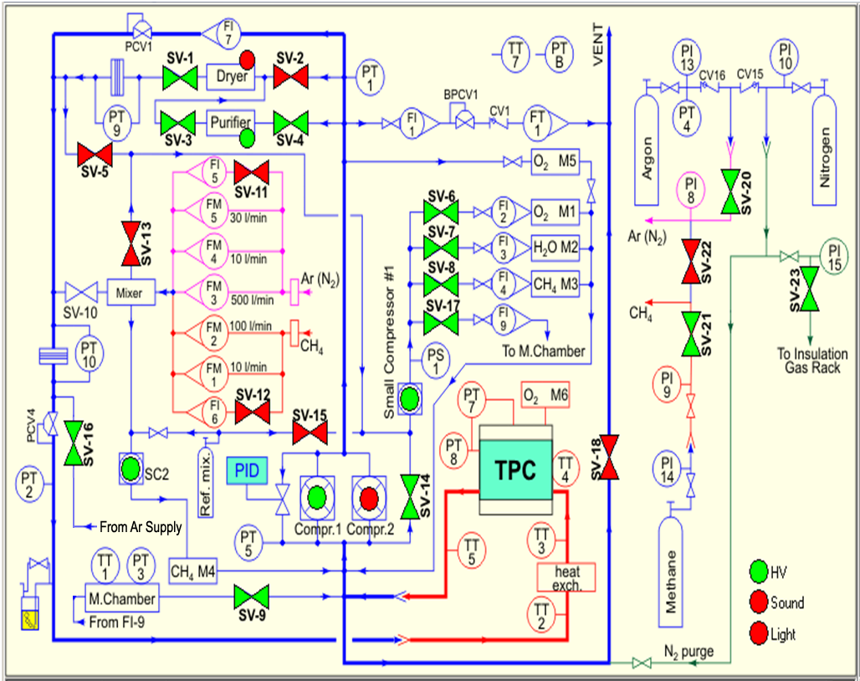
Figure 1: Gas System Schematic Diagram: Normal Circulation Mode Shown

