Procedure to start high flow P10 purge in the TPC valid 7/14/2009

This procedure is used to flow P10 gas into the TPC before turning on the recirculation.

- Make sure the TPC is filled with AR - see the Ar purge procedure. Typically you should flow Argon at 100 lpm for 50 hours to exchange 6 volumes of gas. This will remove all of the N2.
- Obtain a copy of the “STAR Flammable Gas Procedure Checklist” from the CAD web pages ( http://www.c-ad.bnl.gov/ESSHQ/SND/OPM/Ch11/11-4-1-c.pdf ) or obtain a copy from the TPC Operations page (listed as “Checklist for Flammable Gas Startup and Blue Sheet”). Fill out this checklist as you go through the remainder of the P10 startup procedure. When the checklist is complete, keep it on file as proof that the blue sheet was signed (see below).
- STAR is not allowed to flow methane until the safety systems have been certified for the year. If this has been done (contact Bill Christie and the STAR liason engineer), call the RHIC MCR and ask for the operations coordinator. Tell the operations coordinator that you are ready to start flowing flammable gas (methane) and ask them to send the CAS watch down to STAR with the “blue sheet”. As TPC system manager, sign the blue sheet in the areas indicated by the CAS watch - this certifies that the TPC has been readied for methane etc.
- Confirm from the STAR shift sign-up page that there is a 24 hour watch in place for STAR (at least one shiftleader and one detector operator.) Tell the current shiftleader that you will be starting methane flow. Make sure the TPC alarm box on the wall is plugged in and active. Make sure the contact numbers for the gas system expert are posted in the STAR control room and in the gas mixing room.
- In the gas room, confirm that there is 100 lpm Ar flow in FM3.
- On the gas pad, connect the flexible hose from one of the methane 6-packs to the wall mounted methane manifold. CGA connections are LEFT handed threads.
- Open the bottle valve for each of the 6 bottles.
- Open the 6-pack outlet valve which is connected to the flexible hose.
- Using a wrench, crack open the fitting where the flexible hose connects to the manifold - this will purge the line. Let gas flow for ~ 10 seconds. Tighten the connection.
- Open the manifold inlet valve, (MV26A or MV26B) and turn the two way valve MV26 so it selects the attached 6 pack. Confirm the delivery pressure on PI14 - it should be ~2000 PSIG for a full 6 pack.
- In the gas mixing room open the manual valve MV25, behind Rack 3.
- Using the control PC, close SV22 and open SV21.
- Confirm the methane delivery pressure on PI9 (Rack 3) Should be ~ 15 PSIG.
- Open the manual valve MV7 on rack 2. This is the inlet valve for FM2.
- In Rack 1, select FM2 on the left hand Hastings controller. FM2 is the high-flow methane flow meter that is slaved to FM3. Check that the command value for FM2 is ~ 10.7. Switch to flow and confirm methane flow of 10.7.
- Confirm on methane analyzers (M4 and M3) that input gas is now ~ 10.0 %. If needed, adjust the slave pot on the FM2 controller to get 10.0% methane in.

Note: Before starting P10 purge flow, the methane analyzers M3 and M4 should have been calibrated. However, the methane reading will vary with barometric pressure, so this needs to be taken into account. The variation is ~0.1% per mbar. Use the Excel spreadsheet on the TPC operation web page to create a calibration plot.

The purpose of this initial purge is to get close to 10% methane in the chamber. The final (constant) percentage will be set by setting the mass flowmeters during normal running. This process will take a few days.

- Record the time, Ar level in the tank and the methane bottle pressure (PI14).
- Since the system is in purge mode the alarms are still not active. During the P10 purge we have the STAR shift crew check the system every 2 hours through the night. So put post-it notes with canonical values and ranges on the following gauges: M4, M3, FM2, FM3, PT8, PI8, PI9, M1. The crew should call the expert if readings deviate from the posted values over night. Let the system purge 18 hours.
- Send an email to the following people informing them that you have started flowing P10 in the TPC: ingrassia@bnl.gov, sampson@bnl.gov, pendzick@bnl.gov, chrisite@bnl.gov, soja@bnl.gov
- Confirm that MV3A and MV3B are directed to “P10 to SV16” position
- Open P10 cylinder and set 22PSIG pressure on PI52 using PCV50 pressure regulator(Gas Pad)
- Open SV16 to purge the line for 20seconds and then close SV16 using PC

---------------------------------------------------------------------------------------------------------------------------------------------------------------

After the 16 hour purge we need to make sure P10 gets to all parts of the system and also check the return methane percentage and oxygen level.

- Open SV1, SV3, SV4 using the PC. This opens the purifier/dryer path.
- Open the bubbler bypass valve MV14a for ~ 1 hour.
- Open MV9 (the big compressor bypass valve) fully.
- Make sure SV18 is open.
- Turn on the circuit breaker for the big compressor 2 (BC2) at the bottom of rack 2. Using the PC turn BC2 on and run for ~ 1 minute.
- Turn BC2 off and turn BC2 breaker off.
- Turn BC1 on. Running in this mode (SV18 open, MV 9 open, PID controller OFF) allows for purging and recirculation simultaneously.
- With BC1 on, check the return gas. Open SV14 and close SV13.
- Read the return O2 on M1 (should be ~ 10 ppm) and the return water on M2 (should be < 20 ppm).
- Check the return methane content on M3. It will probably read low (<9.5%).
- Leave the system in recirculation/purge mode. At this point, you can raise the input methane content to ~11% by adjusting the FM2 slave pot.
- Continue like this until the return methane content is 10.0% adjusted for barometric pressure.
---------------------------------------------------------------------------------------------------
(continued on next page)
When the return methane content is ~10.0%, prepare the system for normal operation.

- Open SV13 and close SV14.
- Turn off BC1
- Set the FM2 slave pot back to ~10.7.
- Close the bubbler bypass valve MV14a.
- Close MV9 fully.
- Go to the recirculation startup procedure “Procedure to put TPC gas system into normal operation (recirculation mode)”. The final adjustment of the methane ratio will be done during normal recirculation and takes a couple days.

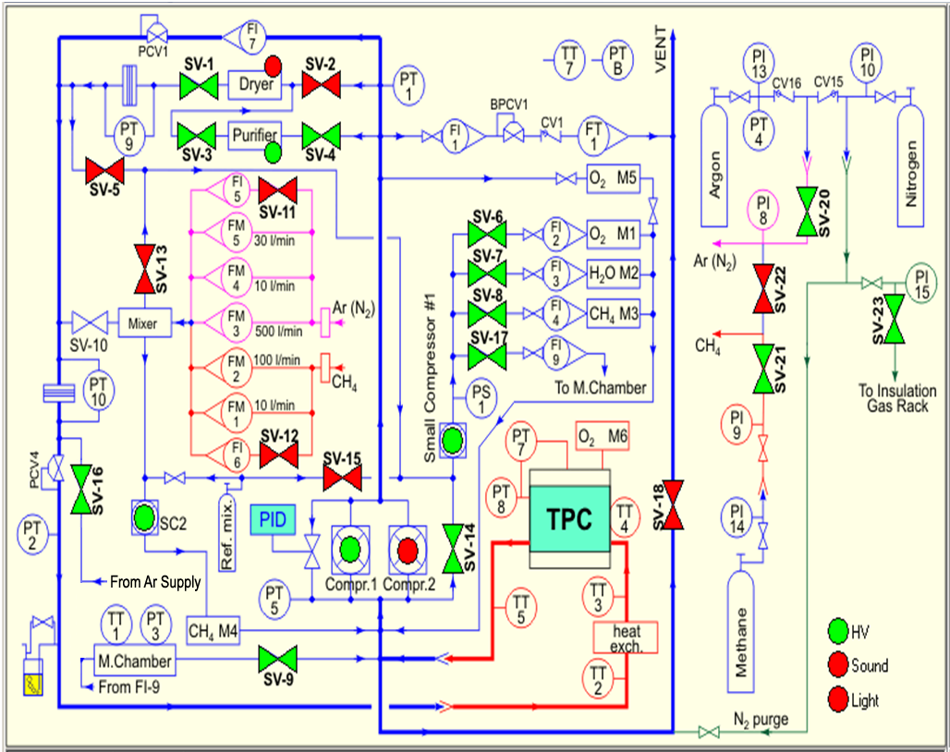
Figure 1: Gas System Schematic Diagram: Normal Circulation Mode Shown

