11/21/2007

Procedure to put TPC gas system into normal operation (recirculation mode).

This procedure assumes that the system in is P10 high purge mode (i.e. 100 lpm Ar and 10 lpm Methane flow rates).

- Open MV4 (manual valve for FM5). Open MV8 (manual valve for FM1.)
- On the computer, set FM3 to 0 and set FM5 to 16.0 (this is the fresh gas makeup flow for recirculation mode). The course setting for Flow Meters is done with the mouse and the slider. Fine adjustment can be done with the right arrow to increase the flow by a small increment.
- Close the manual valves MV6 and MV7.
- On the right hand Hastings controller, select FM5 and confirm the command and flow are set to 16.0. If the reading are unstable, adjusting the argon or methane pressure in step 6 will help.
- On the left hand Hastings controller, select FM1 and set the slave pot to a command of 1.55. This sets the canonical methane percentage for the run.
- Reduce the Argon regulator PCV5 to ~18PSIG. On Rack 3 confirm that the Argon delivery pressure (PI8) is ~ 2 PSIG greater than both the methane pressure (PI9) and the N2 pressure (PI15).
- Confirm again the settings for FM5 and FM1. Also check the methane content reading on M3 and M4 - they should be ~ equal, within the calibration accuracy.
- Make sure MV10 (Rack 2) and the bubbler bypass valve are closed.
- Confirm that SV11 and SV12 are closed (red) and that SV1, SV 3, and SV4 are open (purifier path).
- Open MV9 (compressor bypass valve, Rack 2) ~ ¾ of a turn.
- Turn on the PID controller (power supply inside Rack 1 at bottom right.) If not done before- check power for flowmeter FI7 and Hydrometer(M2) on rack1.
- Open the PID controller display program (PID_NEW) and click on “Start”. The program should start to scroll and show the set point (red line) and reference pressure (yellow line).
- On rack 2, clear the latch for both SV18 and the big compressor (push buttons).
- Close SV18 (bang!).
- Watch pressure rise - when TPC pressure (PT8) reaches ~ 1300 microbar, start BC1.
- On the PID display the yellow reference pressure should slowly rise up to the setpoint. At the setpoint the PID controller should start to regulate by pushing gas to the vent through FI1a. For normal operation, FI1a should vary around ~30 and PT8 should vary around 1850 microbar. The stable yellow line should be a little bit below setpoint line and it’s position is regulated by manual MV9 valve. Sometimes it could takes 10-15 minutes to stabilize. Closing MV9 pushes the yellow line down.
- Let the system run for 5 minutes to check for stability. Then open SV14 and close SV13 - this will sample the return gas. Record the O2 and methane levels.
- Check the hardware alarm box in Rack 1 - all of the red lights in the top row should be out - i.e., no alarms. If this is the case, enter 79 on the keypad and push unblock. All the lights on the bottom row should go out. Alarms are now active.
- In Rack 2, adjust the redlines for PI7 to the marks on the face of the gauge.
- Using the PC, click the HV button to change it from red to green. Confirm on the Allen-Bradley PLC panel in rack 4 that the top row of lights are all green. Push any buttons on the bottom row of green buttons that are not lit - this sets the permissive for the anode, cathode etc. There now should be NO red lights on this panel unless a key is in the over-ride position. To reset flashing button that has been in over-ride, you have to insert a key and move it to the vertical position, then remove the key.
- Finally, on the PC, click the “Enable Alarms” button - the program should acknowledge that the alarms are active.
- After one hour, fill out the two page check list to make sure all parameters are within normal limits.
- Confirm that the “Flammable Gas” signs on the two access doors into the WAH are turned around.
- Make a STAR shift log entry that P10 is started and alarms are active.
25. At the first opportunity (no beam or stable beam) turn on the TPC HV and do a laser run - for good gas the flash off the central membrane should be in ~time bins 345 to 350.

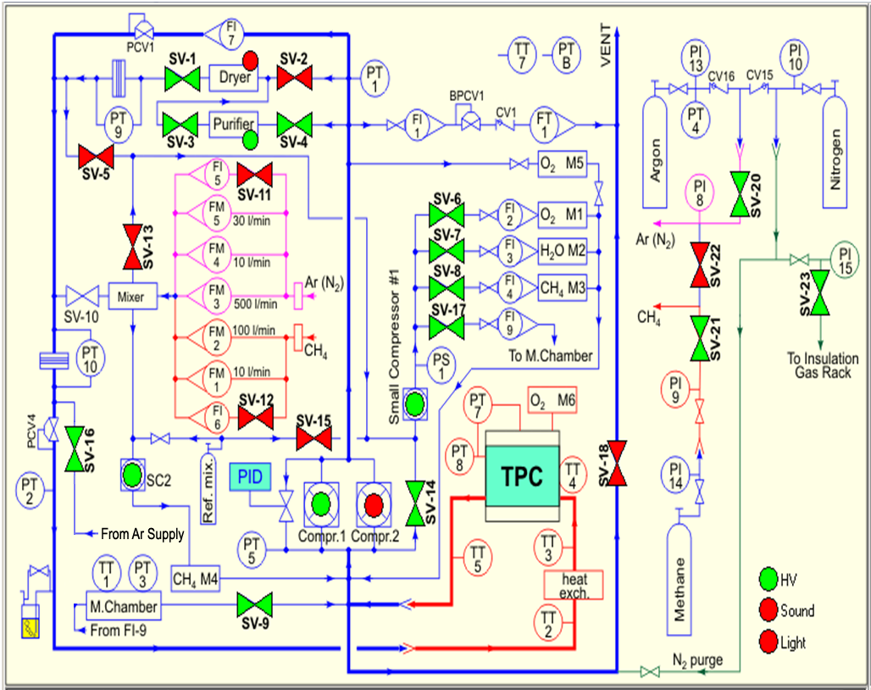
Figure 1: Gas System Schematic Diagram: Normal Circulation Mode Shown

