Startup of TPC gas system after summer shutdown valid 7/14/2009

This procedure brings the TPC gas system to a ready state after the long summer shutdown. During the shutdown power to all racks is off and the TPC is continuously purged with N2 through the analog flowmeter FI5. This procedure will power all racks, boot the control computer, turn on all meters (O2, H2O, CH4 etc) and start the small compressors.

- Make sure the circuit breakers on top of Racks 2, 3, and 4 are on. Turn them on if they are off - use appropriate PPE.
- Push the green button on the TPC interlock panel (Rack 4) labeled “Gas System Power”.
- Check that the red LED on the solid state relay mounted on the wall between Racks 2 and 3 is on - this supplies the power to Rack 2.
- Turn on the CAI methane meter M3a (Rack 3)
- Turn on the two Illinois Oxygen meters M5 and M1 (AC switch on the back of each meter inside Rack 3)
- Open the exhaust valve for M1 and M5 (mounted on the back of the meter)
- Crack open the input valve on M1 and M5 ¼ turn (mounted on the back of the meter.)
- Plug in the small compressor SC3 (located inside Rack 3) (Supplies flow to M5)
- Adjust the flow on M5 by turning the input valve - set flow to be between 0.1 and 0.2 lpm. If you need to make a courser adjustment than is allowed by the input valve, then adjust the unmarked bypass valve that goes around SC3.
- Turn on the CAI methane meter M4 (top of Rack 2)
- Confirm that there is N2 flowing to the TPC through FI5 (Rack 2) - adjust to the arrow if needed.
- Turn on the lower hardware alarm box (Rack 1). The AC switch is on the back of the box.
- Turn on the power for the SCXI input/output crate (Inside Rack 1)
- Turn on the power for the temperature controller MUX box (Inside Rack 1). AC switch is on top of the box.
- Turn on the power for the three Hastings mass flow controllers (Rack 1). The AC on is a rotary dial on each controller.
- Plug in the water meter M2 (inside Rack 1)
- Turn on the control computer and monitor and allow it to boot up.
- Log into the control computer and start the gas system control program - double click on the icon labeled “Star_New”.
- Using the control program close SV12 if it is open. (Closed = red)
- Open SV13 (open = green). This is the inlet valve for the small compressor SC1
- Open SV6,SV7, SV8, SV17
- Using the control program, start Small Compressor 1 (SC1) and Small Compressor 2 (SC2).
- Check the output pressure for SC1 on PI2 (Rack2). Adjust the pressure to be between the marks using the bypass valve MV16.
- Check the output pressure for SC2 on PI8a (back of Rack 2). Adjust the pressure to be on the indicator line using the bypass valve MV17.
- Check the flow for M2 on FI3 (back of rack 2). See the checklist for flow range.
- Check the flow for M4 on FI2a (front of Rack 2) and adjust if needed.
- Check the flow for M3a on FI4 (front of Rack 3) and adjust if needed.
- Adjust the flow for M1 Oxygen meter by turning the input valve for M1 (inside Rack 3) - set the flow between the marks on FI2. (This is very sensitive!)

This next section starts the meters and pump for the gap gas (N2):
During the summer shutdown, ~ 10 lpm N2 goes to the gap through FI10 (Rack 3).

- At Rack 4, open MV52 and close MV54 - this path selects fresh gas for the meters.
- Plug in M7 (H2O) (inside Rack 4) and turn on M6 (O2) (AC switch on back of the meter.)
- Check that FI10 (Rack 3) reads ~ 10 lpm.
- Turn on the sample pump (switch on the control panel in Rack 4)
- Check the sample flow (FI55) - it should be ~ 2 lpm.
- Let the meters warm up for a few hours.
- Open MV52 and close MV54 - this will sample the return gas from the gap.
- After a few hours, check the meters readings. H2O < 10ppm, O2 < 20 ppm.

If this startup is in preparation for a new run, then you can also do the following steps:

- If Leonid has already regenerated the purifier and dryer and the run will start in a week or so then turn the Purifier on using the computer control, The purifier will come on and heat up to the set point (~ 210 degrees C). Check after a few hours that it is regulating at this setpoint. For normal running the dryer is OFF.
- Check that the computer data is being written out to slow controls. In the lower task bar (right side) find and left click on the icon “EPICS communicator”. If the data is being successfully written you should see the message “Data saved to files” with a date and time stamp. The box next to “File writing to” should be checked and the path should be \\sc.starp.bnl.gov\gas_sys_data\ The box labeled “Direct connection to Epics channels” should NOT be checked. This process writes the gas system data to SC. You should also check the gas system GUI on CHAPLIN (accessible from the Top Level GUI) - the data should be refreshed every ~ 1 minute. If the data is not being written to SC or is not being updated on the GUI contact Wayne Betts and a slow controls expert. Also see page 148 in the gas system logbook.
- If this is the start of a new run you also need to create a new local database on the gas system control PC. In the task bar (lower right) left click on “dbwriter”. You should see the message “Data saved to database” with a date and time stamp. Click on the “Create New Database” button and create a new database identified by the year’s run number (currently Run8). Close the window. Then from the desktop open the program dBviewer and click on “Change database”. Select the new database that you just created (should be in the folder “databases”). After a few minutes , check that the dBviewer program is displaying data from the new database (i.e. there should not be any data before the current day.)

Go to the “Procedure to start 100 lpm Argon Purge in TPC”.

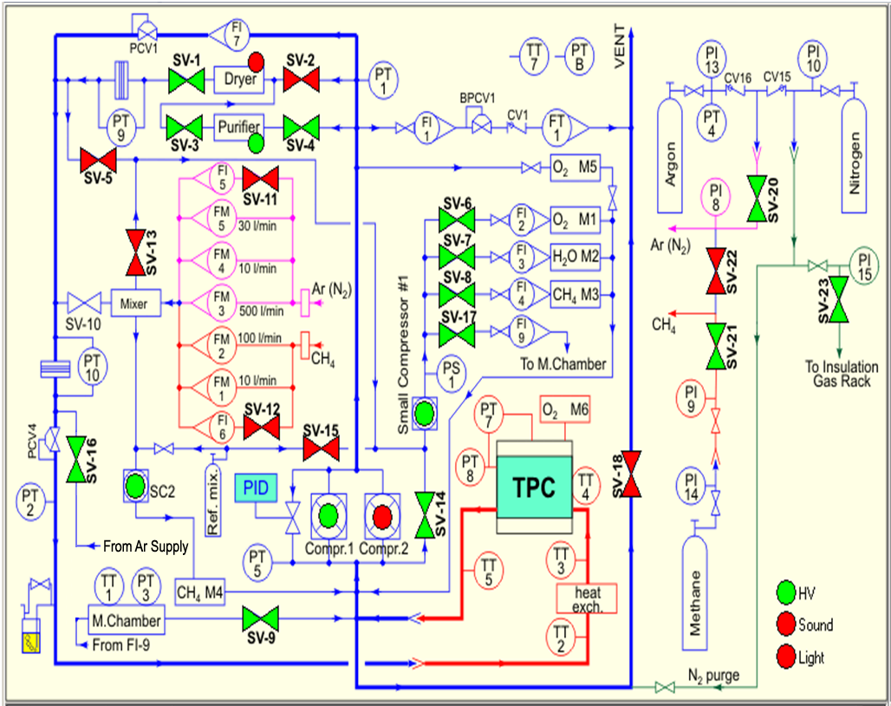
Figure 1: Gas System Schematic Diagram: Normal Circulation Mode Shown

