TPC INTERLOCKS MANUAL

Blair Stringfellow
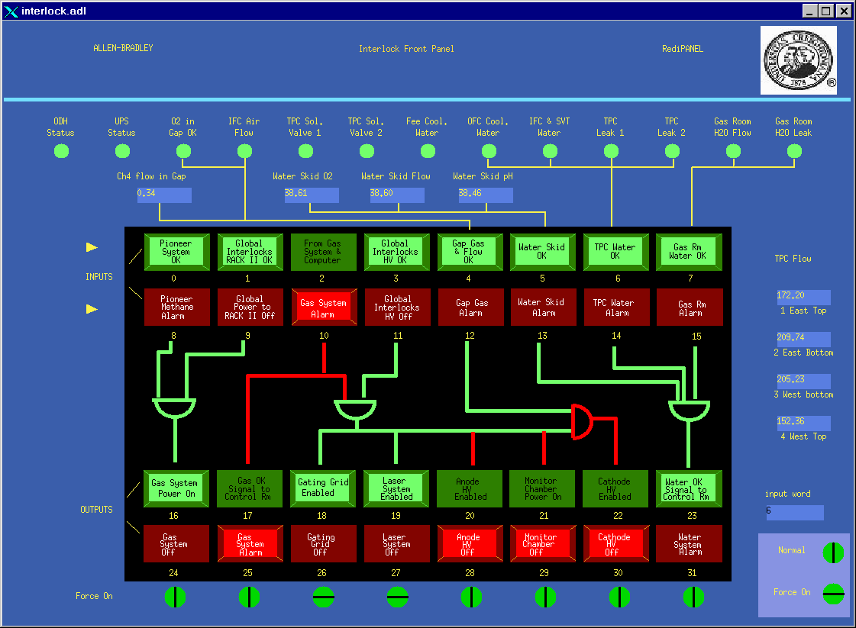
5/2/00

INTRODUCTION

The STAR TPC interlock system is a stand-alone Allen-Bradley PLC that is primarily
used to automatically protect the TPC and sub-systems. It receives inputs from various
sources and takes actions according to programmed logic. This document is intended
to be a guide for dealing with the interlock trips that may arise and getting the TPC
safely running again. See also the document SOP-TPC-GAS-06-A, “Allen Bradley
Interlock system for the STAR TPC Gas System” by Jim Thomas.

NOTE: The PLC takes actions AUTOMATICALLY without operator intervention
if unsafe conditions arise. This document is meant as a guide for the operator
to figure out what happened, how to correct the problem, and get running again.
Even though there is some override capability built into the system, YOU
do not have authority to implement these overrides! Running with a bypassed safety
system can only be attempted for debug purposes and only with the permission
of Blair Stringfellow or Howard Wieman (in consultation with STAR and RHIC
safety officers.) Ignoring these guidelines can result in severe damage to the TPC
and/or denying STAR permission to run.

The TPC interlock system was implemented and is maintained by Jim Thomas (LBNL).
Operational questions should be addressed to him or to Blair Stringfellow.

BLOCK SCHEMATIC

SGIS PASS THROUGH
MASTER TPC PLC

LIGHTS & BUTTONS&
OVER RIDE KEYS

RACK # 4
TPC GAS SYSTEM
GAS MIXING ROOM
RICH PLC

GAS MIXING
ROOM
REMOTE TPC SLAVE
PLC

RACK 2A8
SGIS:
STAR GLOBAL
INTERLOCK
SYSTEM

MASTER PLC

DAQ
ROOM
RACK DC5
SGIS
REMOTE PLC

RACK 2A1

The master TPC PLC is in the gas mixing room in Rack #4 of the TPC
gas system. This is the main indicator/input/override panel. A representation of this
panel (and additional inputs) is available in the control room via slow controls.
On the top level TPC GUI, click on the “Interlocks” button.
The master TPC PLC communicates over fiber optics with the main
STAR GLOBAL INTERLOCK SYSTEM (SGIS) PLC located in the DAQ room.
It also uses a remote (slave) PLC on the platform (back of RACK 2A8) to collect
sensor inputs and send out permissives to various HV power supplies etc.

ALARM ANNUNCIATION

TPC interlock alarms (also called gas alarms) are indicated in four separate places
simultaneously in the STAR complex:

1. Control room – a box is mounted on the wall containing two
sets of red/green lights, a beeper and an acknowledge (silence) button.
One set of lights is for gas alarms, the other for TPC cooling water
skid problems. For normal running, both lights will be green.
For an alarm, one or both lights will be red and the beeper will
sound.

2. Counting house – a similar box is mounted in the counting house.

3. Gas Mixing Room – There is a large mechanical bell mounted
on the wall of the Assembly Building (AB) just outside the gas mixing
room. For any type of TPC alarm this bell will sound. There is also
a flashing red light mounted on the top of Gas Rack #3 in the mixing room.

4. Detector – There is a loud horn and flashing red light mounted on the
second level of the south platform. This will go off for any TPC alarm.

The global interlock system (SGIS) can also sound alarms. In the control room
and counting house there is a separate box (2 red lights and beeper) for SGIS.
In addition, SGIS can INDEPENDENTLY sound the horn on the detector
for a global alarm. Note that for a major detector problem it is entirely possible
for ALL alarms to go off simultaneously since the TPC system and SGIS have
a significant degree of overlap.

TURNING OFF THE ALARM

For some alarms up to five bells or beepers will be sounding. The first job is
to acknowledge (and silence) the alarms:

1. Control room and counting house – for a TPC gas or water alarm, push the acknowledge button on the beeper box and then go to the gas mixing room.

2. Gas mixing room and detector – The alarm silence pushbutton is located in TPC Gas Rack #4 near the PLC panel Pushing this button silences the alarm
in both places.

3. SGIS Alarm – go to the DAQ room, Rack DC5 and push F3 on the touch
panel (Alarm Silence)

Note that silencing the alarm has in NO WAY solved the problem – it just gives
you peace and quiet to get on with finding out what went wrong.

TPC INTERLOCK PANEL & SCHEMATIC

The TPC interlock front panel in the gas mixing room has lights and
push buttons that reflect the status of the inputs (sensors) and condition of the
output permissives. As shown in slow controls, the panel looks like:

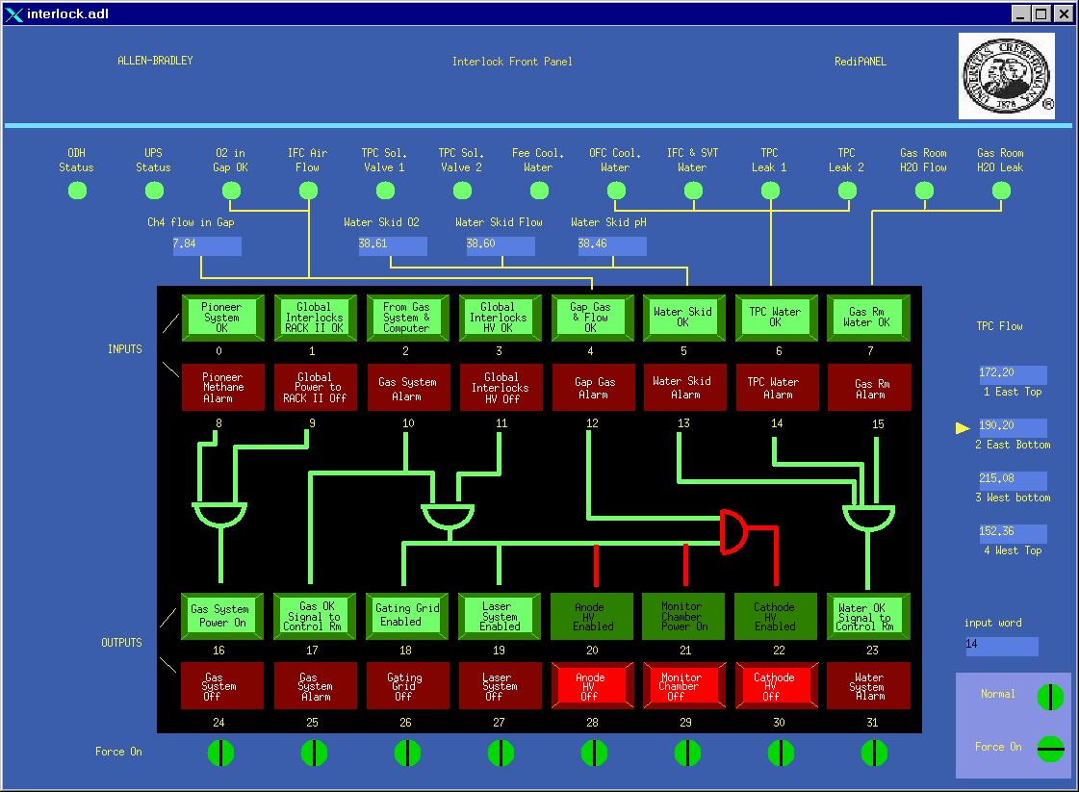

The top two rows of lights are indicators only, reflecting the status of the various
safety system inputs. As shown, all inputs are green (= OK to run). If one of the inputs
goes to red (= not OK) the affected subsystem will lose its permissive and the alarm
will sound.
The bottom two rows of lights are both indicators and buttons. As shown,
three subsystems currently do not have permission to turn on (Anode HV, Monitor Chamber and Cathode). Since the inputs for these systems are OK (i.e. all the inputs in the top row are green) their permissive can be enabled by pushing the corresponding green output buttons.

NOTE: After an alarm that drops a permissive the output will stay in a not OK
state (latched off) even after the problem has been fixed. You must go to the
gas mixing room to re-enable each output after an alarm.

The output lights/buttons have two additional states. A permissive can be
FORCED OFF at any time by pushing the corresponding red button. The light will
then flash. A flashing red light means someone wants the system to stay OFF, so
you need to find the reason for this. An output can also be FORCED ON by
using an override key – this can only be done by the TPC subsystem manager
or his designate. Note that OUTPUT permissives can be over ridden – inputs can not be.

The slow controls GUI for the interlock system contains additional information
that is not shown in the gas mixing room.

The row of round status lights across the top show various sensor inputs to the system. Also, the four TPC cooling water flow rates are shown on the right.. A more
complete logic schematic for the interlock system is shown on the next several pages:
Attachment 2: Allen Bradley Logic Diagram
Attachment 2: Allen Bradley Logic Diagram (continued)
Attachment 3: Allen Bradley Crate & Module Map
Attachment 3: Allen Bradley Crate & Module Map (continued)

ALARM RESPONSE FOR OPERATORS

In the following pages, each type of alarm will be explained. Specifically, for
each input to the interlock system, the following information will be given:

1. INPUT: Where the sensors are located, what they are measuring, and what the
alarm threshold is.

2. ACTIONS TAKEN BY PLC: What actions are taken by the PLC and what subsystems are affected.

3. RESET: What needs to be done to reset the interlock, including who
to call if it is not solely STAR’s responsibility.

PIONEER METHANE DETECTOR

The Pioneer methane detector checks for leaks in the gas mixing room. The controller
is mounted on the south wall between TPC Racks 1 & 2.

INPUTS: There are three sensor heads in the mixing room. One is mounted on
top of TPC Rack 2, another is mounted inside TPC Rack 3 and the
third is located at the bottom of the RICH gas rack. The sensors are
sniffing the room air for the presence of methane and will alarm
for a concentration of 18% LEL Methane in air. (LEL = Lower
Explosive Limit = ~ 5% in air).

ACTIONS TAKEN BY PLC: For any ONE of the three sensors above threshold, the following actions are taken:

1. AC Power to Rack 2 of the TPC gas system is cut. This puts the
TPC gas system into purge mode (Argon) and closes the methane
inlet solenoid valves.

The power to Rack 2 comes from a three phase solid state relay mounted
in a box on the south wall of the gas mixing room between racks 2 & 3.
The power is held on by the 24 volts control voltage supplied by the
interlock system. Absence of this control voltage drops the power to
Rack 2.

2. ALL permissives for the TPC HV are dropped (Gating Grid, Laser,
Anode, Monitor Chamber, & Cathode)

3. The RICH gas system goes into safe mode.

RESET: This is a MAJOR alarm and recovery can not be attempted by shift
leaders alone! CALL:

TPC Expert
TPC Gas Expert
RICH Expert

GLOBAL INTERLOCKS RACK II OK

This is an input from the STAR Global Interlock System (SGIS) that permits
the TPC gas system to run with P10.

INPUTS: There are two conditions that cause the permissive to be removed:

1. High Level Alarm: High Sensitivity Smoke Detector.(HSSD) This is a system that senses smoke around the detector in the WAH.

2. High level gas alarm. There is a sniffer system located in Rack 2A2
that draws air samples from the TPC face through 8 separate tubes.
If methane is detected at the level of ~ 12% LEL, the unit generates
a high level alarm.

ACTIONS TAKEN BY PLC: For a HSSD High Alarm:

1. After a 10 minute delay, drop the permissive for the gas system.

For a High Level Gas Alarm:

1. Immediately drop the permissive for the gas system.

Upon removal of the permissive, the power to Rack 2 of the TPC
gas system goes off, the TPC is purged with Ar and the methane
inlet valves are closed.

NOTE: The TPC volume is 50,000 liters of P10. The Argon purge
is at the rate of ~ 120 lpm. To purge the TPC to a level that is considered
safe by CAD (i.e. P8) takes ~ 1 hour.

Both these alarms are major STAR alarms and the SGIS will take
further action, such as tripping platform power. See the SGIS manual.

RESET: These are major STAR alarms that result in complete shutdown of the
STAR detector. For HSSD, the fire department will be on the way.

Call: MCR X4662
STAR Global Interlock Expert
TPC expert
TPC gas expert
FROM GAS SYSTEM & COMPUTER

This is the input from the TPC gas system. The gas system has its own system of
interlocks and alarms, which can come from the hardware alarm box (top of Rack 2)
or from the control computer (Rack 1). These alarms can be of varying degrees of
severity, but they are ALL annunciated through the Allen-Bradley system.

INPUTS: The gas system alarms can be split into two broad categories:

1. High level alarm – usually indicates something wrong with the
TPC pressure, methane content etc. Various actions are taken
by both the gas system itself (compressor turned off, vent opened)
and by the Allen-Bradley PLC (see below)

2. Low level (informational alarms). Usually indicates a non-
emergency problem (gas bottle low, delivery pressure not adjusted etc)

ACTIONS TAKEN BY PLC:

High level alarms that turn off the permissives for the TPC HV
(Gating grid, laser, anode, monitor chamber and cathode.)

From the computer:
TPC pressure too high (PT8)
TPC pressure too low (PT8)
Oxygen too high (M1)
Water too high (M2)
Ar-Methane flowmeter ratio too high
Ar-Methane flowmeter ratio too low

From the hardware alarm box:

Return Pressure from TPC too high (PT5)
Return pressure fromTPC too low (PT5)
Oxygen too high (M1)
Water too high (M2)

Truth tables for the gas systems (with alarm limits) are posted in the
gas mixing room.

For low level alarms, the PLC merely sounds the alarm (“gas alarm”
in control room, counting house, AB and WAH). No other action is taken.

RESET: ANY gas alarm needs attention from a gas system expert – call.
GLOBAL INTERLOCKS HV OK

This is a separate input from the global system (SGIS) which permits the TPC HV to
be turned on. There is a significant overlap between this input and the “Global Interlocks
RACK II OK” (see above), since putting the gas system into purge mode will independently turn off all HV. However, this input adds one more condition dealing with
water leaks.

INPUTS: There are three conditions that cause the HV permissive to be dropped:

1. High Sensitivity Smoke Detector (HSSD) High Alarm.

2. High level gas alarm – from the methane sniffer in Rack 2A2.

3. Cooling water leak – east TPC face, west TPC face or RICH.
There are three “Tracetek” water detection cable circuits that loop
through the water cooling manifolds of the TPC and RICH. Any
alarm from these circuits causes the HV to trip and the TPC water
skid to shut down (see below).

ACTIONS TAKEN BY PLC: For a HSSD High Alarm:

1. Causes an immediate trip of the HV (but a 10 min delay before causing a gas system purge – see above). Note also that this alarm turns
off ALL power on the platform, so it is triply redundant.)

For a High Level Gas Alarm:

1. Trips all TPC HV ( and power to the platform)

For a Water Alarm:

1. Trips all TPC HV (Gating Grid, Laser, Anode, Monitor Chamber &
Cathode) and shuts down the water skid (see below under “TPC Water
OK”).

RESET: Again, the smoke and gas alarms are major STAR alarms that shutdown
the whole detector. Call MCR, SGIS expert, TPC gas expert.

A water alarm will require an access to investigate the cause and
to reset the Tracetek controller (Rack 2A1). See below under “TPC Water
OK”.

GAP GAS & FLOW OK

Between the TPC outer field cage and the outer gas containment vessel is a
5 inch gas insulating gap. This volume is continuously purged with dry nitrogen,
which acts as the insulator. The return gas is sampled to test for oxygen,
water and methane. The controls and meters for the insulation gas system are
in Rack 4 in the gas mixing room. In addition, to prevent a possible buildup of
Methane in the inner field cage region (where the SVT is mounted), a continuous
flow of conditioned air is maintained. The air blower is maintained by the SVT group
and sits in the WAH on the floor (east end of the magnet). This are is not sampled,
but there is a flow switch in the exhaust line.

INPUTS: 1. Oxygen in gap is < 200 ppm. The Oxygen meter (M6) is mounted
in Rack 4 in the gas mixing room.

2. Methane in gap < 18% LEL. The methane meter is in Rack 4
in the gas mixing room (M8).

3. IFC air flow ok. The flow switch is mounted in a grey PVC tube
which comes from the SVT cover plate on the west side. The
end of the tube (and the switch) is mounted on the magnet face.

ACTIONS TAKEN BY PLC: 1. For high oxygen, high methane, or no IFC flow the permissive for the cathode only is dropped, since it is the only ignition source in these regions.

RESET: 1. For a high oxygen or high methane, contact a TPC gas system expert.

2. For the IFC air flow, request an access and check the SVT air
blower. If ok, check the flow switch – it has a red LED that should
be OFF if the flow is ok. If the interlock still won’t clear, contact
a TPC expert or Jim Thomas (interlock expert.)

Note: The only place to check the status bit of the IFC air flow is on the
slow controls Interlock GUI accessible from the top level TPC
GUI. The status is indicated by the “IFC Air Flow” light (green = ok).

WATER SKID OK

This input has not been implemented yet and should always be OK (= green).
It will eventually have inputs from the TPC water skid (located in AB second
floor utility room) indicating total water flow, dissolved oxygen and pH.

TPC WATER OK

The TPC water skid (located in the second floor utility room) supplies water
for the TPC FEE and read-out boards (RDO), SVT RDO boxes, RICH safety
box and the gas mixing room. The skid exchanges heat with the STAR Modified
Chilled Water (MCW) that is also cooling the racks on the platform and in the DAQ room. In general, the interlock system is checking for minimum flow rates in
all branches and for leaks.

INPUTS: 1. Flow rates from the four main cooling branches:
East top, East bottom, West Top, West Bottom
The flow meters are mounted on the magnet face, shielded
by mu metal.
2. Global HV OK (see above)
3. Flow rate from the branch that circulates water along the
outer containment vessel (called CTB flow on the schematic).
4. IFC & SVT Flow – a dummy input always OK.
5. TPC leak #1 & #2 – from the east and west Tractek leak
detection circuits threaded through the cooling manifolds.
6. RICH leak – independent Tracetek circuit for the RICH loop.

ACTIONS TAKEN BY PLC: For any alarm (low flow, Global HV or leak) the platform slave PLC for the TPC will close the main supply and return valves for the cooling water. This will cause the skid to shut down.

The TPC water alarm will sound (second red/green light in the
control room and counting house) and if there is a leak there
will also be a global alarm.

The valves are located in the water lines just after they cross
from the west wall to the magnet. They are driven open or closed
by 110 VAC. There is an indicator on the backs of the valves
which shows if they are open or closed.

RESET: For a leak:

An access will be needed to check for the source of the leak.
With the pole tips in this may be non-trivial! Also, the Tracetek
control units, mounted in Rack 2A1 have a reset button that has to be
pushed before the alarm can be cleared. For a real leak, the
control box will have a red LED status light on. Once the source of the
leak alarm has been determined, the skid can be restarted. Note that
the leak indication MUST be cleared both at the controller and at the
Global PLC.

Restarting the skid:

The skid will be shutdown for an alarm, but it can also trip off
during a power dip etc. To restart:

Call the CAS watch (X2024) or MCR (4662) and request that they send a
pump room person over. The skid is the responsibility of CAD but the
interlocks and permission to restart are STAR’s responsibility. DON’T restart the skid unless you are satisfied that there are no leaks in the WAH!

Before restarting the skid it is necessary to over ride and open the
main supply and return valves. Go to the back of Rack 4 in the gas mixing
room and locate the two keys labeled “TPC H2O OVRD” and “GAS RM
H2O OVRD”. Turn both keys to the over ride position (horizontal).
This will force the supply and return valves open. On the front
PLC panel (Rack 4) the top green lights labeled “TPC Water OK”
and “Gas Rm Water OK” should be flashing green.

Tell the pump room tech to start the skid. When the skid comes up to
full flow, a green ok light will come on (near the start pushbutton).
Check that the skid flow is ~ 270 GPM or greater (flow meter on the
skid front panel.) If skid flow looks ok, return to the gas mixing room
and return both keys to the normal (vertical) position. The green light
near the keys (labeled “FEE cooling water ok” should be green and
the two lights on the PLC panel should be green and not flashing.

If the alarm goes off again when you turn the keys to normal, then
there is still a problem and the skid will shutdown again.

NOTE: NEVER run the TPC skid with the keys in over ride for longer
than it takes to restart the skid. In override there is NO leak protection
and the entire contents of the reserve tank could be dumped on the
experiment.

GAS ROOM WATER OK

A branch of the TPC water line is used to cool equipment in the gas mixing room.
The lines are located on the south wall of the AB just outside the gas mixing room.
A manifold with visual flowmeter, flow switch and solenoid valves is also located
there. The water is used in three of the TPC gas system racks:

1. Rack 1 for the Rosemount methane analyzer water jacket.
2. Rack 2 for the heat exchanger after the compressor and for
the mass flowmeters.
3. Rack 3 for the cooling jackets of the two Rosemounts.

Leak detection is provided by a local Tracetek circuit with the controller mounted
in back of Rack 4.

INPUTS: 1. Flow switch ok – mounted on the manifold outside the mixing room.
Flow >` 1 GPM = OK.

2. Tracetek leak detector ok.

ACTIONS TAKEN BY PLC: For lack of flow or leak indication:

1. Close the local supply and return solenoid valves mounted
on the manifold. The solenoids are powered open (110 VAC)
by supplying a 24 V control signal to a solid state relay mounted
in a box on the south wall of the AB.

2. Sound the TPC water alarm in the control room, counting house,
WAH and AB.

Closing the gas room water solenoids will NOT affect the water
skid – it will keep running. Lack of cooling water to the gas system
is not necessarily a major alarm. However, the Rosemount methane
analyzers will quickly lose calibration and the gas being sent to the TPC
will not be constant temperature.

RESET: For a leak, find the source and fix it. After the leak has been repaired,
allow the Tracetek cable to dry out and then push the reset button
on the Tracetek controller (back of Rack 4). Then turn the over ride
key labeled “Gas Rm H2O OVRD” – this should open the
solenoid valves. Go to the water manifold outside the mixing room
and check that the visual flowmeter shows ~ 2 GPM and that the
LED on the flow switch is out.

Return the over ride key to the normal position.
HARDWARE CONNECTIONS

The following is a brief description of how the PLC controls each system:

1. Gas system:
The power to Rack 2 comes from a three phase solid state relay mounted
in a box on the south wall of the gas mixing room between racks 2 & 3.
The power is held on by the 24 volts control voltage supplied by the
interlock system. Absence of this control voltage drops the power to
Rack 2 . This will cause the gas system to close the methane inlet valves,
open the vent valve, and start an Argon purge (~75 lpm).

2. Gas system alarm:
1. The alarm boxes in the control room and counting house are home
built devices containing lights, relays and a reset switch. They get
power from local AC to DC converters. The signals from the
PLC get to the alarm boxes using phone lines.

2. The alarm bell in the AB (mounted on the wall outside the gas mixing room)
is a 110 VAC bell controlled by a solid state relay mounted in a box
nearby. The PLC supplies the control voltage (24 V) for the relay.

3. The alarm horn and light mounted on the platform in the WAH are
controlled from the remote TPC PLC.

3. Gating Grid – the VME crate for the gating grid driver modules (Rack 2A6) has
an inhibit input at the front of the crate (DB15 connector). The remote PLC
on the platform supplies 24 volts for this input, which is dropped to 12
volts by a Zener diode in the connector hood. A voltage < 12 volts = inhibit.

Note: The pulser VME crate (Rack 2A5) has a similar inhibit input (for
historical reasons.) Thus, even though the pulser is not an ignition source,
it has the same interlock as the gated grid, also supplied from the remote
PLC via a DB 15 connctor.

4. Laser System – the laser system is interlocked by a contact closure from the remote
PLC. (Contact closed = OK to run.) The cable goes into the laser interlock
box mounted in back of Rack 1A9. (Burndy twist lock connector).

5. Anode HV off – the interlock for each Lecroy HV crate is supplied by the remote
TPC PLC. The permissive to run is a contact closure supplied on a BNC
cable which plugs into the “Macro” input on the front of the Lecroy crates
(Rack 2A7). We use the macro input in place of the normal interlock input
since it is remotely resettable.

6. Monitor Chamber – the monitor chamber is located inside Rack 3 in the gas
mixing room. It can be used to measure electron transmission in the
TPC gas ( in case of questions about gas quality). Under normal condirtions
the chamber is OFF and is of no concern. It is interlocked by turning
off the Nim Bin which contains the HV modules. The Nim Bin is mounted
in Rack 4 of the gas system.

7. Cathode HV – the Glassman HV power supply (mounted in Rack 2A3) is interlocked
by a contact closure from the remote TPC PLC.. The cable attaches to
the TB1 terminal strip on the back of the Glassman. (See the Glassman manual
and documentation supplied by Greg Harper from U of Wash.)

8. Water System Alarm – the water skid is shut down by powering closed the supply
and return valves located in the WAH. This slows the flow enough that the
flow switch on the skid interupts the pump power. The AC power to drive
the valves is controlled by the remote PLC, with the AC coming from the
UPS at the top of Rack 2A9. The power for the five water flowmeters
also plugs into this UPS, as does the PLC itself.

