Valid for RUN 7 and beyond 3/1/2007

Minor Updates by Jim Thomas 7/14/2009

TPC

SHORT OPERATIONS MANUAL FOR

DETECTOR OPERATORS
(written by Blair Stringfellow)

Table of Contents

1. Rules of operations:

1.1 FEEs………………………………………….pg 2
1.2 HV……………………………………………pg 2
1.3 Frequency and method for pedestal run………pg 2
1.4 Frequency and method for laser run………….pg 3
1.5 Frequency and method for pulser run………...pg 3

2. Operations for various subsystems:

2.1 Boot up of control computer…………………..pg 4
2.2 VME crates & Processors……………………..pg 5-6
2.3 Interlocks……………………………………...pg 7
2.4 FEE’s & MWC FEE’s………………………...pg 8
2.5 Gated Grid…………………………………….pg 9-10
2.6 Cathode and field cage………………………..pg 11-13
2.7 Anode & trips…………………………………pg 14-19
2.8 Laser…………………………………………..pg 19
2.9 TPC alarm handler…………………………….pg 20

3. Alarms:

3.1 Gas alarms……………………………………..pg 21
3.2 Water alarms………………………………….. pg 21

4. Call list of experts…………………………………………pg 22

5. TPC state table for various runs…………………………..pg 23
1. Rules of Operation

1.1 FEE’s (Front End Electronics)

There are two sets of FEEs (and RDOs) for the TPC:
1. The pad plane FEE’s
2. The MWC FEE’s that terminate the anode wires.

Both sets are cooled by the TPC water skid (nominal temperature = 75 F). The temperature is monitored by a computer program which periodically reads out 120 thermistors mounted on the FEE and RDO cooling manifolds. These temperatures are displayed in a GUI available from the top level TPC GUI.
These temperatures are also watched by the TPC alarm handler (alarm = 80 F).

RULE 1: If the overall average reads > 80F, power down the FEE’s and MWC FEE’s until the cooling problem is solved.

The TPC water skid exchanges heat with the STAR Modified Chilled Water (MCW). To maintain the TPC
at 75, the MCW must typically be < 64F. A problem with the TPC cooling water temp can usually be traced to a MCW problem. Note also that the FEE’s are interlocked to the TPC water skid – a loss of flow will automatically turn off the FEE’s.

Because of an uncertainty about induced currents associated with the magnet, we also have:

RULE 2: Turn off all FEE’s and MWC FEE’s when the magnet is being ramped up or down.

1.2 HV

Ultimate responsibility for the safe operation of the TPC rests with the Detector Operator! For this reason,
the final authority for turning on (and off) the HV also rests with the detector operator. To protect the TPC,
the most important rule is:

RULE 3: The anode and cathode HV are to be kept OFF UNTIL RHIC has stable stored and cogged beams. There are NO exceptions to this rule except by explicit permission from Blair Stringfellow or Howard Wieman.

We have seen both field cage sparkdowns and multiple anode trips that were clearly beam induced. This can happen at any energy and any intensity. Note that this means turning ON the HV AFTER the beams are stored AND turning OFF the HV BEFORE the beams are dumped. It is the detector operator’s responsibility to encourage the shift leader to always get advance notice of a beam dump.

1.3 Frequency and method for Pedestal Runs

It is now possible to save the TPC pedestal values on disk, so a DAQ reboot doesn’t necessarily mean having to take a new pedestal run. Pending further study, it is recommended to take a pedestal run at least once per shift. Pedestal runs are configured through trigger and DAQ. Number of events > 250.
The state of the TPC should be:

FEE’s and MWC FEEs ON
Gated Grid ON
Cathode HV on or off
Anode HV at pedestal values or less (pedestal values are Inner = 500V, Outer = 500V)

1.4 Frequency and method for Laser Runs

Laser runs are used to check the TPC drift velocity, and should be taken once a store, usually 1 hour into the store. (The STAR Period Coordiantor may define a different schedule so check with your shift leader or the STAR Period Coordinator for an update on this schedule.) You should stop the current physics run and make a dedicated laser run. (Include Trigger, DAQ and TPC in run control – NO other detectors.) The DAQ rate for a normal laser run should be 10 Hz, triggered by the free running laser. To turn on the laser see the separate laser operations manual. The TPC’s operating parameters (HV) are the same for laser runs and physics runs. The TPC drift velocity is automatically calculated online from event pool events. The result shows up in the online histograms. Typically, ~ 2000 laser triggers are sufficient to calculate a drift velocity. For long stores (typical of pp)
take a laser run every ~ 4 hours after the first one.

1.5 Frequency and method for TPC Pulser Runs

Pulser runs are used to check the TPC FEE’s and RDO’s. They can be taken at any time by reconfiguring trigger and DAQ for a pulser run. A pulser run should be taken once a day, typically during times with no beam. For a pulser run:

Use the LOCAL oscillator (not the RHIC clock)
Make a TPC pedestal run, then a pulser run.
FEE’s and MWC FEE’s ON
Gated Grid On
Cathode On or Off
Anode Off or at or below pedestal values (Inner = 500V, Outer = 500V)
2. Operations for Various Subsystems:

2.1 Boot & setup of Control Computer

All operations for the TPC are controlled from the PC Chaplin-XXX.starp.bnl.gov located in the STAR control room. To get started, log on to Chaplin (username and password posted in the shiftleader’s notebook). After boot, start a putty session to sc5.starp.bnl.gov and start the TPC top level control GUI by issuing the command “tpc_top”. The startup sceen looks like this: (this process is slow – WAIT)

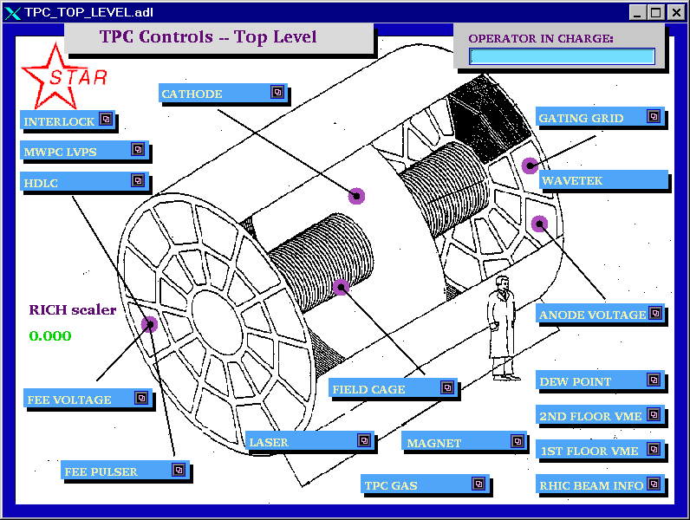

To simplify the controls for the various subsystems. Chaplin is set up to run 9 virtual desktops, each labeled for a specific function:

1. Anodes
2. Cathode and field cage
3. Gating grid
4. FEE’s
5. Laser
6. Gas system
7. Interlocks
8.VME status
9. Pad monitor/General Use.

You can switch between desktops by clicking on the appropriate number in the virtual desktop keypad in the upper right corner of the screen. Switching desktops will reduce clutter and separate each TPC control.

If you are starting from scratch, you will have to move the different screens to the appropriate desktops. See the procedure “How to Start TPC Controls.doc” for an explanation on how to do this. The document should be saved on Chaplin’s desktop (or alternatively it is stored on the TPC Operations page as a “How To” note. http://www.star.bnl.gov/public/tpc/tpc.html )

2.2 VME Crates & Processors

All TPC functions are controlled using VME CPU’s which are located in VME crates on the 2nd floor of the south platform. These crates can be remotely turned on/off using slow controls. To check the status of the crates, click on desktop 8 and select “2nd floor VME”. This will bring up the VME control GUI:

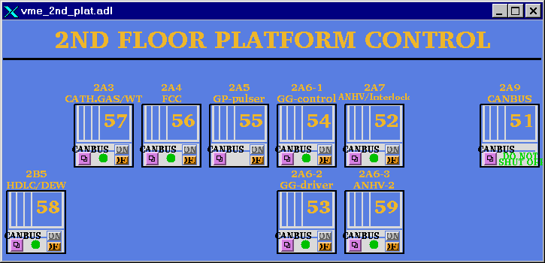

Note that crates are labeled by function, canbus number and rack number. Crate 51 is for slow controls and should not be powered off. The green dot indicates that the crate is powered on (thus, #55 is off.) To turn a crate on (or off), click and hold on the purple button, drag down and release on the “VME xx” button, where xx is the canbus number. This brings up the control GUI for that crate:
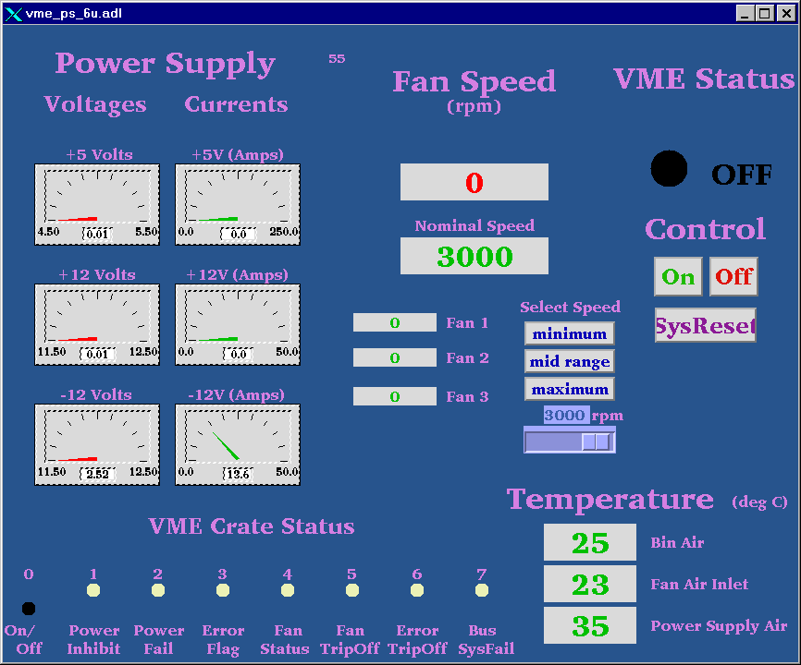

To turn the crate on, click the “ON” button. The fan speed, voltages, currents, and temperatures will be indicated. Kill the window when done.
Before proceeding, make sure all crates for the TPC are ON.
VME PROCESSORS:

Typically, there is one VME processor for each TPC control task, and one CPU per crate. (Some crates may have two processors.) These processors run VxWorks and boot from the main slow controls computer (sc3.starp.bnl.gov). There are two connections for each CPU, one via ethernet and one through a terminal server. Remote login over ethernet is reserved for the slow controls expert. If problems develop with a CPU it can be rebooted by four different methods:

1. For the Gated Grid and Inner & Outer Anodes, there is a reset button on the main GUI. Clicking on this button will reboot the processor. (These three processors crash most often.)

OR

2. Push the sys reset button on the crate’s control GUI – this reboots all processors in that crate.

OR

3. Cycle the power on the crate. (Not recommended, but sometimes necessary.)

OR

4. Login via the terminal server as follows:

On the ASTAIRE desktop, double click on the “putty.exe” icon. In the putty dialog box, double click on the session “sc5.starp.bnl.gov”. At the sc5 prompt, type the username and password (get these from the shift-leaders notebook).

On sc5, type telnet scserv xxxx, CR where xxxx is the port number for the processor.(see below)

After you are attached to the processor, hit CR. To reboot, type “reboot,CR”

After the reboot, exit the session by typing “CTRL ]” simultaneously to get back to the telnet prompt. Type quit to get back to sc3. Type exit to logoff.

ALWAYS release these terminal server sessions when you are done!

The current CPU’s and port assignments are as follows:

1.Field Cage Readout Port 9001 Crate 56 Rack 2A4
2. Gated Grid Port 9002 Crate 54 Rack 2A6
3. FEE Power supplies Port 9004 Crate 58 Rack 2B5
4. Cathode HV Port 9005 Crate 57 Rack 2A3
5. Inner Anode HV Port 9006 Crate 52 Rack 2A7
6. Ground Plane Pulser Port 9011 Crate 55 Rack 2A5
7. Interlock/TPC temperature Port 9012 Non Canbus Rack 2A7 RPS3 Plug A4
8. Outer Anode HV Port 9013 Crate 59 Rack 2A6
9. Platform Hygrometer/TPC gas Port 9015 Crate 58 Rack 2B5
10. Autoramp programs for anode & cathode – STARGATE processor in DAQ room rack DC2
at the bottom of the rack (push the reset button)

Lecroy serial session for inner sectors Port 9037
Lecroy serial session for outer sectors Port 9038
Lecroy serial session for FTPC anodes Port 9023

When a VME processor reboots, a grey MEDM Message Window will pop up with the message “network connection lost”. Close this window. Also, the relevant GUI will turn white until the processor reboots.
2.3 Interlocks

The interlock status for the TPC can be checked from the control room by selecting the “Interlock” button on the top level GUI. (This is a representation of the Allen-Bradley (AB) panel which is located in Rack 4 of the gas mixing room.) The panel looks like:
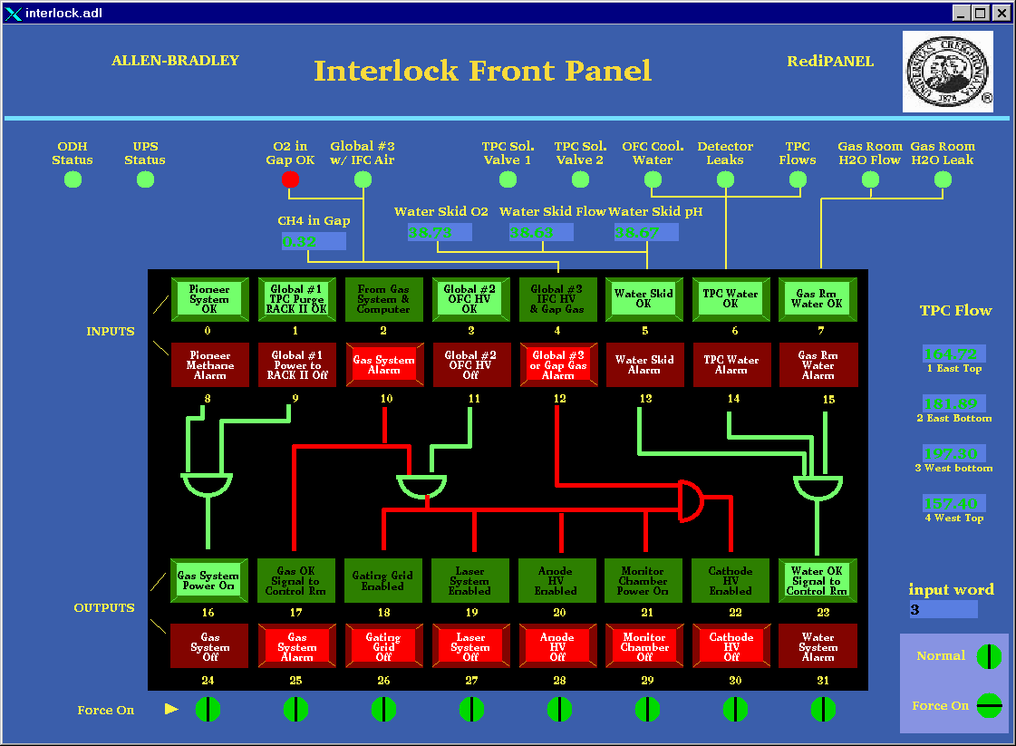

The round lights across the top and the top row of rectangular lights are status lights for the inputs to the interlock panel. The bottom two rows of rectangular lights show the status of the outputs to the various subsystems of the TPC. Under normal circumstances, ALL lights should be green. In the above example, the gas system is off, so no system can run.

Note that if, during a run, one or more of the inputs changes from OK to “not OK”, the AB PLC will take automatic action to shut down the affected subsystem or HV. NO OPERATOR ACTION IS REQUIRED to put the system into a safe state.

If one or more of the inputs changes from OK to “not-OK”, then the outputs will latch off and most TPC system cannot be operated without intervention from an expert or a trained detector operator. See the document “How to recover after a gas alarm.doc” This document explains how to recover from a simple gas alarm condition. More complex gas alarm conditions require intervention by an expert. The procedure for recovery should be saved on CHAPLIN’s desktop and is available on the TPC operations web page http://www.star.bnl.gov/public/tpc/tpc.html.

2.4 FEE’s and MWC FEE’s

To operate the main TPC FEE’s and RDOs, go to desktop 4 and select “FEE Voltage” on the toplevel GUI. The FEE control looks like this:

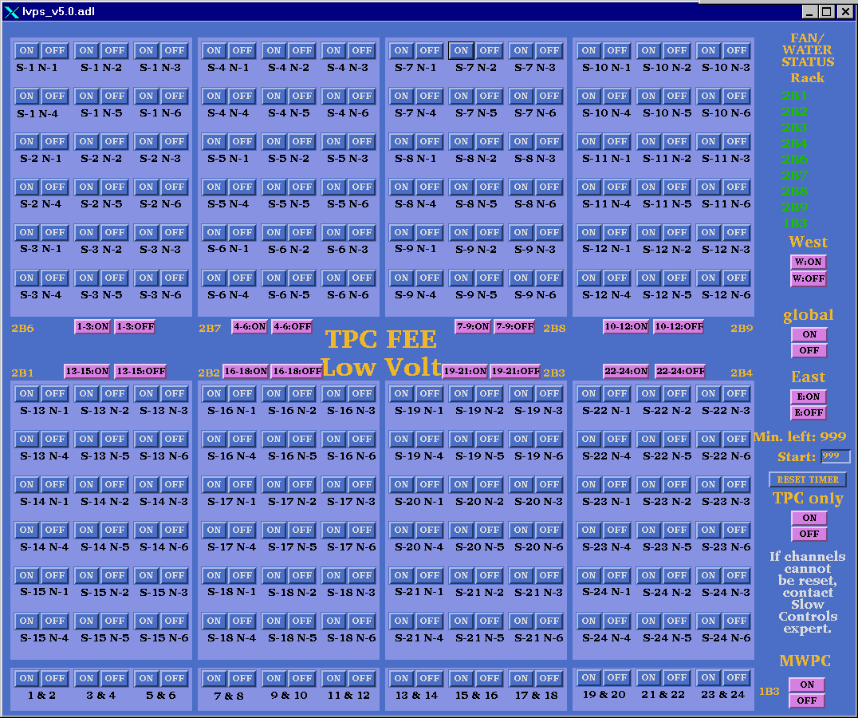

To turn all the FEE’s and RDOs on click on the “global” on button. Each of the supplies will turn green in turn. There are also “on” buttons for each rack (= 3 supersectors), east and west ends, and individual supplies. To turn off, click the corresponding “off” button.

The MWPC FEES, listed on the bottom of the screen, are obsolete and are not used. Please ignore them.

Each TPC RDO is read out by a DAQ receiver card. These cards are in VME crates and are visible from the control room. During normal data taking the LEDs on the receivers flash green as data comes in. It sometimes happens that a DAQ receiver/RDO pair will hang. This will be indicated by a slowing or stopping of DAQ and red lights on the affected receiver. For the TPC there are 12 crates of receivers with
12 cards per crate. The crates are labeled TPC 1,3,5..... Since there are 6 RDOs per TPC supersector (inner + outer) each crate reads out 2 supersectors. You can sometimes clear the bad RDO/receiver pair by cycling the power for that RDO. STOP THE RUN FIRST! As an example if the 8th card in crate TPC 3 is hung you would cycle the power for RDO S6-N2. (Crate 3 reads out supersectors 5 & 6. The first 6 cards from the left are 5-1 through 5-6, the next 6 cards are 6-1 through 6-6). If the run still freezes after cycling the power and also rebooting DAQ it may be necessary to mask out this RDO/receiver in the run. The shiftleader has instructions for this.
2.5 Gated Grid

To turn on the gated grid, go to desktop # 3 and click on “Gating Grid” on the top level GUI. This brings up the main gated grid GUI:

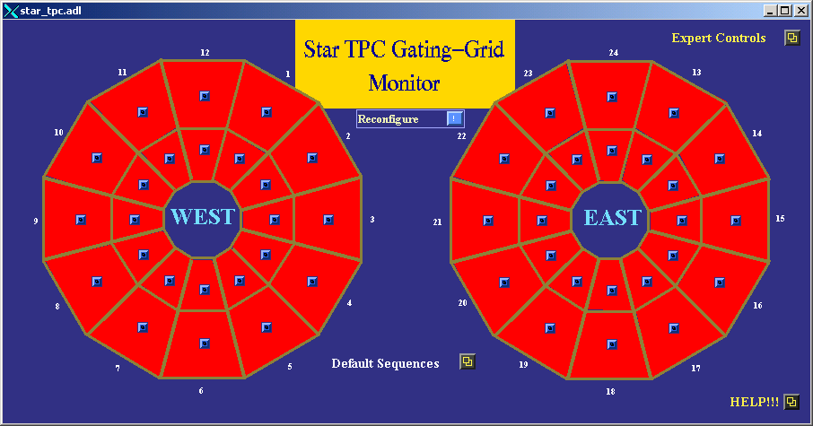

1. Click on the “Default Sequences” button. This brings up the control screen:

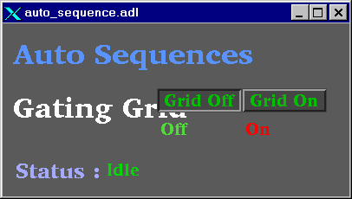

2. Click on the “Grid On” button. This will run a program to set all the GG power supplies. You should see the message “Downloading Setpoints”. It should take ~3 minutes for all sectors to come up to voltage. When the gated grid is ready, all sectors on the main screen turn green:

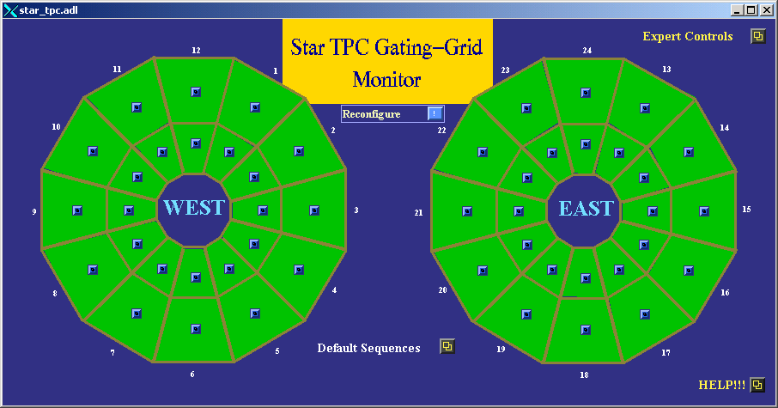

3. If the status remains “idle” after clicking on the “Grid On” button, you will have to regain control of the program. First, run the TPC anodes to zero and click “Grid Off”. When the anodes are at zero volts, click and hold on the “Reconfigure” button, drag down to “Recover control” and let go. Try the “grid on” button again. If this still doesn’t work, reboot the crate by clicking and holding on the “Reconfigure” button, drag down to “Reboot control crate” and let go. The processor should reboot.

NOTE: Before rebooting the Gated Grid processor run the TPC anodes to zero if there is beam in RHIC. Rebooting causes the GG voltages to turn off, causing high currents in the TPC.

4. To check on the voltage setpoint for a sector, click on the button for that sector. This brings up the control window:
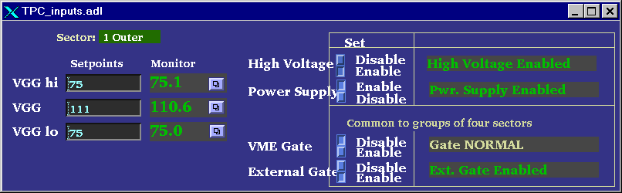

5. The display for the main GG panel is color coded – a sector whose voltage deviates 2% from the setpoint will turn yellow, 5% will turn red. You will also get an alarm from the TPC alarm handler. For yellow, the run can continue – for red, STOP the run.

6. To turn the GG off, click the “Grid Off” button in the Default Sequences window.

7. For normal running the gated grid stays ON all the time, even when there is no beam.

2.6 Cathode HV & Field Cage

AUTORAMP MODE

1. To turn on the cathode HV using autoramp mode, first go to desktop # 2 and click on “cathode” to open the cathode GUI. Also click on “Field Cage” to open the field cage current read back screen.

2. The cathode control looks like:
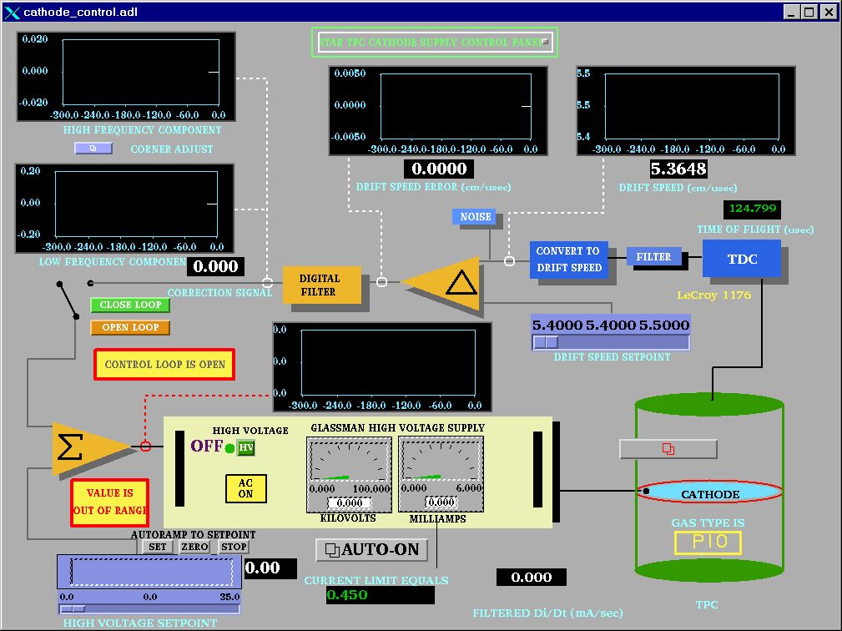

3. Make sure the slider switch is set to 0 and then click the HV button if the HV is off. The HV will turn on and the light will go to red. Note that it is not possible to turn the HV back off again by pushing this button!

4. Make sure that the RHIC beam is stored, cogged and stable before proceeding.

5. Click on the “Auto-On” button. This brings up the GUI:

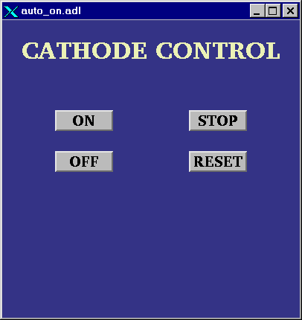

6. Click the “ON” button. The program will then automatically do the following:

Ramp to 10 kV
Check that the four field cage currents are all equal.
Ramp to 20 kV
Again check the currents
Ramp to final HV (currently 28 kV)
Check the currents

This process takes ~ 10 minutes.

If the currents are not equal, the program will stop and ramp the HV back to 0. The operator can also stop the autoramp at any time by clicking on “STOP”. Clicking “OFF” ramps the HV back to 0.

IF AT ANYTIME THE AUTORAMP REPORTS A PROBLEM OR THE CURRENTS ARE NOT EQUAL (TPC ALARM HANDLER), RUN THE VOLTAGE IMMEDIATELY TO 0 AND CALL AN EXPERT!

REMEMBER: The cathode HV should not be turned ON until the RHIC beams are stable at collision energy and it should be ramped to ZERO before the beam is dumped.

AUTORAMP PROCESSOR

The VME program that controls the autoramps for the cathode and anodes is running on a processor (STARGATE) that is located in rack row DC2 in the DAQ room. If the autoramp program stops working it may be necessary to reboot this processor. First, try and run the cathode voltage to zero using the GUI for the cathode. Then go to the DAQ room and press the reset button on the STARGATE processor. After it reboots the autoramp should work again.

MANUAL MODE

The HV can also be set manually as follows:

1. Turn on the HV as before.

2. Drag the slider switch to the desired HV (this should be done in 10 kV steps max).

3. Click on “SET” above the slider bar and the voltage will ramp up. You can stop the ramp by clicking on “STOP” and go back to 0 by clicking on “ZERO”.

4. When the HV stops ramping, check the field cage GUI:

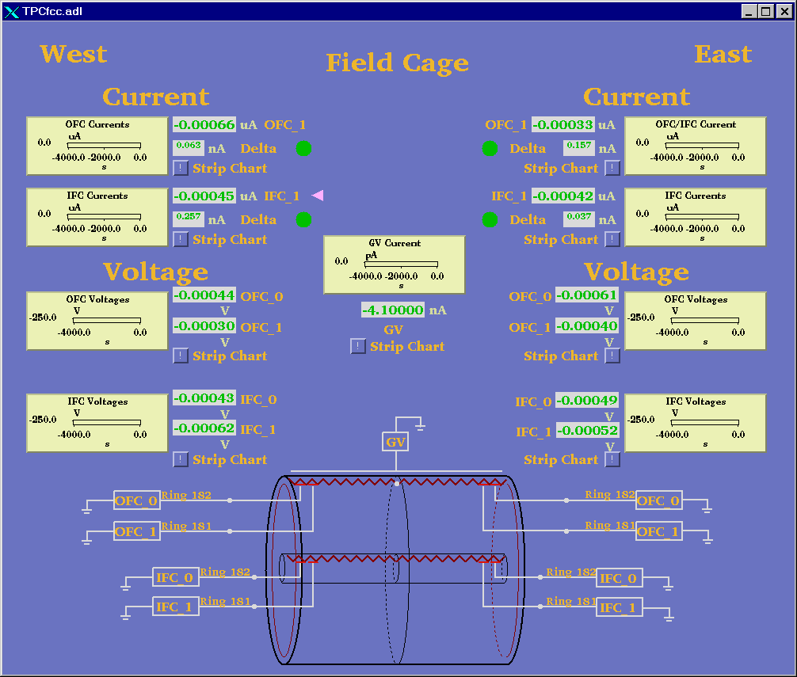

This program is reading the 4 field cage resistor chain currents, the current going to the ground shell (GV current) and the voltage on the next-to-last and last stripes. It also checks that all four resistor chain currents are equal within 100 nA (Delta green lights.)

5. After the HV stops ramping, confirm that the currents are equal before ramping further.

6. Once the HV is set to the final value, the currents are monitored by the TPC alarm handler. For an alarm, immediately ramp the cathode to zero and call an expert.

Typical Field cage currents and voltages at 28.0 kV nominal.

OFCW 76.555 µA OFCE 76.553
IFCW 76.547 IFCE 76.552

WOFC_0 -33.43 V EOFC_0 -33.74
WOFC_1 -177.21 EOFC_1 -177.66
WIFC_0 -23.774 EIFC_0 -23.779
WIFC_1 -177.58 EIFC_1 -177.47

If the TPC has a short circuit across one of the resistors in the field cage, then you may see different values than listed above. Deviations by up to 0.5 μA may be normal. Check with your shift leader or a TPC Expert to see if the readings are normal.
2.7 ANODE & TRIPS

AUTORAMP

To turn the anodes on using the autoramp program:

1. Go to desktop # 1 and click on “Anode Voltage” on the top level GUI. This brings up the Anode GUI:
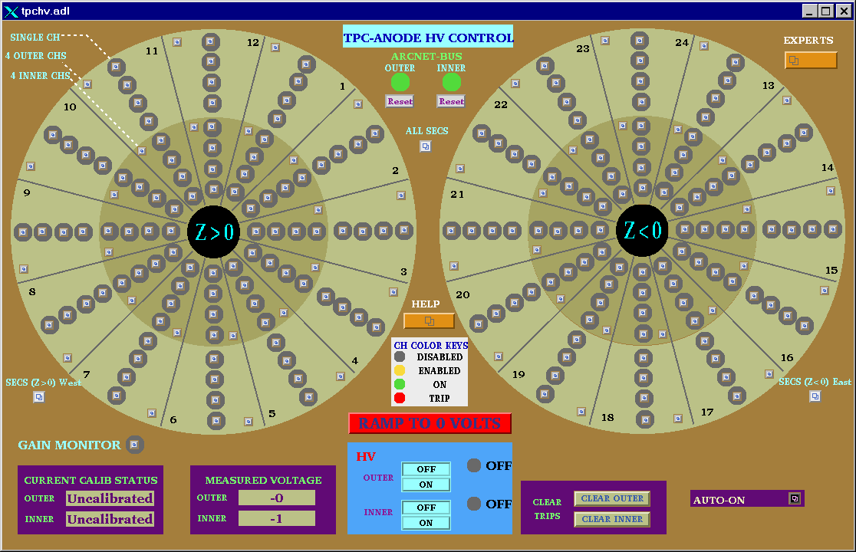

2. Check the ARCNET-BUS status lights for the Inner and Outer sectors – if either or both are red, click the corresponding “reboot” button. This will reboot the processor. (The display will go white while it reboots). WAIT ~ five minutes for the reboot. The state of the anode voltages (on or off) is unaffected by rebooting the processor – the Lecroy system has local memory.

3. When the status lights have turned green, click on the “Auto-On” button. This gives the GUI:

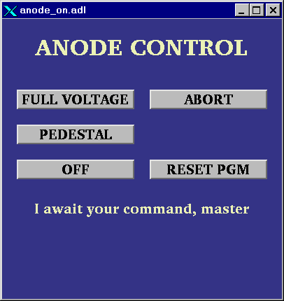

If the autoramp GUI displays the message “ARCNET connection lost”, click on the “Reset PGM” button.

4. Make sure RHIC has stored, cogged and stable beam!

5. At this point, you can go to pedestal voltage (Inner = 500, Outer = 500) or to full operating voltage (Inner = 1170, Outer = 1390). Note: as of Run 9, the full voltage values may no longer be 1170/1390. Check with your shiftleader or a TPC expert for the current settings.

6. To go to pedestal voltage, click “pedestal”. The program will:

Turn on the HV
Enable all channels
Ramp HV to 400 volts
Calibrate the currents (subtract out any DC offset)
Ramp to pedestal voltage

If the HV is already on, the program will just ramp up (or down) to pedestal values.

At any time the operator can stop the process by clicking “Abort”. This will ramp the voltage back to 0.

After the voltages are at pedestal values, the TPC is ready to take a pedestal run (make sure the GG is on!)

7. One can go to full voltage from either the off position or from the pedestal position.

From off, the program will repeat the pedestal procedure, and then:

Check for tripped channels
Check for excessive currents
Ramp to Inner = 1000, Outer = 1200
Check for trips
Check for currents
Ramp to Inner = 1100, Outer = 1300
Wait for 2 minutes
Check for trips and currents
Ramp to final voltage (Inner = 1170, Outer = 1390)
Check for trips or currents.
HV ready for data

This procedure takes ~ 10 minutes.

If a trip or high current is detected during this procedure , the voltage for all channels will be ramped back to pedestal values automatically.

To turn the HV off, click on the “Off” button in the auto-on window, or click on the red “Ramp to 0 Volts” button on the main anode GUI.
MANUAL ANODE OPERATION

There are 193 separate anode supplies, 1 for the gain chamber and 192 for the TPC. For each sector, the anode wires are grouped in sections, so there are four supplies per sector. The operator can control the voltage for all sectors (including the gain chamber), for the east or west end only, for a sector only (4 sections) or for an individual section (usually necessary to reset a trip.) In the main GUI above, the status of each power supply (section) is indicated by the round color field surrounding the control button. Thus:

Grey = Channel is disabled. Even if the HV is turned on and you set a demand voltage for that channel, nothing will happen.
Yellow: Channel is enabled but the HV is off or <10 volts.
Green: Channel is on at some voltage > 10 volts.
Red: Channel has tripped off due to excessive current draw. (> 2 μA)

NOTE: The Anode program is very slow. You MUST wait for each command to be acknowledged before issuing another command or it will crash!

To turn on all sectors manually:

1. Check the status lights of the Arcnet-Bus. If either is red, click and drag on the reboot button to reboot the processor. Wait ~ 5 minutes. (There is a separate processor for the inner and outer sectors).

NOTE: The ARCNET link is lost frequently – you will get a TPC alarm when this happens. When this link is down the program can’t get updated information from the Lecroy HV mainframe, BUT the HV is still on and the chamber is still protected. Rebooting the processor has no effect on the HV.

2. When the ARCNET lights are green, click the HV on button for the inner and outer sectors. Wait for the HV lights to turn green.

3. Open the “ALL SECS” control panel:

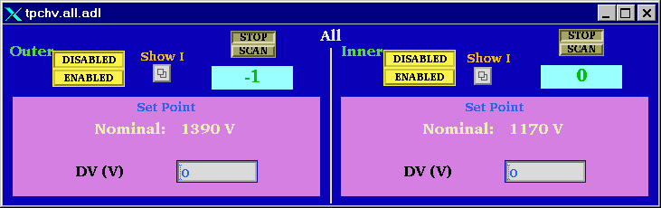

4. Check that the demand voltage DV (V) for inner and outer reads 0. If not, enter 0, CR in each window.

5. Click on “Enabled” for the inner and outer. Wait until the color circles turn green on the main anode GUI.

6. Type in a demand voltage of 400 V for the inner and outer sectors. Wait until the voltage ramps up and is confirmed in the readback window.

7.Check the Current Calibration status window in the main anode GUI. If the status is “calibrated” continue raising the voltage (see below step 10 ). If the status is uncalibrated, click on the Outer “SHOW I” button in the “ALL SECS” control GUI, drag down to “I (Z > 0) West) and release. This brings up the current display for all the outer sectors on the west end:
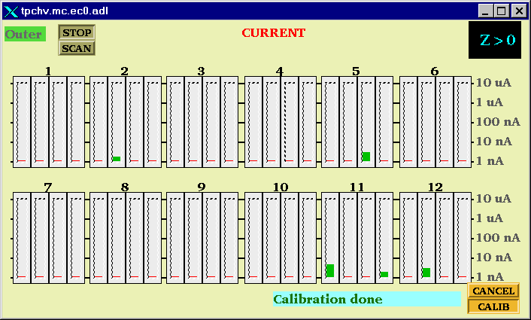

8. Click on the “Calib” button. The status window will say “Current is Ready” and then “Calibration in Progress”. The program will subtract the DC current offsets FOR ALL OUTER SECTORS (east and west). The status window will then say “Calibration Done”.

9. Repeat this procedure for the Inner sectors, if needed.

10. Set the demand voltage to pedestal values (Inner = 500, Outer = 500). Wait for the voltage to ramp up.

11. Continue to raise the voltage in steps, checking the currents after each step:

Inner = 1000, Outer = 1200
Inner = 1100, Outer = 1300
Wait ~ 2 minutes
Inner = 1170, Outer = 1390

Note: as of Run 9, the full voltage values may no longer be 1170/1390. Check with your shift-leader or a TPC expert for the current settings.

12. To turn the Anodes off, either type in 0 for the demand voltage or click on the red “Ramp to 0 Volts” button on the main anode GUI.

RESETTING TRIPS

Occasionally, one or more channels will draw excessive current (> 2 μA) and automatically trip off. There will be a TPC alarm. These trips can be random or beam induced. First, STOP the current run. Then, to reset a tripped channel:

1. Click on the individual control button for the tripped channel in the main anode GUI. This brings up the channel status panel:

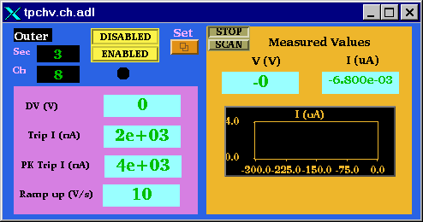

2. Click on the “SET” button. This brings up the control panel:
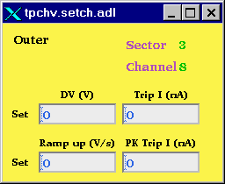

3. In the demand voltage window “DV (V)”, type in 0,cr to set the demand voltage back to zero. Do this FOR ALL tripped channels.

4. In the main anode GUI, click on the “Clear Trips” button for inner or outer sectors, depending on which channels tripped. Wait – the tripped channels which were red should turn back to green.

5. If the tripped channel remains grey on the main GUI after 2 minutes, it is neccesary to enable it manually. Click the “Enabled” button for the channel on the channel control GUI shown in step 1 above. If the channel is not green, you cannot raise the voltage.

6. Using the individual channel control windows, slowly raise the voltage in stages back up to the operating point. Monitor the current for each channel. For any indication of excessive current draw, lower that channel back to 0 and call an expert. (Excessive current for constant voltage = 50 nA)

7. Record the tripped channels in the “STAR TPC ANODES” binder.

NOTE: The current limits can only be changed by the subsystem manager. If a channel will not stay on with a limit of 2 μA, LEAVE IT OFF and call an expert.

ALTERNATE METHOD FOR CLEARING MULTPLE TRIPS

Sudden RHIC beam losses can cause multple anode trips. A more efficient method for clearing these trips is:

1. If the RHIC beam is lost: Use the autoramp to run ALL anode HV down to zero. Then click on the “Clear Trips” buttons. The tripped channels should clear and be ready for the next autoramp.

2. If RHIC still has beam and the run will continue then:

First, STOP the current run. Use the autoramp program to run ALL anode HV down to pedestal voltage. Then click on the “Clear Trips” button for inner and outer, depending on which channels tripped. WAIT for the tripped channels to reset – they should automatically ramp back up to pedestal voltage. You can then autoramp back up to full voltage if the RHIC losses have stopped.

2.8 LASER

See separate laser manual.

2.9 TPC ALARM HANDLER

There is a specific TPC alarm handler which is running on a separate PC – the monitor is located up and to the right of Chaplin. To start the alarm handler, click on the “Shortcut to Alarms_groups” icon on the desktop. The alarm handler monitors the following TPC parameters:

Anode trips
Excessive Anode currents (any channel)
Cathode HV not on (must be > 25 kV)
TPC FEE temperatures < 80 F
Temperature in the WAH < 82
Dewpoint in WAH < 62
Inner and Outer Arcnet links active
Field cage currents equal
All gated grid voltages at nominal
Inner Anode current sum (all channels) < 10 µA
Outer Anode current sum (all channels) < 4 µA
Anode HV – check whether any channel is not equal to demand voltage.

The alarm handler reads the status of these parameters every few minutes and will sound an audible alarm if something is out of range. There is a 10 minute snooze button that can be used when bringing up the TPC voltages to prevent frequent (false) alarms. If an alarm goes off, it can be silenced (acknowledged) by clicking the button below the alarm.

The alarm buttons are color coded:

Green = OK
Yellow = warning but run can continue
Red = alarm
Grey = the data was not read on this try – this usually clears on the next read.

An alarm condition will automatically clear and revert back to green on the next read cycle IF the reason for the alarm has been fixed. There is also a “read now” button that will initiate a read cycle.

These same parameters plus many others (gas system etc) are also monitored by the slow controls alarm handler running on sc5.starp.bnl.gov.

3. ALARMS

3.1 GAS ALARMS

In case of a TPC gas alarm:

1. Hit the acknowledge button on the alarm box in the control room. This silences the local alarm.

2. Go to the gas mixing room – hit the acknowledge button located next to the TPC AB PLC panel in rack 4

3. Call an expert – the list is posted in the mixing room.

4. The expert will tell you what to do.

For a major gas alarm all the TPC HV will trip off automatically. For a minor alarm the HV will stay on and the run can continue.

3.2 TPC WATER ALARMS

In case of a water alarm:

1. . Hit the acknowledge button on the alarm box in the control room. This silences the local alarm

2. Go to the gas mixing room – hit the acknowledge button located next to the TPC AB PLC panel in rack 4

3. Call a TPC water expert. A water alarm means the skid has shut down (the FEE’s will also trip off).
This alarm is also repeated to the CAD pump room, so someone may respond from there. Do NOT
restart the TPC water skid until the problem has been diagnosed and the TPC water expert has
given the ok.

TPC CALL LIST

TPC

Alexei Lebedev
Office (Ops support trailer) x3101
Cell (631) 255-4977
Home 821-2838

Jim Thomas
Office x3918
Cell (510) 759-4936
Home 928-8661

TPC WATER

Alexei Lebedev
Jim Thomas

TPC GAS

Alexei Lebedev
Jim Thomas

TPC INTERLOCKS

Jim Thomas

TPC LASER

Alexei Lebedev

5. TPC State Table for Various Conditions

Standby: Anodes Off
Cathode Off
FEES On or Off (FEEs must be off when ramping the magnet)
Gated Grid On (Gated Grid should always be on)

Pedestal Run: Anodes ON at pedestal voltage (or less)
Cathode On/Off (but not ramping)
Gated Grid On
FEEs On

Physics Run: Anodes On at full voltage
Cathode On at full voltage (28 kV)
Gated Grid On
FEEs On

Laser Run: Same as Physics Run but with Lasers On

Pulser Run: Anode Off or less than pedestal voltages
Cathode Off/On
Gated Grid On
Fees On
Clock in Local (not RHIC clock)

Magnet ramp up or down:
Anodes Off or at pedestal
Cathode Off/On
Gated Grid On
FEES OFF

Take a laser run 1 hour after the beginning of each store. Take ~ 2000 events and check the drift velocity in the online histograms.

Take a pulser run once a day. Make sure clock is set to local oscillator and take a pedestal run first!

