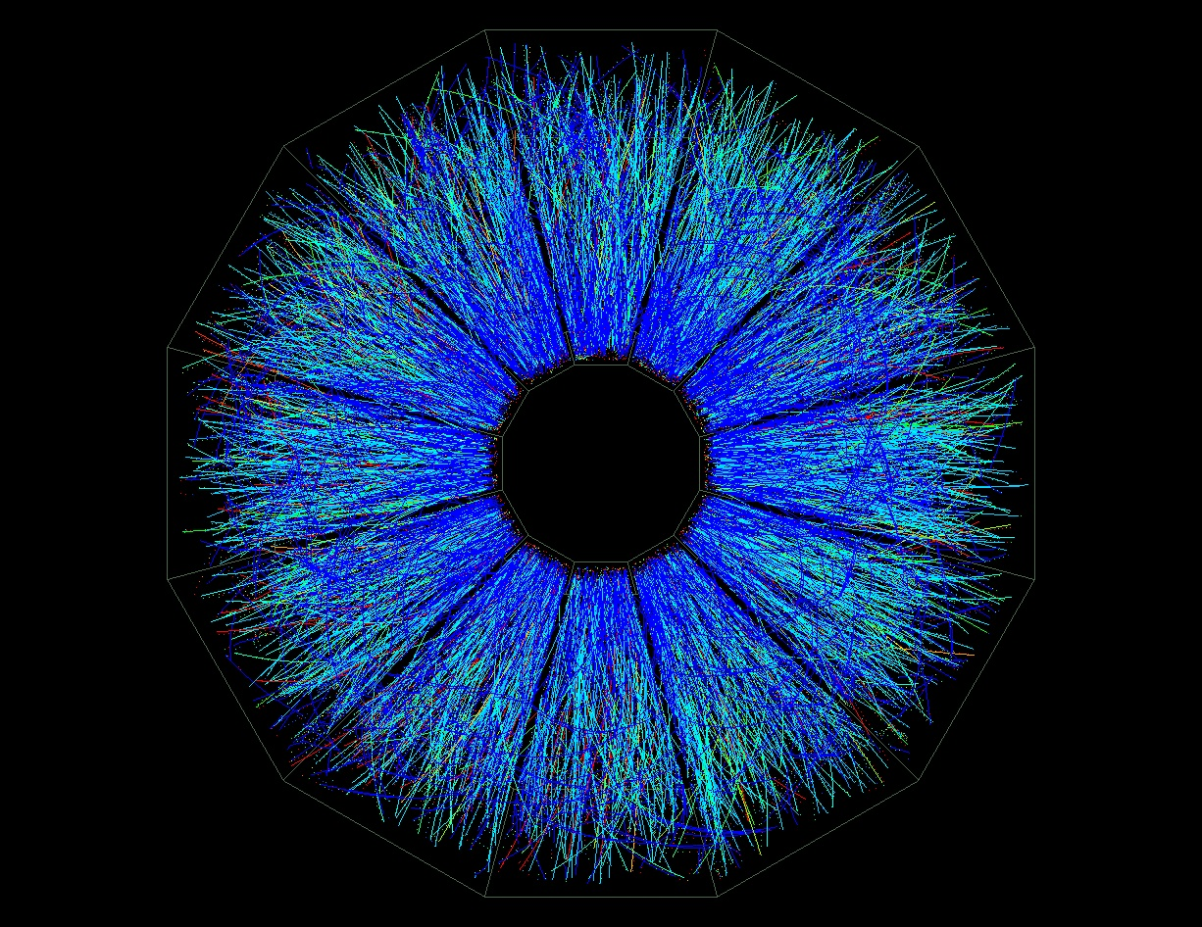

**RHIC Beam Use Request**

**For Runs 15 and 14**

**The STAR Collaboration**

**Version 0**

**May 05 2014**

1 Executive Summary 3

2 Highlights from STAR Science Programs: 3

2.1 Polarized Proton+Proton Data: 3

2.1.1 The Proton Helicity Structure: 3

2.1.2 The 2+1 Dimensional Structure of the Proton 5

3 Run-14 Performance Report 8

4 Run-15 BUR request on p+p and p+A collisions 8

4.1 Physics with 200 GeV longitudinally polarized p+p collisions 8

4.2 Physics with 200 GeV transversely polarized p+p collisions 8

4.3 Physics with transversely polarised p+A collisions 8

5 Run-16 Request 8

5.1 Transverse polarized p+p running at √s=500 GeV 9

6 Detector and Upgrades relevant to BUR 9

6.1 The Phase-II\* Upgrade of the Roman Pots around STAR 9

6.2 A Preshower for the FMS 9

# Executive Summary

# Highlights from STAR Science Programs:

## Polarized Proton+Proton Data:

### The Proton Helicity Structure:

The STAR spin physics program seeks to advance our understanding of the spin and flavor structure of the proton in terms of its constituent quarks and gluons, exploiting the unique capability of RHIC to provide access to polarized p+p collisions.  Using longitudinally polarized beams, one can probe the helicity preferences of the gluons and (flavor-separated) antiquarks, to determine the contribution of each to the total spin of the proton.  With spins transverse to their momentum direction, the p+p collisions exhibit kinematic and dynamical effects that are directly sensitive to quark transversity and partonic motion within the proton.  This program is complemented by studies of polarized p+p elastic scattering and central exclusive production, in which a far-forward proton is detected intact.

Since 2009 RHIC has just completed several very successful polarized p+p runs both at *√s* = 200 GeV and *√s* = 510 GeV. The STAR recorded luminosity and the average beam polarization as measured by the H-jet polarimeter are summarized in Table 2‑1.

|  |  |  |  |  |
| --- | --- | --- | --- | --- |
| **Year** | **√s (GeV)** | **Recorded Luminosity for Transverse p+p** | **Recorded Luminosity for Longitudinal p+p** | **<P>** |
| 2009 | 200  500 |  | 25 pb-1  10 pb-1 | 55  39 |
| 2011 | 500 | 25 pb-1 | 12 pb-1 | 48 |
| 2012 | 200  510 | 22 pb-1 | 82 pb-1 | 61/58  50/54 |
| 2013 | 510 |  | 300 pb-1 | 50/54 |

Table 2‑1: The STAR recorded luminosity and the average beam polarization as measured by the H-jet polarimeter.

These data sets formed the basis for papers and new preliminary results, which are highlighted in the following. Since the last PRC the STAR spin-working group published one paper in PRD [[[1]](#endnote-1)] and submitted two to PRL [[[2]](#endnote-2),[[3]](#endnote-3)]. The later two present milestones in our understanding of the proton helicity structure and such how the spin of the proton is decomposed by it constituents.

The inaugural run at √s = 500 GeV in 2009 yielded the first but still statistics challenged measurement of the longitudinal single-spin asymmetry AL in W± production [[[4]](#endnote-4)]. The rapid analysis of the 2011 (√s = 500 GeV ) and the high statistics 2012 (√s = 510 GeV) longitudinal polarized p+p data sets yielded the first results for *W±* providing impact on the light sea quark polarizations. Figure 2‑1 shows the final result of the longitudinal single-spin asymmetry, *AL*, for *W±* production as a function of lepton pseudorapidity *e*, in comparison to theory predictions. The STAR preliminary *AL* results based on the 2012 data set alone, have been included pQCD-fit by the DSSV group [[[5]](#endnote-5)]. A clear improvement on the determination of the polarization of the light sea quarks was observed. For a shift away from the current best mean value was observed, reflecting that the new STAR data lie above the central curve based on DSSV fits to semi-inclusive and inclusive data. Already, with only the preliminary 2012 STAR data, the new global analysis showed a preference for in the range x > 0.05. New pQCD fits based on the published STAR data are already underway by the DSSV and NNPDF groups.



|  |  |
| --- | --- |
|  |  |
| Figure 2‑1: Longitudinal single-spin asymmetry, *AL*, for *W±* production as a function of lepton pseudorapidity *e*, in comparison to theory predictions. | Figure 2‑2: Midrapidity (|**| < 0.5, upper panel) and forward rapidity (0.5 < |**| < 1, lower panel) inclusive jet *ALL* vs. parton jet *pT*, compared to predictions from several NLO global analyses. The error bars are statistical. The gray boxes show the size of the systematic uncertainties. |

In 2009, with improved luminosity and polarization, as well as upgraded triggering and data acquisition systems at STAR, the uncertainties on the inclusive jet *ALL*measurements at √s = 200 GeV could be considerably improved. Figure 2‑2 shows the final inclusive jet *ALL* vs. parton jet *pT* at Midrapidity (|**| < 0.5, upper panel) and forward rapidity (0.5 < |**| < 1, lower panel), compared to predictions from several NLO global analyses. The error bars are statistical. The gray boxes show the size of the systematic uncertainties. The impact of the new inclusive jet data on the polarized gluon distribution and its integral was studied using the reweighting method developed by the NNPDF group [[[6]](#endnote-6)], which allows to include new experimental data into an existing PDF set without the need to repeat the entire fitting process. The obtained results are shown in Figure 2‑3. The integral of *g(x,Q2=10 GeV2)* over the range 0.05 < *x* < 0.5 is 0.06 ± 0.18 for the original NNPDF fit and 0.21 ± 0.10 when the fit is reweighted using the STAR jet data. The DSSV group has performed a new global analysis [[[7]](#endnote-7)] including the STAR jet *ALL* results. They find that the integral of *g(x,Q2=10 GeV2)* over the range *x* > 0.05 is at 90% C.L., consistent with the value STAR finds by reweighting the NNPDF fit.



|  |  |
| --- | --- |
|  | Figure 2‑3: Gluon polarizations from NNPDF (blue dot-dashed curve, 135o hatched uncertainty band), and from modified versions of NNPDF that we obtain when including the 2006 (green dashed curve, 45o hatched uncertainty band) or 2006+2009 (red solid curve and uncertainty band) STAR inclusive jet *ALL* results through reweighting. |

.

### The 2+1 Dimensional Structure of the Proton

A natural next step in the investigation of nucleon structure is an expansion of our current picture of the nucleon by imaging the proton in both momentum and impact parameter space. At the same time we need to further our understanding of color interactions and how they manifest in different processes. In the new theoretical framework of transverse momentum dependent parton distributions (TMDs) we can obtain an image in the transverse as well as longitudinal momentum space (2+1 dimensions). This has attracted renewed interest, both experimentally and theoretically in transverse single spin asymmetries (SSA) in hadronic processes at high energies, which have a more than 30 years history. First measurements at RHIC have extended the observations from the fixed-target energy range to the collider regime up to the highest center-of-mass energies to date at RHIC of √s = 500 GeV. Figure 2‑4 summarizes the measured asymmetries from different experiments as functions of Feynman-*x* (*xF ~ x1-x2*).

|  |
| --- |
|  |
| Figure 2‑4: Transverse single spin asymmetry measurements for charged and neutral pions at different center-of-mass energies as function of Feynman-*x.* |

The surprisingly large asymmetries seen are nearly independent of  over a very broad range. To understand the observed significant SSAs one has to go beyond the conventional collinear parton picture in the hard processes. Two theoretical formalisms have been proposed to generate sizable SSAs in the QCD framework: transverse momentum dependent parton distributions and fragmentation functions, which provide the full transverse momentum information and the collinear quark-gluon-quark correlation, which provides the average transverse information. STAR has made several important contributions to this program, primarily through study of forward neutral pion production in p+p collisions (see, for example, ref. [1,[[8]](#endnote-8)]). This effort has been extended to include the first measurements at *√s* = 200 GeV of the transverse spin asymmetry *AN* for the *η* meson [[[9]](#endnote-9)]. The Run-11 data taken with transverse polarization at *√s* = 500 GeV have revealed several surprising results. Figure 2‑5 shows the transverse single spin asymmetry *AN* for electromagnetic jets detected in the forward meson spectrometer (2.5 < ** < 4.0) as function of the jet *pT* and the photon multiplicity in the jet in bins of the jet energy. It can be clearly seen that with increasing number of photons in the electromagnetic jet (increasing jettiness of the event) the asymmetry becomes smaller and smaller. Jets with isolated *0*have the largest asymmetry consistent with the asymmetry in inclusive *0*events, see Figure 2‑4 most right panel. For all jet energies and photon multiplicities in the jet the asymmetries are basically flat as function of jet *pT* , a feature also already seen for inclusive *0* asymmetries.

|  |
| --- |
|  |
| Figure 2‑5: The transverse single spin asymmetry *AN* for electromagnetic jets detected in the forward meson spectrometer (2.5 < ** < 4.0) as function of the jet *pT* and the photon multiplicity in the jet in bins of the jet energy. |

To further study these effects the transverse single spin asymmetry *AN* of these electromagnetic jets was measured if in addition a correlated away side jet in the rapidity range -1 <  < 2 was required. Figure 2‑6 shows clearly that for requiring an additional correlated away-side jet the asymmetry for isolated forward 0s becomes smaller. For further details see reference [[[10]](#endnote-10)].

All these observations raise serious questions how much of the large forward *0*asymmetries are caused by 2🡪2 parton scattering processes.

|  |
| --- |
|  |
| Figure 2‑6: The transverse single spin asymmetry AN for electromagnetic jets detected in the forward meson spectrometer (2.5 < ** < 4.0) as function of the jet pT and the photon multiplicity in the jet in bins of the jet energy (red points). The blue points represent the transverse single spin asymmetry AN if further a correlated away side jet in the rapidity range -1 <  < 2 was required. The blue and red bands represent the systematic uncertainties. |

The Sivers function  is one of the transverse dependent parton distribution functions, which is of special interest. It describes the correlation of parton transverse momentum with the transverse spin of the nucleon. A non-vanishing means that the parton distribution will be azimuthally asymmetric in the transverse momentum space relative to the nucleon spin direction. There is evidence of a quark Sivers effect in semi-inclusive DIS (SIDIS) measurements of the HERMES, COMPASS, and JLab Hall-A experiments [[[11]](#endnote-11)]. An important aspect of the Sivers effect, which has emerged from theory lately, is its process dependence and the color gauge invariance. In SIDIS, the quark Sivers function is manifested in association with a final state effect from the exchange of (any number of) gluons between the struck quark and the remnants of the target nucleon. On the other hand, for the virtual photon production in the Drell-Yan process, the Sivers asymmetry appears as an initial state interaction effect. As a consequence, the quark Sivers functions are of opposite sign in these two processes and this non-universality is a fundamental prediction from the gauge invariance of QCD. The experimental test of this sign change is one of the open questions in hadronic physics and will provide a direct verification of QCD factorization.



While the required luminosities and background suppressions for a meaningful measurement of asymmetries in Drell-Yan production are challenging, other channels can be exploited in *p*+*p* collisions, which are similarly sensitive to the predicted sign change. These include prompt photons, W+/- and Z bosons, and inclusive jets. These are either already accessible with the existing STAR detector or need only modest upgrades and continued polarized beam operations.

The transverse polarized data taking in run-11 at *√s* = 500 GeV allowed to reconstruct the transverse single spin asymmetries for *AN*for W+/- and Z0 Bosons. Especially the measurement of the *AN*for *W+/-* Bosons is challenging as contrary to the longitudinal case it is required to completely reconstruct the W-Bosons as the kinematic dependences of *AN*can not easily be resolved through the high *pT* decay lepton, for details see [[[12]](#endnote-12)]. Due to the large STAR acceptance it was possible to reconstruct the W-Boson kinematics from the recoil jet, a technique used at D0, CDF and the LHC experiments to reconstruct the W-Boson kinematics. Figure 2‑7 shows the transverse single spin asymmetries for *AN*for *W+/-* as function of the W-Boson rapidity *y*. The asymmetries have also been reconstructed as function of the pT of the W-boson. For the *Z0*-Boson the asymmetry could only be reconstructed in one bin in *y* due to the limited statistics (25 pb-1) of the Run-11 transverse polarized data set. Details for this analysis can be found in [[[13]](#endnote-13)]. The analysis represents an important proof of principal equally as the run-09 *W+/- AL* measurement that a higher statistics run will allow to access the sign change and to constrain the till today unknown sea quark Sivers functions.

|  |  |
| --- | --- |
| hd_Wp_AsymAmpSqrtVsRap.eps | hd_Wm_AsymAmpSqrtVsRap.eps |
| Figure 2‑7: The transverse single spin asymmetries for *AN*for W+/- as function of the W-Boson rapidity y. | |

# Run-14 Performance Report

# Run-15 BUR request on p+p and p+A collisions

## Physics with 200 GeV longitudinally polarized p+p collisions

## Physics with 200 GeV transversely polarized p+p collisions

## Physics with transversely polarised p+A collisions

# Run-16 Request

## Transverse polarized p+p running at √s=500 GeV

# Detector and Upgrades relevant to BUR

## The Phase-II\* Upgrade of the Roman Pots around STAR

A short description of the project and status will be added

## A Preshower for the FMS

A short description of the project and status will be added

1. [] L. Adamczyk et al., Neutral pion cross section and spin asymmetries at intermediate pseudorapidity in polarized

   proton collisions at √s = 200 GeV, Phys. Rev. D **89** (2014) 012001; arXiv:1309.1800 [↑](#endnote-ref-1)
2. [] L. Adamczyk et al., Measurement of longitudinal spin asymmetries for weak boson production in polarized proton-

   proton collisions at RHIC, submitted to PRL; arXiv:1404.6880 [↑](#endnote-ref-2)
3. [] L. Adamczyk et al., Precision Measurement of the Longitudinal Double-spin Asymmetry for Inclusive Jet

   Production in Polarized Proton Collisions at √s = 200 GeV, submitted to PRL; arXiv:14 [↑](#endnote-ref-3)
4. [] M. Aggarwal *et al.*, Phys. Rev. Lett. **106**, 062002 (2011), arXiv: 1009.0326 [↑](#endnote-ref-4)
5. [] E.C. Aschenauer et al., The RHIC Spin Program: Achievements and Future Opportunities, arXiv:1304.0079 [↑](#endnote-ref-5)
6. [] R. D. Ball et al., Nucl. Phys. B 849, 112 (2011) [Errata: ibid 854, 926 (2012) and 855, 927 (2012)];

   R. D. Ball et al., Nucl. Phys. B 855, 608 (2012). [↑](#endnote-ref-6)
7. [] D. de Florian, R. Sassot, M. Stratmann, and W. Vogelsang, arXiv:1404.4293 [↑](#endnote-ref-7)
8. [] B. I. Abelev *et al.*, Phys. Rev. Lett. **101**, 222001 (2008), arXiv: 0801.2990 [↑](#endnote-ref-8)
9. [] L. Adamczyk et al.,Transverse Single-Spin Asymmetry and Cross-Section for 0 and   Mesons at Large Feynman-x in Polarized p+p Collisions at √s=200 GeV, Phys. Rev. D **86** (2012) 051101; arXiv:1205.6826 [↑](#endnote-ref-9)
10. [] M. M. Mondal, talk at DIS-2014;

    http://indico.cern.ch/event/258017/session/6/contribution/216/material/slides/1.pptx [↑](#endnote-ref-10)
11. [] HERMES Collaboration, Phys. Rev. Lett. **94** (2005) 012002;

    COMPASS Collaboration, Phys. Lett. **B673** (2009) 127;

    The Jefferson Lab Hall A Collaboration, Phys. Rev. Lett. **107** (2011) 072003. [↑](#endnote-ref-11)
12. [] Z.-B. Kang and J.-W. Qiu, Testing the Time-Reversal Modified Universality of the Sivers Function, Phys. Rev.

    Lett. **103** (2009) 172001, arXiv:0903.3629

    A.Metz and J. Zhou, Transverse spin asymmetries for W-production in proton-proton collisions, Phys. Lett. B **700**

    (2011) 11, arXiv:1006.3097

    M.G. Echevarria, A. Idilbi, Z.-B. Kang and I. Vitev, QCD Evolution of the Sivers Asymmetry, Phys. Rev. D **89**

    (2014) 074013, arXiv:1401.5078 [↑](#endnote-ref-12)
13. [] S. Fazio, talk at DIS-2014, http://indico.cern.ch/event/258017/session/11/contribution/219/material/slides/0.pptx [↑](#endnote-ref-13)