**Answers to the questions raised on the FMS Preshower proposal**

A summary of all the questions received can be found here <https://drupal.star.bnl.gov/STAR/blog/oleg/2013/dec/03/preshower-review>.

Flemming sent us the following action items, which will be answered in the following.

1. **Physics and simulation:**
   1. Concerns were raised about a number of the plots, what was actually shown, and how they were obtained.

Fig. 1.5 was done with a fast MC using suppression factors and identification efficiencies for leptons, hadrons and photons based on single particle GSTAR simulation. The correlation between FMS clusters and hits in the different preshower layers have not been used. Additional plots from studies of different geometries have been shown in a presentation at the FMS meeting and pp-pA face-to-face meeting which can be found at <https://drupal.star.bnl.gov/STAR/system/files/Akio.FMSPS_.20140111.pptx>.

Some more detailed answers for questions can be found below.

* 1. Has the segmentation of pre-shower vs. that of FMS been optimized? How is the matching of pre-shower hits to FMS clusters achieved?

The granularity of the preshower was chosen to match that of the FMS towers on first order (no accurate projection). The position resolution of clusters in the FMS is smaller than the single tower size, so the matching with the preshower will be dominated by the transverse size of the scintillator bars. This approach should be sufficient since the track multiplicity per quadrant in minbias p+p collisions at 200 GeV is ~0.8. Also, clusters from photonic meson decays do not merge in the FMS until E>60 GeV or more.

For the identification of photons with the expected track multiplicities, we study the matching of tracks in the preshower layers in front of the converter with hits in the FMS in a fast Monte Carlo simulation. The cluster position is assumed ideal, i.e. it is the track position on the FMS front. For the preshower, we use the transverse center of the channel as the hit position. We then match projections of all hits in PS1&PS2 with the clusters in the FMS. All combination was taken in case there were multiple hits in PS1 and PS2. The distance of the closest match is plotted below in Figure A (all lengths are normalized to a z=1 m position).

There is a clear peak from charged tracks and a wide distribution of photonic clusters that are accidentally matched with hits from charged tracks in the preshower. The large FMS tower size is about 0.008 (normalized to a z=1m), the smaller towers are 2/3 of this. The distribution of the charged tracks peaks is at half of the tower size. With this simple approach (taking all combination from PS1 and PS2 and using minbias event), there is ~5% chance that we veto real prompt photon event by accidental hits. Given that prompt photon will be more isolated, and more sophisticated analysis can be developed, probability of accidental veto may become lower.

The next steps in the fast simulation will include the efficiencies and MIP response in the preshower layers as well as the position resolution and cluster energies in the FMS with the converter in place. These effects will obviously not change the major properties of the matching distribution. They will be helpful in establishing an analysis technique to remove decay photons from the inclusive photon yield. In combination with the cross sections, this will also be needed to quantify the expected statistical uncertainties of the proposed measurements.

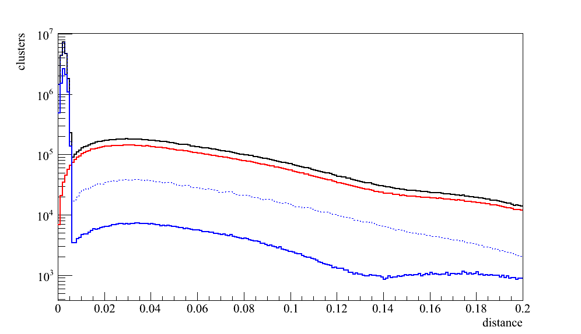

all hits

photons

charged tracks

-- full FMS acceptance

─ with fiducial cut to match PS acceptance

Figure A: Closest match of FMS cluster with preshower hits (normalized to z=1 m for all detectors).

* 1. Are differential cross section measurements intended to be part of the physics motivation and, if so, how will gain (-stability) be determined AND ensured?

As the physics observables related to transverse polarized protons are only explainable by twist-3 observables measuring a cross section, which is dominated by leading twist observables, will not teach anything about the underlying physics processes causing the big forward asymmetries, such measuring cross sections was not part of the physics program. But if there is desire to measure cross sections, it can be done.

The main reason for gain drifts in SiPMs are due to temperature changes in the surrounding environment. Adjusting the HV can compensate these gain drifts. The readout boards have a temperature measurement as well as a HV adjustment integrated; therefore the gain can be very well stabilized better than 10%.

The gain stability will be also easily monitored by the MIP peak position (see Figure 2‑3 upper and lower left plot) as well as noise in the photo sensors from the data itself. A relatively simple simulation of the scintillation and optical readout based on Geant4 is currently being studied (mainly for the design of the light guides and the light yield in the MPPTs).

1. **Detector readout:**
   1. The expected rad. Doses expected for the SiPM should be evaluated in view of available information already available. This can then be used to justify beam tests.

The main source for radiation damage for SiPMs are neutrons, see studies done by JLab Hall-D

<https://halldweb1.jlab.org/wiki/index.php/SiPM_Radiation_Hardness_Test>

and arXiv:1207.3743. Using the GSTAR simulation by Yuri Fisyak et al. (Nuclear Instruments and Methods in Physics Research 00 (2013) 1), at the Preshower location for 1 MHz interaction rate at √s=500 GeV the expected neutron flux as fct. of energy is:

~3k Hz/cm2 (all neutron)

~2k Hz/cm2 (>100 keV)

~0.2k Hz/cm2 (<0.25 meV)

For a 10 week run with 50% running efficiency at √s=200 GeV and scaling the numbers from 500 GeV with 200/500 as advised by Yuri results in a Neutron flux of 3.6 109 /cm2. According to arXiv:1207.3743 a neutron flux of 3.6 109 1 MeV equiv. neutrons/cm2 results in a ~10% drop of gain and an increase of the dark current of 0. to 0.2A. So the effects are negligible and adjusting the HV can easily compensate the gain drift.

* 1. Can the SiPM be sufficiently characterized before the design is finalized?

By now there is a lot of experience with SiPMs. The largest number of SiPMs have been tested to date is done by a JLAB/Hall-D experiment for their Barrel electromagnetic calorimeter. Expertise and the same type of SiPMs are present at BNL as well. The plan is to characterize the all SiPMs in the same way as Hall-D preferable at the same test stand at Univeristy Técnica Federico Santa María Valparaiso, Chile. A summary of the test done for Hall-D can be found here <https://wiki.bnl.gov/eic/upload/MPPC_UTFSM.pdf>

We are obtaining a small number of scintillators, light guides and SiPMs to measure light yield and its uniformity at BNL’s spin group’s lab space before design is finalized.

1. Schedule:

Delivery schedule, as needed for different tasks should be worked out. What are the critical components? And what is required schedule. The overall manpower is identified. A breakdown of responsibilities and estimated time should be provided

See Purchase and Schedule spreadsheet

1. Infrastructure:

John Scheblein is still finishing the detailed design for the holding structure as shown in Figure C. He is also developing an assembly and installation plan.

1. Scintillators will be individually wrapped with Aluminized mylar
2. Then Scintillators will be glued to a slightly oversized G10/FR4 back plate for each quadrant. Currently we are considering 1/8inch thick back plate for layer1, and 1/4 inch thick for layer2 and 3.
3. The whole quadrant will be made light tight by black sheets and tape.
4. The quadrant back plates will be strengthened through an aluminum frame (1" x 1" T-Slot frame) at the outside (far from the beam) for the lower (for lower quadrants) and upper portion (for top quadrants). At the inside (close to beam) only where the frame does not shadow the detector acceptance.
5. Those 3 back plates [Layer 1 (horizontal slats) Layer 2 (vertical slats) Layer 3 (horizontal slats)], the lead plate and aluminum frames will be sandwiched and bolted together to form 1/4th (quadrant) of the detector.
6. The lower quadrant will be lifted with a crane into place in front of the FMS onto the 12" existing channel.
7. This lower quadrant will be bolted to the FMS structure.
8. The upper quadrant will be lifted, and placed on top of the lower quadrant and bolted to the lower quadrant and the FMS frame.
9. This will create 1/2 of the detector.
10. This procedure is followed again to construct the second half of the detector.
11. Cabling for the detector will be internally routed to the outboard sides into patch panels attached to the outside of the quadrant frame.

Macintosh HD:Users:akioogawa:Desktop:FMS PreShower 2014 Slide 2.pdfMacintosh HD:Users:akioogawa:Desktop:FMS PreShower 2014 Slide 1.pdf

Figure C: FMS PS support structure drawings from John Scheblein.

**Craig Woody:**

1. For photon identification: Based on FPD/FMS experience (for example Len Euen’s PYTHIA study: <https://drupal.star.bnl.gov/STAR/blog/leun/2011/may/16/run6-single-photon-test>), hadron background for single photon cluster (in FPD) is 20% (at 40GeV) to 10% (at 80GeV), and electron background is negligible. Layer-1 and 2 of the pre-shower detector will give charged particle (charged hadrons and electrons) rejection of ~98% while keeping ~98% of photons, which will be more than sufficient to make the charged hadron contribution to photon sample negligible. Layer-3 will not give much of charged hadron rejection for photons.

For electron identifications: As shown in Figure 3 of the proposal the J/psi peak using the FMS 2-cluster analysis has a background to signal ratio of 3 to 10 as function of the pT-cuts . Pre-shower layer-1 & 2 will give 98% photon rejection while keeping 86% of electrons. Layer3 will give 40% photon rejection and 86% hadron rejection, while keeping 98% of electrons. These rejection works on both clusters independently, thus total rejection power for J/psi (and DY) will be the square of those factors.

We have studied different thickness for the lead sheet and the scintillator as shown at page 8 of

<https://drupal.star.bnl.gov/STAR/system/files/Akio.FMSPS_.20140111.pptx>. Having more lead and scintillator layers will impact the FMS performance and is therefore not desirable.

Also we agree that multiple hits will have an impact on the efficiency and rejection power. We are starting to run more realistic PYTHIA + GEANT simulation. But given that particle multiplicity is low per quadrant as shown in Fig 2-4, and single particle study shows more than enough rejection power for photon and J/psi channels (but may not be enough for DY), we think the current justification is enough.

1. FPD/FMS study showed that it separate single photon cluster from two photon clusters up to 80~100GeV using log weighted cluster size

(<http://arxiv.org/pdf/1205.6826v1.pdf>).

1. Our estimate is that 5% of photon events will be vetoed by accidental hits in PS detector using simple analysis of taking all combinations. We have considered having smaller segmentation, but concluded that having 2 layers (xy) will help more. Indeed there will be a bias coming from such selection, but this will be part of isolation cut and can be and has to be studied with data and MC as a part of analysis.
2. We are obtaining few scintillators, light guides, SiPMs and test DAQ system to measure light yield and uniformity at BNL soon
3. See detector readout section above for neutron damage estimate

**Richard Majka**

Fig 2-3: Sorry for the confusion. The horizontal axis is the threshold value (thr) on the energy deposition in the scintillator (dE). The vertical axis is:

For top figure black (photon): **efficiency** for keeping photon applying dE<thr cut

For top figure red(e)/green(pi)/blue(muon): fraction of particles **rejected** by dE<thr cut

For bottom figure green(pi)/blue(muon): **efficiency** for keeping pi/mu by dE<thr cut

For bottom figure black(photon)/red(e): fraction of particles **rejected** by dE<thr cut

1. See infrastructure section above
2. See purchase & schedule spreadsheet
3. Yes
4. MIP peaks will give absolute calibration from data itself.
5. We had a pre-shower detector for FPD made of Pb-glass oriented vertically. It was quite challenging to get absolute calibration for the pre-shower detector, and this resulted some degradation of FPD energy resolution. Since proposed pre-shower has less material (1cm scintillator compare to 3.8cm Pb-glass), we expect the effect is less. Because FMS calibration will be done using pi0 reconstruction, it will be automatically corrected for pi0/photons. We may need extra study and apply correction to electron energy due to less energy loss in pre-shower layers.
6. We now have 244 pieces of scintillators, and have 5 for tests and 15 spare (8%). We’ll have 10% spare (244*2*0.1 = 39, total 539) for SiPM
7. See purchase & schedule spreadsheet
8. No contingency or overhead was applied to the costs. Most of the costs are from company quotes from 2014, applying a contingency if things need to be ordered 2 month later seems not needed.

**Rahul Sharma:**

Design) see section above on infrastructure.

Assembly) see section above on infrastructure.

Installation) John’s design for frame includes pick points on the frame. The plan is to use crane and strap and/or counter weights to install quadrants in the place. The installation plan is under development by John and Bob Soja.

**Flemming Videbaek:**

1. See purchase & schedule spreadsheet
2. With recent developments SiPMs are getting rad-harder. This together with Yuri’s estimate on the neutron flux (see detector readout section above) the risk seems to be very low.
3. -
4. See purchase & schedule spreadsheet
5. See purchase & schedule spreadsheet
6. -
7. See infrastructure section above
8. See purchase & schedule spreadsheet
9. –
10. –

**Ernst Sichtermann**

Fig 1-5: This is fast simulation study based on rejection factor/efficiency from single particle GEANT simulation. See simulation section above.

Fig 2-3: This is simulation result from GSTAR (STAR standard AGML geometry + starsim, i.e. GEANT3). For different configuration, see page 8 of

<https://drupal.star.bnl.gov/STAR/system/files/Akio.FMSPS_.20140111.pptx>

Fig 2-4: This plot is to show what kind of particles and energy will be incident on the pre-shower detector in unbiased sample. We are looking into the turn over of pion at low pT. Spectra for prompt photons vs. backgrounds (pi0, eta) have been studied before (for example Len Euen’s PYTHIA study:

<https://drupal.star.bnl.gov/STAR/blog/leun/2011/may/16/run6-single-photon-test>)

See more on FMS-PS matching simulation at simulation section above.