**eSTAR: A Letter of Intent**

**The STAR Collaboration**

Version 9 - September 9, 2013

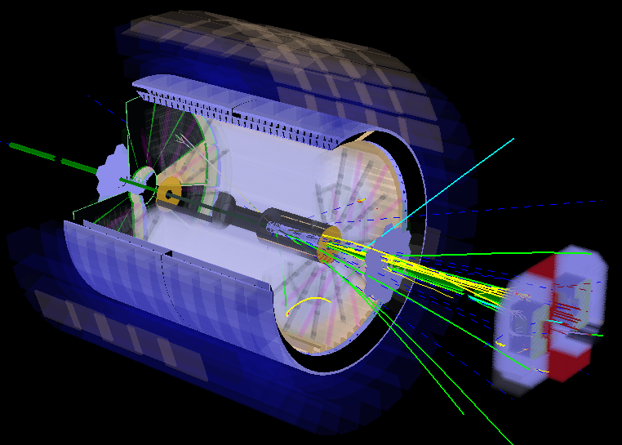

This page is intentionally left blank.

**Executive Summary**

…

**Contents**

1 Introduction 5

2 eSTAR Capabilities to Explore the EIC Scientific Highlights 8

2.1 Machine Performance 8

2.2 Physics Performance 9

2.2.1 Inclusive Measurements 10

2.2.2 Semi-Inclusive Measurements 13

2.2.3 Exclusive and Diffractive Measurements 16

3 Detector Configuration and Components 20

3.1 Current Detector Configuration 20

3.2 Proposed eSTAR Detector Configuration 21

3.3 Expected DIS Coverage and Performance 22

3.3.1 Resolution and Coverage of Detecting Electrons and Hadrons 22

3.3.2 Particle Identification 23

3.3.3 TPC Occupancy and Pile-up with eRHIC Luminosity 25

4 Detector Performance Simulations 26

4.1 Detector Kinematic Acceptance and Efficiency 26

4.2 Detector Momentum and Energy Resolution 28

4.3 DIS Kinematics Reconstruction at eSTAR 29

5 Proposed Upgrades and R&D 31

5.1 Major Upgrades to STAR before eRHIC 31

5.1.1 Inner TPC Sector Upgrade (iTPC) 31

5.1.2 Forward Calorimeter System (FCS) 32

5.2 eRHIC Specific Upgrades and R&D 33

5.2.1 Endcap TOF and TRD for identifying electrons (ETTIE) 34

5.2.2 Crystal Calorimeter based on BSO (CEMC) 35

5.2.3 Other Upgrades and planned R&D Activities 36

6 Collaboration Evolution 37

Appendix: Charge for the eSTAR Letter of Intent 40

References 41

# Introduction

STAR is the one large acceptance detector at RHIC. Major advantages of the STAR experiment comprise large acceptance with full azimuthal angle coverage, TPC tracking within |η|<1.0 with particle identification through Time-of-Flight. The central Barrel and End-cap ElectroMagnetic Calorimeters (BEMC and EEMC) provide coverage for electron, photon, neutral pion measurements, and jet measurements, when combined with charged particle tracking from the TPC. These unique capabilities have set the stage for the future research opportunities at RHIC. STAR has developed a *p + p*, *d(p) + A* and *A + A* program[[1]](#endnote-1) that drives the RHIC science program during the current decade and addresses the overarching questions defined for the subfield of Quantum Chromodynamics (QCD) during the 2007 Nuclear Physics Long Range Plan[[2]](#endnote-2):

The STAR experiment has already addressed many of these questions over the last years with measurement in *A + A*, *d + A* and (un)-polarized *p + p* collisions. Some of the latest most striking results closest related to the core physics program of a future electron-ion-collider (EIC)[[3]](#endnote-3) are listed here. Polarized *p* + *p* collisions have set the most precise constraints to date on the polarization of the gluons in the proton. New global analyses, which include results both from PHENIX (*0 ALL*) and STAR (jet *ALL*) indicate that the integrated contribution to the proton spin from gluons in the momentum range 0*.*05 *< x <* 0*.*2 is 20%. This should be compared to the 30% quark contribution in the quark momentum range 0*.*001 *< x <* 1.0. The STAR preliminary results ontaken during 2012 have been included in a pQCD-fit and show clear improvement on the determination of the polarization of the light sea quarks and their integral for  and  in the range  at *Q2*=10 GeV2. For a shift away from the current best mean value is observed, reflecting that the new STAR  data lie above the central value based on a fit to the world data. Already, with only the preliminary 2012 STAR data, the new global analysis shows a preference for  in the range *x* > 0.05. The observation of a dramatic broadening of forward *0--0* correlations in *d* + Au collisions provides the clearest indication to date that the onset of gluon saturation is accessible at RHIC. Related theoretical developments point to a potential connection between gluon saturation and the “ridge”.

Significant advances have been made in quantifying the properties of the Quark Gluon Plasma. Measurements of the non-photonic electron RAA indicate that even hadrons containing heavy quarks are suppressed in central *Au + Au* collisions, thus motivating further understanding of the partonic energy loss mechanism(s) in nuclear matter. Jet-like correlations and higher harmonic decomposition of particle azimuthal momentum distributions have identified novel characteristics in heavy-ion collisions relative to *p + p*, including the near-side “ridge” that may probe the early state of the collisions. Ultra-peripheral heavy-ion collisions utilize the high-flux of high-energy Weiszacker-Williams photons to mimic electron-ion collisions and provide a first-glimpse and proof of principle of exclusive diffractive vector meson production. RHIC has completed an initial beam energy scan program with center-of-mass beam energies down to 7.7 GeV. Many analyses are currently still at a preliminary stage, but already now there are measurements that point towards the increasing dominance of hadronic interactions at the lower center-of-mass energies.

In the coming years the STAR detector system will continue to evolve through several upgrades towards superior detection capabilities and/or broader kinematic coverage, this will position STAR well for the *p + p*, *p + A* and *A + A* measurements in the coming years and at the initial phase of an EIC. These upgrades are in short described in the following and in more detail in Section 3.

The Heavy Flavor Tracker (HFT)and Muon Telescope Detector (MTD) will be essential to quantify the properties of the strongly-coupled Quark-Gluon Plasma created in high energy heavy ion collisions through heavy quarks, which represent excellent probes for these investigations as they are not expected to be modified by the surrounding QCD medium. Upgrades to boththe trigger and data acquisition system will also be required to answer several of the heavy-ion questions described in [1]. To enhance the STAR capabilities for the Phase-II RHIC beam energy scan an upgrade of the inner sectors of the STAR TPC (iTPC) is proposed. By increasing the segmentation on the inner pad plane better momentum resolution, better dE/dx resolution, and most importantly improved acceptance at high rapidity upto |η|<1.7 compared to the current TPC configuration of |η|<~1.0 will be achieved. Upgrades will also be necessary to take advantage of the opportunities presented by *p* + *p* and *p* + A collisions at RHIC. Upgrades to the current forward (3<η<4) electromagnetic calorimeter are needed to provide *e/h* and */0* discrimination. This will allow first studies to unravel the origin of the large transverse spin asymmetries and the partonic structure of heavy nuclei. A further upgrade of the STAR forward detection system will combine a high-resolution tungsten-powder electromagnetic calorimeter with a high resolution hadronic calorimeter and forward tracking (in the following abbreviated FCS) is needed to give definite answers on the origin of the large transverse spin asymmetries at high *xf* and the question have heavy nuclei a saturated gluon distribution in the initial state. The upgrades will through double spin asymmetries in forward di-jet production constrain the shape and the magnitude of the gluon helicity distribution at low parton momentum *x*. An upgrade to the current Roman pot system will permit a high-sensitivity search for glueballs, the study of exclusive and diffractive reactions in *p + p*, and (un)-polarized *p + A* collisions, which will allow one to study generalized parton distributions through exclusive *J/Ψ* -production.

The above described current and future STAR physics program and detector capabilities are well aligned with the science goals of the EIC as described in the recent EIC White Paper3. An Electron Ion Collider is being considered as the next generation national QCD facility in nuclear physics. The most intellectually pressing questions that an EIC will address that relate to our detailed and fundamental understanding of QCD in this frontier environment are:

1. How are the sea quarks and gluons, and their spins, distributed in space and momentum inside the nucleon? How are these quark and gluon distributions correlated with overall nucleon properties, such as spin direction? What is the role of the orbital motion of sea quarks and gluons in building the nucleon spin?
2. Where does the saturation of gluon densities set in? Is there a simple boundary that separates this region from that of more dilute quark-gluon matter? If so, how do the distributions of quarks and gluons change as one crosses the boundary? Does this saturation produce matter of universal properties in the nucleon and all nuclei viewed at nearly the speed of light?
3. How does the nuclear environment affect the distribution of quarks and gluons and their interactions in nuclei? How does the transverse spatial distribution of gluons compare to that in the nucleon? How does nuclear matter respond to a fast moving color charge passing through it? Is this response different for light and heavy quarks?

Answers to these questions are essential for understanding the nature of visible matter.

An EIC is the ultimate machine to provide answers to these questions for the following reasons:

1. A collider is needed to provide kinematic reach well into the gluon-dominated regime;
2. Electron beams are needed to bring to bear the unmatched precision of the electromagnetic interaction as a probe;
3. Polarized nucleon beams are needed to determine the correlations of sea quark and gluon distributions with the nucleon spin;
4. Heavy ion beams are needed to provide precocious access to the regime of saturated gluon densities and offer a precise dial in the study of propagation-length for color charges in nuclear matter.

The addition of the envisioned electron beam to the RHIC hadron facility (eRHIC) will accomplish the machine requirements for an EIC as listed above.

# eSTAR Capabilities to Explore the EIC Scientific Highlights

The science case for a high-energy polarized Electron-Ion Collider (EIC) in the U.S. has been developed and is described in a recent community whitepaper. One of the possible EIC realization paths envisions an energy-staged electron beam upgrade to the RHIC facility, eRHIC. In the following, we report our initial assessment of the significant measurement capabilities afforded by a suitably evolved STAR experiment, eSTAR, at an initial stage (phase-I) of eRHIC.

The core of the STAR[[4]](#endnote-4) instrument, consisting of the 0.5T solenoidal magnetic field, the Time-Projection-Chamber (TPC) and surrounding detector subsystems, is maintained. It is complemented with upgrades along the electron-beam direction in the form of a compact transition-radiation detector (TRD) and time-of-flight system (ETOF), which serve primarily to enhance the detection capabilities for the electron scattered at rapidities between -1 and -2[[5]](#footnote-1), and a high-resolution crystal calorimeter (CEMC) with a pre-shower detector to detect and measure with precision the scattered electrons at more forward rapidities. These upgrades and upgrades prior to the eRHIC era, in particular the upgrade of the TPC inner sectors and a forward calorimeter system (FCS, consisting of EMCAL and HCAL) with an associated tracker, are described in more detail in Section 3. The latter will enable the reconstruction of photons, neutral pions, and charge-identified hadrons in semi-inclusive observables in a kinematic regime that connects the current measurements in fixed target kinematics with the collider kinematics of eRHIC, will aid the identification of diffractive events, and has considerable acceptance for hadrons produced in scattering events where the electron cannot be measured with precision and the event kinematics must be reconstructed from the hadronic final state.

The EIC scientific highlights3 are, from an experimental point of view, directly related to accelerator performance and measurement capability for inclusive, semi-inclusive, and exclusive deep-inelastic scattering events, as well as for diffractive events. The remainder of this section is organized accordingly.

## Machine Performance

eRHIC (phase-I) is assumed to deliver:

* electron beams with energies of up to 10 GeV and 70% polarization,
* hadron beams as currently available at RHIC, thus including in particular:
  + polarized proton beams with energies of up to ~250 GeV,
  + gold beams with energies of up to 100 GeV/nucleon,
* instantaneous luminosities of 1x1033 cm-2s-1 for *e +p* and 6x1032 cm-2s-1 for *e +Au* collisions at the respective top energies,

in accordance with the charge from the Brookhaven National Laboratory Associated Laboratory Director (Appendix).

The above luminosities are assumed to be inversely proportional to the hadron beam energy and to be constant with electron beam energy for the range of nuclei and energies under consideration. The interaction region (IR) design for eSTAR is anticipated to be similar in layout to that shown in Figure 5.4 of the EIC whitepaper. However, due to the length of the envisioned eSTAR detector, the beam elements closest to the IR will have to be placed at 8m from the nominal interaction point instead of the 4.5m in the EIC whitepaper. This is expected to degrade the luminosities available to eSTAR by a factor of about two. The sharing of beam with one other eRHIC IR is anticipated to result in a reduction of the luminosity available to eSTAR by an additional factor of two compared to the values stated above.

Delivered integrated luminosities of 1 fb-1 for any of the beam energies and species at both IRs are thus well within the range of the initial eRHIC beam-operation periods and we have, unless stated otherwise, taken this value as a basis for our assessment of the eSTAR physics performance below.

The accelerator and IR designs are integral aspects to the eSTAR performance. We envision an active optimization for achieving maximum eSTAR performance in the future, possibly involving modest reconfiguration of some of the eSTAR forward detector subsystems.

## Physics Performance

In deep-inelastic scattering events a virtual photon, *W*, or *Z* boson is exchanged in the scattering of a beam lepton, electrons in the case of eRHIC, and a target proton or nucleus. The simulations in this section focus on reactions in which a virtual photon is exchanged. The event kinematics, in terms of the invariants Bjorken-*x*, the photon virtuality *Q*2, and the inelasticity *y*=*Q*2/(*x s*) where √*s* is the center-of-mass energy, can be fully reconstructed from the beam energies and measurement of the scattered electron. Alternatively, the event kinematics can be reconstructed from measurements of the hadronic final state that is produced in the scattering, or from a combination of scattered lepton and hadronic observables.

Figure 2.1 illustrates the eSTAR acceptance in *x* and *Q*2 and the effects of finite measurement resolutions for the case of electron beam energies of 10 GeV and 250 GeV proton beam energies. The overall characteristics for other combinations of beam energies are similar. We focus here mostly on measurements in which *x*, *Q*2, and *y* are reconstructed through the measurement of the scattered electron. In this case, the resolutions in *x* and *y* inevitably become worse as *y* decreases*.* These characteristics and the corresponding effects on purity and stability or bin-survival probability are clearly seen in Figure 2.1. They are common to all deep-inelastic scattering measurements discussed in this section.

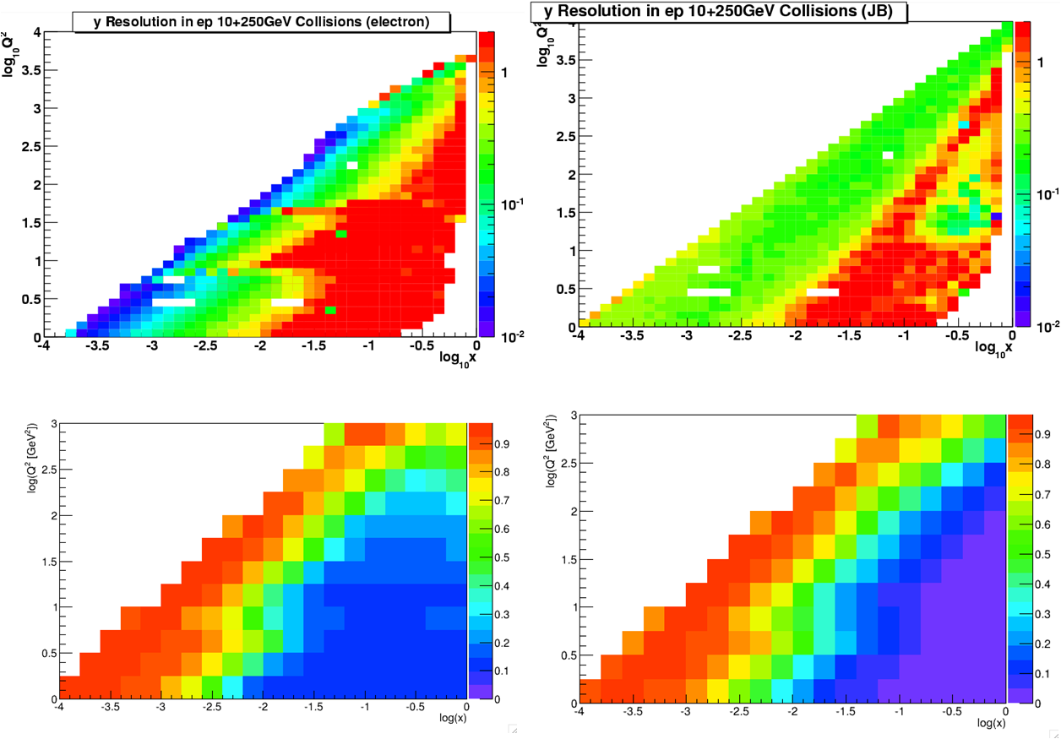

Figure .1: (Top) The simulated resolution in y for different values of x and Q2 in the eSTAR acceptance for the deep-inelastic scattering of 10 GeV electron beams off 250 GeV proton beams when y is reconstructed from measurements of (left) the scattered electron and (right) the hadronic final state. (Bottom) The corresponding purity (left) and simulated bin-survival-probability (right) for different values of x and Q2 in the eSTAR acceptance when the event kinematics are reconstructed from the scattered electron.

### Inclusive Measurements

#### Unpolarized measurements

A key goal of the EIC is the precise determination of the inclusive structure functions *F*2 and *F*L over a wide and resolved kinematic range in *x* and *Q*2 and for various nuclei to study nuclear parton distributions and their saturation for low values of *x*. The inclusive structure functions *F*2 and *F*L are related to the (reduced) one-photon-exchange cross-section:

$$σ_{r}= \frac{d^{2}σ}{dxdQ^{2}} \frac{x Q^{4}}{2πα[1+{(1-y)}^{2}]}=F_{2}\left(x,Q^{2}\right)- \frac{y}{1+{\left(1-y\right)}^{2}}F_{\text{L}}\left(x,Q^{2}\right)$$

and can be resolved from measurements at equal *x* and *Q*2 for different *y* in a so-called Rosenbluth separation analysis. This entails measurements at different beam energies.

To assess the eSTAR capabilities in measuring *F*2(*x*,*Q*2), a Rosenbluth separation analysis was performed on simulated data. Pseudo-data were generated for different incident electron beam energies of 5 and 10 GeV and Au beam energies of 50, 75 and 100 GeV per nucleon using Pythia with the EPS09 LO PDFs for Au. The eSTAR fast detector response, discussed in detail in Section 4, was applied to the scattered electron. The reduced cross section as seen in the eSTAR acceptance was extracted for different values of *x* and *Q*2 from the simulated data for 50, 75, and 100 GeV/nucleon *Au* beams and 5 and 10 GeV incident electron beams. The pseudo-data correspond to an integrated luminosity of 1fb-1 for each of the combinations of beam energies. The actual measurements will be dominated by systematic uncertainties.

The values extracted for *F*2(*x*,*Q*2) are shown for both electron beam energies in Figure 2.2. Point-by-point systematic uncertainties of 3%, consistent with the values achieved at the HERA experiments, were included in the pseudo-data and a minimum lever arm in *y*/[1+(1-*y*)2] of 0.1 was imposed in the extraction of *F*2(*x*,*Q*2).

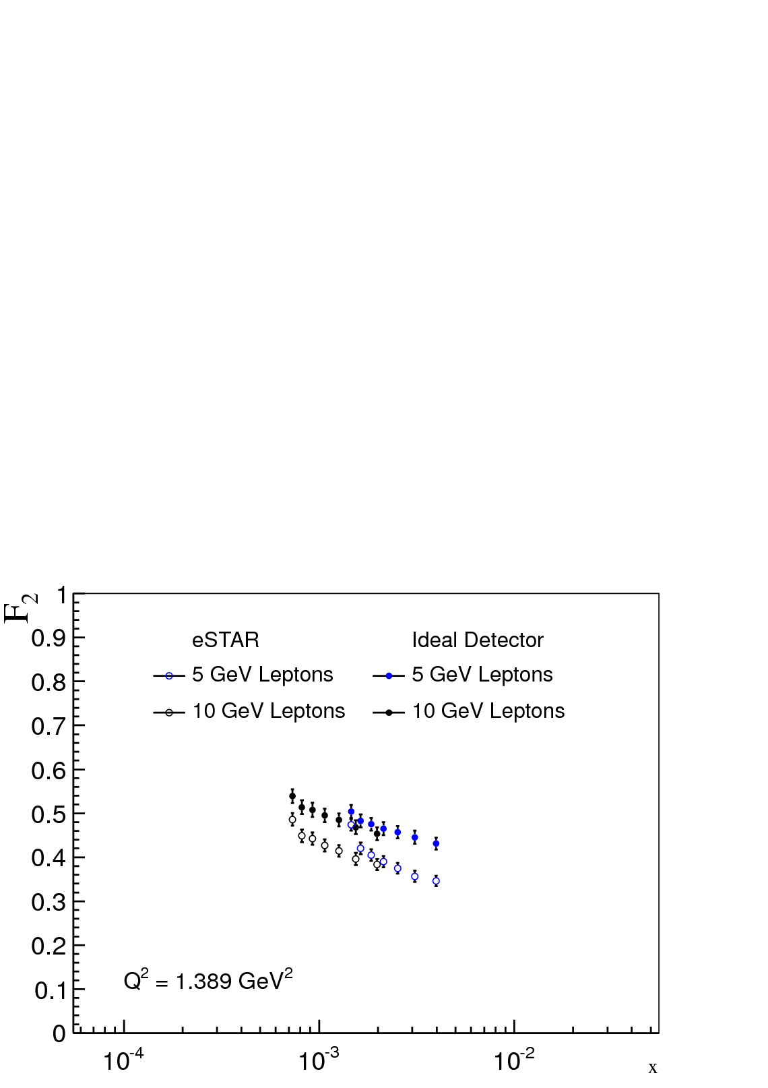

Figure .2: Projected measurements of the unpolarized inclusive structure function F2(x,Q2) in deep-inelastic scattering of electrons of the indicated energies with Au nuclei of 50-100 GeV/nucleon energies to study nuclear parton distributions and their saturation at low values of Bjorken-x. The eSTAR projections are shown in comparison with those for an ideal detector.

The comparison of the values extracted for *F*2(*x*,*Q*2) with eSTAR and with an ideal detector in Figure 2.2 shows large and similar acceptance in Bjorken-*x*. The vertical offset between the sets of data results from differences in acceptance and resolution. These effects can and would be corrected in actual measurements using full detector acceptance and response simulations.

A key goal of the EIC in the case of polarized deep-inelastic scattering is the precise determination of the inclusive spin structure function *g*1 of the nucleon over a wide and resolved kinematic range in *x* and *Q*2. Perturbative QCD analysis of *g*1(*x*,*Q*2) at an EIC is anticipated to give definitive insight in the size and distribution of the quark and gluon spin contributions to the nucleon spin.

The projected eSTAR measurement capabilities for *g*1(*x*,*Q*2) are shown in Figure 2.3 for integrated luminosities of 1 fb-1 at each of the energies, 70% beam polarizations, and 50% running efficiency. The analysis methods are different from the analysis of the spin-independent structure functions *F*2 and *F*L in that they do not necessitate a Rosenbluth separation analysis. Spin-dependent analyses, however, do impose stringent demands on purity and stability. The results shown in Figure 2.3 impose a minimum purity of 80%, an upper value on *y* of 0.9 to reduce sensitivity to radiative backgrounds in the measurement, and a limit of 0.1 on the depolarization of the exchanged photon. The latter is positively correlated with *y* and in effect imposes an approximate threshold of *y* > ~0.1.

The eSTAR capabilities for measurements of *g*1(*x*,*Q*2) will thus cover a wide region in *x* and *Q*2, well beyond that achieved by existing fixed-target measurements. For 0.001 < *x* < 0.2, the eSTAR data offer a lever arm of one decade or more in *Q*2 and will enable precision QCD analysis to determine the quark and gluon spin distributions in the polarized nucleon.



Figure .3: eSTAR pseudo-data on the inclusive spin structure function g1(x,Q2) versus Q2 at constant x for 5 and 10 GeV longitudinally polarized electron beams colliding with 50, 100, and 250 GeV longitudinally polarized proton beams at eRHIC, as indicated. The projected uncertainties are statistical only. The data for each of the indicated x values is offset by the constant in brackets for clarity. The dotted line indicates the central value of the DSSV expectation.

### Semi-Inclusive Measurements

In semi-inclusive deep-inelastic scattering measurements, one or more of the final-state particles produced in the collision are detected and measured in addition to the scattered lepton. The primary goals of 1-particle semi-inclusive deep-inelastic scattering measurements at an EIC include a full flavor separation of the polarized quark and anti-quark distributions in the polarized nucleon, the study of polarized and unpolarized transverse-momentum-dependent (anti-)quark and gluon distributions and their scale dependences, and the precision study of hadronization and energy loss in cold nuclear matter. Two-particle correlation measurements have traditionally been used to probe gluon distributions by means of their significant scattering contributions from photon-gluon fusion processes and have been proposed as a robust probe of gluon saturation in nuclei at an EIC.

The requirements to identify and measure the scattered lepton in semi-inclusive deep-inelastic scattering measurements are essentially the same as those for inclusive measurements. However, additional acceptance requirements are imposed by the need to measure and identify the final-state hadrons. The final-state hadrons in 1-particle semi-inclusive deep-inelastic scattering measurements are typically characterized by their transverse momenta, *p*T, with respect to the virtual photon that is exchanged in the interaction, by their energy fractions, *z*, and by their angles with respect to the reaction plane as well as the hadron spin direction in the case of polarized measurements.

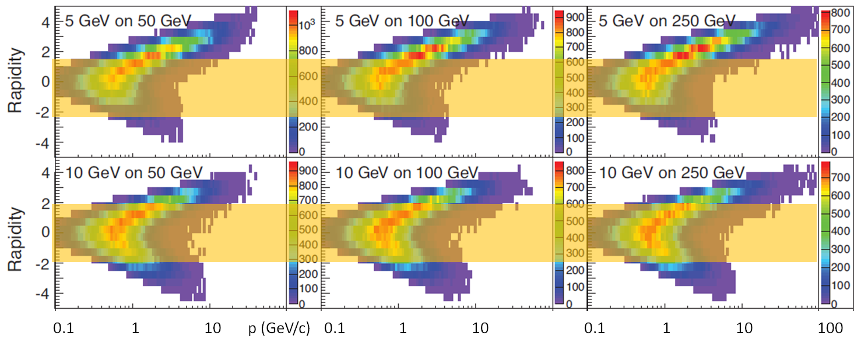

Figure .4: Momentum vs rapidity distributions in the laboratory frame for pions from non-exclusive reactions. This figure is adapted from figure 6.2 in the EIC whitepaper. The region of eSTAR capabilities is overlaid in yellow.

Figure 2.4 shows the combined momentum and rapidity distributions in the laboratory frame for pion production in non-exclusive reactions. The range of existing STAR capabilities is overlaid in yellow. The capabilities for identified Kaons span a smaller range in *p* of up to about 4 GeV/c. The existing STAR TPC and TOF will be maintained in eSTAR and will be complemented with forward time-of-flight coverage to provide adequate start-time resolution. eSTAR is thus projected to have significant 1-particle semi-inclusive deep-inelastic scattering measurement capabilities to delineate the spin-flavor structure of the nucleon. The resolutions in transverse-momentum-dependent measurements remain to be quantified explicitly through simulations at the time when this document was written.

#### Parton Energy Loss in the Nuclear Medium

Collisions of electron beams with ion beams of various species at an EIC make it possible to study with the precision and resolved kinematics of 1-particle semi-inclusive deep-inelastic scattering processes the mechanisms by which quarks and gluons lose energy and hadronize in cold nuclear matter. This is complementary to the studies of jet quenching in heavy-ion collisions, a fast moving color charged parton losing energy in a hot and dense quark-gluon plasma, which is among the major discoveries of the RHIC physics program.

We have carried out Pythia-based fast simulations of the eSTAR response for 5 GeV and 10 GeV electron beams with 50 and 100 GeV hadron beams, following closely the presentation of energy-loss studies in cold nuclear matter in the EIC whitepaper. Figure 2.5 shows the resulting acceptance for high and low values of the photon virtuality *Q*2 and energy ν. These regions are thought to probe hadronization of the parton outside and inside the nuclear medium. The difference between the generator level and eSTAR observed distributions are caused primarily by the acceptance gap for π0 rapidities between 2.0 and 2.5 and the lack of π+- identification in the forward hadron region. Significant capability is seen to exist despite these limitations.

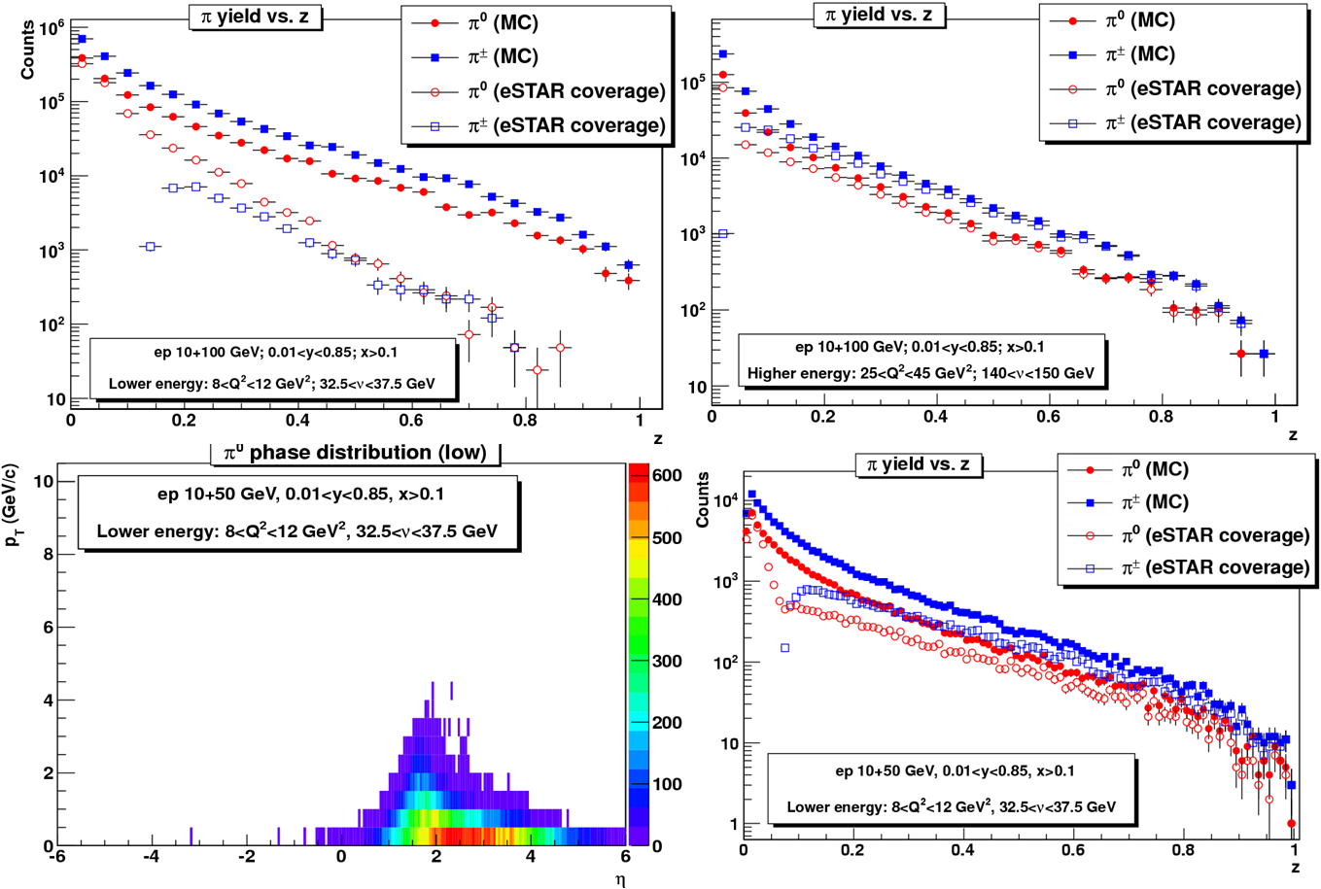

Figure .5: The eSTAR acceptance for charged and neutral pion production versus the fragmentation momentum fraction z for partons with high (top left) and low (top right) energies in deep-inelastic scattering collisions of a 10 GeV electron beam with a 100 GeV hadron beam. The lower panels show (left) the combined rapidity versus transverse momentum distribution and (right) the corresponding z-spectrum in 10 GeV on 50 GeV collisions. The samples presented here correspond to only a small fraction of the 1 fb-1 integrated luminosity that serves as a baseline in our other simulations.

#### Dihadron correlations

Dihadron correlation measurements, *e* + *A* → *e′* + *h*1 + *h*2 + *X*, offer access to gluon distributions via scattering contributions from photon-gluon-fusion processes. The nonlinear QCD evolution of multi-gluon distributions is expected to be different from that of the single-gluon distribution and can be measured through modification of the di-hadron correlation distributions[[6]](#endnote-5). Saturation models predict the functional form of the multi-gluon distribution as functions of the gluon transverse momentum, kT, and the saturation momentum, *Q*2S(*x*)[[7]](#endnote-6),[[8]](#endnote-7).

The left panel of Figure 2.6 shows the spectrum of the difference Δφ in azimuthal angle between a trigger-hadron with momentum pTtrig> 2 GeV/*c* and an associate-hadron with momentum pTtrig > pTassoc > 1 GeV/*c*. The projected eSTAR precision is shown together with theoretical expectations. The eSTAR projected precision was evaluated for an integrated integrated luminosity of 1 fb-1 in *e* + *p* and in *e* + *Au* collisions with 10 GeV electron beams and 100 GeV/nucleon hadron beams. The expectations are saturation model predictions and conventional non-saturated correlation functions. Their difference can be clearly differentiated in eSTAR measurements, considering even the uncertainties in the expectation caused by uncertainty in the saturation scale as shown by the grey band.

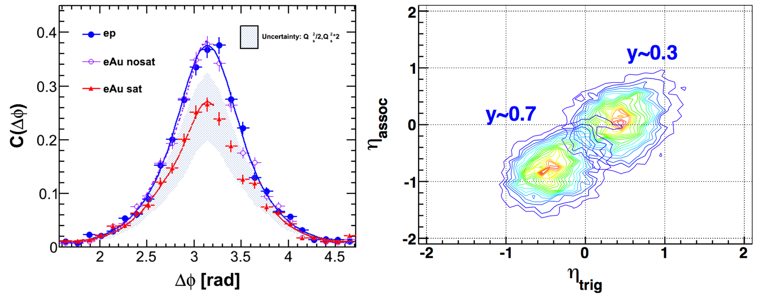

Figure .6: Left panel: Azimuthal angle differences Δφ of two hadrons at Q2 =1 GeV2 at 10x100 GeV with an integrated luminosity of 1 fb-1 for  e+p (solid circle) and e+Au (open circle) from conventional non-saturated models. Right Panel: Pseudorapidity (η) distributions of two hadrons at Q2 = 1 GeV2 and y~0.3, 0.7.

The final-state hadron pairs are produced near mid-rapidity as shown in the right panel of Figure 2.6. The eSTAR mid-rapidity capabilities are thus well suited for this measurement at the eRHIC (phase-I) energies.

### Exclusive and Diffractive Measurements

Exclusive deep-inelastic scattering describes measurements that involve measurement of the scattered electron, the beam hadron (either intact or dissociated), and the reconstruction of the final-state particle(s) produced in the interaction. In the region of low-*x*, the beam hadron (typically a proton) scatters at such a small angle that it very often remains in the beam pipe and its measurement requires forward detectors installed in Roman Pots along the beam pipe. The reconstruction of the final-state particle(s), typically a photon or a vector meson decaying into leptons, imposes additional detector requirements, mainly on tracking and calorimetry. Measurements of this kind are thus challenging.

The objective of these measurements with an EIC is to provide spatial imaging of quarks and gluons in the (polarized) nucleon and in nuclei. The reaction channels of main EIC interest are deeply-virtual Compton scattering (DVCS), *e + p/A → e’ + p’/A’ + * and the exclusive production of a J/ψ, φ, or ρ vector meson, *e + p/A → e’ + p’/A’* + vector meson. These reactions are described in terms of Generalized Parton Distributions (GPDs), which in turn describe the 1+2D distribution of longitudinal momentum and transverse spatial distribution of the target nucleon/nucleus.

Diffractive events, *e + p/A → e′ + p’/A’ + X*, are closely related in that the proton/nucleus remains intact also in these events. The highly virtual photon hadronizes into a final state, *X*, that is separated from the scattered proton/nucleus by a large rapidity gap without any particles. These events are indicative of a color-neutral t-channel exchange between the virtual photon and the proton over several units in rapidity. Their main objective at an EIC is to probe gluon saturation in a new regime of QCD.

#### Deeply Virtual Compton Scattering

The MILOU generator[[9]](#endnote-8) combined with the eSTAR response parametrizations have been used to assess the eSTAR capabilities for DVCS measurements. The electrons are detected with tracking detectors or the calorimeters, which serve also for the detection of photons. Instrumented Roman Pot stations are used to detect the scattered proton over an assumed range of 0.03<-|t|<2 GeV2 and the exclusivity of the event will be ensured by full azimuthal coverage in -4<*η*<5.2. eSTAR offers good acceptance in (x, Q2), which is essential in the study of evolution effects predicted by perturbative QCD theory and to extract gluon GPDs from such effects.

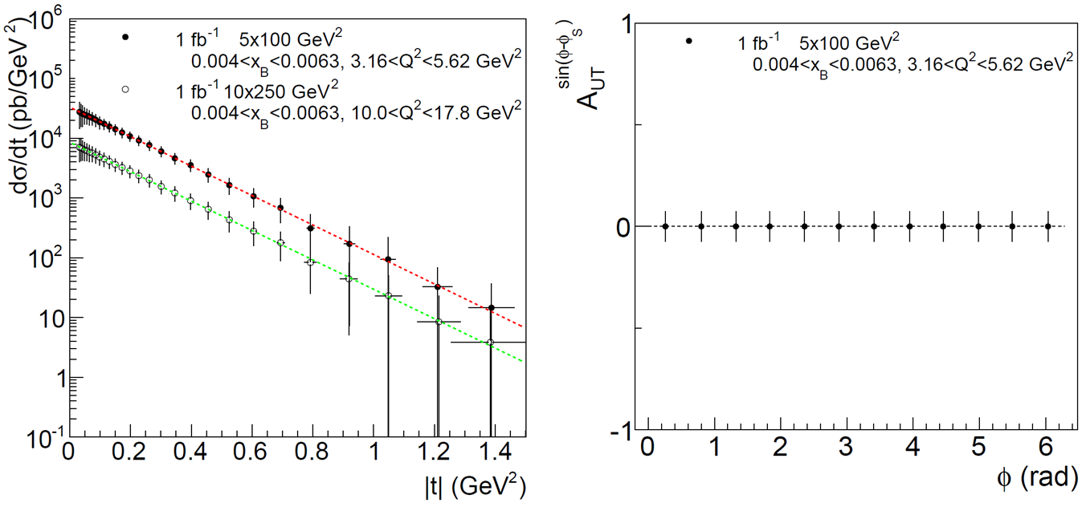

Figure .7: (Left) eSTAR performance for exclusive photon production in specific (x,Q2) intervals, as indicated, for e +p collisions of 5 GeV electron beams off 100 GeV proton beams and of 10 GeV electron beams off 250 GeV proton beams. The uncertainties are statistical and correspond to an integrated luminosity of 1 fb-1. (Right) The DVCS spin asymmetry versus azimuthal angle for unpolarized electrons scattering off transversely polarized protons for the indicated (x,Q2) interval.

The left panel in Figure 2.7 shows projections for the measurement of the differential DVCS cross-sections and transverse target spin asymmetry for 1 fb-1 of data collected within the eSTAR acceptance. The main background contribution to the DVCS cross-section measurements is from the Bethe-Heitler process. The latter has been subtracted in these projections and a 3% systematic uncertainty on its contribution is propagated into the projected DVCS cross-section measurement uncertainties. Other background contributions include low multiplicity diffractive meson production and π0/η semi-inclusive DIS production. Such background contributions were found to be negligible for the HERA experiments. They have been omitted from consideration here, since the eSTAR calorimeter has better spatial resolution in general than the calorimeters employed by the HERA experiments. Also included in the projected cross-section results is an additional 5% systematic uncertainty according to the experience of the HERA experiments. The right panel in Figure 2.7 illustrates the projected uncertainties for the corresponding DVCS spin asymmetry measurements. eSTAR is expected to have good capability also for measurements of exclusive J/ψ production in view of its electron and muon capability for mid-central rapidities. The corresponding distributions of partons in impact parameter bT obtained from the measured DVCS cross-section results shown Figure 2.7 in Figure 2.8.

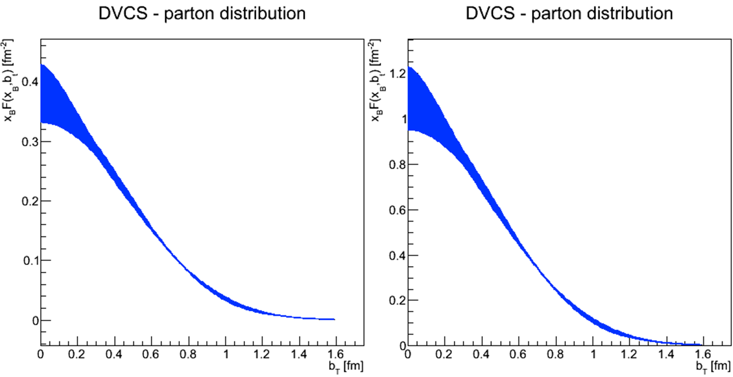

Figure .8: Distributions of partons in impact parameter bT obtained from the measured DVCS cross-section results shown in Figure 2.7. Left: 0.004<xB<0.0063, 3.16<Q2<5.62 GeV2; right: 0.004<xB<0.0063, 10.0<Q2<17.8 GeV2. The bands represent the parametric errors in the fit of measured differential DVCS cross-section results.

#### Diffractive Vector Meson Production

Diffractive vector meson production, *e + A → e’ + A’ + V* where *V=J/ψ, φ, ρ* is a unique process from an experimental point of view, because it allows the measurement of the momentum transfer, *t*, at the hadronic vertex even in *e + A* collisions where the 4-momentum of the outgoing nuclei can in general not be measured. Since only one final state particle is produced, the process is experimentally clean and can be identified unambiguously by the presence of a rapidity gap. The *J/ψ* vector meson has a compact dipole size and is thus not expected to be particularly sensitive to gluon saturation phenomena. Larger mesons such as *φ* or *ρ* are anticipated to be considerably more sensitive.

To assess eSTAR capability for these measurements, we have carried out fast simulations using the SARTRE event generator and eSTAR response parametrization. Instead of deriving |*t*| from the 4-momentum of the scattered electron and the created vector mesons, an approximation is used, |*t*|=(*pxe’+pxV*)2+(*pye’+pyV*)2, using only the transverse momenta of the particles. This approximation is found to be justified and results in good resolution. Figure 2.9 demonstrates that eSTAR measurements are able to resolve the diffractive pattern used in the EIC whitepaper and shows that the thus achieved eSTAR |*t*|-resolution is projected to be approximately 2.5% (relative).

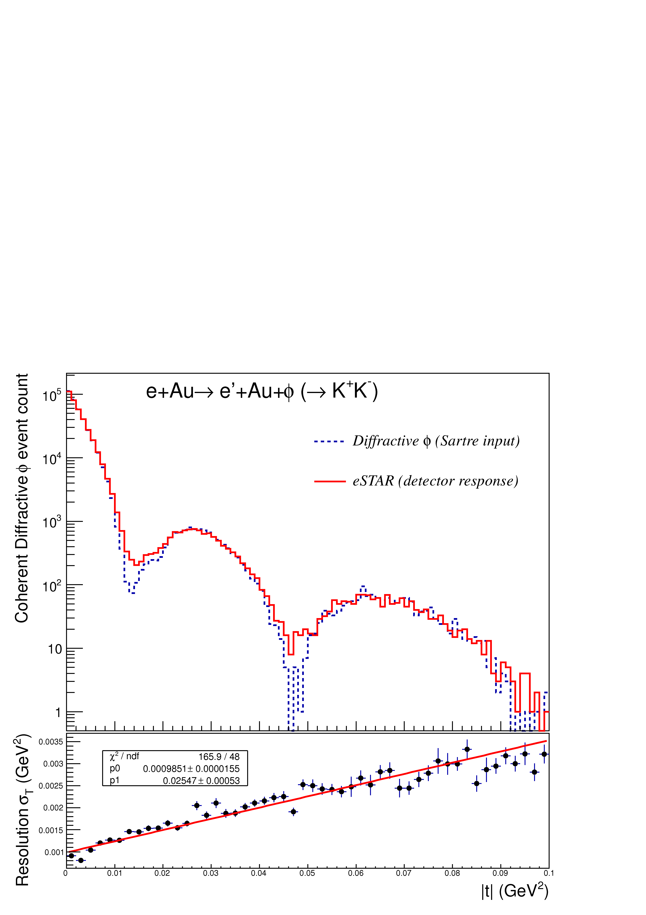

Figure .9: The |t|-spectrum for the coherent diffractive production of φ mesons in e +Au scattering in collisions with 10 GeV electron beam energy and 100 GeV/nucleon energy for the Au beam. The dashed line is the SARTRE generated input distribution and the solid red histogram is the result after eSTAR detector response. The bottom panel shows the |t| resolution versus |t| and is described by σt=2.5%|t|+0.1%.

# Detector Configuration and Components

## Current Detector Configuration

Since the beginning in 2000, STAR has had a strong upgrade program to take advantage of luminosity upgrades of the machine and to enhance the physics program. The currently approved and ongoing upgrades are the Forward Gem Tracker (FGT), completed in run12, and the Heavy Flavor Tracker (HFT), a major MIE that is projected to be ready for the STAR heavy flavor program with topological identification for Run 14. The Muon Telescope Detector (MTD) has completed over 60% of installation and is projected to be ready for run14, enabling a significant di-muon program alongside the heavy flavor program with HFT. A number of additional proposals have been reviewed internally within STAR. One is to study central production in *p*+*p* collisions though an upgrade of the Roman Pots.

STAR mid-rapidity acceptance and particle identification capabilities, paired with more forward instrumentation aimed at high (total) energies, form key strengths into the EIC era. The STAR mid-rapidity region with the upgrade TPC, MTD, existing BEMC, and TOF is relatively well matched to the demands of inclusive and semi-inclusive deep-inelastic scattering measurements at hard scales *Q*2>10GeV2 for the initially low electron beam-energies foreseen at an EIC. Figure 3.1 describes the current STAR detector coverage in (x, Q2) phase space for *e + p* (*e + A*) collisions at beam energies of 10x100.

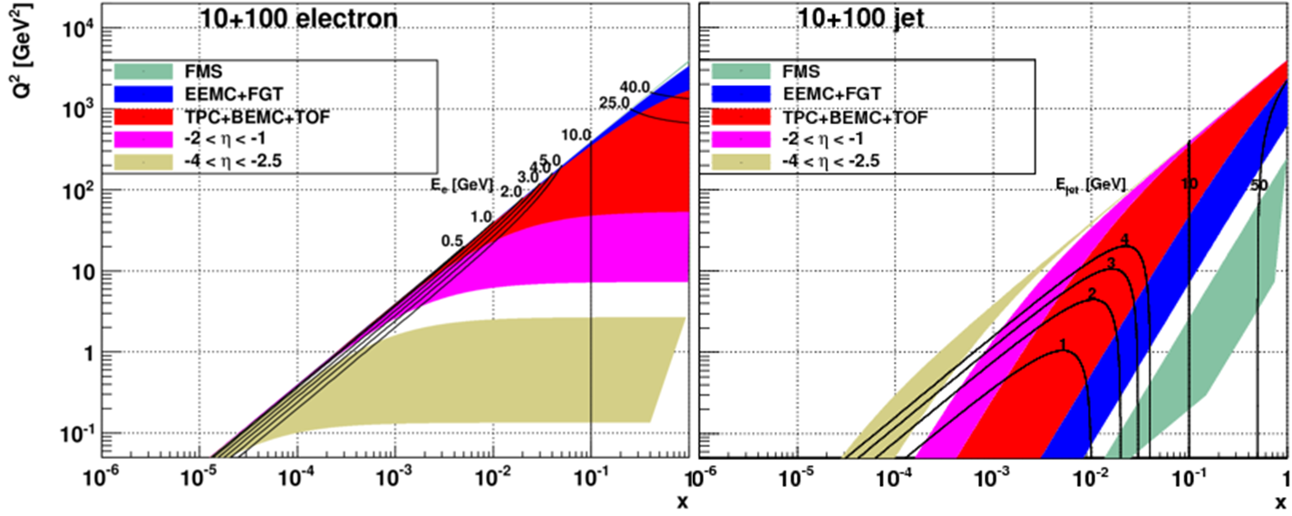

Figure 3.1: DIS kinematics of scattered electrons and jets with STAR existing detector coverage.

The extension of this coverage to smaller x or Q2 requires forward instrumentation, in particular to identify and measure the forward scattered electron with good efficiency, purity, and resolution.

Coverage over the region −4 *< η*  *<* −1 (on the east end of STAR, opposite to the EEMC) would expand the *Q*2 range of inclusive and semi-inclusive measurements accessible to STAR to cover essentially the entire conventional deep-inelastic regime, *Q*2 *>* 1 GeV2. The low-*x* region, below *x* = *Ee/Eh* with *Ee*(*h*) the electron (hadron) beam energy, is of particular interest. In this region, the scattered electron energies range up to the electron beam energy. This holds also for the energies of the hadrons produced at backward angles in scattering of low-*x* partons. The identification of hadrons with these energies is of particular importance to semi-inclusive measurements.

## Proposed eSTAR Detector Configuration

STAR has proposed a baseline eSTAR detector configuration for eRHIC with electron beam energy of 10 GeV and below, depicted in Fig.3.2. In addition to the major upgrades of inner TPC sectors (iTPC) and forward calorimeter and associated tracking system (FCS) before the completion of RHIC program, we have proposed a series of upgrades specifically designed for eSTAR: endcap TOF on both east and west pole-tips covering pseudorapidity of 1<|η|<2, GEM based TRD (GTRD) (-2<η<-1), BSO based crystal calorimeter (CEMC) and its pre-shower (-4<η<-2).

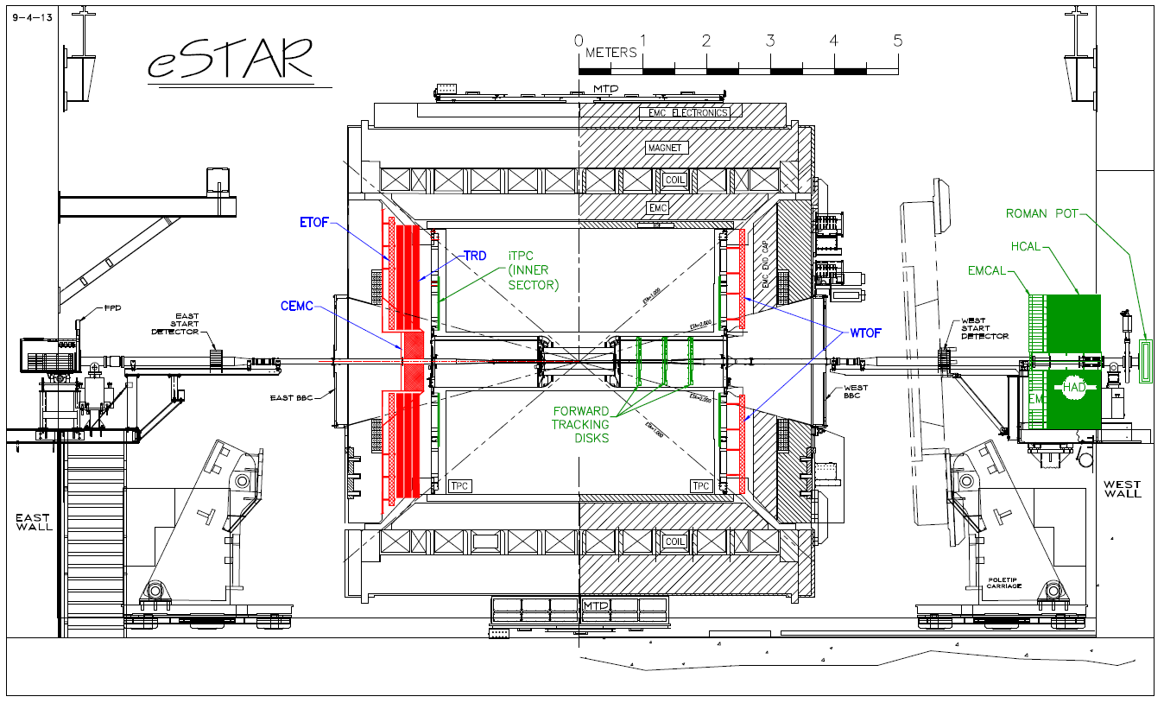

Figure 3.2: eSTAR layout with the proposed upgrades of iTPC, Forward Calorimetry System (FCS), Endcap TOF (E/W TOF), BSO Crystal Calorimeter (CEMC), GEM based TRD. In this configuration, the electron beam is from right to left (eastward) while hadron beam from left to right (westward).

## Expected DIS Coverage and Performance

### Resolution and Coverage of Detecting Electrons and Hadrons

Due to the asymmetry of the collisions and DIS kinematics, different components of the detector serve a specific purpose in different pseudorapidity ranges. Table 3.1 lists the detector subsystems in different pseudorapidity ranges and their energy (momentum) resolutions. The resolutions of existing detector subsystem are obtained from the actual performance while the resolutions of proposed detectors are based on simulation and prototype test results. A series of publications outline the performance of existing detectors4,[[10]](#endnote-9).

|  |  |  |  |  |  |
| --- | --- | --- | --- | --- | --- |
| **Coverage** | **Orientation** | **Tracking** | **EMC** | **HCAL** | **Resolution (momentum or energy)** |
| -4<η<-2 | Beam Electron direction; eSTAR EAST | hit | BSO |  | σE/E=2%/√‾E⊕0.75% |
| -2<η<-1 | iTPC+GTRD+ETOF | Converter |  | σp/p=1/(pT/pZ-1/6) ×(0.45%pT⊕0.3%)   ⊕(pZ/pT) ×0.2%/p/β |
| -1<η<1 | Middle Rapidity | TPC+TOF | SMD+EMC |  | σE/E=14%/√‾E⊕2%  σp/p=0.45%pT⊕0.3% ⊕0.2%/p/β |
| 1<η<1.7 | Beam Hadron direction;  eSTAR WEAT | iTPC+TOF |  |  | σp/p=1/(pT/pZ-1/4) ×(0.45%pT⊕0.3%)   ⊕(pZ/pT) ×0.2%/p/β |
| 1<η<2 | iTPC+FST | SMD+EMC |  | σE/E=16%/√‾E⊕2% |
| 2.5<η<5 | Forward Tracking | W-fiber EMC (FCS) | HCAL | σE/E=12%/√‾E⊕1.4%  σE/E=38%/√‾E⊕3% |

Table 3.1: eSTAR Detector Coverage and Resolution in the pseudorapidity range.

### Particle Identification

Besides coverage and resolution, another detector quality important to the EIC program is particle identification. With the combination of dE/dx from TPC, velocity measured by TOF and energy deposit in electromagnetic calorimeter covering 2 azimuthal angle, STAR is an ideal collider detector for particle identification of electron, π0 and charged hadrons. With the precise track trajectory provided by helix in TPC in a soneloidal magnetic field, V0 reconstruction is proven to be efficient in wide momentum range.

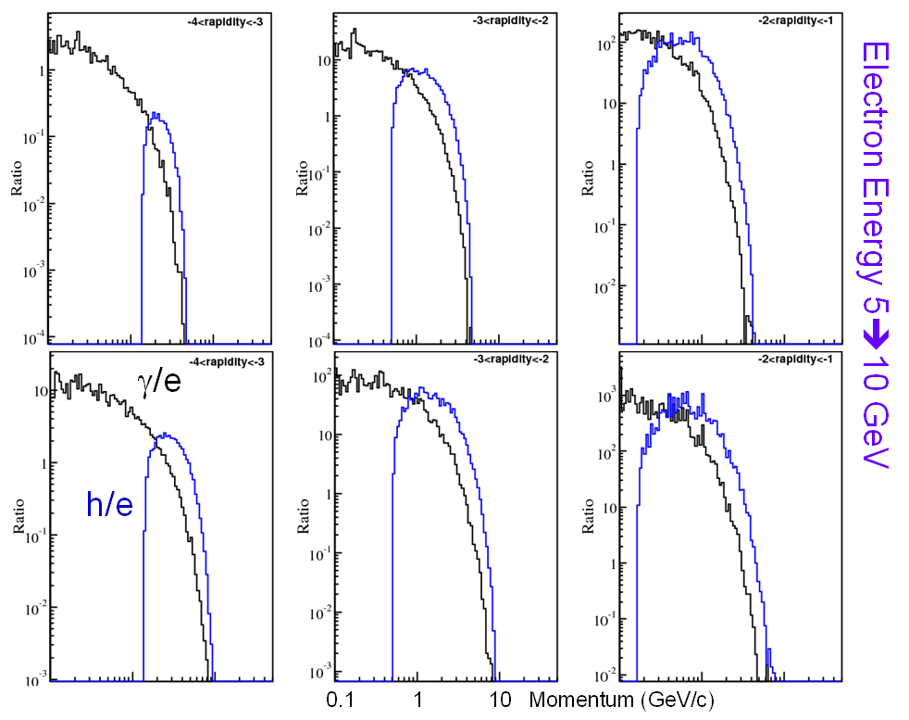

Figure 3.3: photon and hadron background to electron ratio as a function of momentum for different rapidity range in e+p collisions with electron beam energy of 5 GeV (top panels) and 10 GeV (bottom panels).

The measured spectra of particles in STAR include γ, μ, π0, π±, η, ρ, φ, K±, Ks, K\*, p, Λ, Ξ, Ω, J/Ψ and ϒ. Ref.[[11]](#endnote-10) provides a complete list of STAR publications. The identified charged and neutral pion spectra have been measured in the transverse momentum range of 0.2<pT<15 GeV/c at mid-rapidity of |y|<1. Electron identification and hadron rejection are essential to the eSTAR physics program. At mid-rapidity |y|<1, STAR has proven to have excellent electron detection due to its low low material (<1% X0) and large hadron rejection over a large momentum range9. From the publication in Ref.[[[12]](#endnote-11)], STAR has shown to be able to achieve hadron rejection at a level better than 105 at pT=2 GeV/c. The proposed upgrades of iTPC, TRD and ETOF aim to achieve the necessary electron identification in the pseudorapidity range (-2<η<-1) in the DIS kinematics of the scattered electrons essential to the eSTAR physics program. Going even more forward in the electron scattered direction, the requirement for hadron rejection decreases dramatically. However, the requirement of precise measurement of electron kinematics and the need to reject photon conversion and misidentification as electron become increasingly demanding. Figure 3.3 shows the ratio of photons and hadrons to the scattered electron as function of momentum and rapidity. Although the h/e ratio is about 1000 at mid-rapidity, hadron contamination is negligible at very forward rapidity. However, photond becomes the major source of background for misidentification. We have proposed to leave only the beam pipe and its necessary support structure along this direction, and to install a crystal calorimeter and preshower to precisely determine electron energy and angle with minimum material along the electron path. Table 3.2 lists the pseudorapidity coverage and particle identification capabilities.

|  |  |  |  |  |  |
| --- | --- | --- | --- | --- | --- |
|  | **e±** | **γ/π0** | **π±** | **K±** | **p** |
| -4<η<-2 | 🗹 | 🗹 | 🗷 | 🗷 | 🗷 |
| -2<η<-1 | 🗹 | 🗷 | 🗹 0.1<p<15 | 🗹 0.1<p<3 | 🗹  0.1<p<5 |
| -1<η<1 | 🗹 | 🗹 |
| 1<η<1.7 | 🗹 | 🗹 |
| 1.7<η<2 | 🗹 | 🗹 | 🗷 | 🗷 | 🗷 |
| 2<η<2.5 | Tracking without PID (charged hadrons) | | | | |
| 2.5<η<5 | 🗹 | 🗹 | Tracking and Energy without PID | | |
| -4<η<5 | Hits | Hits | Hits | Hits | Hits |

Table 3.2: eSTAR particle identification capabilities.

In addition, the acceptance and identification of hadrons at low momentum is important for the diffractive vector meson sensitive to the gluon saturation effect. Figure 3.4 shows the daughter kaon momentum distribution in the exclusive process e+Au🡺e’+Au+φ🡺e’+Au+K++K-, illustrating the importance and strength of STAR capability of kaon identification and acceptance at low momentum around mid-rapidity.

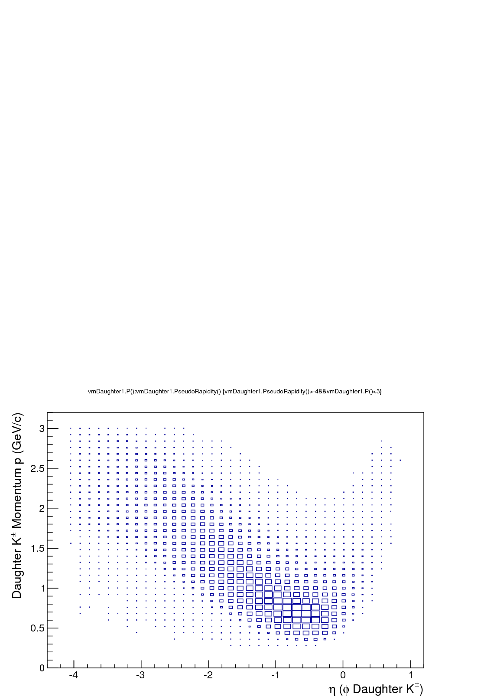  
Figure 3.4: charge kaon momentum distribution as a function of pseudorapidity from diffractive phi production generated by SARTRE in e+Au collisions at 5x100.

### TPC Occupancy and Pile-up with eRHIC Luminosity

At the heart of STAR detector is the Time Projection Chamber. Therefore, it is necessary to verify that STAR TPC can handle the high luminosity expected in eRHIC. Table 3.3 lists the collision species of e+p, Au+Au, p+p at 200 GeV and p+p at 500 collisions with luminosity achieved or projected. The TPC occupancy is characterized by the track density per unit of pseudorapidity per time interval. The results from PYTHIA e+p simulation and achieved luminosity at RHIC so far show that the track density in eRHIC is about an order of magnitude lower than that achieved at RHIC. We have concluded that STAR TPC is suitable for EIC environment in terms of event pile-up and occupancy.

|  |  |  |  |  |  |
| --- | --- | --- | --- | --- | --- |
| Beam species | Sqrt(s) | Peak Luminosity (cm-2s-1) | Cross section (cm2) | Nch/dη | **Track density (dNch/dη MHz)** |
| e+p | 5x250 | 1034 | 10-28 | 0.7 | **0.7** |
| Au+Au | 100x100 | 5x1027 | 7x10-24 | 161 | **6** |
| p+p | 100x100 | 5x1031 | 3x10-26 | 2 | **3** |
| p+p | 250x250 | 1.5x1032 | 4x10-26 | 3 | **18** |

Table 3.3: STAR TPC occupancy in different collision environment.

# Detector Performance Simulations

This section will discuss the results from simulations used to predict the resolution, efficiency and kinematic coverage provided by the detectors discussed in Section 3. All of the studies presented here, with the exception of the TRD, are based on STARSIM, a simulation framework developed by the STAR collaboration. GEANT3 is used to implement the detector systems and describe interactions between particles and experimental materials. The STARSIM package has been used and tested against the STAR data for over a decade and provides a solid base for the eSTAR upgrade simulations. The transition radiation process is not included in GEANT3 so the TRD simulations were produced with a stand-alone package that incorporated GEANT4. Deep inelastic e+p and p+p scattering events were generated with the PYTHIA 6 Monte Carlo package. CDF tune A parameters with intrinsic momentum <kT> = 0.5 GeV, the tune that most accurately reproduces the particle production seen in data in the forward region, were used for the p+p studies in the FCS.

## Detector Kinematic Acceptance and Efficiency

As discussed in Section 5, the inner sectors of the existing TPC will be re-instrumented with 48 readout pad rows. Figure 4.1 demonstrates the significantly improved particle reconstruction efficiency with the iTPC (red) compared to the existing TPC (blue). The coverage in pseudo-rapidity increases from |η|<1 to |η|<1.5, with the efficiency dropping to ~10% at η = 1.6. The increase in efficiency is fairly flat across particle pT, and ranges from a 10-20% effect at mid-rapidity to a 300-400% increase in the forward regions. This improvement in efficiency will extend particle reconstruction to lower pT as well.

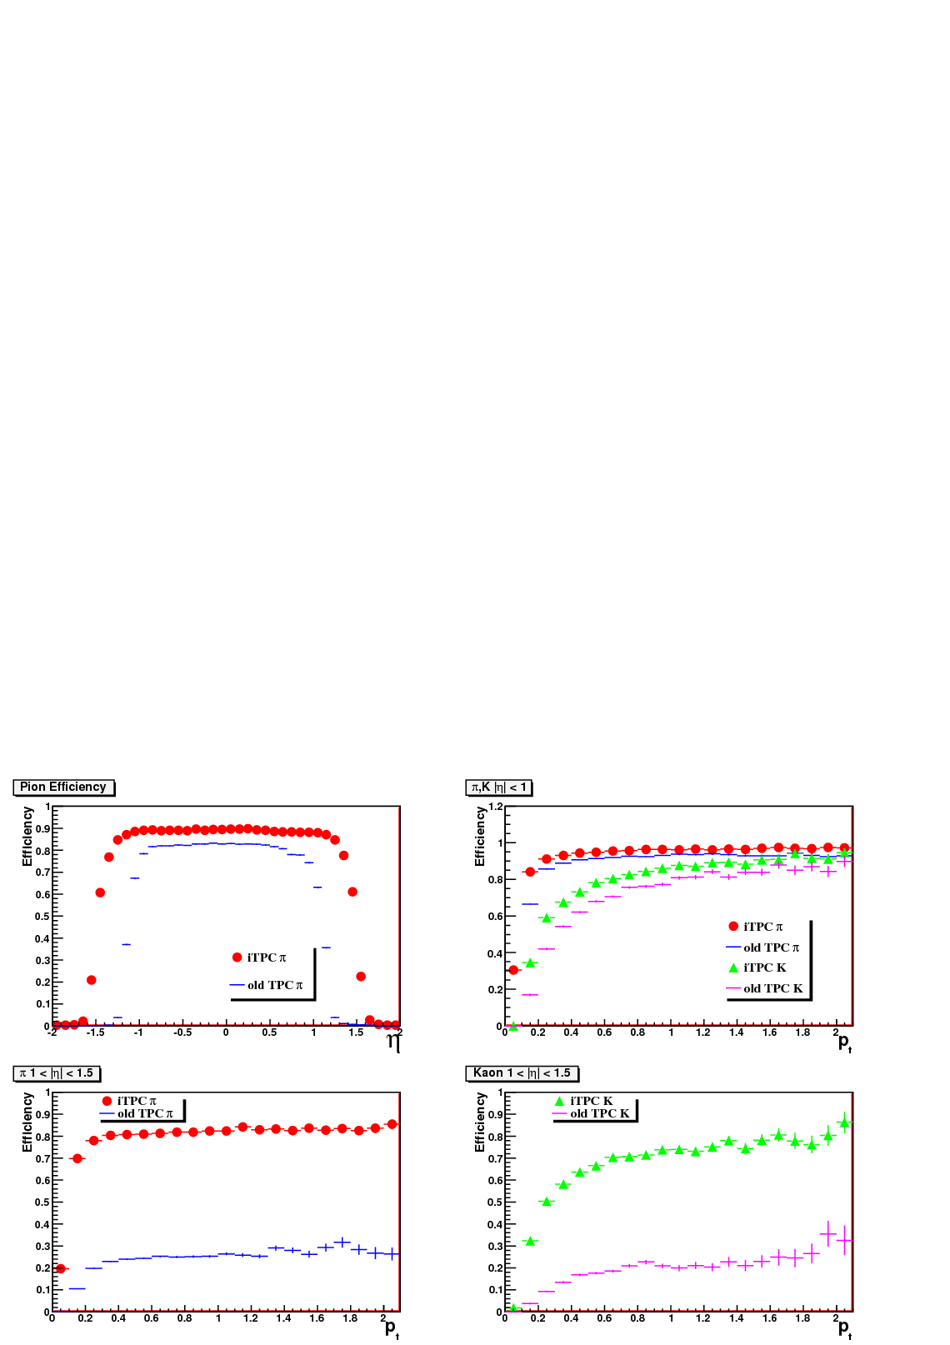

Figure 4.1: The top-left plot compares the pion reconstruction efficiency as a function of pseudorapidity for the proposed iTPC (red) and the existing TPC (blue). The top right plot demonstrates the marked improvement at lower pT for both pions and kaons at mid-rapidity. The bottom two plots show a factor of four increase in reconstruction efficiency, for all pT values, for pions and kaons in the forward region.

An Endcap TOF+TRD system for Identifying Electrons (ETTIE) will be installed on the electron beam side of the TPC. The TRD will perform the critical function of identifying the scattered electrons in e+p collisions, in addition to providing energy loss measurements and additional track points for momentum reconstruction. The electron identification power was studied for the ETTIE by using the hit position and total energy deposition in the Xe gas absorber of the TRD to construct a likelihood function, allowing the separation of electrons and hadrons.

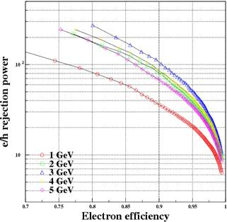

Figure 4.2: The ETTIE e/h rejection power.

Figure 4.2 shows the electron to hadron rejection power as a function of electron efficiency. At 90% electron efficiency, the rejection power ranges from ~30 to 100 depending on the energy of the electrons. Although not included in these studies, the Endcap TOF information and the energy deposited in the convertor sandwiches can also be used to increase the electron identification capability. Overall we estimate the e/h rejection can be pushed above 1000 for 2-5 GeV electrons.

The CEMC, a homogeneous electromagnetic calorimeter constructed from BSO crystals, will fill the acceptance gap between ETTIE and beam pipe. The efficiency of the CEMC is expected to be 90%. Additional details are discussed in section 5.2.2.

Macintosh HD:Users:rfatemi:Desktop:LOI:plots_photon:isol2.epsMacintosh HD:Users:rfatemi:Desktop:LOI:plots_photon:Isol.eps

Figure 4.3: Prompt photon discriminating power in the FCS using electromagnetic only and EM+hadronic calorimeter isolation conditions.

The forward calorimeter system (FCS) will span the region 2.2<η<4, with respect to the proton beam, and will allow for photon, charged and neutral hadron and full jet reconstruction. Figure 4.3 illustrates the FCS prompt photon discriminating power. The ability to isolate prompt photons is significantly increased (~50%) for all pT ranges when an isolation cut from the hadronic calorimeter is included.

## Detector Momentum and Energy Resolution

The pT resolution of the iTPC upgrade is shown in Figure 4.5. The pink curve in the left plot shows the resolution for the current TPC detector in a realistic luminosity and pile-up environment at mid-rapidity. The open squares and fit indicate a marked improvement from 0.45% to ~0.2% resolution due to reconstruction with the iTPC upgrade and additional beamline constraints. At higher pT, > 1 GeV/c, the resolution increases linearly with momentum, but degrades at low pT due to Coulomb multiple scattering. The right plot demonstrates how the linear resolution term varies with η, ranging from 0.4% at η=1 to 1.7% at η=1.6.

Macintosh HD:Users:rfatemi:Desktop:LOI:ptReso_pt_midrapidity.epsMacintosh HD:Users:rfatemi:Desktop:LOI:ptReso_linearterm.eps

Figure 4.5: Reconstructed particle pT resolution in the TPC (left-pink curve) and iTPC (left-open squares) at mid-rapidity and as a function of η (right plot).

Figure 4.6 demonstrates the charged and neutral pion energy resolution in the FCS as a function of the initial energy of the thrown particle. The energy resolution is largely determined by the hadronic calorimeter and ranges from 24%/√E at E = 10 GeV to 14%/√E at 40 GeV for the charged pions. The jet pT resolution is of similar scale and ranges from 24% to 18% for pT= 1-6 GeV.

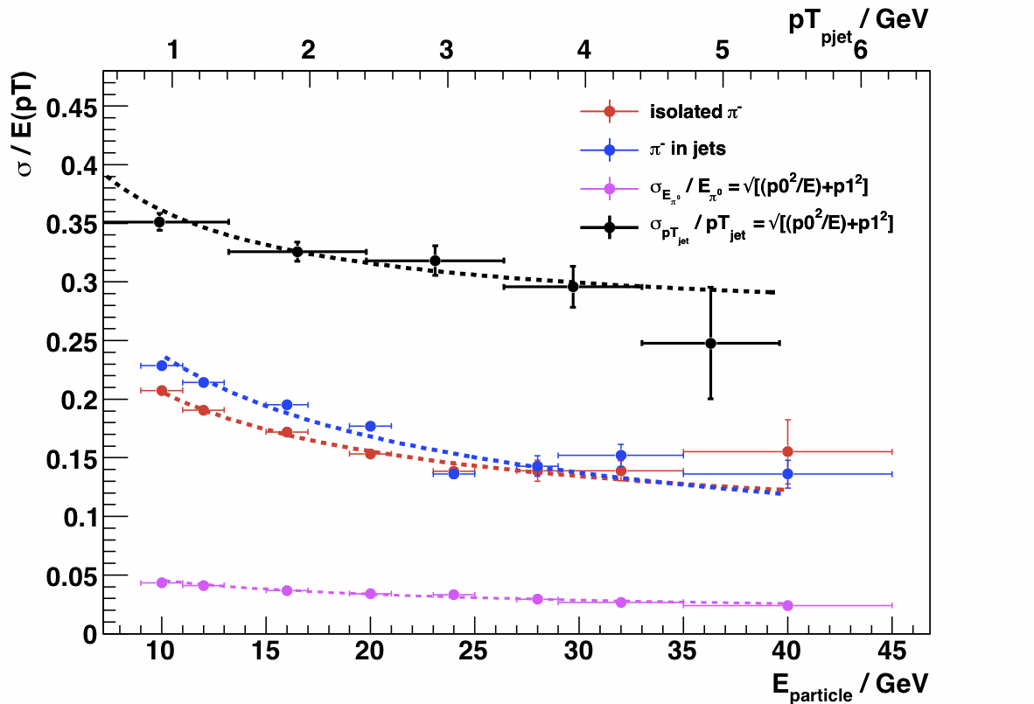

Figure 4.6: Resolutions for charged (red and blue) and neutral (pink) pions as a function of the generated energy (bottom axis). The jet resolution is plotted versus jet pT (top axis).

The CEMC energy resolution for photons and electrons is estimated to be similar with that of PANDA EMC based on PWO (cooled) crystals. It is 0.2%/√E ⊕ 0.75%

## DIS Kinematics Reconstruction at eSTAR

Figure 4.6 illustrates the x, y and Q2 resolution in e+p 10+100 GeV DIS events reconstructed with the iTPC, endcap TRD and BSO based EMC detectors. The recoil electron detection efficiency maximizes in the region of 5x10-4 <x< 5x10-2 and 5 < Q2 < 50 GeV. The narrow region of inefficiency is due to the lack of detector coverage between the ??? and ???. The x and y resolutions are similar, small in the region of high electron detection efficiency, but growing rapidly when pushed to larger x. This is caused by the uncertainty in electron energy at low y. The Q2 resolution is small and fairly uniform, less than 20% for the entire electron reconstruction region.

**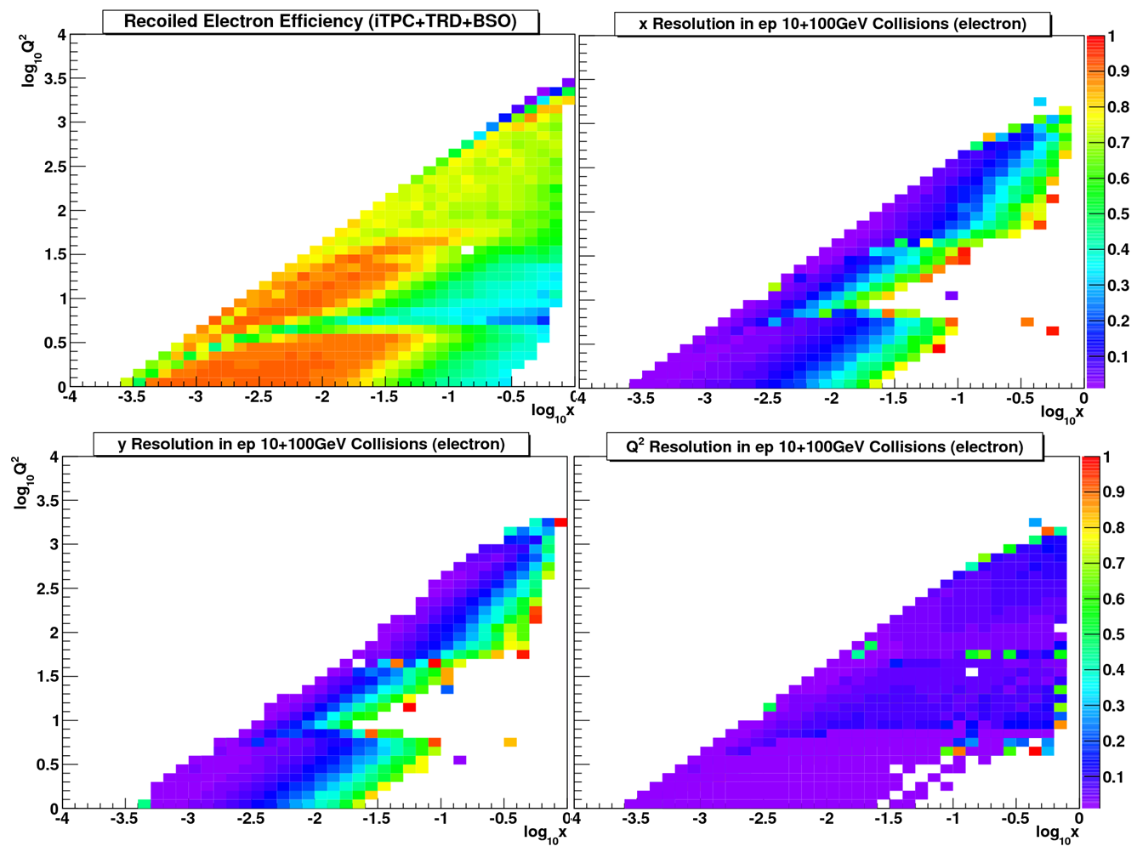**  
Figure 4.6: Electron detection efficiency (upper left) and resolution in x, y and Q2 for e+p 10+100 GeV DIS events.

# Proposed Upgrades and R&D

R&D projects are first steps toward realizing a cutting-edge detector to achieve the research goals. STAR Collaboration has been active in many R&D projects over the large decade and the R&D activities have resulted in many detector systems installed in STAR. Every detector component proposed in this LoI has an active R&D and several R&D projects have benefitted from the generic detector R&D program organized by BNL in association with Jlab and DOE to address the scientific requirements for measurements at a future Electron Ion Collider (EIC).

The needs for the upgrades and their performance are described in the previous sections. Here we give a brief description of the upgrades and the current R&D efforts.

## Major Upgrades to STAR before eRHIC

### Inner TPC Sector Upgrade (iTPC)

We plan to upgrade the inner sectors of the STAR TPC (iTPC) to increase the segmentation on the inner pad plane and to renew the inner sector wires, which are showing signs of aging. The new inner sector pad-plane replaces the old plane, which has only 20% coverage of the fiducial volume. A reconfiguration of the RDOs and FEEs is being considered so that they are inserted along the sector boundary to reduce the material in the fiducial area. The upgrade will provide better momentum resolution, better dE/dx resolution, and most importantly it will provide improved acceptance at high rapidity to |η|<1.7 compared to the current TPC configuration of |η|<~1.0. Increased acceptance at higher rapidity is a crucial part of STAR’s future as we contemplate forward physics topics such as *p + A*, *e + A* and the proposed phase II of the Beam Energy Scan program (BES II).

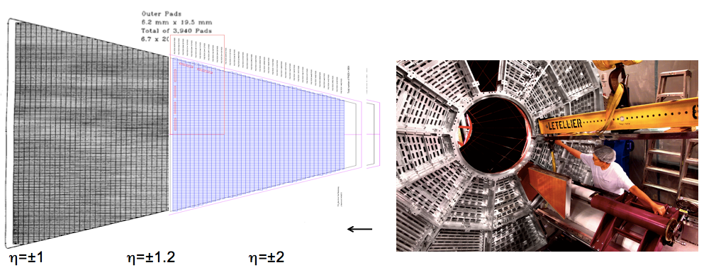

Figure .1: (Left) TPC outer and inner sector pad-plane. The new inner sector pad-plane replaces the old plane which has only 20% coverage of the fiducial volume. The RDO and FEE are planned to be inserted along the sector boundary to reduce the material in the fiducial area. (Right) TPC sector insertion.

The hardware upgrade (c.f. Figure 5.1) consists of three components: multiple-wire proportional chambers (MWPC), electronics, and sector support strong-backs. The hardware upgrade aims at 1) providing hermetic coverage of TPC readout in its fiducial gas volume by re-instrumenting the pad-plane readout; 2) eliminating the concern of wire aging from ever increasing integrated and instantaneous luminosity successfully delivered by RHIC over the course of the operation; 3) fixing the majority of the ion leakage from gating grid through the electronic field gap at the boundary between the inner and outer sectors; 4) reducing the material in the support structure and strong-backs in inner sectors for appropriate future detector instrumentation behind the TPC to prepare for a possible eSTAR detector as a first-stage eRHIC detector.

The current R&D[[13]](#endnote-12) is aimed to finalize the mechanical structures and the pad plane layout to finalize the proposal.

### Forward Calorimeter System (FCS)

The proposed forward instrumentation upgrade will allow STAR to measure photons, neutral pions, electrons, hadrons and jets in the forward rapidity region from 2.5 to 4.5. The kinematics of the parton-parton scatterings are such that the Bjorken x values for these partons scattering towards the forward rapidity are very asymmetric, which will enable us to access low-*x* partons. Preliminary Monte Carlo simulations indicate that the proposed FCS will provide good photon and neutral pion separation, electron identification and hadron rejection, and jet energy resolutions.

The Forward Calorimeter System (FCS) consists of a Spaghetti electromagnetic Calorimeter (SPACal), followed by a Lead and scintillator plate sampling Hadronic Calorimeter (HCal). The SPACal will be made of Tungsten powder and Scintillating fibers in spaghetti geometry. The novel SPACal detector construction technique has been developed by a team from UCLA/TAMU/PSU through an EIC generic detector R&D project. A prototype module has been tested at a FNAL testing beam in early 2012 and satisfactory performance of the detector has been achieved as shown in Figure 5.2. The proposed SPACal has 120x80 towers each approximately 2.6x2.6x17 cm3 corresponding to 24X0 length.

The HCal section will be made of Lead and Scintillating tiles with each tower of 10x10x81 cm3 corresponding to 4 interaction length. There will be 30x20 towers of HCal covering the same area as the SPACal. A novel construction technique will be investigated to build the detector by stacking the tiles in-situ to allow for smooth integration in the STAR configuration. We are also considering the option of using the E864 calorimeter as a part of the HCal system after validation of the E864 calorimeter performance.

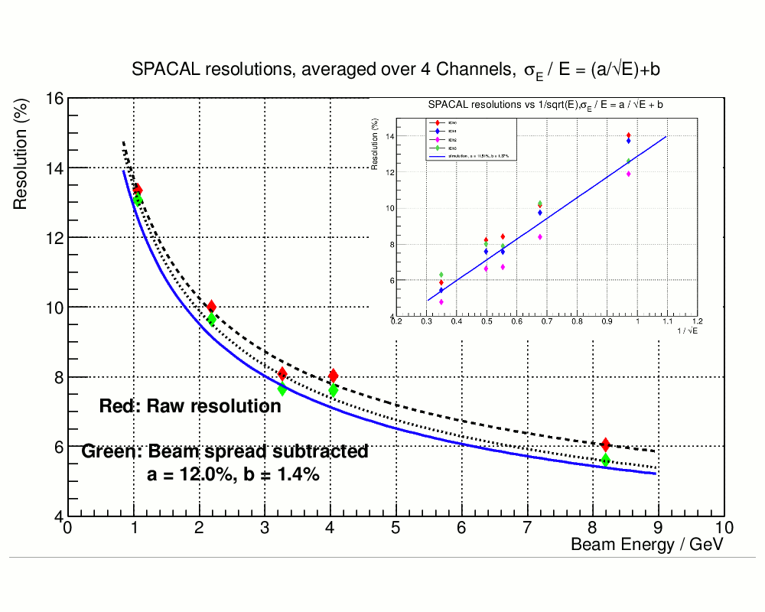

Figure .2: Test beam results of prototype Tungsten fiber calorimeter at FermiLab. Shown is energy resolution as a function of incident electron beam energy in comparison to GEANT simulation.

The readout of the SPACal will be on the front of the module and the readout of the HCal will be at the rear end of the module. There will be no space gap between the SPACal and the HCal. The ratios of the Tungten/Scintillator for the SPACal and the Lead/Scintillator for the HCal are designed to ensure approximately the same responses from electrons and hadrons. The SPACal has a very fine segmentation and the dimension of the tower size matches the Moliere radius of the Tungsten/Scintillating Fiber SPACal. Silicon PhotoMultipliers (SiPM) will be used as photon sensors for both the SPACal and the HCal detectors.

We have initiated an R&D project[[14]](#endnote-13) to construct a full scale prototype of the FCS module. Major goals of the R&D include the establishment of the HCal detector construction technology, optimization of the photon readout scheme and measurements of the detector performance in a test beam run. A beam test-run will be carried out at FNAL in the winter of 2014.

## eRHIC Specific Upgrades and R&D

In addition to the upgrades (iTPC, FCS and Forward Tracking) in the coming decades for RHIC, we have carried out two major R&D projects, targeting at improving STAR’s capability in eRHIC era:

1. An Endcap TOF and TRD for Identifying electrons at EIC(ETTIE),
2. Forward Crystal Calorimeter for electron identification at EIC (FCC).

### Endcap TOF and TRD for identifying electrons (ETTIE)

We consider a combined functionality of a MRPC based Time-of-Flight detector (TOF) and a GEM based Transition Radiation Detector (TRD) at forward direction (-2<η<-1) behind low-material TPC tracking detector to provide electron identification with high hadron rejection (~>103) over a wide momentum range (0.2 GeV/c<p<~10 GeV/c). In addition, the configuration also provides start time for the produced hadrons in TOF detectors in other locations and additional precise tracking points for hadron reconstruction in the case that the struck particle is a hadron. Simulation has been performed in the STAR GEANT framework and has shown that such combination with the iTPC is likely to provide a cost-effective detector system for extending STAR’s excellent electron identification and tracking to η=-2. In the case of a 5 GeV electron beam, the setup will provide complete coverage with Q2>1 GeV/c in e+p and e+A collisions at the first-stage eRHIC.

An R&D project[[15]](#endnote-14) supported by the EIC Detector R&D Committee has been carried out to use GEM detector with Xe+CO2 for detection of transition radiation and to further evaluate the feasibility of ETTIE for eSTAR. The on-going R&D goals are: a) study the GEM readout performance for dE/dx (TR) signals and its position resolution in the TPC-style readout with 3-4cm ionization chamber; b) investigate different GEM configuration (regular GEM vs. Thick GEM) and its impact on tracking and dE/dx. A schematic and illustration of initial results are shown in Figure 5.3.

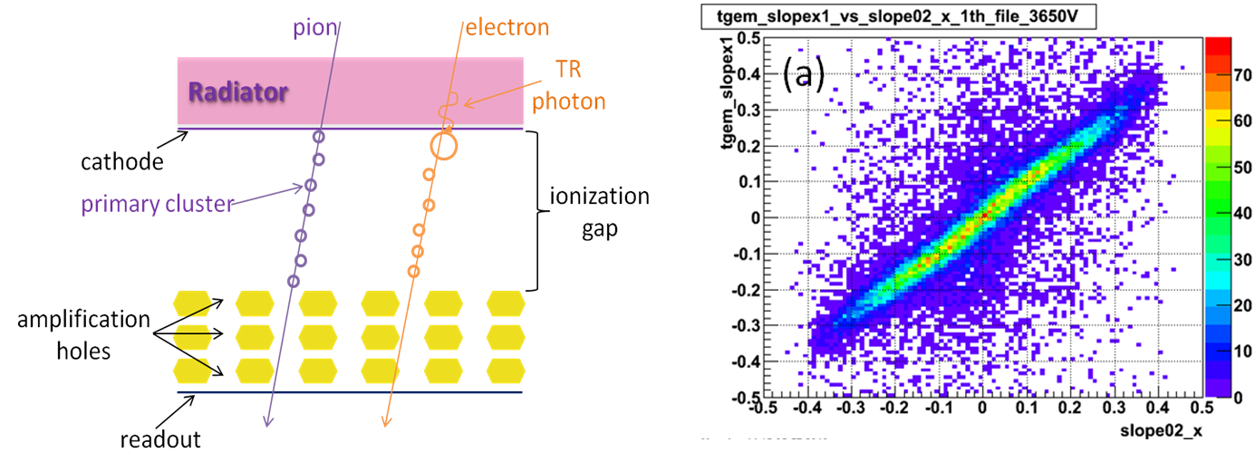

Figure .3: (Left) schematic of GEM based transition radiation detector and (right) tracklet slope measured from GTRD prototype vs slope from two regular GEM detectors placed on top and bottom of GTRD in cosmic ray test stand. Results show that the GTRD has good position and angular resolutions.

ETTIE also includes TOF based on MRPC technology and Custom electronics, based around CERN HPTDC that was successfully used in the STAR BTOF sub-system. It will providev very High Resolution timing information. An overall TOF time resolution of 70 to 100ps is expected.

As a part-II of the ETTIE R&D we expect to investigate TOF prototype detector with sufficient radiation and rate capabilities, and TOF electronics options and installation of prototype in realistic magnetic and radiation environment e.g. behind STAR TPC sectors.

### Crystal Calorimeter based on BSO (CEMC)

For higher electron beam energy (10 GeV) or acceptance for lower Q2 physics even at electron beam energy of 5 GeV, further forward acceptance for scatter electron is necessary. For the forward scattering electrons at this angle, the backward scattered hadrons are comparable in rate to the scattered electrons and not as overwhelming as other locations ( *η* >-2). A crystal calorimeter, with an energy resolution of 2‐3% for 2‐5 GeV electrons in a forward direction (*η* < ‐2) of the electron beam, is crucial for electron identification with electron beam energy 5-10 GeV. Crystal detectors with good energy resolution have been widely used in experiments for the identification of electrons and photons. Crystal detectors can also provide trigger capability for electrons and photons. We have proposed to use BSO crystal as the forward calorimeter. The BSO at room temperature has comparable light yield as to the PWO at low temperature (-25oc). The BSO calorimeter will provide a cost-effective electromagnetic calorimeter for electron detection at -4<*η* <-2 and is ideal for eSTAR. An R&D project supported by the EIC Detector R&D Committee has been conducted by collaboration between STAR institute (USTC) and Shanghai Institute of Ceramics, Chinese Academy of Sciences (SICCAS). Shanghai SICCAS High Technology Corporation, a research‐based enterprise wholly invested by SICCAS, is able to supply crystals with high quality for worldwide customers, especially suitable for crystal detectors in high energy experiments, such as Jefferson Lab (USA), KEK (Japan), INFN (Italy), PANDA (Germany). The group has produced a set of 3x3 BSO crystals, each with dimensions of 2x2x20cm3. Preliminary test shows high light output as expected. Figure 5.4 shows that the light yields improve significantly over time with improved production procedure and crystal purity. We have estimated that the CEMC calorimeter requires about 1500 high-quality crystals.

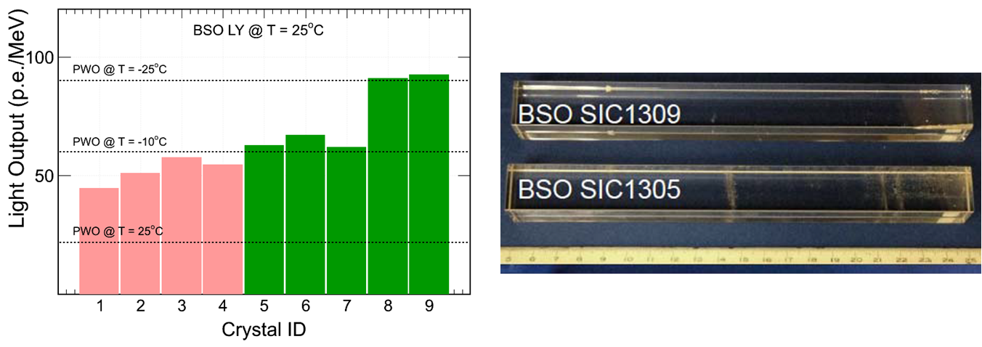

Figure .4: Light output of BSO crystal produced by SCCAS in Shanghai. The light yields of last two produced crystals at room temperature were measured to be similar to the PWO at temperature of -25C. Right panel shows the two crystals (ID#8,9 in left panel. The dimensions of the crystals are 2x2x20cm3.

### Other Upgrades and planned R&D Activities

To achieve many of the physics goals in the forward physics before eSTAR, and also during the eSTAR era it is necessary to have forward tracking for charged particle in the 2.5 < *η* < 4 region. The primary goal is to have charge sign separation and good pointing towards the calorimeters. The momentum resolution will be modest due to the small integrated Bdl in the STAR magnet for small angle scattering. Two options are considered for the tracking, namely based on min-strip Silicon detectors, and Gem based. Simulations. GEM based R&D is carried out by several groups under the auspices of generic EIC R&D. STAR is planning to initiate R&D on the Si-based tracking proposed forward tracking.

STAR is completing a Heavy Flavor Tracker (HFT), which is a crucial device for RHIC physics program in the coming decade. The current configuration has its support structure and utility in the east side of the STAR in the pseudorapidity range of -2 < *η* < -1. In eRHIC era, that acceptance is an important range for the scattered electron. We have considered several options for eSTAR inner tracking system that would support a heavy flavor program: a) reconfigure HFT to direct its support and utility to a different location; b) rotate HFT toward west side where the hadrons go and material budget is not as crucial; c) relocate HFT toward west side and add a compact mini-TPC in the east side. These considerations are under active investigation and will be decided based on the detailed simulations and physics requirement for an inner tracker in eRHIC. These are not part of the baseline upgrades needed for eSTAR.

There are on-going and planned R&D efforts that can benefit such reconfiguration on such a longer time scale in the context of developing MAPS technology with faster readout times that currently presently available (ALICE /LBNL/IPCH) and (BNL-LDRD).

# Collaboration Evolution

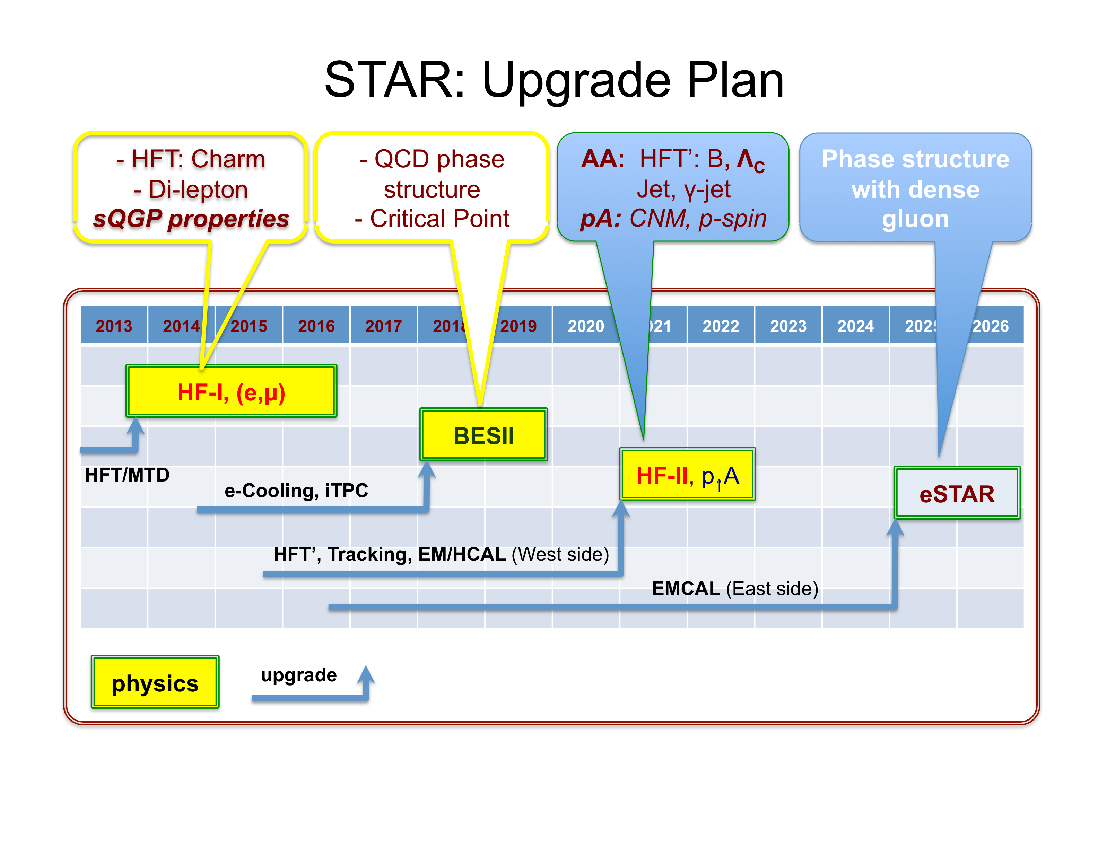

Figure .: STAR’s future physics programs: 2014-16, studying sQGP properties with heavy flavor and di-leptons; 2018-19, RHIC beam energy scan, narrowing in on the region of √sNN ≤ 20 GeV; 2021-22, (a) sQGP properties with the upgraded faster Heavy Flavor Tracker, specifically for the measurements of bottom and ΛC, and (b) polarized p + p / p + A program at the forward-rapidity region; 2025 and beyond, starting of the e + p and e + A program.

As is illustrated in Figure 6.1, the STAR collaboration is pursuing three well-defined and focused physics programs prior the presumed turn on of eRHIC in 2025. These programs allow the collaboration’s emphasis to evolve smoothly from the study of sQGP properties, the QCD phase structure, and proton spin structure at mid-rapidity, to a physics program enabled by new forward instrumentation and ultimately the polarized *e + p* and *e + A* physics programs at eRHIC.

The initial phases of the overall physics program focus on the hot QCD properties. These studies will continue early in the next decade with the new capabilities of a faster Heavy Flavor Tracker and be complemented by studies of cold nuclear matter effects with polarized proton beams at RHIC energies and new instrumentation to access the low-*x* region of high gluon density. This research is then naturally culminates in the polarized *e + p* and *e + A* collision in the eRHIC era.

We emphasize that, while we anticipate that the details of the plan will continue to evolve in the process, the integrated approach aims to optimize the unique capabilities of the RHIC facility and STAR experiment to advance QCD physics. Each phase of the program is a stepping stone for the next and each program is executed along with upgrade projects for the next phase. At the end of the day, with high precision, we will be able to study the QCD phase diagram over a wide range of baryonic-chemical-potential (20 ≤ μB ≤ 700 MeV), the properties of the sQGP – the hot QCD matter, gain understanding of the internal spin structure of the proton and of nuclear matter at extremely large gluon density – cold nuclear matter properties. We will be able to elucidate the underlying dynamical evolution from the cold nuclear matter to the hot QGP created at RHIC.

At present, the STAR collaboration consists of 53 active institutes and 25 of them are from the United States. The majority of the collaboration, 60% as of August 14th 2013, is strongly supportive of the eSTAR effort and is starting to engage in the forward-upgrade and/or eSTAR efforts. Due to their commitments towards relatively new LHC projects, a large fraction of European and Indian institutes have thus far not been involved directly in STAR’s future projects. In order to expand and strengthen the efforts on the forward upgrades and eSTAR, we need to engage additional institutes both from within and outside the STAR collaboration, including in particular those from the deep-inelastic-scattering community. A vibrant *p + A* physics program plays an integral and natural part in *maintaining, training,* and *growing* the scientific community for *e + p* and *e + A* physics programs with eSTAR at eRHIC.

|  |  |  |  |  |
| --- | --- | --- | --- | --- |
| Upgrade projects | Year of completion | Total project cost (M$) | DOE new fund (M$) | likely in-kind contributions |
| iTPC | 2017 | 5.5 | 1.7 | Foreign |
| FCS | 2019 | 15 | ~<10 | Refurbish E864 HCAL |
| Forward Tracking | 2019 | 4.5 | 4.5 | HFT technology |
| CEMC +preshower | 2025 | 5 |  | Generic EIC R&D |
| ETOF+WTOF | 2025 | 4 |  |  |
| GTRD | 2025 | 5 |  | Generic EIC R&D |
| Total (M$) |  | 39 |  |  |

Table 6.1: Project cost estimates for the baseline eSTAR detector with main upgrades from 2017 to 2025.

The upgrade projects necessary for the baseline eSTAR instrument are listed inTable 6.1. We estimate the total project costs from 2017 to 2025 to amount to 39 M$. The detector configuration presented in this Letter of Intent provides the baseline eSTAR instrument and we continue to anticipate and welcome science-driven proposals and ideas to further strengthen the eSTAR instrument and physics capabilities.

Appendix: Charge for the eSTAR Letter of Intent

**Charge to PHENIX and STAR Collaborations: LOI for Transition to eRHIC**

In 2010 the PHENIX and STAR collaborations each generated decadal plans laying out proposed science goals and detector upgrade paths for the period 2011-2020. At the request of ALD Vigdor, the Decadal Plan documents provided by both collaborations included conceptual ideas for utilizing these detectors for the study of ep and eA collisions in an early stage of the eRHIC program. In the case of PHENIX, the subsequent sPHENIX proposal includes a more extensive discussion of a possible ePHENIX upgrade through inclusion of additional particle identification and forward detectors.

We now have an EIC White Paper with a comprehensive outline of the physics questions for an Electron Ion Collider, a rapidly maturing machine design for eRHIC, and a clearer view of a possible path to an early-stage eRHIC program leading to first measurements in the mid-2020s. Therefore, the PHENIX and STAR Collaboration are now being asked to consider their role in a transition from RHIC to eRHIC on this time scale, and to provide specific plans (i.e. Letters of Intent) to upgrade/reconfigure the detectors from their present form to first-generation eRHIC detectors. These Letters of Intent (LOI) will be an important part of BNL’s strategic planning as we move toward the next Nuclear Physics Long Range Plan. They should include an assessment of how the collaborations may evolve through this transition, and of the size and breadth of the scientific staffing required to carry out these plans.

In preparing these LOI the collaborations should assume an eRHIC machine with an electron beam energy up to 10 GeV, hadron beam energies as provided by the current RHIC machine (255 GeV for p and 100 GeV/nucleon for Au), and design luminosities of 1033 cm-2 s-1 for 10 GeV on 255 GeV ep collisions and the equivalent of 6 × 10 cm-2 s-1 for 10 GeV on 100 GeV/nucleon eA collisions.

The LOI should include a description of the physics reach of the upgraded detectors, based on their detection capabilities, taking into consideration the key measurements identified in the EIC White Paper for Stage 1 (but now for 10 GeV electrons instead of 5 GeV). Further details of the desired detector requirements will be soon posted by the eRHIC Task Force on a Wiki page.

The technical details of the proposed upgrades should be given in sufficient detail to make a preliminary cost estimate. We assume that the upgrades may come in stages, with some elements implemented during the on-going RHIC heavy ion operations. Sufficient detail should be provided for each step to allow a rough outline of the overall construction schedule, assuming a 2–3 year shut-down of collider operations before the commencement of eRHIC operations, and an estimate of the required funding profile.

The Letters of Intent should be submitted by September 30, 2013. A brief statement of progress by each collaboration at the time of the June 2013 PAC meeting would be appreciated.

References

1. STAR Decadal Plan, [http://www.bnl.gov/npp/docs/STAR\_Decadal\_Plan\_Final[1].pdf](http://www.bnl.gov/npp/docs/STAR_Decadal_Plan_Final%5b1%5d.pdf) [↑](#endnote-ref-1)
2. NSAC Long Range Plan (2007), <http://science.energy.gov/np/nsac/> [↑](#endnote-ref-2)
3. A.A. Accardi et al., arXiv:1212.1701 (2012). [↑](#endnote-ref-3)
4. K.H. Ackermann et al. (STAR Coll.), Nucl.Instrum.Meth. A499 (2003) 624. [↑](#endnote-ref-4)
5. We follow the HERA convention, which defines angles w.r.t. the hadron beam direction. The direction of the incident electron beam is from West to East in the STAR coordinate system. [↑](#footnote-ref-1)
6. D. Kharzeev, E. Levin, and L. McLerran, Nucl. Phys. A748 (2005) 627. [↑](#endnote-ref-5)
7. C. Marquet, B. Xiao, and F. Yuan, Phys. Lett. B682 (2009) 207. [↑](#endnote-ref-6)
8. F. Dominguez, B. Xiao, and F. Yuan, Phys. Rev. Lett. 106 (2011) 022301. [↑](#endnote-ref-7)
9. E. Perez, L. Schoeffel, and L. Favart, hep-ph/0411389v1 (2004). [↑](#endnote-ref-8)
10. M. Shao *et al*., Nucl. Instrum. Meth. A 558 (2006) 419. [↑](#endnote-ref-9)
11. STAR journal publication database, <https://drupal.star.bnl.gov/STAR/publications/> [↑](#endnote-ref-10)
12. STAR Collaboration, Phys. Rev. D 83 (2011) 52006. [↑](#endnote-ref-11)
13. J. Dunlop et al., [iTPC – An Upgrade to the TPC Inner Sector Pad Planes](https://drupal.star.bnl.gov/STAR/system/files/iTPC_RandD%20Proposal_final.pdf), (2012). [↑](#endnote-ref-12)
14. J. Dunkelberger et al., [Prototyping for a STAR Forward Calorimeter System (FCS)](https://drupal.star.bnl.gov/STAR/system/files/STAR_UCLA_RD_Proposal.docx), (2012). [↑](#endnote-ref-13)
15. Z. Xu and M. Shao, [ETTIE EIC R&D proposal](https://wiki.bnl.gov/conferences/images/3/3d/TRD_EIC_RDproposal_FY2012_v3.pdf), (2011). [↑](#endnote-ref-14)