**A polarized p+p and p+A program for the next years**

**The STAR Collaboration**

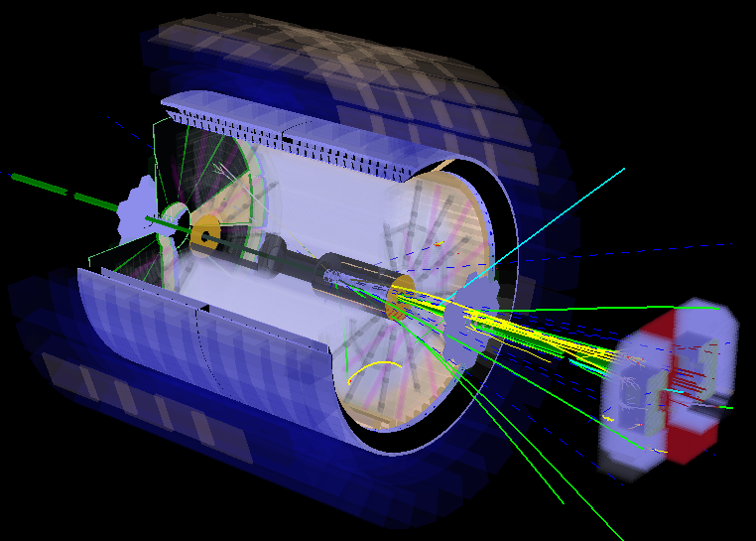

**Version 1**

**February 2014**

1 How to write this document 3

2 The science of polarized p+p and p+A 4

2.1 Polarised p+p 4

2.1.1 The Helicity Structure of the proton 4

2.1.2 CONFINED MOTION OF PARTONS IN NUCLEONS: TMDs 5

2.1.3 The search for exotics in p+p 5

2.2 THE NUCLEUS AS A LABORATORY FOR QCD 5

2.2.1 PHYSICS OF HIGH GLUON DENSITIES AND LOW-X IN NUCLEI 5

2.2.2 HADRONIZATION AND ENERGY LOSS 5

3 STAR Upgrades in the next years 5

# How to write this document

Please use this style file. Lets discuss a couple of things we agreed on

* All citations will be at the end of the document using endnote, here is an example [[[1]](#endnote-1)]. Here is how you do this click on insert, select footnote, on the menu click endnote and there you go.
* The text is supposed to be justified to both sides
* Figure, table and equation numbering are numbered through a chapter with the chapter id included Example is here: Figure 1‑1.
* We use cross-references to reference tables, equations and figures in the text.
* Please don’t hardcode any cross references to chapters, sections, tables, figures, equations or

This is normal text and now comes an example of a figure and its caption. After a line break the text gets intended as the beginning of this line. This is a cross reference to a chapter to do it correctly type chapter and insert cross-reference and this is the cross reference to Figure 1‑1. We do the same for equations. All cross references are inserted as hyperlinks so you can click on it to jump to the respective item.

|  |  |
| --- | --- |
|  | Figure ‑: at this moment in time we number figures through the document without chapter numbers. Note that figure and caption are contained in a 1 column, 2 row table. Picture in row 1 and caption in row 2. This allows expanding it to a 2 column tables (or more) for side-to-side plots. To format and align it is often better to switch on borders. |

Below an example of two figures side-by-side using a 2x2 table. Even if the figures would have a different size the captions would be vertically aligned.

|  |  |
| --- | --- |
| Macintosh HD:Users:ullrich:Documents:EIC:WhitePaper:WhitePaperInWords:tex:figures:figures_eA:xq2plane-xA-EIC.eps | Macintosh HD:Users:ullrich:Documents:EIC:WhitePaper:WhitePaperInWords:tex:figures:figures_helicity:x-q2-poldata.eps |
| Figure ‑: another figure. Upper row, left column. Caption is in it’s own row. | Figure ‑: yet another one. Caption is always aligned |

All variables are please in italics and if we use equations lets please use the internal WORD-equation editor. And here comes an example for an equation. $a=b+d⊗ \frac{s}{ν}$

To reference this equation we will use cross-referencing like for tables, pictures, chapters and so on, if needed. I think this is all which needs to be followed to make it easy to get different topics together.

# The science of polarized p+p and p+A

Describe the big picture on a very high level behind the physics of polarised p+p and p+A running

* Helicity- and dynamic structure of the proton
* Initial state (saturated and non-saturated (*g(x,Q2,b)*)
* CNM, ridge
* Discuss how this physics manifested itself in DOE performance milestones

## Polarised p+p

Describe in detail the physics why it is important to unravel the helicity structure of the proton and what going beyond one-dimensional pdfs brings for our understanding of QCD. This needs a comprehensive description of Sivers, Collins, vs. Twist-3 and SIDIS vs. DY and pp. What does the sign change really teach us.

### CONFINED MOTION OF PARTONS IN NUCLEONS: TMDs

Describe the legacy of transverse polarized p+p to understand the origin of AN. What do we know from all the data we have collected so far in transverse polarized p+p runs with STAR.

* Table with integrated sampled lumi for years > 2005 with average polarization, similar to Table 2‑1.
* Show the major plots from which we draw our current understanding IFF, Sivers, Collins at mid-rapidity. *AN* at forward rapidities vs *pt* and with and without isolation cuts. *AN(W,Z * from run-11
* Show what we will have on statistical precision if all runs including 2015 are analyzed
* We need to describe very well what run-15 will teach us. Alternative interpretations Diffraction, polarized pA

After this we discuss what are the open issues to address with hopefully upcoming pp runs.

* How to address HP13 through *AN(W,Z,DY,*  in one experiment, including “TMD evolution”. Show capabilities for these measurements and when we can do them as early as 2015(?) for sure 2016.
  + Describe the needed upgrades for this 🡪 DY: post shower behind FMS
  + Can the FMS survive a 500 GeV run with good performance
* Making Sivers, and Collins jet measurements at forward rapidities, what can we learn. The same for IFF.
  + What upgrades are needed? FCS and forward tracking (?)
* He-3-physics: needed upgrades

Make a strong point what is unique in p+p, 🡪 what cannot be accessed at eRHIC or JLab and COMPASS. Where RHIC is complementary to COMPASS and JLab, maybe eRHIC.

### The Helicity Structure of the proton

Describe in detail where we stand after RUN-15 with *g(x,Q2)* and *q(x,Q2)*. The following plots/tables are needed:

* Table with integrated sampled lumi for years > 2005 with average polarization.
* Plot for inclusive jets and di-jets showing what stat. precision we will have for 200 GeV and 500 GeV data sets and impact plot on $\int_{0.01}^{1}{dx Δg(x,Q2)}$.
* 2012+11 W-result, + projection stat precision for 2013 run impact plots on *q(x,Q2)*.

|  |  |  |  |  |
| --- | --- | --- | --- | --- |
| **Year** | **√s (GeV)** | **Main Goal of the Run** | **Recorded Luminosity for Longitudinal p+p** | **<P>** |
| 2006 | 200 |  |  |  |
| 2009 | 200  500 | *g(x,Q2)* through inclusive jets | 25 pb-1  10 pb-1 | 55  39 |
| 2011 | 500 |  | 12 pb-1 | 48 |
| 2012 | 200  510 |  | 82 pb-1 | 61/58  50/54 |
| 2013 | 510 |  | 220 pb-1 (till 22 May) | 54/55 |
| 2015 | 200 |  |  |  |

Table ‑: Luminosity recorded by STAR in the past longituginal polarized p+p runs, together ….

Describe what are the open questions an how to resolve them. This will include discussions about:

* Inclusive jets and Di-jets and hadron-jet, photon-jet at forward rapidities to measure *g(x,Q2)* at low-*x*. Need plots, which show statistical precision and what *x* can be reached.
* Need to discuss new instrumentation to perform these measurements
  + FCS, forward tracking (?) and relative luminosity measurements
* Hyperon DLL: what can be measured with what precision, needed instrumentation
  + FCS and forward tracking

Need to compare this program to a longitudinal spin program at eRHIC. Uniqueness for RHIC p+p (200 GeV in parallel to sPHENIX), 500 GeV longitudinal discussed, but depending on eRHIC coming according to BNL current time line or not.

### The search for exotics in p+p

Need help from the experts to layout this section. 500 GeV uniqueness to STAR and in general to RHIC, because of RP, does not require a special 500 GeV run, can be done in the 500 GeV transverse p+p run. Competition from Hall-D, PANDA, LHC and Belle

## THE NUCLEUS AS A LABORATORY FOR QCD

Describe in detail how p+A can improve our understanding of the PDFs in nuclei/initial state (saturated and non-saturated). Can cold nuclear matter effects shed light on the energy loss of heavy vs. light quarks, long range rapidity correlations, what can we learn.

Importance of A scans, no special requirements for polarized p+A, as protons in RHIC always come polarised. Energy lever-arm RHIC – LHC, makes an energy scan at RHIC not really attractive, modulo surprising discoveries.

### PHYSICS OF HIGH GLUON DENSITIES AND LOW-X IN NUCLEI

Describe what we know from STAR measurements till today on saturation effects.

* Show plots from the still unpublished FMS di-hadron correlations in pp and pA from the 2008 data and any other hint from the STAR data about saturation.
* Discuss what new measurements Run-15 can bring to the table to get more insight in the initial state. Need to make very clear Run 15 needs to result in a significant data set, which can provide guidance for the A scan and the important observables for the later runs.
  + First polarized *AN*for *0* and ** in p+A to study *Qs*; first diffractive measurements;
  + Di-hadron correlations for different *pttrig* and *ptasso* bins to step in and out of the saturation region.
  + direct photon cross section to measure *g(x,Q2)*
  + *J/Ψ* through UPC in p+Au to measure *g(x,Q2,b)*

Describe the remaining open questions, which can be addressed in a p+A run in the 2020s. The observables to further study *g(x,Q2)* and *g(x,Q2,b)* as well as saturation in a more definite way are:

* DY and NLO-DY, jets and jet-hadron and jet –  correlations for al these observables it will be important to discuss the upgrades needed to make this measurements possible.

### HADRONIZATION AND ENERGY LOSS

we should follow the same structure as for section 2.2.2 but discuss observables as *RpA* for different final states and the *pt*broadening for *J/Ψ* and DY.

# STAR Upgrades

Discuss short-term upgrades for Run-15/16 preshower, RP, post-shower. Discuss realization details (manpower, hardware details) and cost of the upgrades needed for STAR to realize this program. Make correlation for importance of ugrades to eRHIC program by referring to eSTAR LoI.

1. [] Endnote example [↑](#endnote-ref-1)