Season’s Greetings

News from the Castros:

- Jason, Mom & Dad came out to Long Island in September.
- Dad, Marie & Gene spent a day at the U.S. Open tennis championships along with friends Amy Hsu and Brian Tung, getting to see several stars.
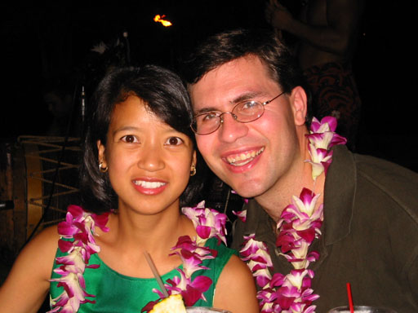
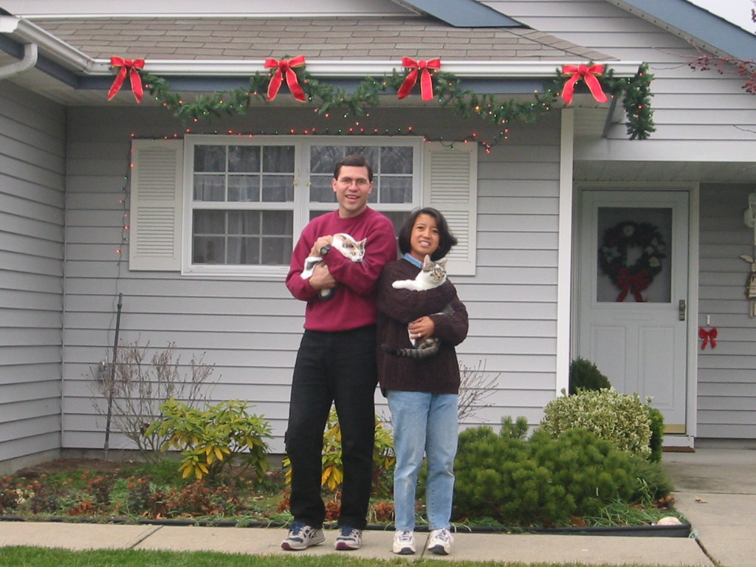

Christmas 2001
News from the
Van Buren clan:

- Randy & Lisa had their second child on May 8th. We went down to North Carolina in June to meet our new niece, Rachel Louanne Van Buren, also seeing Gene’s mom there.
- Thanksgiving was another chance for a family get-together. We again went to a beach house on Caswell Beach on the North Carolina coast.

From Marie & Gene Van Buren

A Homecoming…

Tikka & Maki
Our new kittens! A friend of ours had five new kittens this summer, and we decided to take in two of them. Gene has wanted cats for years, and finally moving out of apartments gave us the chance. Tikka (pronounced teek’-kuh) is a beautiful calico (we’ve learned that pretty much all calicos are female – we’ve learned many things about cats recently!) with a gray half-mustache, and Maki (rhymes with “rocky”) is her little runt-of-the-litter brother. He didn’t stay that way for long! They’ve grown up quickly and now Maki’s the big one, often watching (or chasing) his excitable little sister at close to supersonic speeds around and around and around. Their personalities are quite different, but they’re both quite loving to us and to each other, if not to our house plants and carpets…They do bring many smiles :-) For the curious, yes – we did name them after Indian and Japanese cuisine.

They say that home is where your heart is. Whether this is the time of year when you return home to family, or a time when you simply stay at home, you can find a home for the holidays wherever you are. For us this year, we will indeed be going out to Anaheim, CA to be home with Marie’s brother and parents. But it is a small, humble abode on eastern Long Island to which we return when coming home the rest of the year.
After many months of searching, and still several more in the closing process, we moved into our new (to us) house in the middle of March this year! From the outside, ours is nothing special amongst the many similar homes in our quiet, somewhat secluded development. But for us, this is something new: a house of our own. We could hardly ask for more!

We know that our home is not on the common path; few of our traveling friends find themselves passing through from one place to another. For that reason, it means even more to us when family and friends do pay us a visit. The welcome mat is always out, and so is the invitation to come stay with us for all of you. Come on home! Our house is your house! It’s also home for more than just the two of us…
How to find us:

- Mailing address:
16 Westchester Ct.
Middle Island, New York
11953-1929
- Phone:
(631) 924-4350
- Email:
mcastro@alum.mit.edu
gene@bnl.gov
- On the web:
www.geocities.com/mariecvb

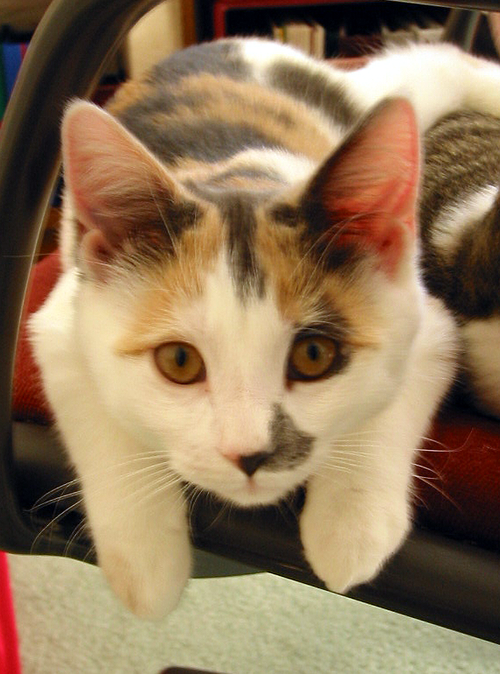

We ended last year visiting Marie’s family in Anaheim for the holidays and seeing the Cejoco family in Bakersfield. We returned home for the ringing in of the new year. At the time, we had already settled on our new house and were in the midst of the wranglings involved in getting a home loan. Our inexperience as first-time homebuyers combined with the nuances of the process in the state of New York made this a drawn-out, stressful, and sometimes frustrating period for us. It took over three months to reach closing (including an additional final delay of one week while Gene spoke at a conference in Nashville, Tennessee for work – a chance to see his father and some old friends as well!), so we had plenty of time in January and February to slowly pack up our belongings in preparation for moving. Closing day was nerve-wracking, exciting, and relieving all in one. At last, we were homeowners!
Our friend Amy Hsu came down from Boston at the end of March to help us move. We didn’t put her to work too hard as it didn’t work out to get the moving truck while she was here. Instead, she helped us get some really nice window curtains and earned the distinction of being our very first houseguest! : - )
Our usual April trip to the CART race in Nazareth, Pennsylvania got postponed by a late-season snowfall. The makeup date fell on a May weekend after Marie had spent a week at a software training course in New Jersey, so we decided to stay with our friend Shane Shih in New Jersey for one night, and drive to Philadelphia the next morning. We spent the day as tourists and enjoyed the hospitality of Phil Le and his wife Nicole, who were in the process of moving to a new home and imminently expecting the birth of their first child. (Nicole gave birth to their son, Toshan, a little over a week after we left Philadelphia, on May 16th.)
These seasons also included visits in New York City from Jon & Binnah Han, Gene’s brother Mark, and Thoa Pham & Trung Vu. We only wish they could also have made it out here to see our new house! But we still welcome the chance to see old friends when they’re “close by” in NYC.
Gene appreciated the chance to play on a high-level USAV volleyball team this year. The team did very well, but won’t be together for another year, sadly. He’s still hoping to get the chance to play some USAV tournaments, but at least both of us still get to play in leagues at BNL.

Winter & Spring

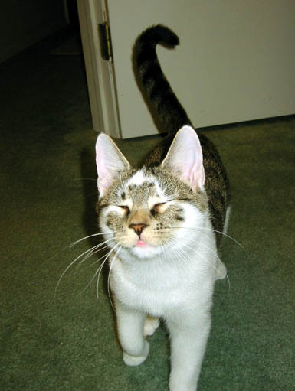

The Year in Review - 2001
Summer seems to be wedding season at this stage of our lives. But after going to six last year, we figure the four this year indicate we’re past the peak! We enjoyed a trip to San Antonio, Texas in July for Van & Trinh Vo’s wedding – we even saw the 4th of July fireworks there and celebrated our own anniversary! Marie went upstate for Sue-Ann and Kelvin Kwan’s wedding in July (Gene missed out because he was helping organize as well as presenting a talk at a physics workshop at BNL). Marie’s family was with us in September to attend Jaie & Christina Solis’s wedding here on Long Island. Marie also made it to one more wedding in the fall (October) for Daebuom and Eunhee Mun (Dae is a former officemate of Marie’s).
The summer also included more visits to our home from Gene’s Aunt Muriel & Uncle Lou (busy on a round-the-country tour!) and our friend Betty Bhudhikanok. Betty even played volleyball with us at the lab! In the fall, we were happy to get a chance to see Julianne Chung and Tomoko Ogura along with Amy Hsu in NYC. Marie hooked up with Tomoko and Amy again in Boston to play in a volleyball tournament there in November, which was a lot of fun.
These seasons were prominently marked by time spent getting away from it all. Marie spent a long weekend in Florida in August with girlfriends from college. She also spent a couple days in Washington D.C. with her family in September. But the big trip was to Maui, Hawaii in October! Gene had to (ahem) speak at a physics meeting there, so we both went out about a week early and saw the sights together. You can see some of the pictures from our trip on our web page! Snorkeling in beautiful blue waters, hiking along rocky shores and atop a dormant volcano, flying in a helicopter along 3000-foot cliffs, and swimming in marvelous natural pools under gorgeous waterfalls, we tried to do it all. Throw in some rest and relaxation on the beach, and that’s what vacation is all about :- )
Of course, our proximity to the big city and work at a government facility has also meant that our lives have been touched by the tragic events that occurred in our country this fall. But it only strengthens our resolve and hope for peace, tolerance, and fellowship among all in the new year. We hope that the holiday season reminds us all of our many blessings.

Summer & Fall

Love to you all,

Maki

Tikka

