StMaker base class

Introduction

StMaker class is a base class for Star Maker Object (Module).
- Each Maker performs specific task;
- Each Maker is independent from other makers;
- Group of Makers forms chain. In this chain, makers are called sequentially;
- Each Maker could have his own sub chain of makers. Hence all chains of makers form tree of makers;
- Maker usually gets input data structure and makes output data structure.
- Maker gets input data by name from “whiteboard” and put maden data into “whiteboard” by name.
- So Maker has no dependency from other makers but it has dependency to input and output data. In other words, dependency between makers is based only on input/output data structures

StMaker Methods

Six methods could be overloaded by user:
- Init() – initialization;
- InitRun(runNumber) – new run initialization;
- FinishRun(runNumber) – run is finished actions
- Make() – do the work. Make output structure;
- Clean(option) – clean maker from old event;
- Finish() – perform the needed action at the end of job;
- All the methods above either automatically, if not overloaded, or by user, if overloaded, call the same method for sub-chain of makers. For instance, expression chain->Make() calls Make() for all the makers of a maker tree;

TDataSet, Makers and STAR infrastructure.

All the STAR infrastructure is heavily based on TDataSet class (http://root.cern.ch/root/html/TDataSet.html)

The main idea of TDataSet is very simple: each TDataSet object has a name and list of the TDataSet objects. It is very similar to UNIX directories and files. The only difference, in TDataSet there is no difference between “file” and “directory”. It is not always good, but it is how it is done. To improve it, TObjectSet class was implemented.
TObjectSet is a TDataSet + pointer to TObject;
Usually TDataSet is used as a base class. Thus, using inheritance, UNIX like structure could be build, from user defined classes.
StMaker, Input/Output structures are inherited from TDataSet.
Let’s look on the organization of the Maker tree. For this is enough to describe only one StMaker object:
StMaker name = “someMaker”. It contains list of TDataSet’s. These data sets have names started by “.” And they are:
“.make “ ➔ contains list of sub makers
“.data “ ➔ contains list of published named TDataSet’s with data made by this maker. This data deleted by Clean()
“.const “ ➔ like “.data” but this data never deleted by Clean(). User can delete it himself;
“.garb “ ➔ also like “.data” but deleted automatically after Make() is finished
In real life it is not used too often;
“.hist” ➔ contains list of histograms filled by user which will be saved in Finish() into output .root file. All histograms, created in or before Init(), automatically go into this list. If user created his histogram later and he wants to save it, he should use the addHist method;
“.runco” ➔ Run Control parameters. Not used in reality but runco.root files still saved into HPSS;
“.AnyUserName” ➔ User can add it and it is his responsibility what to do with it. Typical example is in StTreeMaker;

View of StMaker tree in TBrowser

From http://www4.rcf.bnl.gov/~fine/Publications/Chep2000.ppt
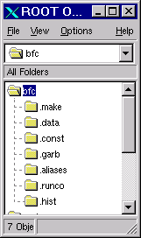 | 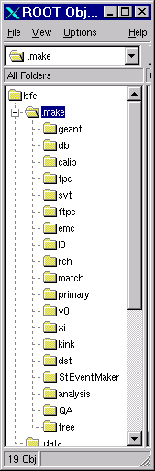 | 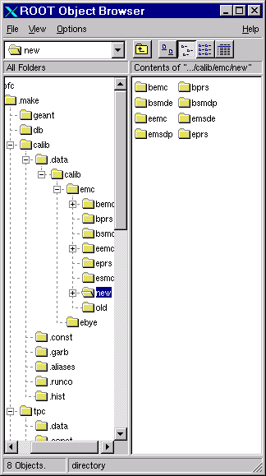

Standard WhiteBoard in STAR

WhiteBoard is a storage for the maker data produced. This data is stored with unique name and could be retrieved by this name. WhiteBoard in STAR consists from 3 parts:
- Constant part. Stored data preserves during all the time. Only user maker can delete it;
- Data part. Stored data preserves only during one event. Deleted in Clean();
- Garbage part. Stored data preserves only during Make(). Deleted at the end of Make. Practically obsolete.

Request data set
In standard WhiteBoard approach the top of data structure must be inherited from TDataSet. Usually an organization of the data structure is Unix like tree. But it is not demanded. The request of data set is simple. Inside of StMaker class user can:
TDataSet *ds = GetDataSet(“dsName”);
Or, when data set is a TDataSet tree:
TDataSet *ds = GetDataSet(“dsName/subName/subSubName”);

Save data set

AddData(ds); // Save dataset into data part. Name is ds->GetName();
AddConst(ds); // Save dataset into const part. Name is ds->GetName();
AddGarb(ds); // Save dataset into garbage part. Name is ds->GetName();

Advanced WhiteBoard in STAR

In Standard WhiteBoard the data structure must be inherited from TDataSet. It is not a big limitation, but users do not like it. They prefer to find maker and directly request his data. As a result, maker chain becomes rigid, not flexible. For example, if you decided to replace one maker by another, producing the same data, you must change the codes of other makers.
Hopefully, allowing the non TDataSet data, will decrease violation of maker independency. But may be not.

Saving an arbitrary, NON TDataSet data

The idea is to wrap non TDataSet object into TDataSet envelope and save it in usual way. In this case the problem of ownership arises. If envelop is deleted by Clean(), should be the object to be deleted as well. And if yes, then how? When an object is the TObject, then there is no problem to delete it. For arbitrary user data object, it is impossible in C++. We choose two ways to do it:
- User can overload Clear() method and delete this object himself;
- User can provide pointer to user function, which can delete this object;
Saving into data part:
AddObj (TObject *obj ,const Char_t *dir, int owner=1); //The easy case. Pointer is TObject. . //Name is obj->GetName()
ToWhiteBoard (const char *name, TObject *dat, int owner); //The same, but name is given
ToWhiteBoard (const char *name, void *dat); // Envelope is not an owner of the object. An . // object could not be deleted by envelope . // destructor
ToWhiteBoard (const char *name, void *dat, void *del); //An object can be deleted.
The last case must be explained:
void UserClassDelete( UserClass *obj) { delete obj;}
void Maker() { … ToWhiteBoard (“username”, dat, & UserClassDelete); // User provided the way to delete
Saving into const part:
To save into const part it is enough to replace a ToWhiteBoard to ToWhiteConst

Retrieving the NON TDataSet data

UserClass *dat=0; TDataSet *envelope = WhiteBoard (“username”,&dat) ; // Pointer dat is filled. If zero, data not found . // Pointer envelope is needed only for deleting

Resume

