Pt Study of the Parity Violating Signals
Vasily Dzhordzhadze
Abstract
In this note a study of the P violation signals, seen in the STAR experiment is presented. The signals are studied as a function of the particle transverse momentum p_{t}. Experimental data shows that signals are caused by high p_{t ( >} 0.6 GeV/c) particles and there is no signal associated with low p_{t} particles, where the statistics is higher.

The STAR experiment at BNL observed clear signals of possible parity violation in heavy ion collisions [1]. In this note I have studied the p_{t} dependence of the observed signals based on Run 4 data (AuAu interactions at 200 GeV cms energy, ~14M events).
I am using a code written by Jim Thomas for a large scale analysis at the STAR computer cluster. In this code, I have included a part which makes P violation correlation parameter calculation and their analysis. The code allows 14M events to be analyzed in ~24 hours. I am using standard criteria for the event selection, described in [1]. The correlation parameters are plotted as a function of the centrality bins (with increased centrality from left to right, thus last centrality bin corresponds to the most central events), corrected by their resolution. This way of presentation was also used earlier by other authors. This presentation is different from [1], where results are presented in so called RefMult (reference multiplicity) dependency. I prefer first way of presentation, where centrality bin has a clear definition.
The p_{t} cut: 0.15 – 2.0 GeV/c was used in the analysis. The p_{t} spectrum before this cut is shown on Fig.1. The vertical scale is logarithmic. Distribution drops very fast at high p_{t}. I have applied standard p_{t} cut and the result is presented in Fig.2. This plot shows a clear signal of the correlation parameters, which differ from zero, for centrality bins 3, 4 and 5 for the same charged particles (black color (--) and green color (++) combinations) with Event Planes (EP) determined either by ++, -- or +- combinations (3 plots for each particle combinations –- or ++). Same time opposite side charge combinations (red points) shows compatible with zero values for all 3 EPs. I have changed the p_{t} cut to 0 – 100 GeV/c, which practically means lower cut of 0.1 GeV/c, a lowest transverse momentum which is measured by STAR TPC and unlimited higher cut (there are no 100 GeV/c particles seen by STAR TPC). The Fig.3 shows the correlation parameters, same way as Fig.2. The signals in Fig.3 are showing same pattern as signals in Fig.2. Thus the p_{t} cut: 0.15 – 2.0 GeV/c is irrelevant to the signals seen.
I decided to investigate influence of the transverse momentum cut on the signals. I have introduced intermediate p_{t} cut and considered tracks below and above this cut. I keep standard pt cut and varied intermediate pt to distinguish a low p_{t} and high p_{t} contributions to the signal. I used 4 intermediate values 0.4, 0.5, 0.6 and 0.7 GeV/c, and I have considered tracks below (low p_{t}) and above (high p_{t}) the intermediate values. Figures 4 – 11 shows obtained distributions of correlation parameters dependencies on centralities for 0.4 (Fig.4 and 5), 0.5 (Fig.6 and 7), 0.6 (Fig.8 and 9) and 0.7 (Fig.10 and 11) GeV/c boundary cuts. Pictures 12 and 13 shows 0.6 GeV/c boundary case, with a general p_{t} cut of 0.1 – 100. GeV/c. All this plots shows that there is no signal at low transverse momentum range, while large signals are seen at high transverse momentum ranges. The result is unexpected. I was expecting a reversed scenario, with most of the signals seen at low pt region, where most of the statistic is, and smaller or no signal at high pt with less statistic. This unexpected picture needs explanation. Also the result needs to be checked independently by other groups. I have thoroughly checked the code I am using. Same program gives a signal when standard p_{t} cuts are applied. In the code I am changing the p_{t} cuts only.
In this study a low and high transverse momentum contributions were estimated. There is also cross region contribution. I didn’t estimated yet, because it needs change in the coding. Probably the cross region correlation will also contribute into the signal. But again, this contribution is due to the high transverse momentum region. Bottom line is that high transverse momentum (> ~0.6 GeV/c) particles are responsible for the signal. This fact needs to be understood. I have estimated the contribution from 3 parts of the p_{t}: low ~40%, high ~14%, cross region ~46%.
[1] http://www.star.bnl.gov/protected/bulkcorr/voloshin/parity/paper/
v14/paper.pdf

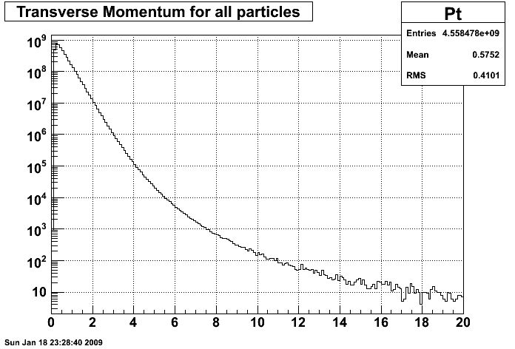
Figure.1 The transverse momentum spectrum of the particles detected by the STAR TPC detector.
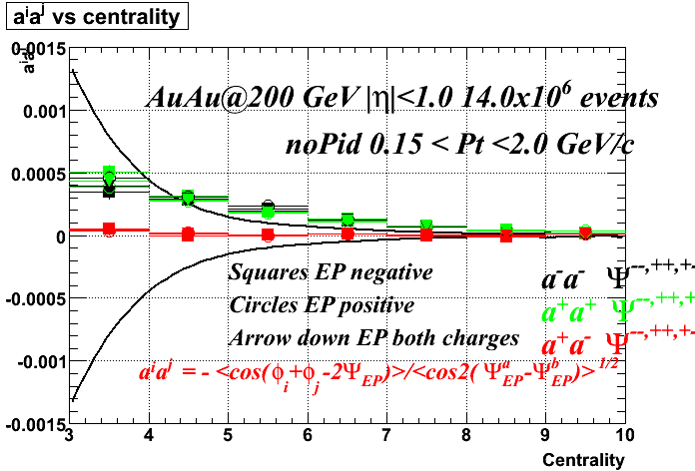
Figure.2. The correlation parameter dependence on a collision centrality for AuAu interactions at 200 GeV, run 4, 14 Million events. The p_{t} cut: 0.15 – 2.0 GeV/c.

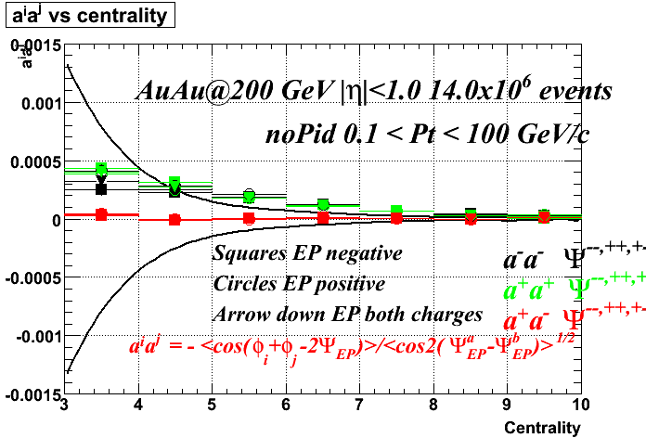
Figure 3. Same as figure 2, with a the p_{t} cut: 0.1 – 100 GeV/c.

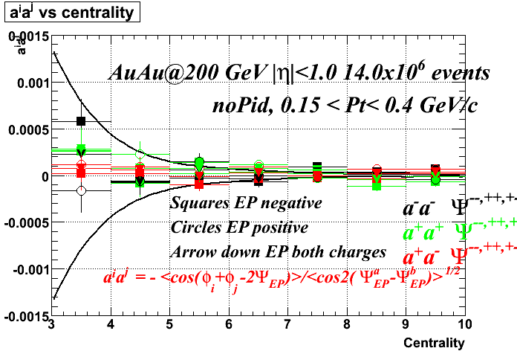
Figure.4. The correlation parameter dependence on a collision centrality for AuAu interactions at 200 GeV, run 4, 14 Million events. The p_{t} cut: 0.15 – 0.4 GeV/c.

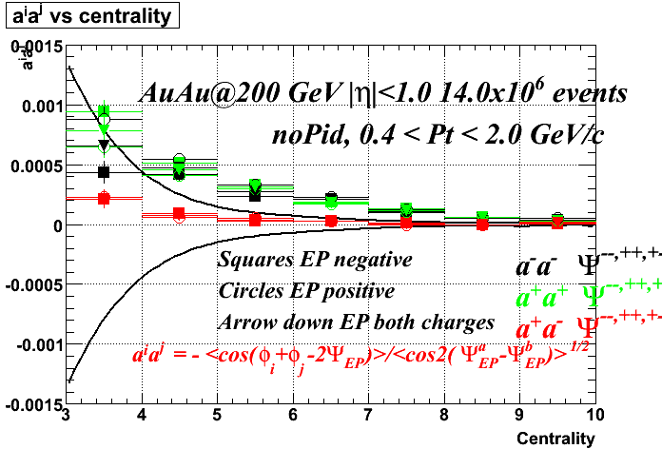
Figure.5. The correlation parameter dependence on a collision centrality for AuAu interactions at 200 GeV, run 4, 14 Million events. The p_{t} cut: 0.4 – 2.0 GeV/c.
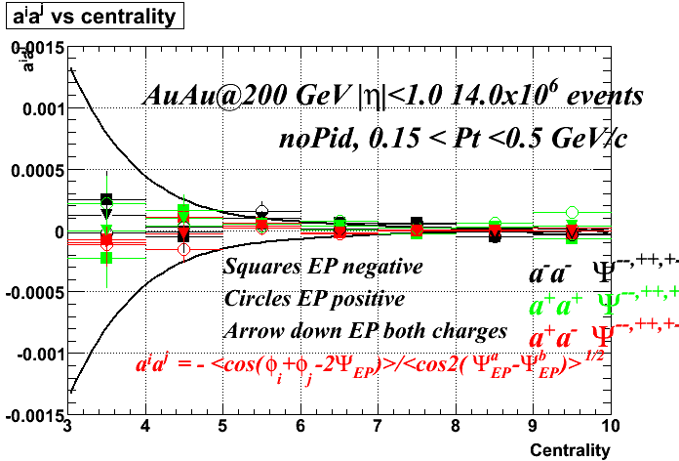
Figure.6. The correlation parameter dependence on a collision centrality for AuAu interactions at 200 GeV, run 4, 14 Million events. The p_{t} cut: 0.15 – 0.5 GeV/c.

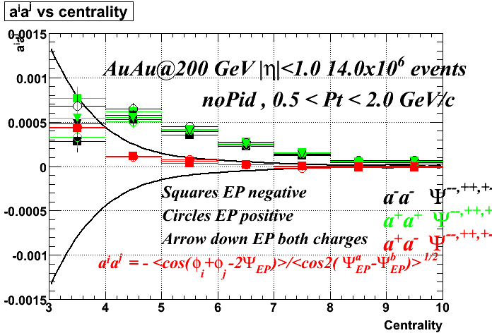
Figure.7. The correlation parameter dependence on a collision centrality for AuAu interactions at 200 GeV, run 4, 14 Million events. The p_{t} cut: 0.5 – 2.0 GeV/c.
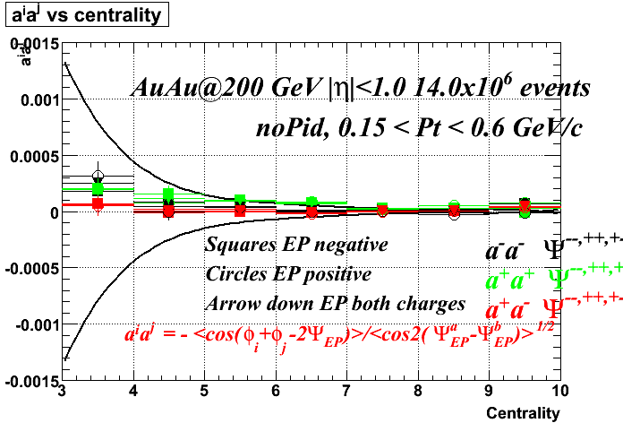
Figure.8. The correlation parameter dependence on a collision centrality for AuAu interactions at 200 GeV, run 4, 14 Million events. The p_{t} cut: 0.15 – 0.6 GeV/c.

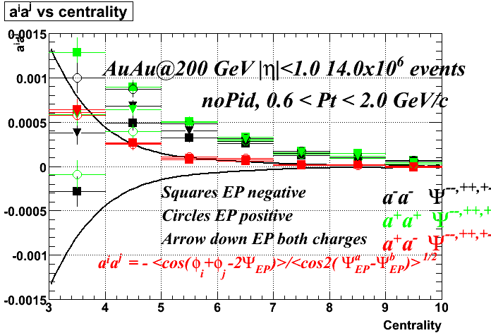
Figure.9. The correlation parameter dependence on a collision centrality for AuAu interactions at 200 GeV, run 4, 14 Million events. The p_{t} cut: 0.6 – 2.0 GeV/c.
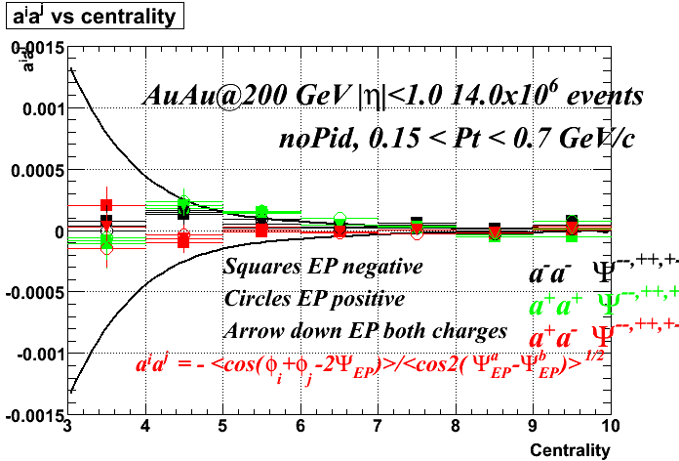
Figure.10. The correlation parameter dependence on a collision centrality for AuAu interactions at 200 GeV, run 4, 14 Million events. The p_{t} cut: 0.15 – 0.7 GeV/c.
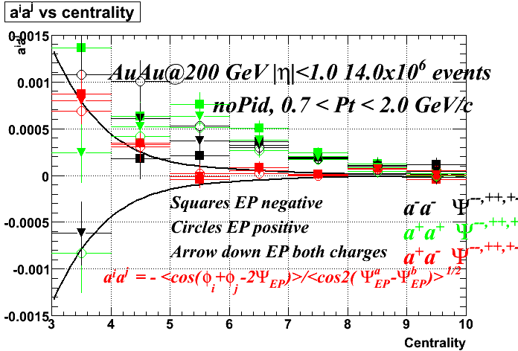
Figure.11. The correlation parameter dependence on a collision centrality for AuAu interactions at 200 GeV, run 4, 14 Million events. The p_{t} cut: 0.7 – 2.0 GeV/c.
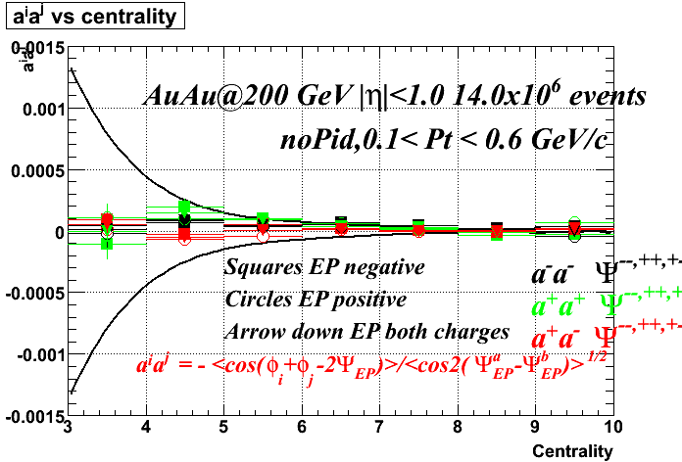
Figure.12. The correlation parameter dependence on a collision centrality for AuAu interactions at 200 GeV, run 4, 14 Million events. The p_{t} cut: 0.1 – 0.6 GeV/c.
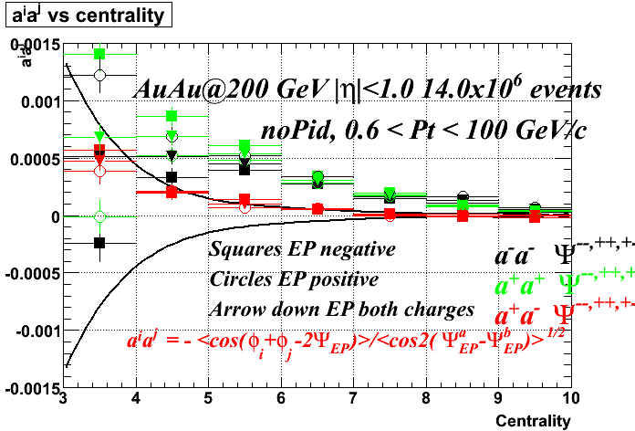
Figure.13. The correlation parameter dependence on a collision centrality for AuAu interactions at 200 GeV, run 4, 14 Million events. The p_{t} cut: 0.6 – 100 GeV/c.

