MT6 SECTION 2
STATIONING AND CONTROL
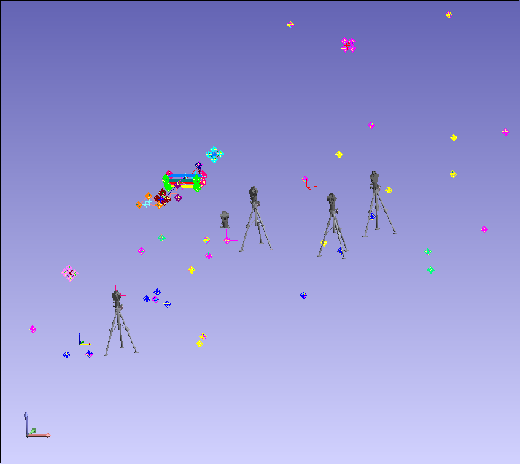
Fit/Query Report:
This is a Local coordinate system based on this task only:
Note: +ve ‘X’ – looking dnst is beam right, +ve ‘Y’ – along beam line (upst towards dnst), +ve ‘Z’ – vertically up
- Plane, Line, Point Transformation
- Plane Fitted to define the Z Axis Direction and Z value for the Origin.
- Point values in the new coordinate frame:
- Plane Points:
- 0: 108.000000, 0.000000, 0.000000
- 1: 108.000000, 705.961257, -0.000000
- 2: -0.007793, -37.605842, 0.000000
- Line Points:
- 0: 108.000000, 0.000000, 0.000000
- 1: 108.000000, 705.961257, -0.000000
- Locator Point:
- 108.000000, 0.000000, 0.000000
Group: USMN Composite FINAL
Point Name | X | Y | Z
190930 | 20.089 | -36.711 | 0.472
190933 | 114.417 | 21.588 | 86.249
190937 | 104.190 | 21.700 | 0.674
190939 | 149.145 | 162.902 | 0.658
190935 | 19.936 | 148.009 | 1.147
190940 | -57.819 | 46.644 | 0.966
190946 | 19.552 | 297.593 | 1.055
190947 | 19.015 | 349.907 | 1.262
190963 | 123.370 | 432.157 | 0.897
190955 | 19.884 | 563.022 | 0.348
190958 | -51.098 | 762.928 | 85.589
190960 | 20.337 | 746.482 | 0.761
190961 | 91.561 | 767.376 | 93.202
190984 | 235.389 | 250.731 | 0.187
190985 | 212.559 | 313.410 | 0.393
190986 | 238.424 | 389.755 | 0.354
190983 | 261.645 | 254.188 | 84.311
190987 | 262.532 | 397.987 | 84.424
PPDS | -41.190 | 353.745 | 2.433
PPUS | -45.041 | 309.237 | 2.549
190945 | 19.875 | 248.028 | 1.404
190949 | 132.850 | 315.975 | 0.391
BRASS MT1436E | 108.000 | 705.961 | -0.000
BRASS MT1436E1 | 107.982 | 706.000 | 0.013
BRASS MT1430E | 23.506 | 647.435 | 0.365
BRASS MT1421E | 107.997 | 525.691 | -0.010
BRASS MT1377E | 108.000 | 0.000 | 0.000
BRASS MT1404E | 108.003 | 345.644 | 0.124
TR MT1370 TOP | 88.788 | -72.005 | 58.238
BRASS MT 1374C | -0.008 | -37.606 | 0.000
BRASS MT 1392E | 12.948 | 174.412 | 0.774
BRASS MT 1390E | 35.112 | 133.756 | 0.710

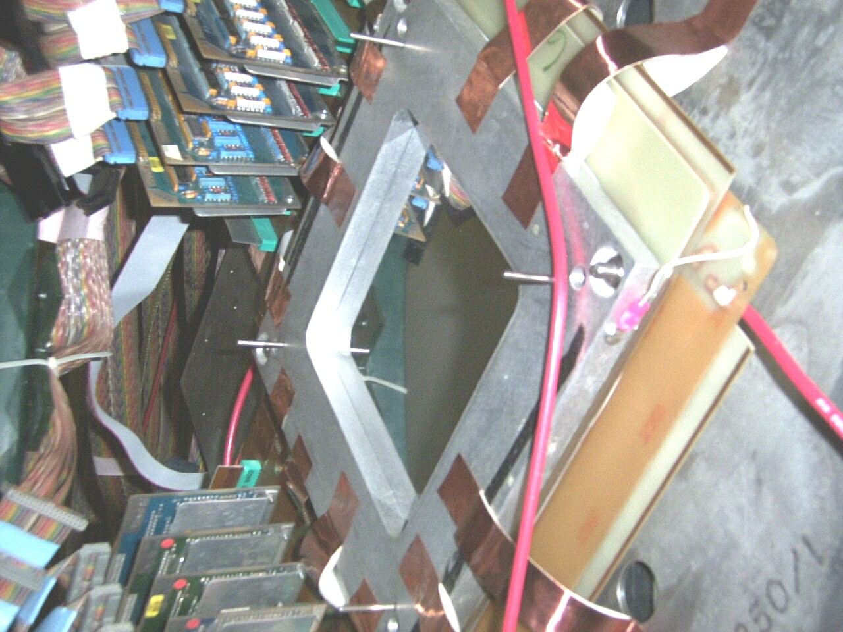
Measured to UPST surface
PWC1
Note: “Offset Points” indicates that the ½ size of the SMR has been applied. Measurement are thus to the surface of planes.
Group: PWC1 Offset Points
Point Name | X | Y | Z
PWC1_1 | -0.326 | -9.537 | 60.648
PWC1_2 | -4.880 | -9.727 | 65.835
PWC1_3 | -0.448 | -9.930 | 69.777
PWC1_4 | 4.181 | -9.774 | 65.319
PWC1_5 | -0.455 | -9.536 | 60.643
PWC1_6 | -5.082 | -9.710 | 65.483
PWC1_7 | -0.528 | -9.925 | 69.816
PWC1_8 | 4.135 | -9.774 | 65.367

Group: PWC1 Cardinal Points
Point Name | X | Y | Z
Centroid | -0.425 | -9.739 | 65.361

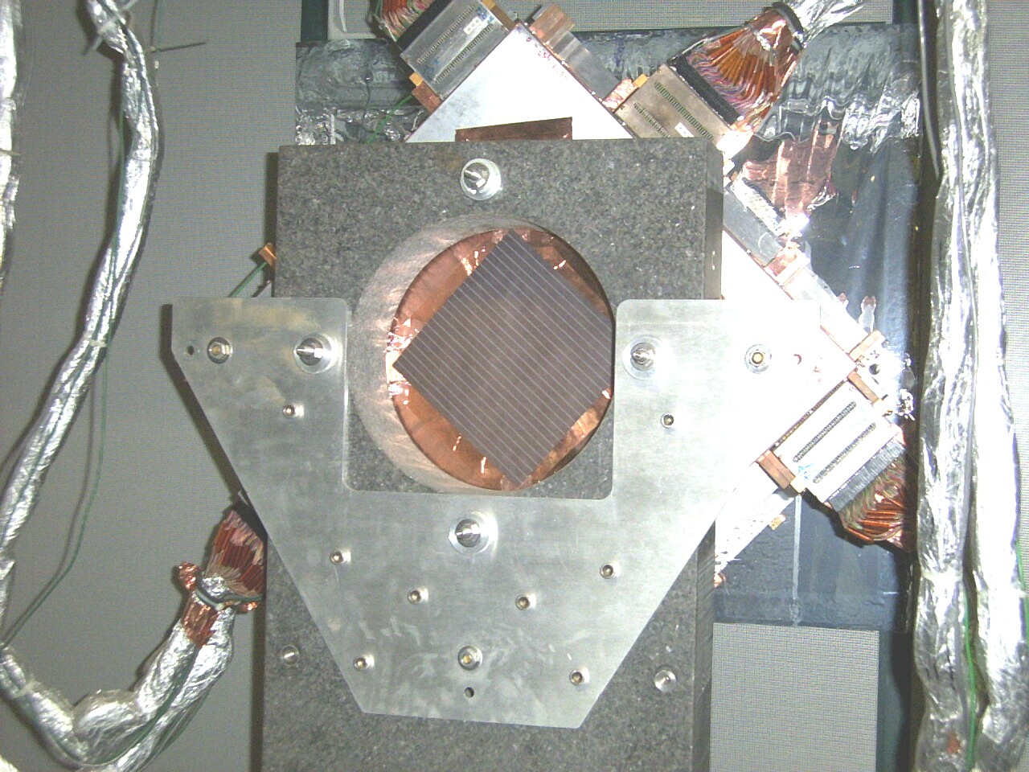
Measured to UPST surface
GRANITE TABLE

Group: GRANITE Offset Points
Point Name | X | Y | Z
GRAN_1 | -9.156 | 209.910 | 68.942
GRAN_2 | 0.060 | 209.908 | 76.896
GRAN_3 | 9.164 | 209.732 | 68.979
GRAN_4 | 9.271 | 209.728 | 68.710
GRAN_5 | 0.415 | 209.908 | 77.291
GRAN_6 | -9.172 | 209.910 | 68.928

Group: GRANITE Cardinal Points
Point Name | X | Y | Z
Centroid | 0.097 | 209.849 | 71.625

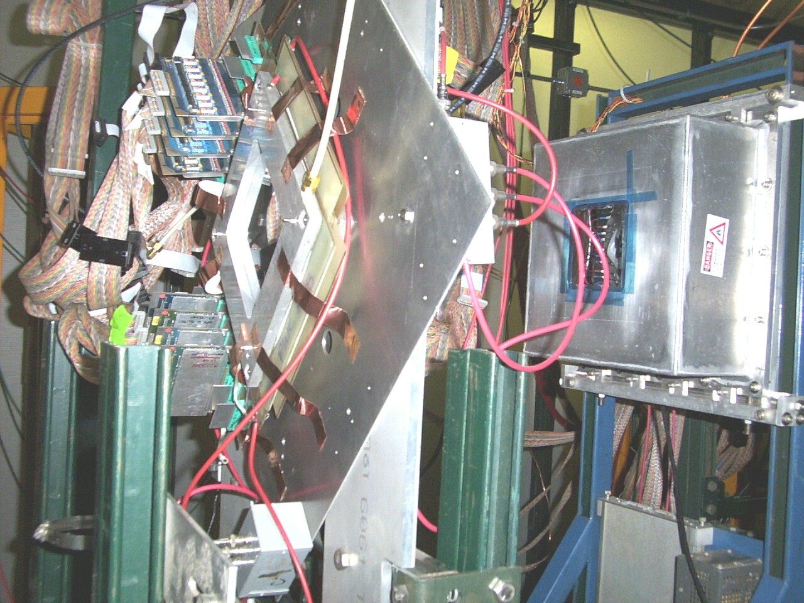
Measured to UPST surface
Measured to UPST surface – See ‘X’ marks on chamber
PWC2 AND SWDC2
Group: PWC2_B Offset Points
Point Name | X | Y | Z
UP1 | 1.570 | 243.679 | 71.686
UP2 | -3.916 | 243.703 | 66.108
UP3 | 0.696 | 243.691 | 61.585
UP4 | 5.307 | 243.668 | 65.454
UP5 | 1.244 | 243.678 | 70.248
UP6 | -3.518 | 243.699 | 65.837
UP7 | 0.788 | 243.688 | 61.633
UP8 | 5.494 | 243.666 | 65.253

Group: PWC2_B Cardinal Points
Point Name | X | Y | Z
Centroid | 0.958 | 243.684 | 65.976

Group: SWDC2_B Offset Points
Point Name | X | Y | Z
SWDC2_1 | 7.365 | 269.104 | 71.940
SWDC2_2 | 7.208 | 268.932 | 60.918
SWDC2_3 | -6.589 | 268.683 | 58.918
SWDC2_4 | 7.447 | 269.103 | 71.735
SWDC2_5 | 7.120 | 268.916 | 60.305
SWDC2_6 | -6.272 | 268.683 | 58.880

Group: SWDC2_B Cardinal Points
Point Name | X | Y | Z
Centroid | 2.713 | 268.904 | 63.783

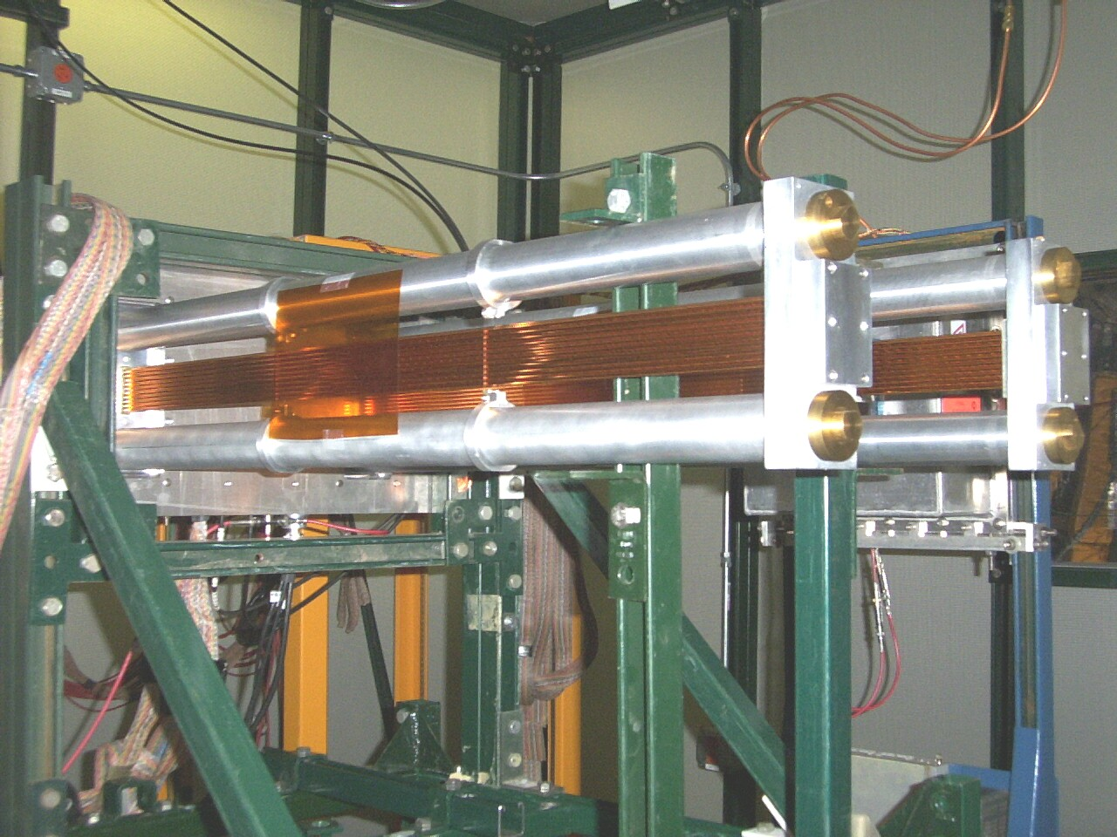
Performed cylinder fit on Top and Bottom Tube.
UPST AND DNST STRAW TUBE CHAMBERS

Group: STRAW_UPST_TOP_B Cardinal Points
Point Name | X | Y | Z
Center | 1.997 | 293.448 | 69.310
Begin | 16.103 | 293.322 | 69.235
End | -12.109 | 293.574 | 69.385

Group: STRAW_UPST_BOTTOM_B Cardinal Points
Point Name | X | Y | Z
Center | 2.603 | 293.446 | 63.705
Begin | 16.093 | 293.327 | 63.640
End | -10.887 | 293.566 | 63.770
Group: STRAW_UPST_B OFFSET POINTS
Point Name | X | Y | Z
Center | 1.997 | 293.448 | 69.310
Begin | 16.103 | 293.322 | 69.235
End | -12.109 | 293.574 | 69.385
Center | 2.603 | 293.446 | 63.705
Begin | 16.093 | 293.327 | 63.640
End | -10.887 | 293.566 | 63.770

Group: STRAW_UPST_B CARDINAL POINTS
Point Name | X | Y | Z
Centroid | 2.300 | 293.447 | 66.508

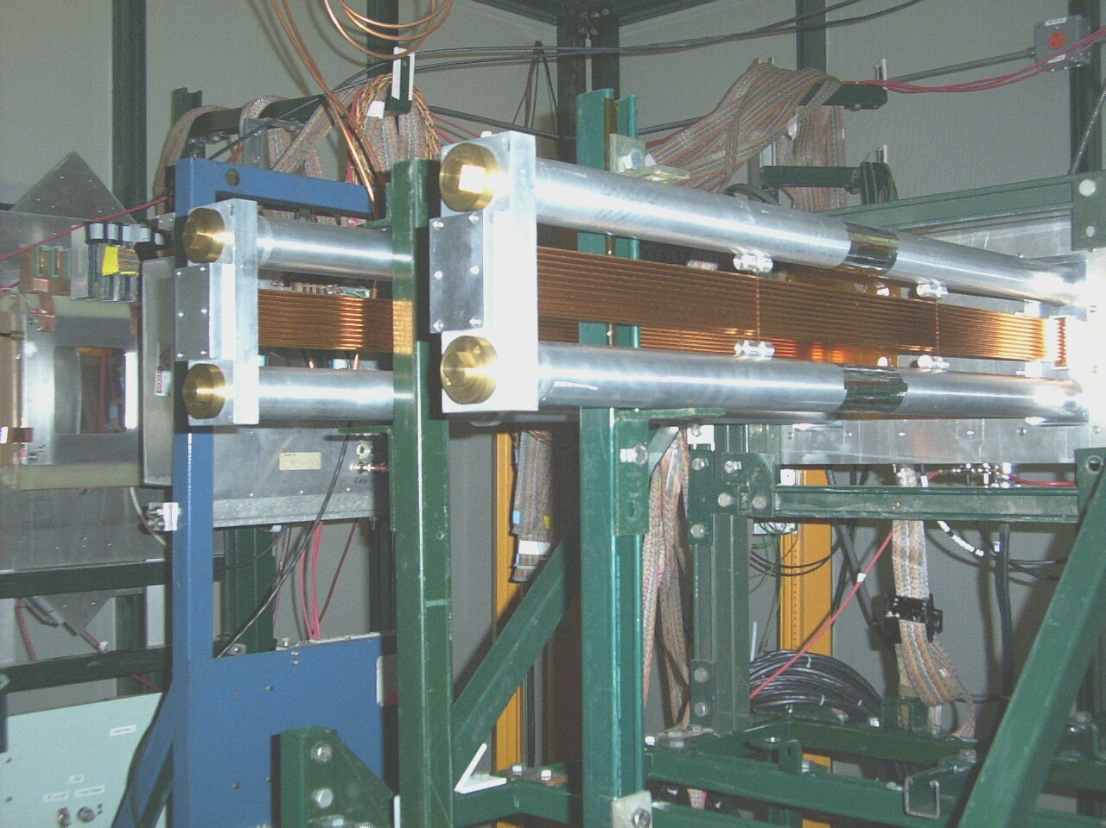
Performed cylinder fit on Top and Bottom Tube
UPST AND DNST STRAW TUBE CHAMBERS

Group: STRAW_ DNST_TOP_B Cardinal Points
Point Name | X | Y | Z
Center | 1.531 | 307.412 | 69.373
Begin | -13.861 | 307.552 | 69.417
End | 16.923 | 307.272 | 69.328

Group: STRAW_ DNST_BOTTOM_B Cardinal Points
Point Name | X | Y | Z
Center | 0.579 | 307.423 | 63.779
Begin | -13.828 | 307.554 | 63.821
End | 14.987 | 307.292 | 63.737

Group: STRAW_UPST_B OFFSET POINTS
Point Name | X | Y | Z
Center | 1.997 | 293.448 | 69.310

Group: STRAW_ DNST_B Offset Points
Point Name | X | Y | Z
Center | 1.531 | 307.412 | 69.373
Begin | -13.861 | 307.552 | 69.417
End | 16.923 | 307.272 | 69.328
Center | 0.579 | 307.423 | 63.779
Begin | -13.828 | 307.554 | 63.821
End | 14.987 | 307.292 | 63.737

Group: STRAW_ DNST_B Cardinal Points
Point Name | X | Y | Z
Centroid | 1.055 | 307.418 | 66.576

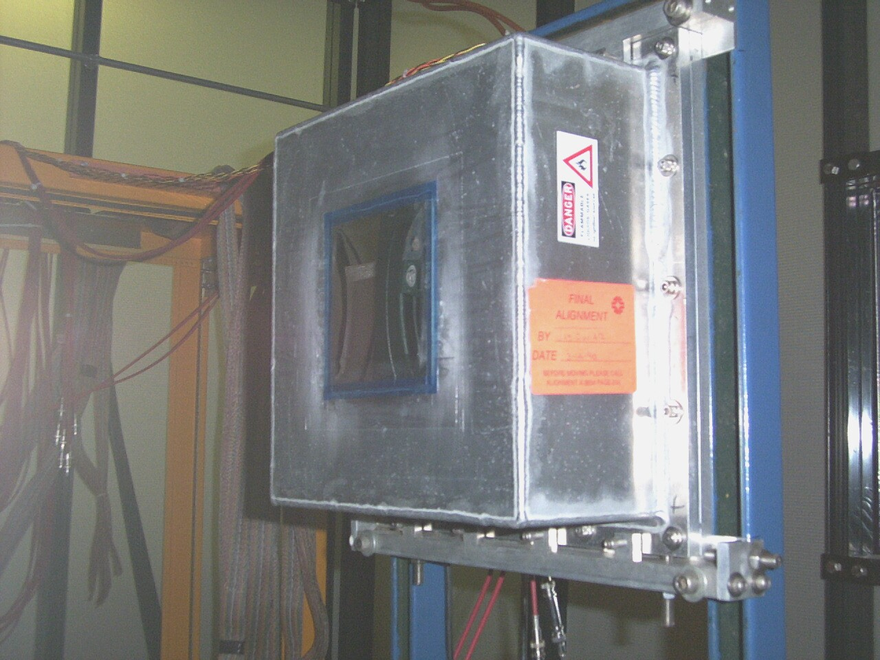
SWDC5
Measured to UPST surface – See ‘X’ marks on chamber

Group: SWDC5_B Offset Points
Point Name | X | Y | Z
SWDC5_1 | 6.299 | 332.112 | 73.019
SWDC5_2 | 6.318 | 332.207 | 61.026
SWDC5_3 | -7.333 | 332.305 | 59.548
SWDC5_4 | 6.364 | 332.108 | 72.895
SWDC5_5 | 6.360 | 332.204 | 61.008
SWDC5_6 | -7.259 | 332.302 | 59.553

Group: SWDC5_B FINAL Cardinal Points
Point Name | X | Y | Z
Centroid | 1.792 | 332.206 | 64.508

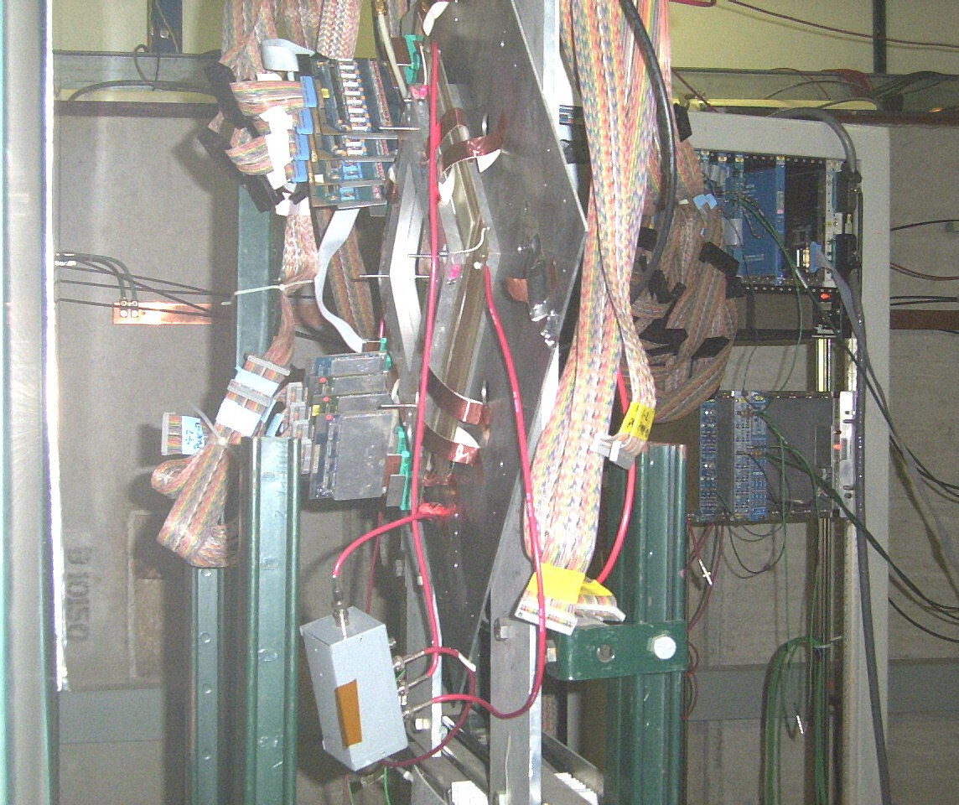
Measured to UPST surface
PWC3
Group: PWC3 Offset Points
Point Name | X | Y | Z
PWC3_1 | 0.474 | 389.215 | 71.858
PWC3_2 | -4.156 | 389.184 | 67.406
PWC3_3 | 0.286 | 389.189 | 63.100
PWC3_4 | 5.970 | 389.232 | 68.027
PWC3_5 | 0.364 | 389.214 | 71.763
PWC3_6 | -4.405 | 389.183 | 67.267
PWC3_7 | -0.082 | 389.186 | 62.847
PWC3_8 | 5.992 | 389.230 | 68.009

Group: PWC3 Cardinal Points
Point Name | X | Y | Z
Centroid | 0.555 | 389.204 | 67.534

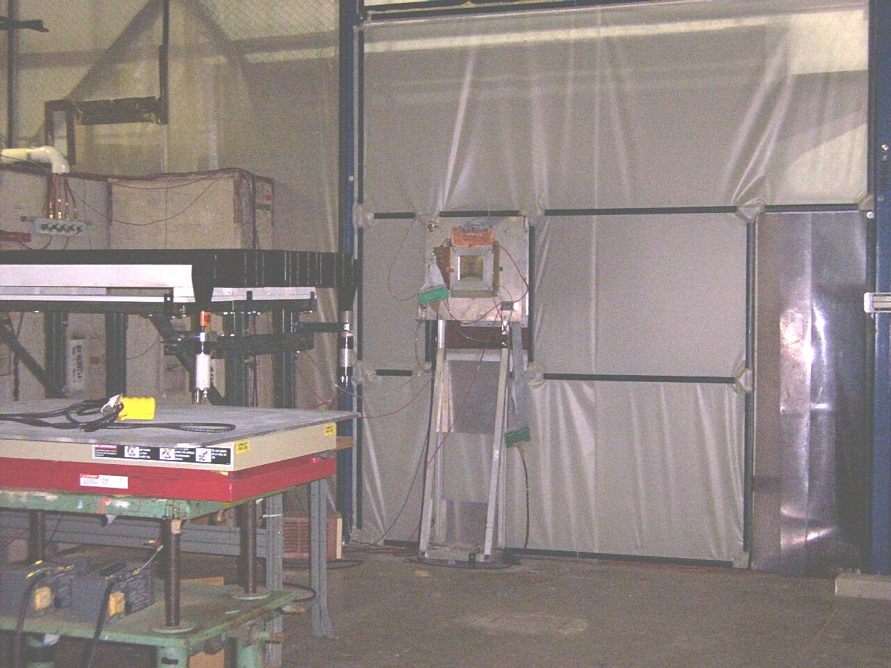
PWC4

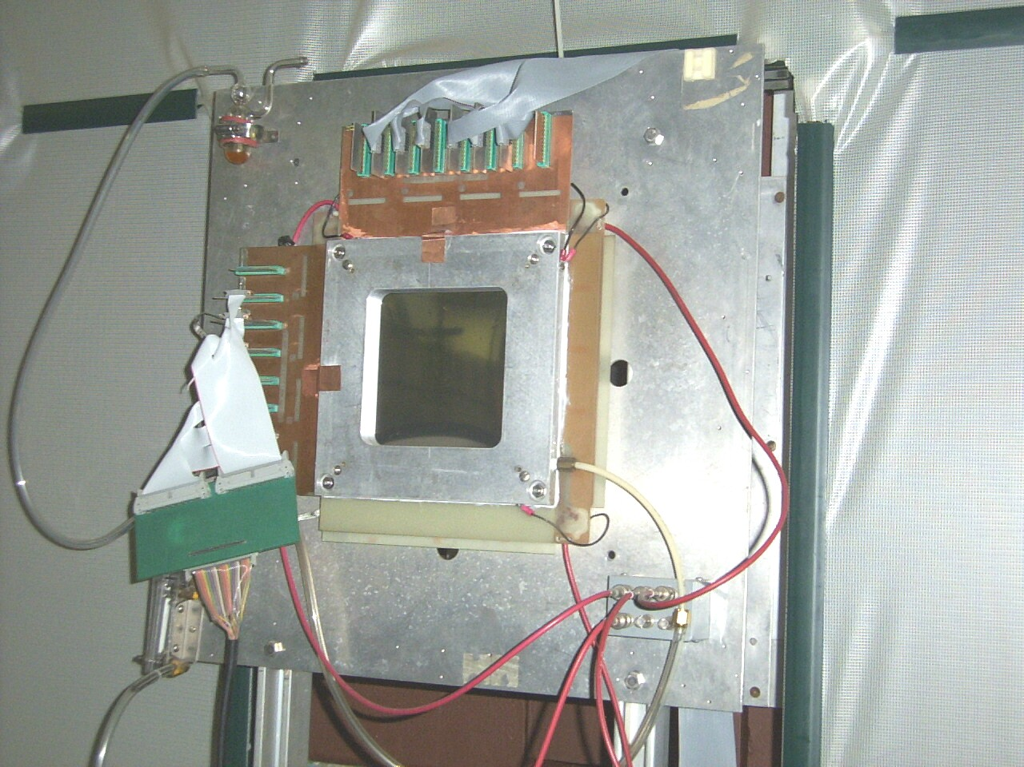
Measured to UPST surface
PWC4
Group: PWC4 Offset Points
Point Name | X | Y | Z
PWC4_1 | -3.056 | 762.687 | 71.334
PWC4_2 | 3.549 | 762.740 | 71.174
PWC4_3 | 3.558 | 762.669 | 64.989
PWC4_4 | -3.269 | 762.614 | 64.825
PWC4_5 | -2.908 | 762.693 | 71.314
PWC4_6 | 3.660 | 762.739 | 71.084
PWC4_7 | 3.543 | 762.668 | 64.887
PWC4_8 | -3.187 | 762.613 | 64.712

Group: PWC4 Cardinal Points
Point Name | X | Y | Z
Centroid | 0.236 | 762.678 | 68.040
Point To Point Distances Between Components
Note:
All distances are indicated from Cardinal Points::Centroid to Cardinal Points::Centroid
PWC1 to GRANITE
- dx 0.523, dy 219.588, dz 6.263, dMag 219.678
GRANITE to PWC2_B
- dx 0.861, dy 33.835, dz -5.649, dMag 34.314
PWC2_B to SWDC2_B
- dx 1.755, dy 25.220, dz -2.193, dMag 25.375
SWDC2_B to STRAW_UPST_B
- dx -0.413, dy 24.544, dz 2.725, dMag 24.698
STRAW_UPST_B to STRAW_ DNST_B
- dx -1.245, dy 13.970, dz 0.068, dMag 14.026
STRAW_ DNST_B to SWDC5_B FINAL
- dx 0.736, dy 24.789, dz -2.068, dMag 24.886
SWDC5_B FINAL to PWC3
- dx -1.236, dy 56.998, dz 3.027, dMag 57.092
PWC3 to PWC4
- dx -0.319, dy 373.474, dz 0.505, dMag 373.474
PWC1 to PWC4
- dx 0.662, dy 772.417, dz 2.679, dMag 772.422

Running Point Distances Between Components (Cumulative)

PWC1 to GRANITE
- dx 0.523, dy 219.588, dz 6.263, dMag 219.678
PWC1 to PWC2_B
- dx 1.384, dy 253.423, dz 0.615, dMag 253.428
PWC1 to SWDC2_B
- dx 3.139, dy 278.643, dz -1.578, dMag 278.665
PWC1 to STRAW_UPST_B
- dx 2.725, dy 303.187, dz 1.147, dMag 303.201
PWC1 to STRAW_ DNST_B
- dx 1.481, dy 317.157, dz 1.215, dMag 317.163
PWC1 to SWDC5_B FINAL
- dx 2.217, dy 341.946, dz -0.853, dMag 341.954
PWC1 to PWC4
- dx 0.662, dy 772.417, dz 2.679, dMag 772.422

Request # : 5253 Requisition Date : 11-JAN-06
Project # : 7001
WBS : 40.13.03
Task Manager : JOHN KYLE
Starting Date : 11-JAN-06 Completion Date : 31-JAN-05
Requested By : ERIK RAMBERG
Expt/Beamline : MTEST
Devices need to be moved or realigned :
None
Description :
Survey locations of front face of 7 chambers in the Meson Test Beam
enclosure. I only need position along the beamline. Accuracy to
about 1 mm should be good. There are 3 stands containing two MWPC
chambers. You can use the front face on each stand. One of these
is in the hut. There are 2 single wire drift chambers in the hut
and 2 straw tube chambers in the hut that also need surveying.

Contact for the job
Fermi ID # : N 8981 Name : ERIK RAMBERG
Extension : 5731 E-Mail : RAMBERG@FNAL.GOV
Mail Stop : 122 Page # : 2660339

Hazard assessor's name : ERIK RAMBERG

